**Curriculum Meeting**

**Headteacher’s report**

Since we last met there has been considerable change which has seen many changes occur both within education and our daily lives. Over the lockdown considerable work has been undertaken by leaders at school in evaluating and developing our core and foundation curriculum. Sadly, due to the ongoing COVID19 restrictions to enable a full reopening in September our curriculum has become rather core centred. However, it is reassuring to know that as a school we have refined and further developed the foundation subjects. Hopefully, the uploaded documents surrounding the evaluation of the curriculum demonstrates the enormity of the work.

**Assessment and target setting**

The first few weeks gave us all an insight into how much the children needed the social interaction from school. By the beginning of October we were beginning to feel a little more settled in terms of gates and COVID19 H&S procedures. It has been unimaginable just how much all of this takes up in terms of resource and time both at the start and the end of the day.

It quickly became apparent when teachers tried to update the school’s assessment system that there were of course gaps and this was evident across all year groups. Therefore targets are not going to set until the first week back in November when we have a secure and robust baseline from which to base our judgements. This decision was also shared with our STEP, Caroline Morgan on her recent inspection visit, 14th October.

Perhaps most notably was the immaturity in learning behaviour from our current Year 2 children, this was also evidenced during the STEP’s visit. These children will need to be ready to undertake formal testing in November and currently those at risk are already receiving accelerated catch up classes three times weekly via our SENCO.

Overall Year 2’s learning has been impacted probably the most and consequently we are going to be redirecting Mrs Harding to this year group four times a week (am only) on her return in early December. If Mrs Harding does not return then the school will try to secure another teacher to undertake this imperative work.

**Catch up Funding:**

The school has read and used the education Endowment Fund guidance to help guide or thinking and our plan makes best use of resources which already exist while also drawing on the importance of parental support and targeted provision.

* 1265 pupil booster classes Yr2 – Yr6.
* Homework Clubs – Yr3 – 6 Three nights per week until May ½ term
* CPG books
  + Home support
  + Additional support
  + Targeted support
* Phonics intervention- To help accelerate the phonic progress prior to the Year 2 phonic test in November our current Year 2 children who are at risk are having targeted support with Mrs Faircloth.

**STEP visit**

Caroline Morgan visited the school and worked with Mr Tatum throughout the morning looking at maths. I have attachd her report for you to see

**Parent meetings & individual reports**

The report below is an example of the format that each parent will receive guarding their chld. The graph on the left details the progress for each year group band. This report is for a child in Year 3. As you can see they are working well within the emerging skills of Year 3 which secures their attainment as above. The majority of children would be expected to be working within or securely within at this stage of the year.

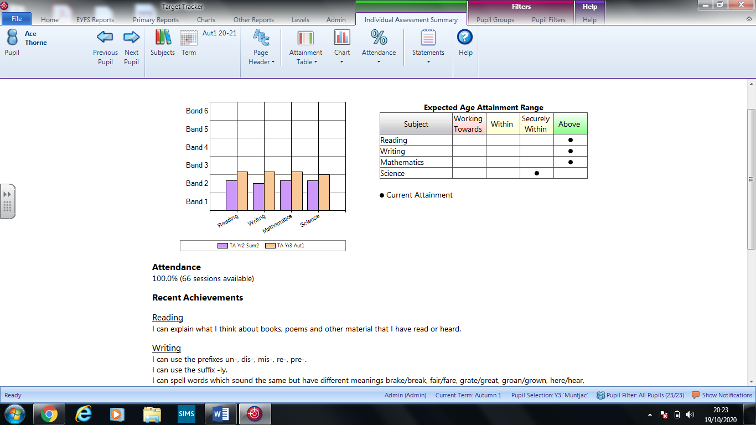

Due to no face-to-face meeting all parent meetings will be via the new school cloud. This has been used successfully in other local schools and provides a secure platform for both parties. Appointments are scheduled and end after exactly 10 minutes. This aspect initially concerned us, although many who have used it as a parent for their own children express their satisfaction, so this is reassuring.

Our appointments will begin on November 8th for KS1 & KS2 with Reception the following week. Parents of children in all year groups will be sent their reports the week prior to their appointments. This will ensure that dialogue is well focussed on pupil’s learning and their next steps.

**Well-being**

Katie Purdy is running her year 4 mindfulness course every Wednesday with children taking part in sessions. This will run until December and after the half term she will also be supporting groups within the classroom to ensure best progress through quality first teaching.

Dory the reading dog is returning after the half term break to continue working with our vulnerable pupils on a Friday afternoon.

ELSA sessions are also now successfully up and running, although the pressure from staff absence due to self-isolation is expected to take its toll here. Fortunately we are hoping to have another member of staff also trained in this area in the next few months as their training re-starts. THIs should ease the situation come

**School visits**

And finally some good cheer…. As you will recall from our earlier COVID19 H&S risk assessment conversations school trips will not take as we feel it places undue pressure on staff and places them at unnecessary risk. However we are hoping to bring some joy to the school at Christmas. While a pantomime is not possible we have hopefully secured a small company who can safely deliver Twas the Night before Christmas & the Christmas Carol. These productions will be delivered to individual Year groups with the actors maintaining a safe distance of at least 4 meters throughout.

In conclusion, this half term has without doubt been incredibly challenging for staff, but especially for school leaders who are feeling exhausted by the sheer demands from the DfE. This will be evident from the extent of material that we have sent you over the last few days in preparation for Thursday.