**Remote Learning Statement**

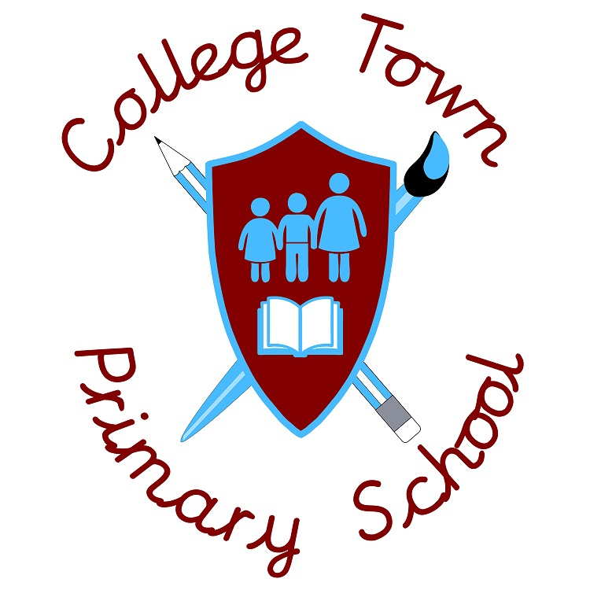

College Town has created a three-tier provision plan in in response to government guidelines on **remote learning**, to ensure that all children can have access to a full curriculum in the event of being absent from school in the context of Covid-19.

A new **Remote Learning Policy** has been created by the Head Teacher and Leadership Team to identify a clear framework for the expectations being set by the school for remote learning at College Town.

The three tiers are:

* **An Individual Learning Plan,** provided by the class teacher via email, for individuals self-isolating in a single class. The learning will include core and foundation subject provision closely linked to the school’s curriculum, with additional opportunities to practise reading and times tables (for older children).
* **A Class Bubble Plan**, where a single class has been sent home to self-isolate for 10 days - due to a confirmed case in the class. In this case the class teacher will adapt the curriculum so that children will still broadly follow the planned school curriculum, with a daily timetable similar to that in school.

The class teacher & TA will be available each day through live video chat on Microsoft Teams: 9:00am -9:15 am and 2:00 -2:15 am, to explain the learning tasks to the children. Additional opportunities will be provided for reading (Bug Club), Guided Reading, My Maths and times-tables practise (Rock Stars- KS 2).

In these circumstances, parent appointmentswith the class teachercan be booked via the School Cloudplatform, one ten minute appointment per week, where more specific feedback with be given about progress against year group objectives

Children with Special Educational Needs and those without access to online devices will be provided with printed copies of tasks in Learning Packs.

* **A Whole Year Group Plan/School Closure,** where a complete year group have been asked to self-isolate at home due to multiple cases being diagnosed or close contact. In these circumstances the class teachers have worked together to adapt the school curriculum to include on-line materials from the **Oak Academy** learning platform. Children will broadly follow the planned school curriculum, with a daily timetable similar to that in school.

The class teacher & TA will be available each day through live video chat on Microsoft Teams at the times specified for each year group:

|  |  |  |
| --- | --- | --- |
| **Reception** | 9:30 – 9:45 | 3:15 -3:30 |
| **Yr. 1** | 9:30 – 9:45 | 3:15 – 3:30 |
| **Yr. 2** | 9:15 – 9:30 | 2:00 – 2:15 |
| **Yr. 3** | 9:00 – 9:15 | 2:15 – 2:30 |
| **Yr. 4** | 8:45 – 9:00 | 2:30 – 2:45 |
| **Yr. 5** | 8:30 – 8:45 | 2:45 – 3:00 |
| **Yr. 6** | 8:15 – 8:30 | 3:00 – 3:15 |

Additional opportunities will be provided for reading (Bug Club), Guided Reading, My Maths, and times-tables practise (Rock Stars- KS 2).

Parent appointmentswith the class teachercan be booked via the School Cloudplatform, one ten minute appointment per week, where more specific feedback with be given about progress against year group objectives

Children with Special Educational Needs and those without access to online devices will be provided with printed copies of tasks in Learning Packs.

* Please note we are unable to respond to Parent Calls through Microsoft Teams.