Competency Framework for Governance
3. People

Building an effective team

These are the skills and behaviours necessary to ensure effective relationships and dynamics around the table. They help to foster a learning culture where constructive challenge is welcomed; thinking is diverse; a variety of experiences and perspectives are welcomed; and continuous improvement is the norm.

Using the bullet points from the “people” competency evaluate your own progress.
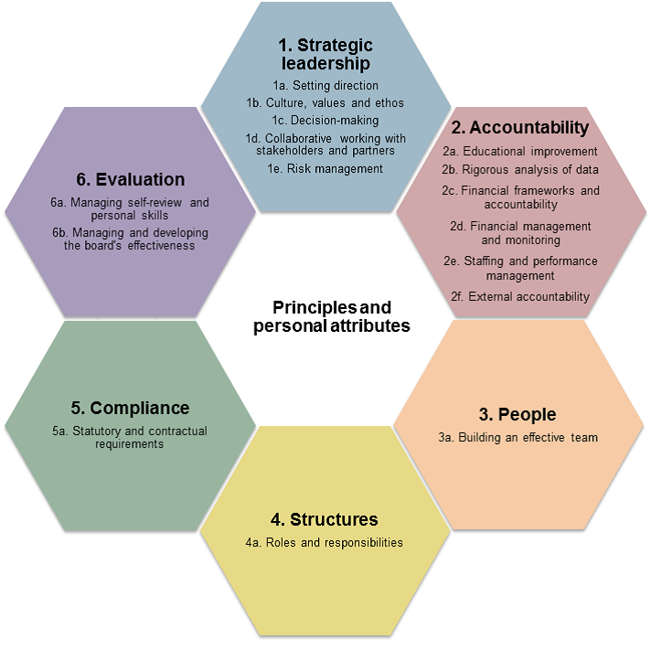
Everyone on the board - Skills and effective behaviours
Are you a governor who? | Not developed | Developing | Competent | Highly Competent
demonstrates commitment to their role and to active participation in governance
has the ability to acquire the basic knowledge that they need to be effective in your role
uses active listening effectively to build rapport and strong collaborative relationships
welcomes constructive challenge and is respectful when challenging others
provides timely feedback and is positive about receiving feedback in return
seeks to resolve misunderstanding at the earliest stage in order to prevent conflict
raises doubts and encourages the expression of differences of opinion
is honest, reflective and self-critical about mistakes made and lessons learned
influences others and build consensus using persuasion and clear presentation of their views
demonstrates professional ethics, values and sound judgement
recognises the importance of, and values the advice provided by, the clerk/governance professional role in supporting the board

What do you think has gone well this year? What could have gone better and what would you do differently?

What focussed school visits have you carried out and what has been their impact to you and school improvement?

Any other comments?

The chair
Knowledge - the importance of succession planning to the ongoing effectiveness of both the board and the organisation
As the chair of governors consider the bullet points below to evaluate your own performance

Skills and effective behaviours
Are you a chair who? | Not developed | Developing | Competent | Highly Competent
ensures that everyone understands why they have been recruited and what role they play in the governance structure
ensures new people are helped to understand their non-executive leadership role, the role of the board and the vision and strategy of the organisation enabling them to make a full contribution
sets high expectations for conduct and behaviour for all those in governance and is an exemplary role model in demonstrating these
creates an atmosphere of open, honest discussion where it is safe to constructively challenge conventional wisdom
creates a sense of inclusiveness where each member understands their individual contribution to the collective work of the board
promotes and fosters a supportive working relationship between the: board, clerk/governance professional, executive leaders, staff of the organisation and external stakeholders
identifies and cultivates leadership within the board
recognises individual and group achievements, not just in relation to the board but in the wider organisation
takes a strategic view of the skills that the board needs, identifies gaps and takes action to ensure these are filled
develop the competence of the vice-chair to act as chair should the need arise
builds a close, open and supportive working relationship with the vice-chair which respects the differences in their roles
values the importance of the clerk/governance professional and their assistance in the coordination of leadership and governance requirements of the organisation
listens to the clerk/governance professional and takes direction from them on issues of compliance and other matters

Personal Action Points

