**Curriculum Governors**

**Jan 30th 2020**

**FSM Whole School Progress Data**

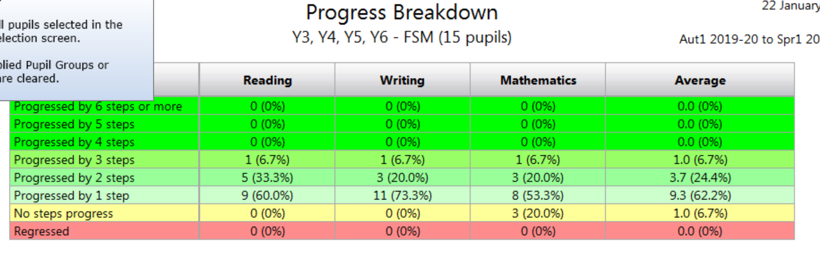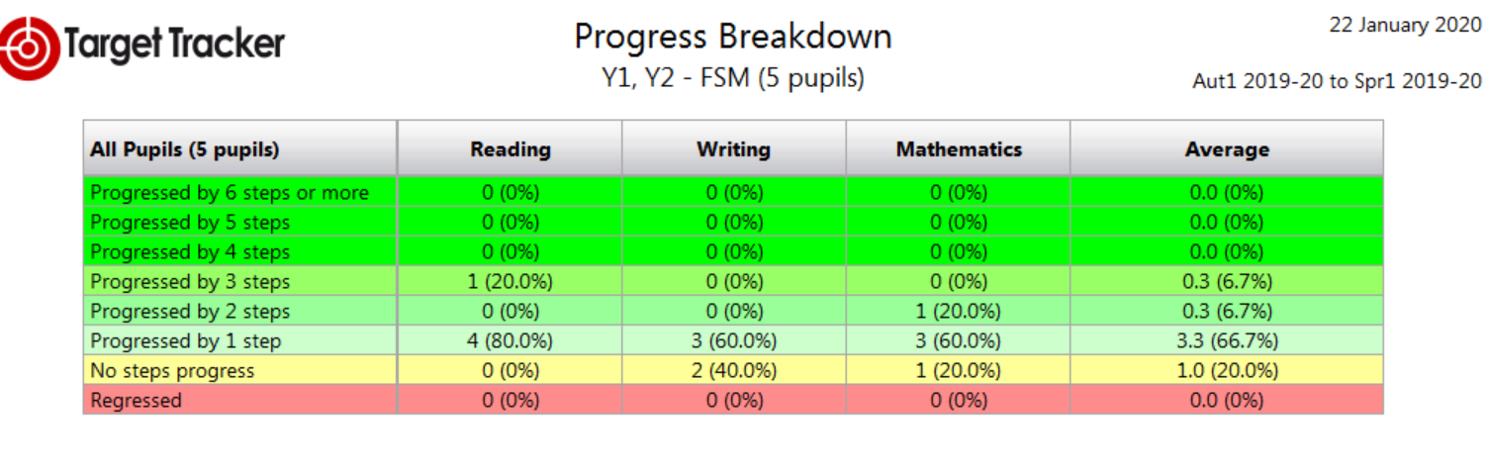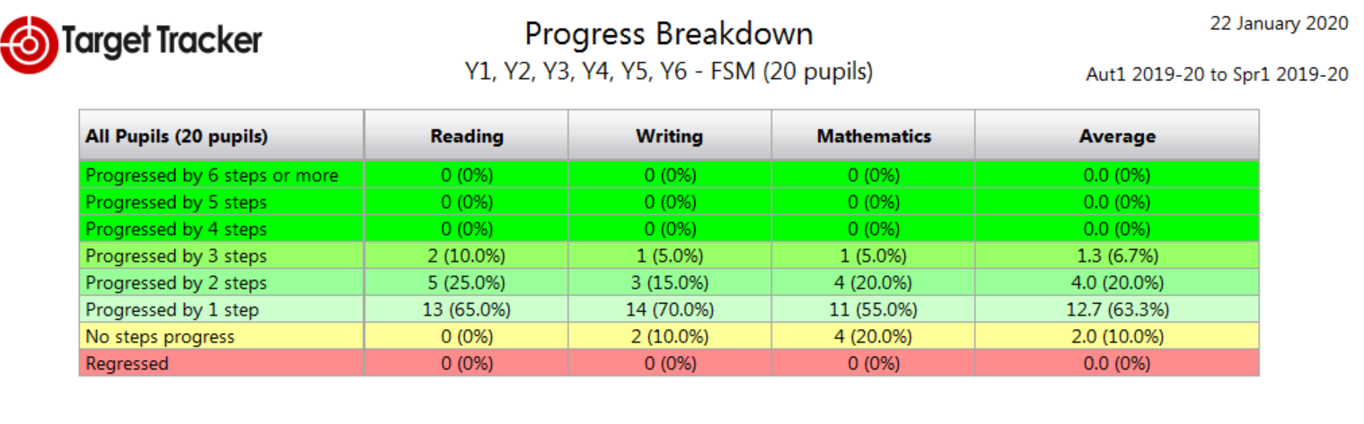

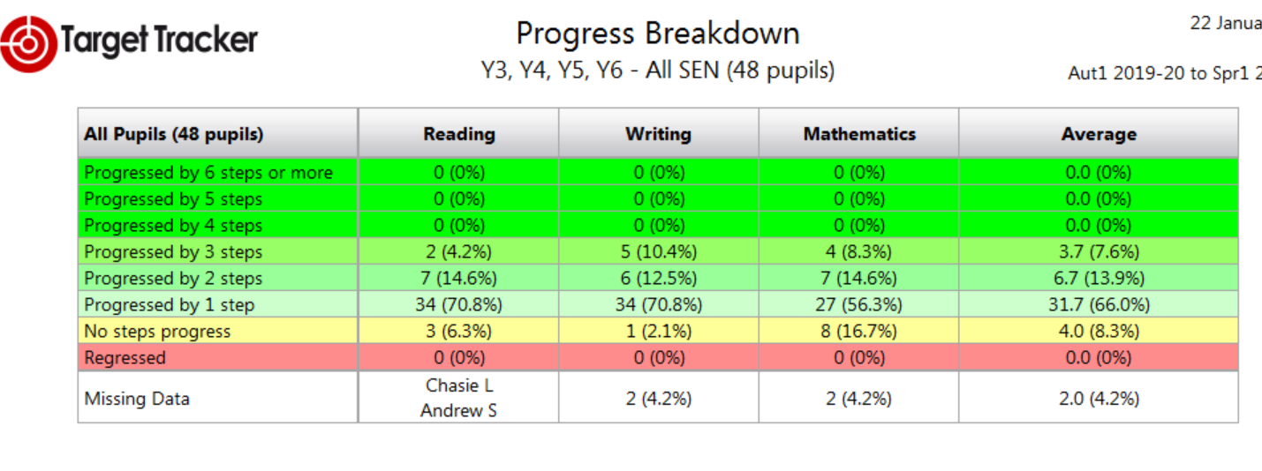

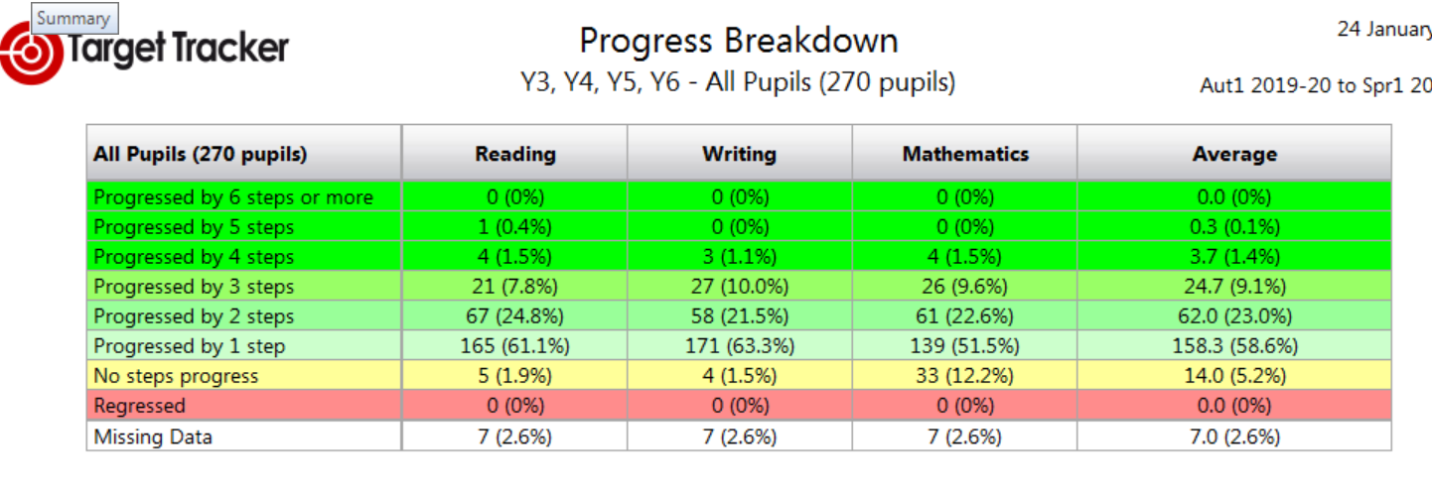

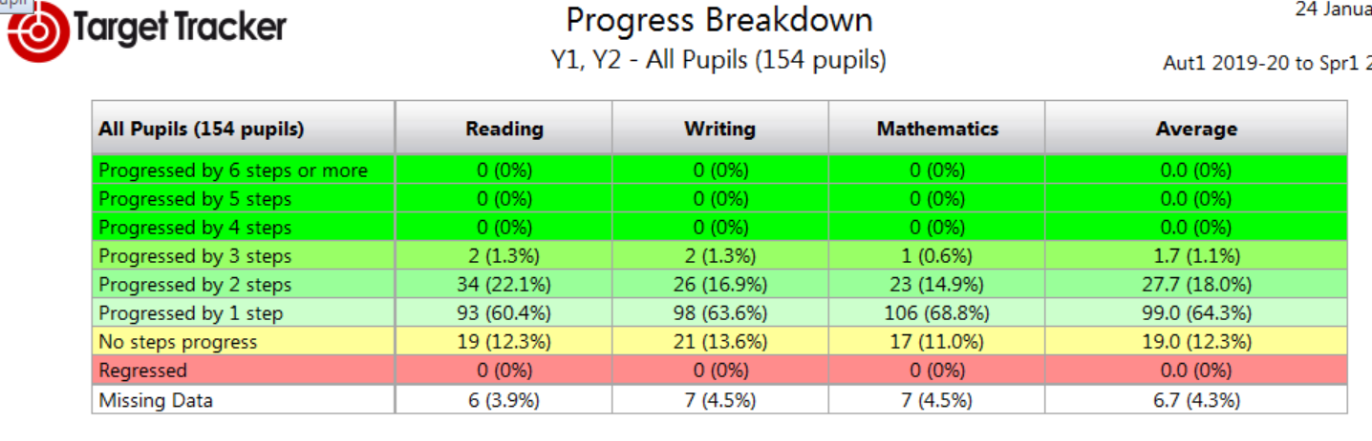

*Please note missing data is for pupils new to the school and not yet assessed on TT. However, these children will be having entry assessments as per policy within the first three weeks and will then be included on TT in the next round of assessments.*

The progress tables show progress for all KS1 & KS2 children up until Feb 3rdwhich is our data point. All year groups with the exception of Y1 (5 points) are expected to make 6 points per year and therefore as you can see there are pupils who are already demonstrating greater progress. However, as a school we do not promote unnecessary accelerated progress, but rather broaden and deepen the child’s learning. Although this will be historic data within a few days it is reassuring to see that progress for all pupils is good with very few children making no steps progress. Indeed one of the children identified as making no progress has not been at school since December 2018 and the other has a high level of SEND.

The report below is an example of the reports which will be going out to parents in the week prior to the half term. Teachers have been given directed time to prepare and ensure that these reports at the mid-point of the academic year are an accurate reflection of their child’s learning. Children who are not working securely within the age expected level for their year group will have been spoken to by the teacher so that there are no surprises when parents receive them.

Year 4 example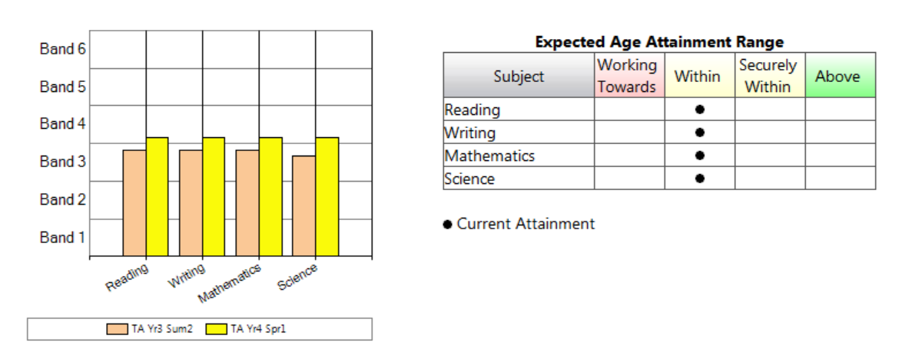

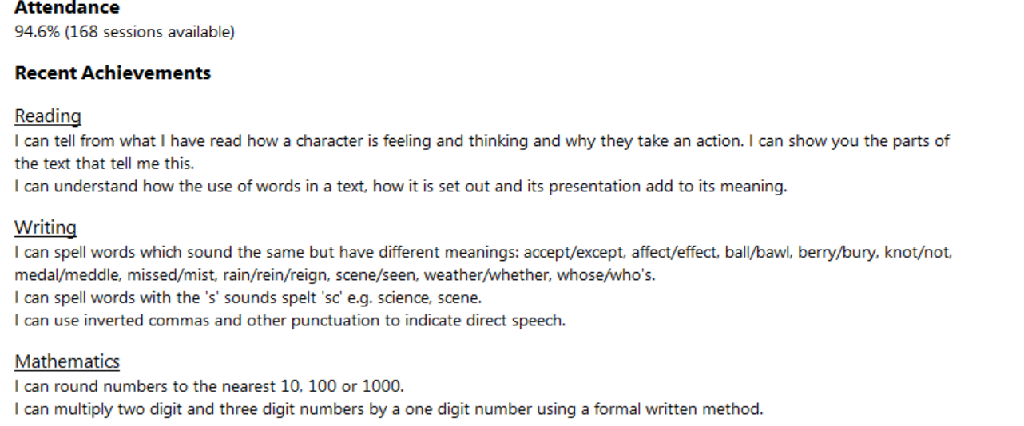

As part of trying try improve parental engagement I feel they provide a good update. Equally they are not too time consuming for the staff either.

**Year 6 Predictions and support**

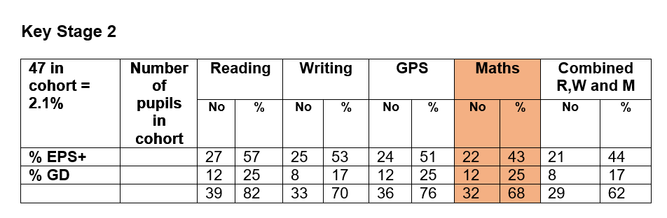

The Year 6 teachers continue to meet with me to discuss the progress of each children within the cohort in an attempt to ensure that despite some erratic teaching in Year 3 & 4 they gain the necessary scores in their exams in May to raise their progress scores. This has been an ongoing area for the school previously as a junior school with some of the lowest outcomes within the country.

Staff have looked at KS1 results for each child and looked at where they would currently assess them. Writing at greater depth and mathematics at both expected and greater depth are the areas of most concern. The table below demonstrates we are hoping to get 62% combined in July although the maths currently is reducing this to around 40%. Clearly this is not acceptable and additional support is being invested into further supporting around 16 children (34%) to ensure that our combined data is at least in line with national and to support greater value added scores for each pupil.

The mobility from KS1 – KS2 also makes straight number conversion a challenge although we have especially targeted those pupils who have remained in our school since Year 1. New arrivals this year and last year have unfortunately given us further challenges with 2 children entering working significantly below their age related expectation. Both have been put on SEND and receive additional support with the school day and beyond.

There are plans to also have a revision and targeting week in the February half term for 16 children and this will focus on developing their arithmetic and reading skills to help them succeed in these areas in the May SATS and beyond. The pupil progress directed time allocated to teachers will also be used in the second half of spring term with reading, writing at greater depth and maths all being specifically targeted and supported to further provide the additional support required for the pupils to be successful and as a school improve our progress schools. 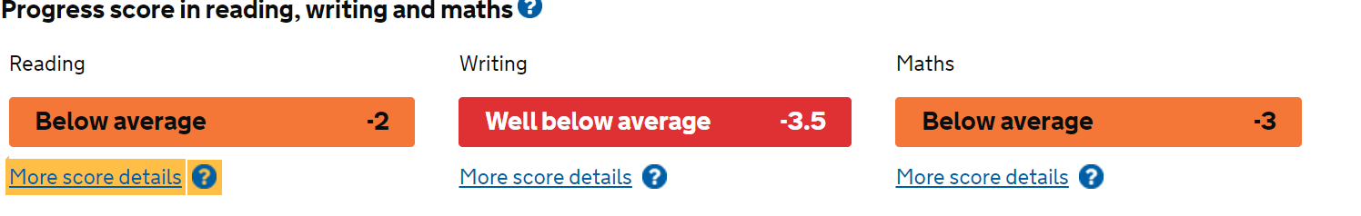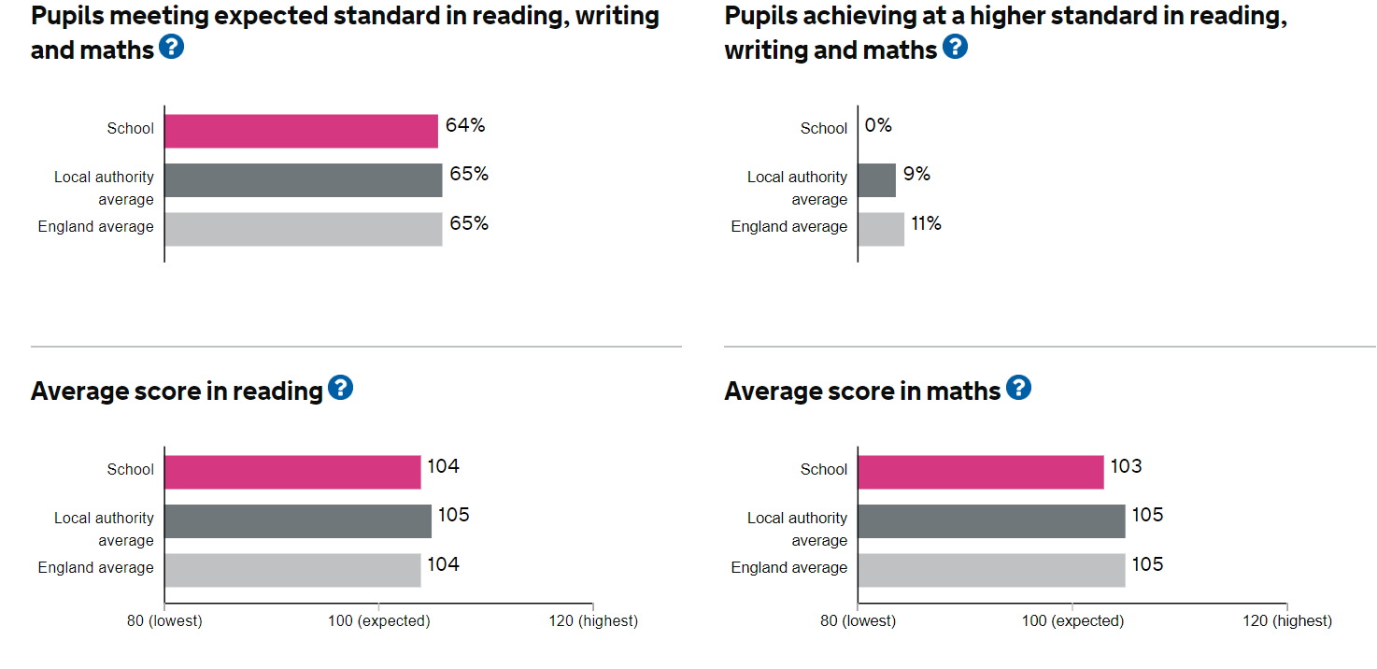

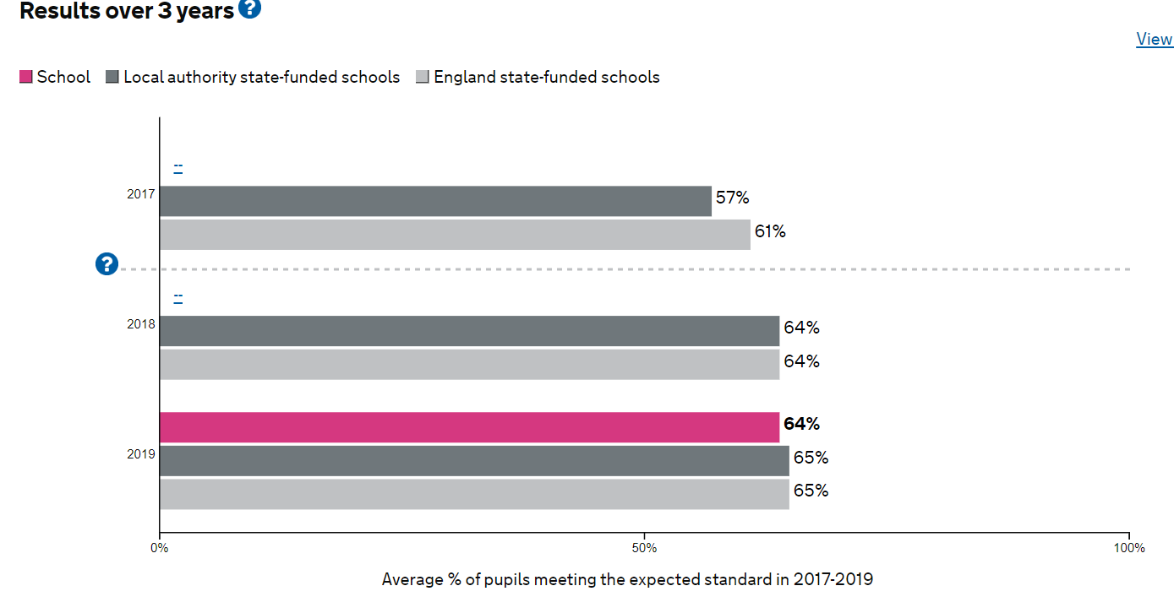

SEN Progress KS1 & 2

EYFS & Year 1 phonics has been a feature of our work since October and the work continues supported by myself and Mrs Duncan. Resources and training have been and continue to be invested so that our phonic teaching and provision meets the national expectation as a very minimum. Mrs Duncan will be reporting in detail on her work during the meeting on Thursday 30th January.

Teacher development as always is high on our agenda and this work will be discussed by the other leaders verbally on Thursday 30th January.

Subject Leaders have currently completing their audits and development plans and these are going to require additional funding than previous years. It is recognised that resources, reading books and training across the school require a distinct upgrade in order to provide the quality of resources and texts required to engage and inspire our pupils.

Reading is a high focus as you would expect within the new framework and as a school we are currently considering ways to further develop and refine our practice. There will of course be an update on this over the next couple of terms.