**Pupil Progress update**

**Phonics results Year 1**

Overall pass rate was 85% which is a great result and our highest pass rate to date. However, the proviso to this is assuming that the pass rate remains at 32 and is not raised. Obviously, any change upwards would cause a decrease to this overall pass rate.

Children from families in receipt of universal credit (FSM) had a pass rate of 1005 all of these were also boys.

***Gender pass rate was:***

Girls: 90% 28 passed out of 31

Boys: 80% 24 passed out of 5 boys

**Phonic results retakes Year 2**

There were 6 retakes and 2 children, which equates to 33% passed the test. The 4 children who failed are all on the SEND register and therefore this is not a surprising result.

**Good Level of Development**

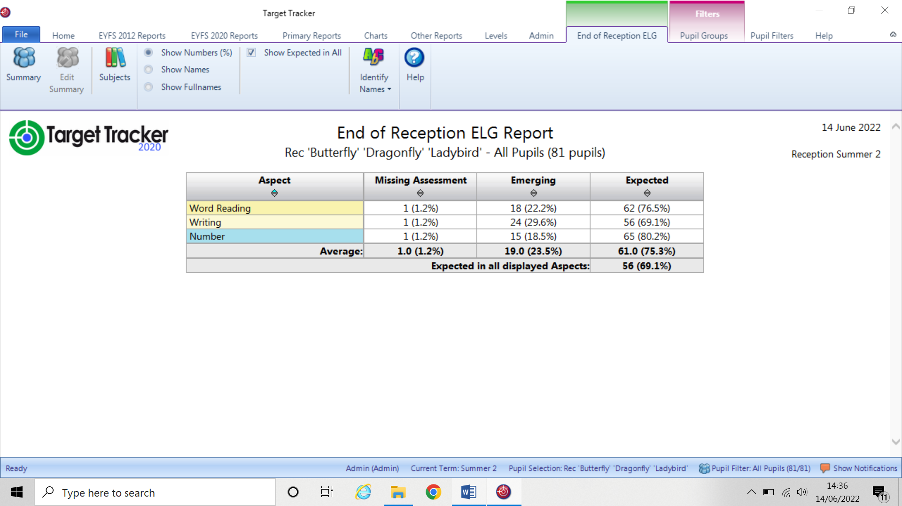

The missing data is a new child who entered after the May half term and therefore their previous school reports on their attainment.

In Reception there are 4 children in receipt of FSM and 75% achieved GLD meaning pupil did not achieve GLD. The child who did not achieve is a pupil known to the Educational welfare Officer due to their very low attendance 60% and declining. This child’s poor attendance clearly demonstrates the impact of non-attendance as they are capable of attaining if they had the same access to education as the other pupils.

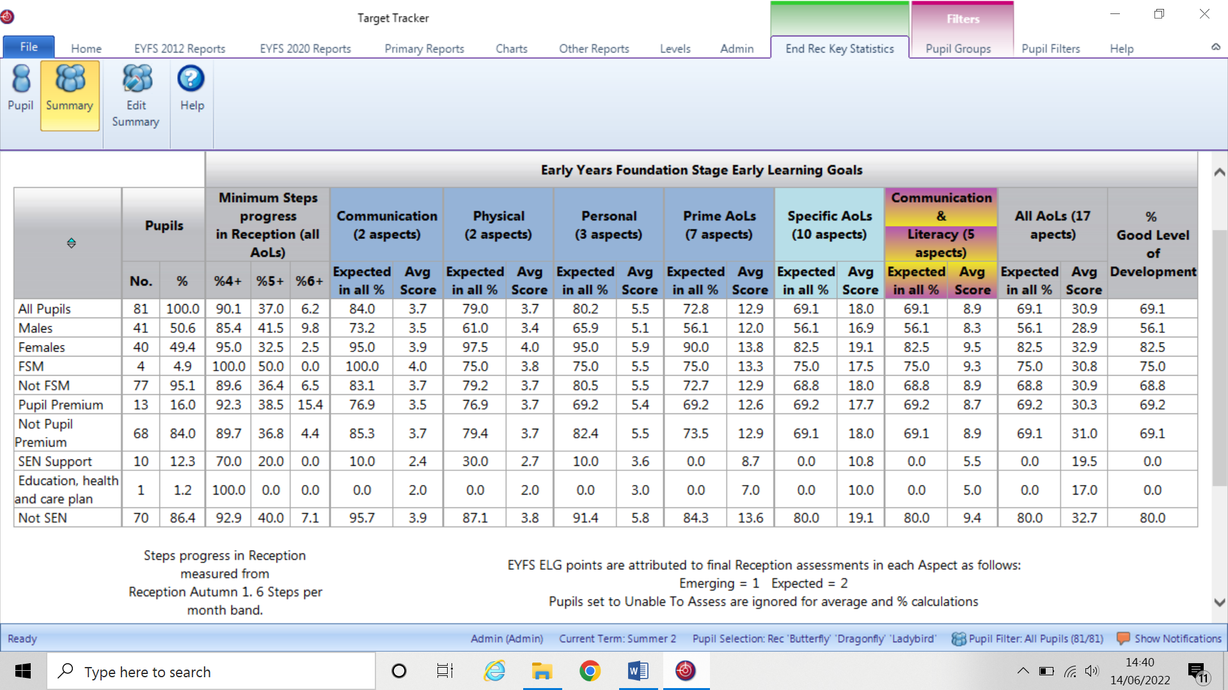

Teacher assessment moderation activities have been set up across BFC to enable teachers from Y2 & Y6 to get together to validate their teacher judgements for writing. Our teachers will be attending on June 15th and 16th and data returns for KS1 & KS2 are at the end of June.

**KS1 SATS**

Below is a table with the outcomes for reading & maths with standardised scores and average.

Please note this is just a snapshot as end of year data is presented in the autumn data once it has been submitted to the LA.

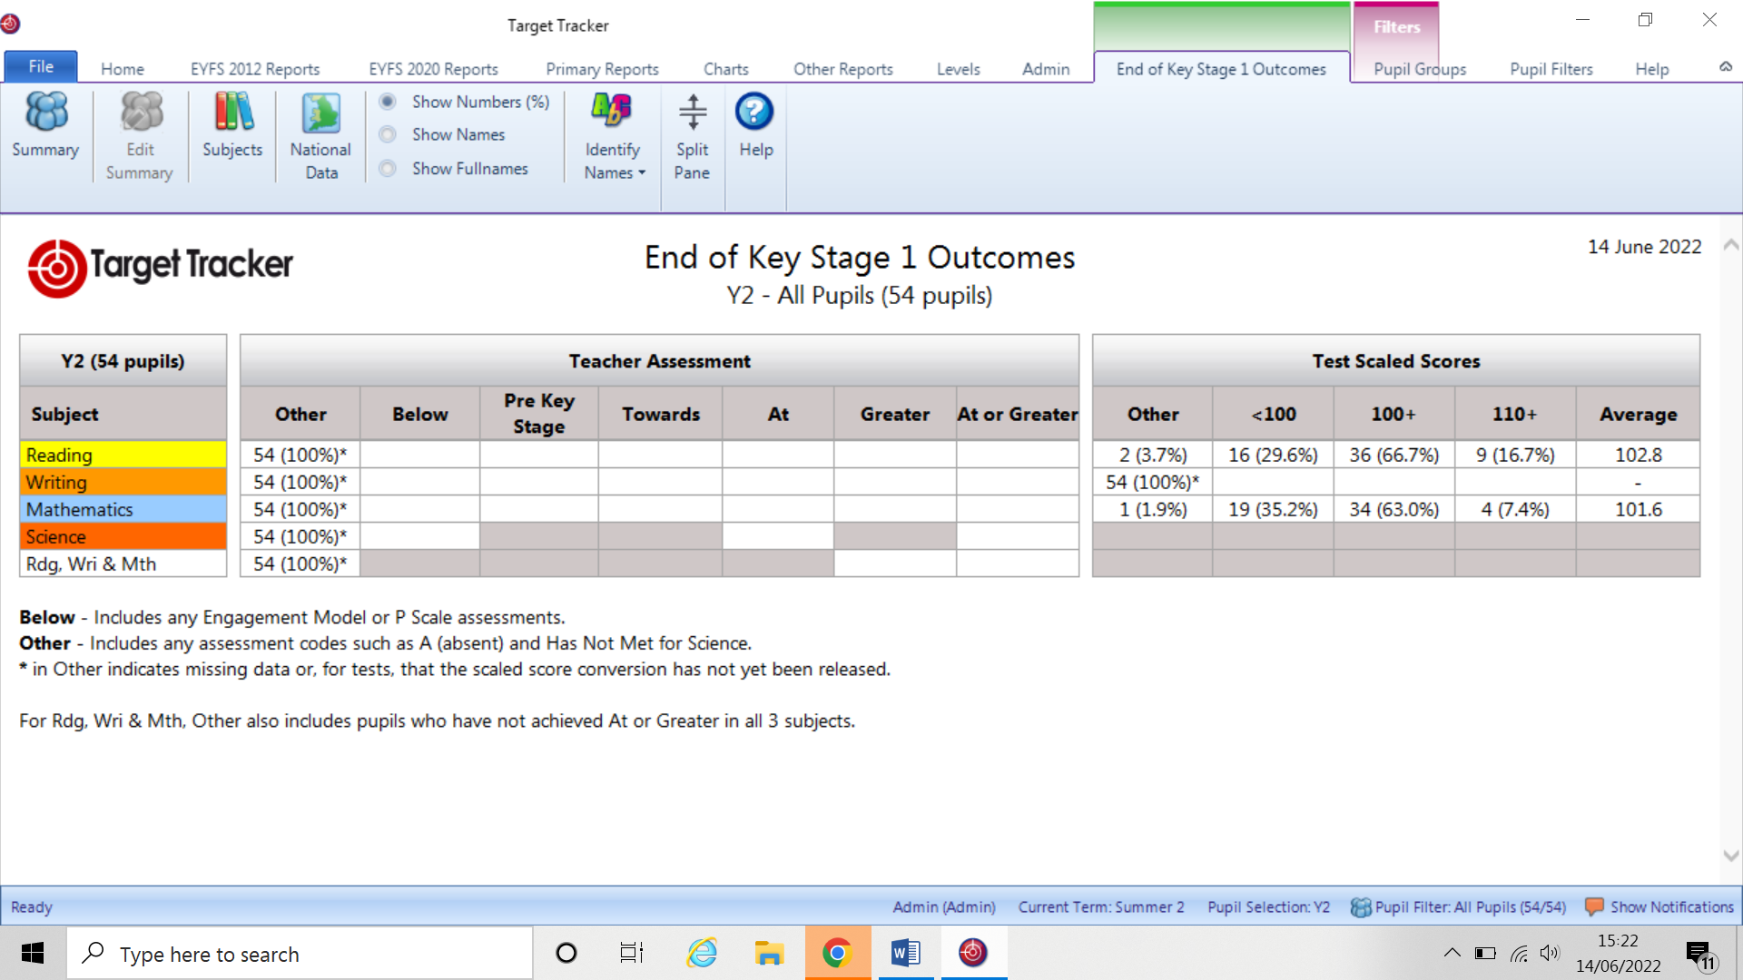

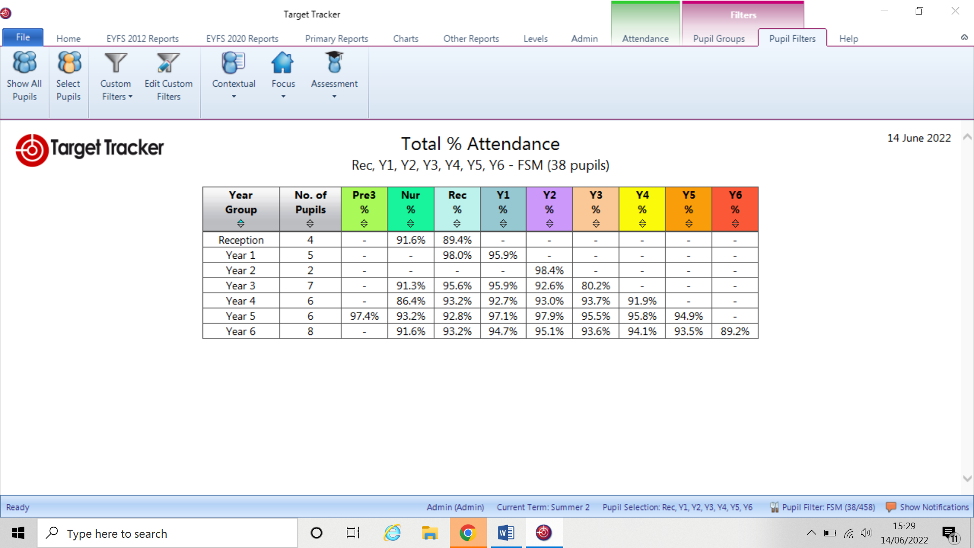

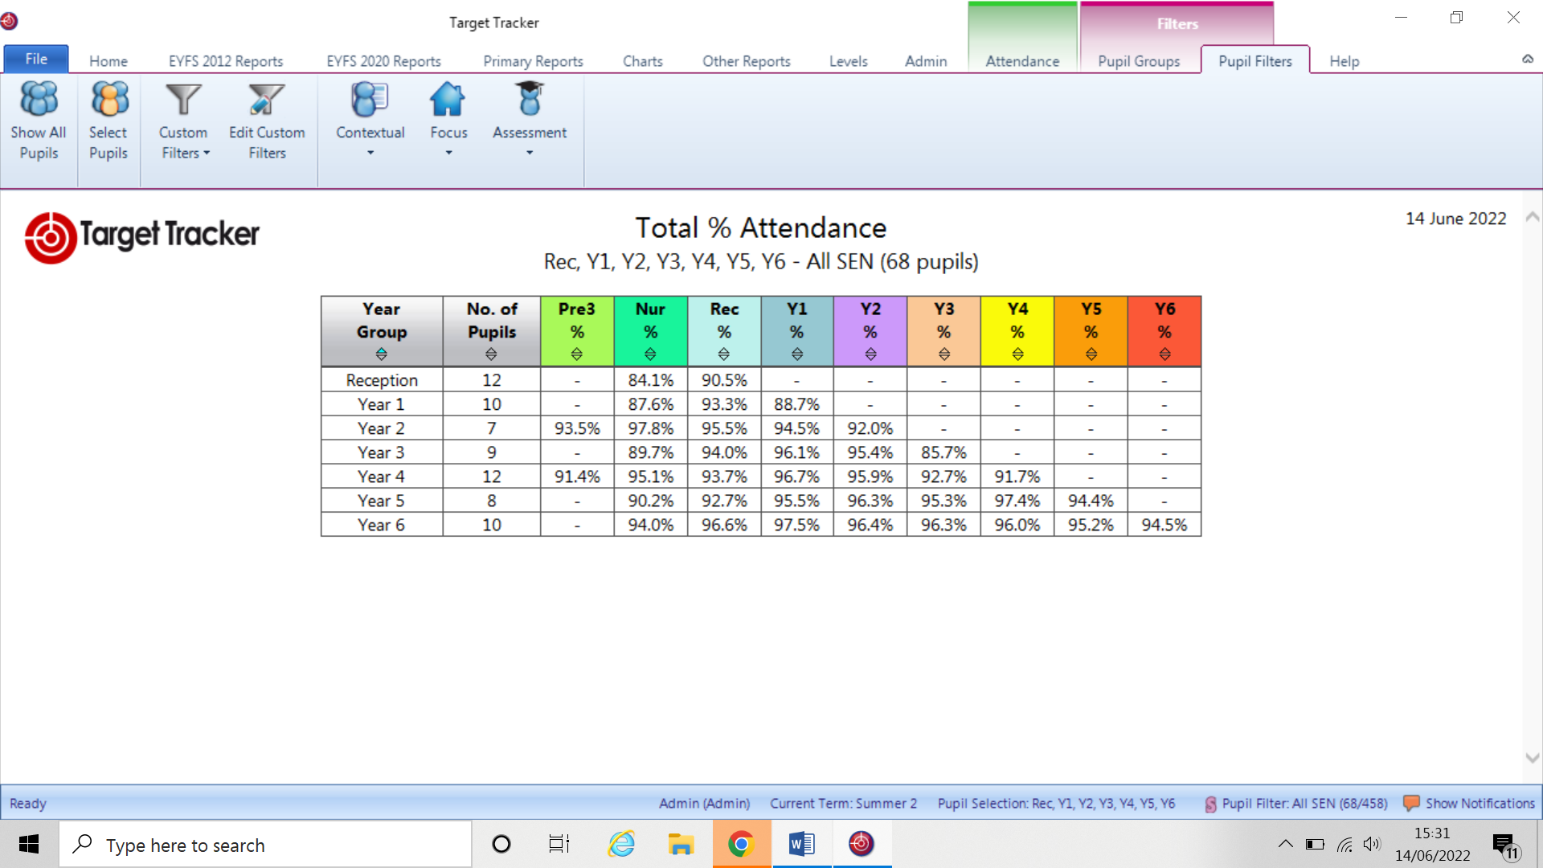

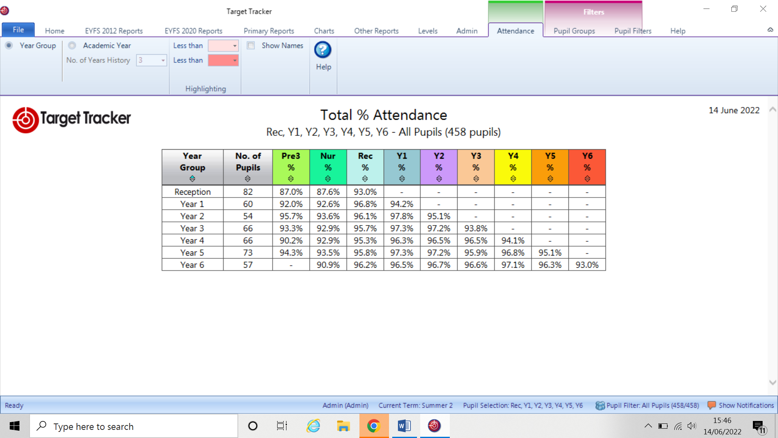

School attendance is currently being reviewed by the government with new expectations from September. Our school is below 96% and this means that attendance is not deemed good enough. Therefore this will be a feature of our new SDP. The two groups where attendance is particularly weak is FSM & SEND and the above data demonstrates the difference between those and other children.

The attainment for FSM & SEND children is commonly lower than in other groups and therefore school attendance is of course even more important.