****SEND REPORT TO GOVERNORS June 2022

Jade Faircloth

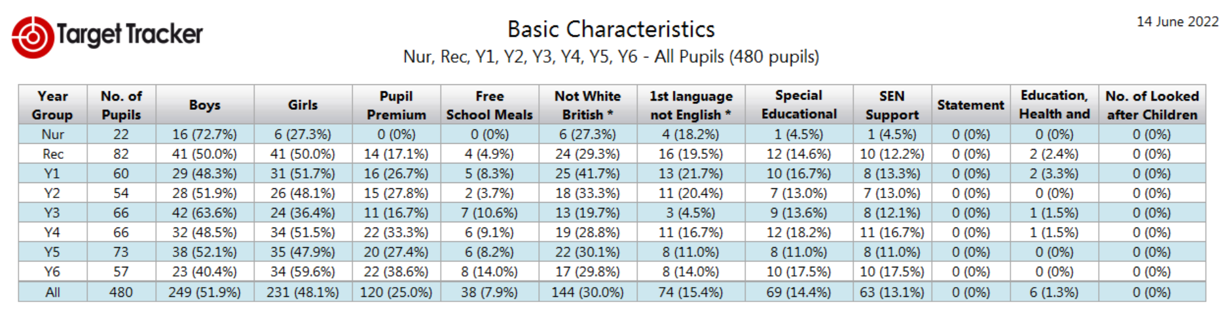

SEND Provision and impact

The most significant needs continue to be in EYFS and Year 1, where 4 of the pupils with EHCPs are being taught. There has been a new arrival in Nursery, a pupil on a decelerated place with significant communication needs, this has resulted in reallocation of staffing to support this pupil. The Year 1 pupil that arrived prior to Christmas has an assessment place at The Link, Manor Green and is proceeding through the EHCP process.

Teachers have been asked to review and update IEPs, PSPs and targets which reflect their current needs, teachers have been questioned as to how they implement these strategies. Teachers need to begin to think creatively about delivering interventions/targets to meet the IEPs as there is not always a TA available to do this for them. This follows on from the third differentiation Inset and the feedback from this.

Interventions have been set up in January across the school ranging from fine motor and phonics (Reception) to Rapid Maths and Writing in Key Stage 2. This has been monitored at each half term data point and across all interventions there has been at least 80% progress. Children who have not made any progress have been identified and discussions have been had with class teachers and parents regarding further assessment from outside agencies.

EHCP Pupils

There are now currently 6 children in school with an Education, Health and Care Plan. -1 on a temporary placement in Nursery -1 in Reception, -2 in Year 1 (although 1 is leaving at the end of the year) -1 pupil in Year 3 (currently not in school) -1 pupil in Year 4.

The pupil on a temporary placement is also a Looked After Child and school are currently working with Hampshire Local Authority to source an appropriate provision for the pupil as the have been decelerated in their learning. 1 pupil, currently in Year 1, is continuing to deteriorate in both their learning and their emotional well-being, despite changing TA support to a highly SEND TA and working with the class teacher to look at appropriate differentiation and the timetable there has been little impact on their learning and behaviour. An early annual review is to be held this term with the view to sourcing a Specialist Resource Provision.

There are 5 annual reviews to be written this term-3 where there will be a request for an alternative placement and 2 are just updated.

Support has been provided to two Year 1 teachers regarding provision and planning for EHCP children. This has been monitored weekly and discussions held with teachers as to how to support the learners. Teachers have been trained in using Clicker, Word Shark and Number Shark as an additional tool to support the children in class.

Training

Specific training modules on Autistic Spectrum Disorder has been ordered for TAs working as one to ones.