End of Year SEND report 2018-2019

Types of support within our school:

|  |  |  |
| --- | --- | --- |
| Type of Support | Number of pupils on SEN register | Percentage |
| Special educational needs (SEN) support | 69 children out of 534 | 12.9% |
| Education, health and care (EHC) plan | 5 children out of 534 | 1% |

Areas of need within our school:

|  |  |  |
| --- | --- | --- |
| Primary area  of need | Numbers of pupils on SEN Register | Percentage |
| Cognition and Learning  (C&L) | 17 children  (12 boys, 6 girls) | 24.1% |
| Communication and Interaction  (C &I) | 18 children  (10 boys, 8 girls) | 24.3% |
| Social, emotional and mental health (SEMH) | 6 children  (5 boys, 1 girl) | 8.3% |
| Sensory and/or physical needs  (PD) | 4 children  (3 boys, 1 girl) | 6.8% |
| No Specialist Assessment  (NSA) | 27 children  (16 boys, 11 girls) | 36.5% |

EHCP Children

* Currently there are 5 children in across the school who have an Educational Health and Care plan; 3 of these children are having additional and continued 1:1 support on a daily basis. 1 child is taught in the learning hub and is on a reduced timetable due to their complex needs and the nature of their behaviour. 1 child has been signed off from school by the Doctor since November and is awaiting a more suitable educational setting.
* 2 children with EHCPs have made good progress this year from their starting points. 1 child has made little progress and is currently undergoing re-assessment from the Local Authority in light of updating his EHCP. 2 children have made no progress (1 due to no longer attending school and 1 due to having multiple complex behaviour needs which cannot be met at a mainstream primary school. (See attached graphs to show progress in Reading, Writing and Maths.)
* At present, there has been 4 Education, Health and Care Plans which have been submitted to the Local Authority. One is for a Year 6 pupil, one is for a Reception pupil who is going to be placed at Meadow Vale Speech and Language Resource and the remaining 2 are for children who will start Reception in September.

EHCP Progress in Writing:

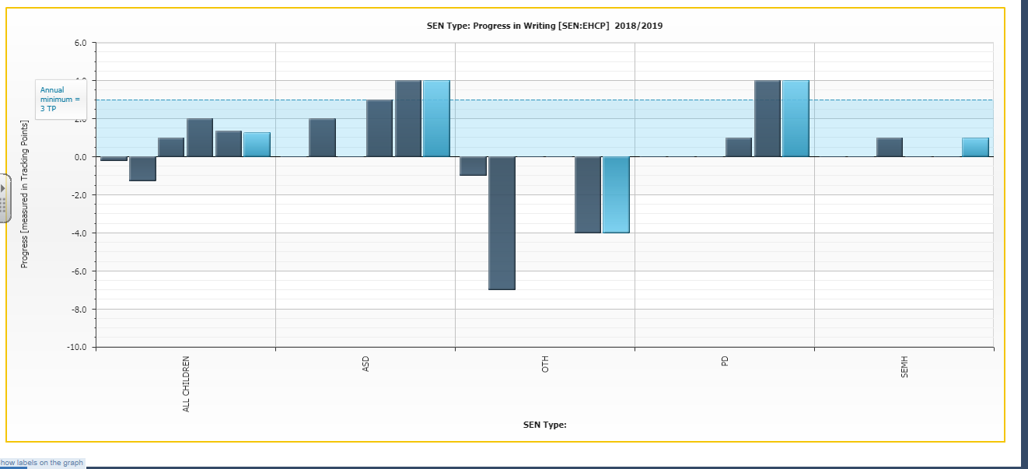

EHCP Progress in Reading:

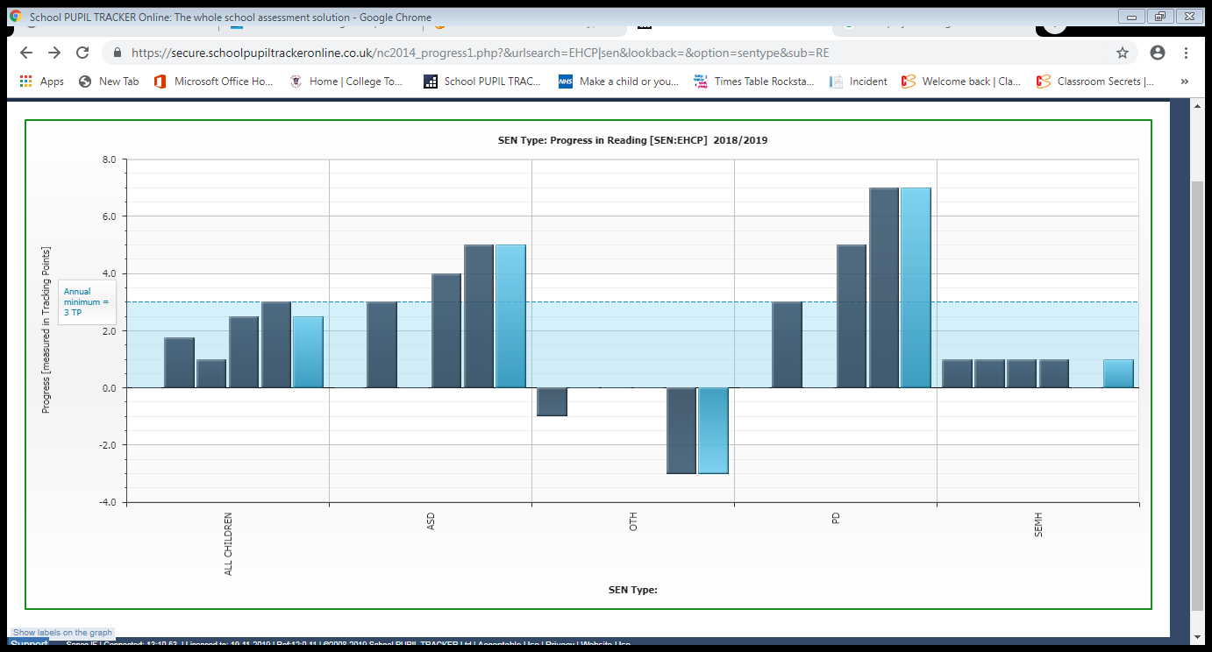

EHCP Progress in Maths:

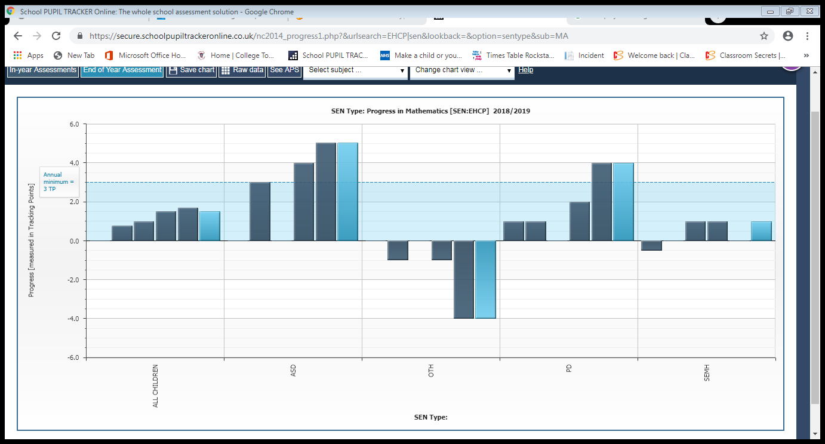

SEN Support Children

* The school has funded play therapy from an external agency in order to support complex additional needs. Currently 6 children receive this additional support.
* The school has funded 1:1 tutoring through Support for Learning for 1 Year 6 pupil who was identified in the summer term of 2018 as making minimal progress since starting Junior School. The child has made limited progress despite this intensive intervention and an EHCP has been submitted.
* The school also now has a qualified ELSA (Emotional Literacy Support Assistant) teaching assistant, who delivers either group sessions or 1:1 sessions every afternoon to meet the needs of the children. Currently she works with 23 children across the week in small groups (1:3) or 1:1 depending on each child’s emotional needs.
* The SENCo has completed training in dealing with emotional trauma and attachment as well as additional qualifications to support understanding of ASD and the use of social stories. She will be completing a course in Emotional First Aid to further support the social, emotional and mental health needs of the school.
* Two Teaching Assistants have attended Team Teach training to support their work in the Learning Hub and supporting children with challenging and complex needs.
* Outside agency referrals this year have predominantly been to either CAMHs for social, emotional, mental health needs or to support children with possible ASD. There have been 7 referrals this year and 5 of which are still awaiting triage from the service.
* Across all core areas of learning children identified as SEN Support have made significant progress due to the significant improvement in Quality First Teaching and the identification of needs. There is now robust monitoring of IEPs, reviews and behaviour plans. There is consistency across the school in how these are written and delivered to ensure that the provision is appropriate to the needs of individual children.

SEN Support Progress in Reading:

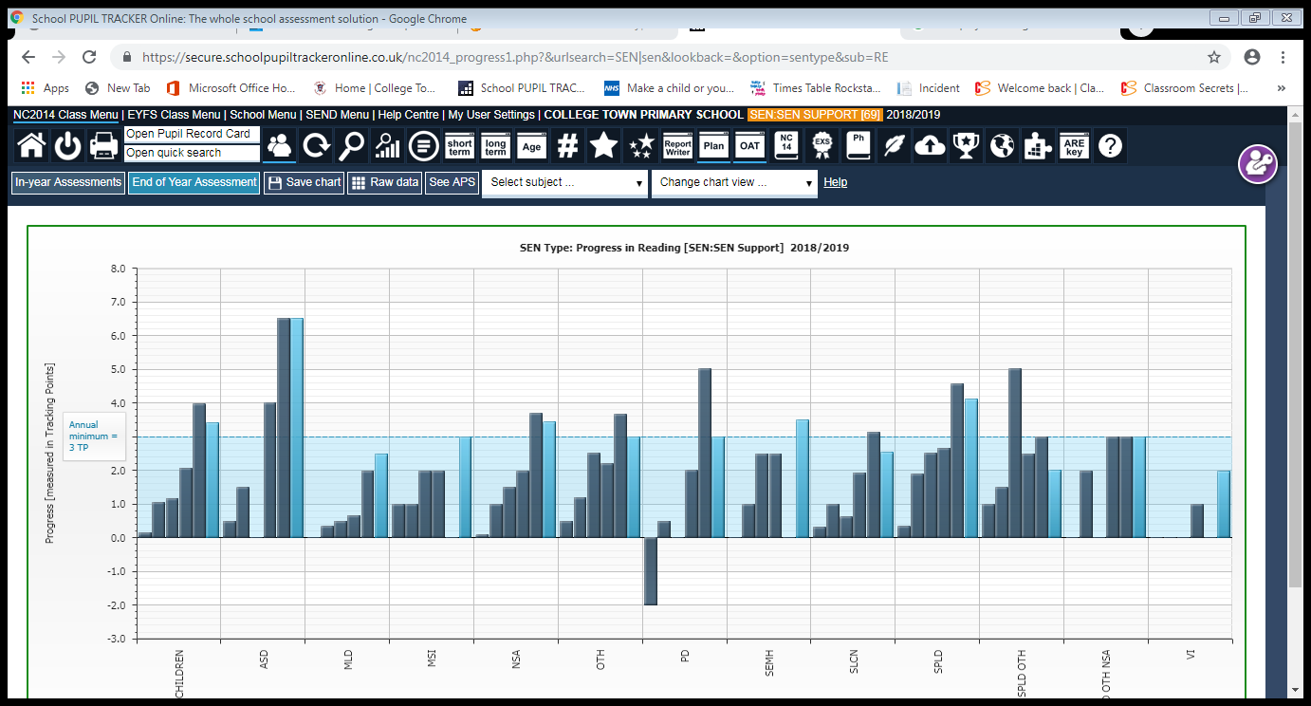

SEN Support Progress in Writing:

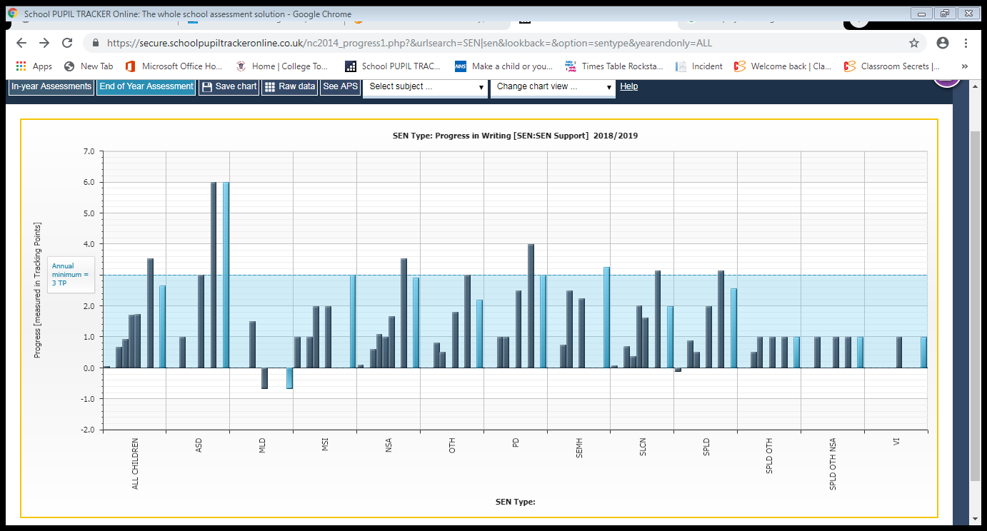

SEN Support Progress in Maths:

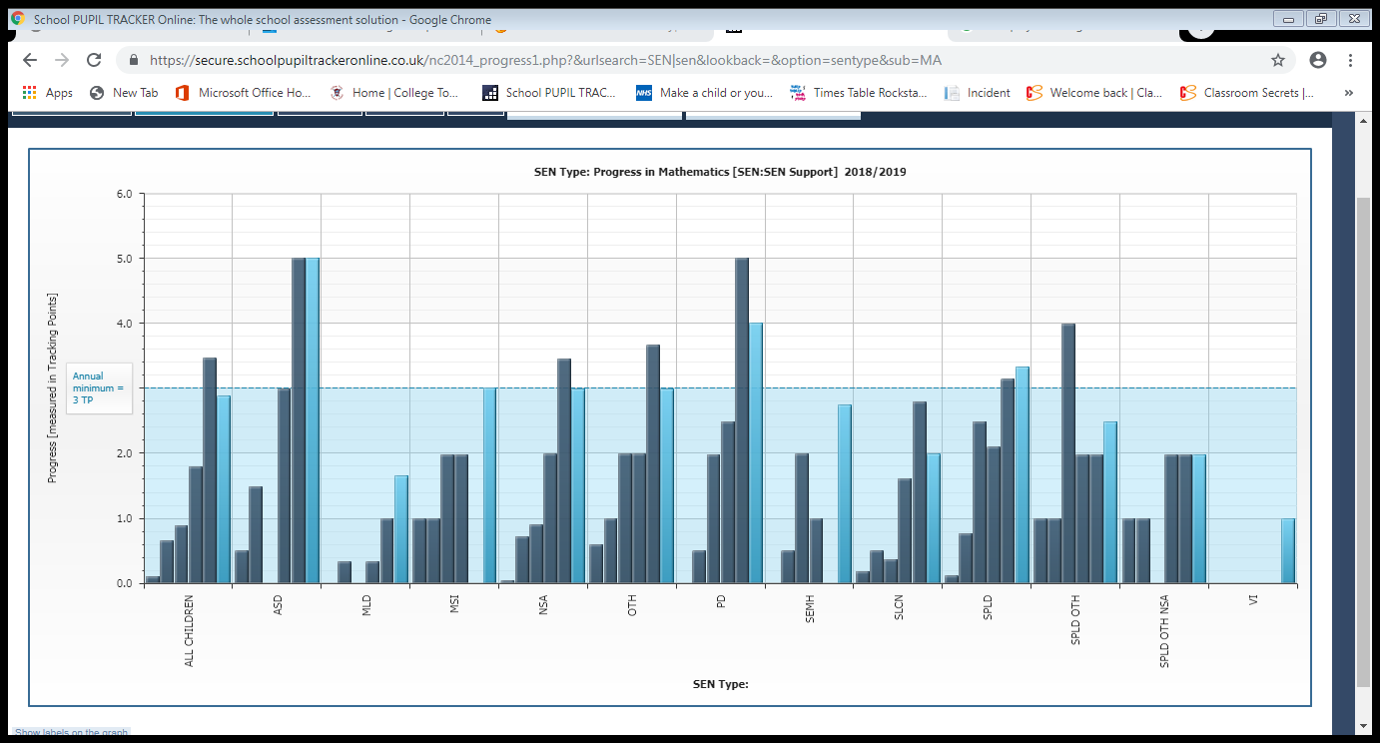

Interventions and their impact

In the Spring Term there was a Rapid interventions focussing on Maths, these took place 4 times a week with children in Year 2 (Squirrel Class). After a term of interventions children were identified as making some progress-children were more confident and secure in their current ability with significant improvements. The interventions were stopped and children were then streamed in class in order to ensure that lower ability groups of children were targeted through quality first teaching.

In Spring Term, a phonics intervention was started to support children in Year 5 and 6, who have specific difficulties with spelling. After Easter this intervention was adapted to support children in learning spelling rules to further support them.

In Summer Term a Rapid Intervention was started focussing on Writing, these took place 4 times a week with children in Year 2 (Squirrel Class). This will continue until July-however children are already more confident in their writing ability and their spelling of High Frequency Words have improved and are more consistent.

All children receiving interventions have made progress throughout the year (see below)

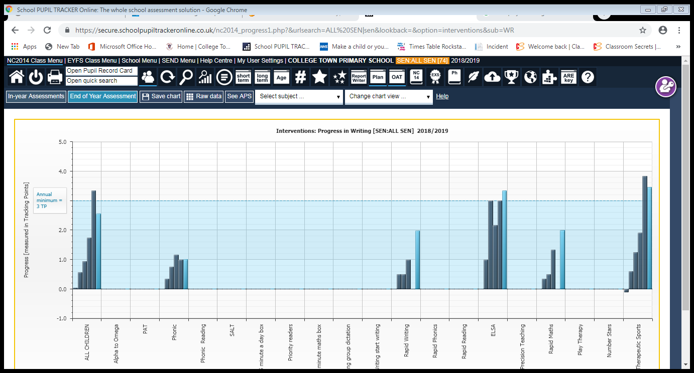

Inclusion RAP

Theme 1: Raising standards for all children to ensure good rates of progress.

Key Priorities:

* Underachievement in Year 2 to be addressed throughout spring and summer term.
* Children not on track to meet ARE receive targeted interventions.
* Implement teaching interventions to support pupils identified as not making adequate progress in maths & reading.

Squirrels have made significant progress across all core areas of learning, some children have made accelerated progress (as much as 4 points progress). Where children have made little or slow progress, interventions have been set up and taught each week to target gaps in reading and maths. Several children also have additional interventions for reading through daily precision teaching of high frequency words.

Children identified as making limited progress in both Year 5 and Year 6 have also had additional interventions to support their reading skills and to target gaps-such as learning alternate spellings.

Theme 2: Improving learning & Teaching.

Key Priorities:

* Ensure Word Shark and Number Shark are well used and known resources to all teachers to support Maths and English teaching.
* Teachers can identify and support children with additional needs and plan effectively.
* To ensure every teacher is fully aware of any barrier that may exist for a child which inhibits their learning potential.

Word Shark and Number Shark were only installed during the Easter holidays-teachers are getting to grips with using this before rolling out to individual pupils. Squirrel class pupils use Word Shark weekly during Guided Reading sessions.

Teachers have received training on differentiation to help support their planning and to deepen their understanding of the code of practice. Some teachers are implementing this effectively into their planning and show they understand the needs of their class. Further support needs to be given to the teachers whose pupils are in the alternative provision, in order to ensure that planning is appropriate and well matched to their current ability.

Theme 3: Leading Learning.

Key Priorities:

* AH Inclusion leads and monitors SEND practice within the classroom and AP.
* Teachers to be responsible for planning and delivering a differentiated curriculum to meet the needs of all learners.

AH Inclusion has been working extensively with one Year 4 to ensure planning and resources are appropriate to support children with complex and challenging needs with the class. Further support is required in Year 5 to ensure that provision is appropriate and meets the needs of all children. AP provision is suitable and monitored, the AH Inclusion works alongside the class teachers and teaching assistant working in the AP to ensure that the curriculum being planned for is suitable and meets the needs of the pupils.

Next academic year 2019-2020

Next year the Alternative Provision will be used in a different way: instead of it solely being used for individual children (the current children in the AP now have EHCPs so will be educated in alternative settings) the AP will be used as an intervention space.

Children working below their current Key Stage will be taught in the alternative provision for core lessons in the morning. Lessons will be delivered either by the AH Inclusion or a teaching assistant and progress will be monitored by the AH Inclusion and the class teachers responsible for individual children.

During afternoon sessions the alternative provision will be used for ELSA sessions as needed, this will be delivered by a trained ELSA member of staff.

The AH Inclusion will continue to monitor IEPs and the effectiveness of these, to ensure the best provision is provided for children with IEPs. Now that standards have been set for IEPs, a more robust monitoring system will be implemented from September to ensure that pupils receive timely and appropriate intervention.

Training will be offered and developed to support staff members in a variety of areas-the main focus will be ASD and continuing to develop differentiation.