Curriculum Governing Body Report

October 21st 2021

**KS1 Data analysis**

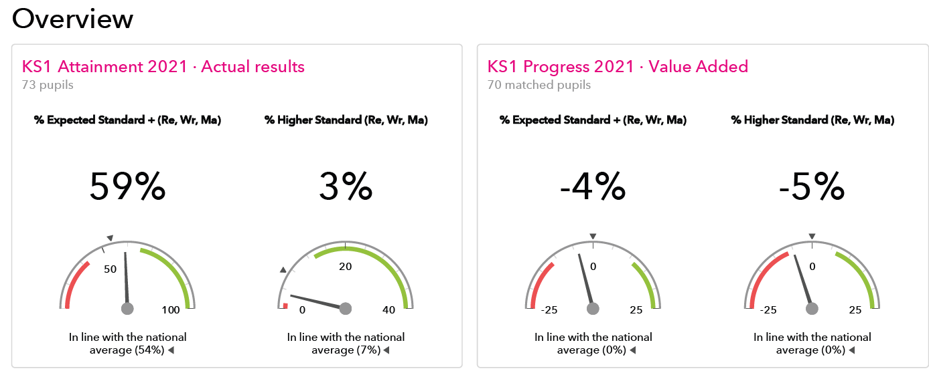

The data table below shows attainment over time in reading, writing & maths for Year 2.

It is evident that the impact of lockdown has been significant on our pupil’s progress, this was particularly evident in achieving the higher grades in reading and writing. However, it is important to also realise that despite the lockdowns and disruption throughout the last 18 months we have remained broadly in line with the national picture.

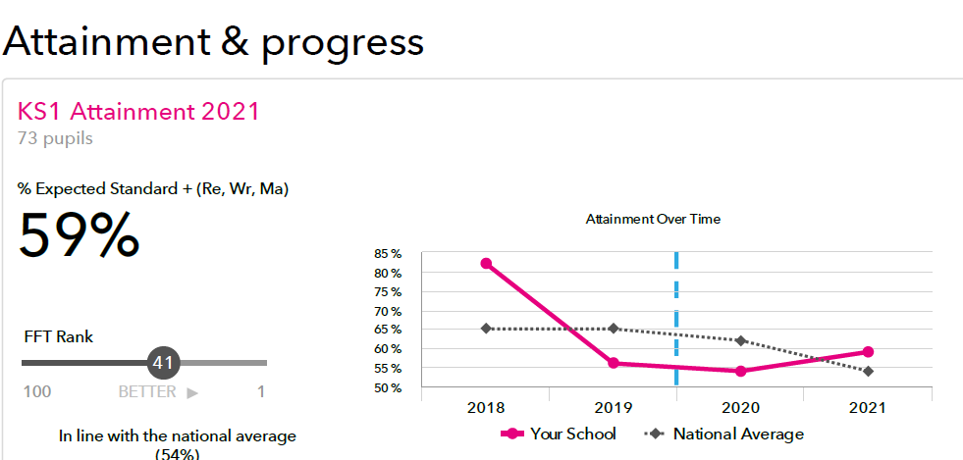

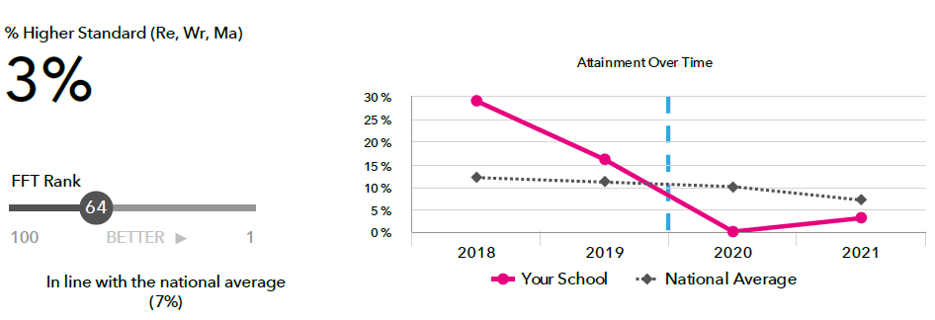

The data for specific groups highlights how poorly our pupils from disadvantaged families compare to those who are not FSM6. The group of FSM6 pupils was very small (4) and is not seen as statistically reliable group and needs to be over 5 pupils. The support for these children was hindered by their non-attendance and their inability to access remote learning due to parental support and resources. The school was quick to ensure IT was supplied to these children and teachers gave 1-1 slots of tutoring in addition to other remote learning opportunities to further support their progress. The internal systems set up in September had to end abruptly in 2021 when lockdown came in place once more. This was addressed moving forwards into the new academic year through staffing capacity to ensure that provision for FSM6 and SEND pupils in Year 3 could be more bespoke and led by an experienced teacher. We are already seeing better engagement and with data to be submitted on Oct 15th their progress will be monitored closely to evidence the impact of a more personalised provision for these groups in Year 3. As a school we knew that this cohort of children were going to require significant support to help overcome the challenges from two school years of lockdowns. These children missed key learning in Year 1 and again in Year 2.

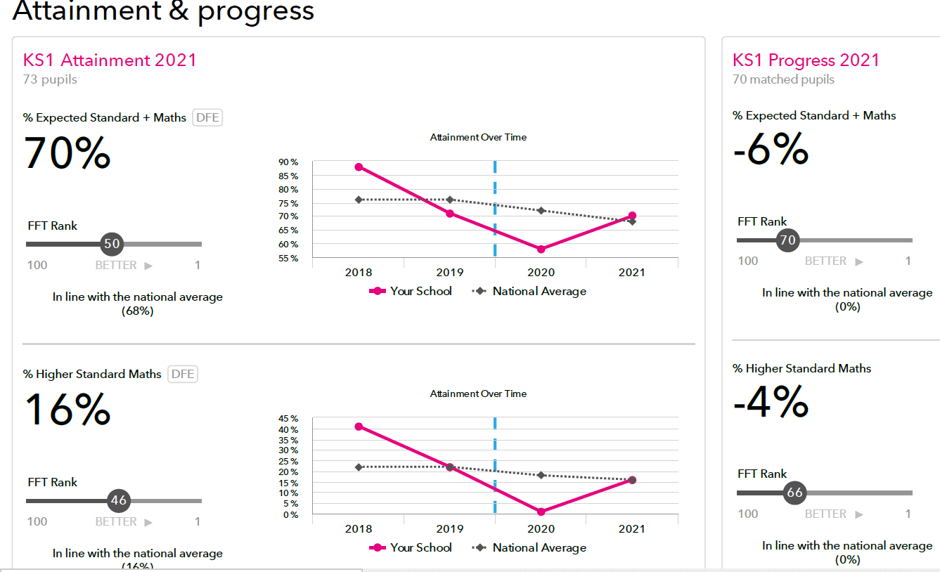

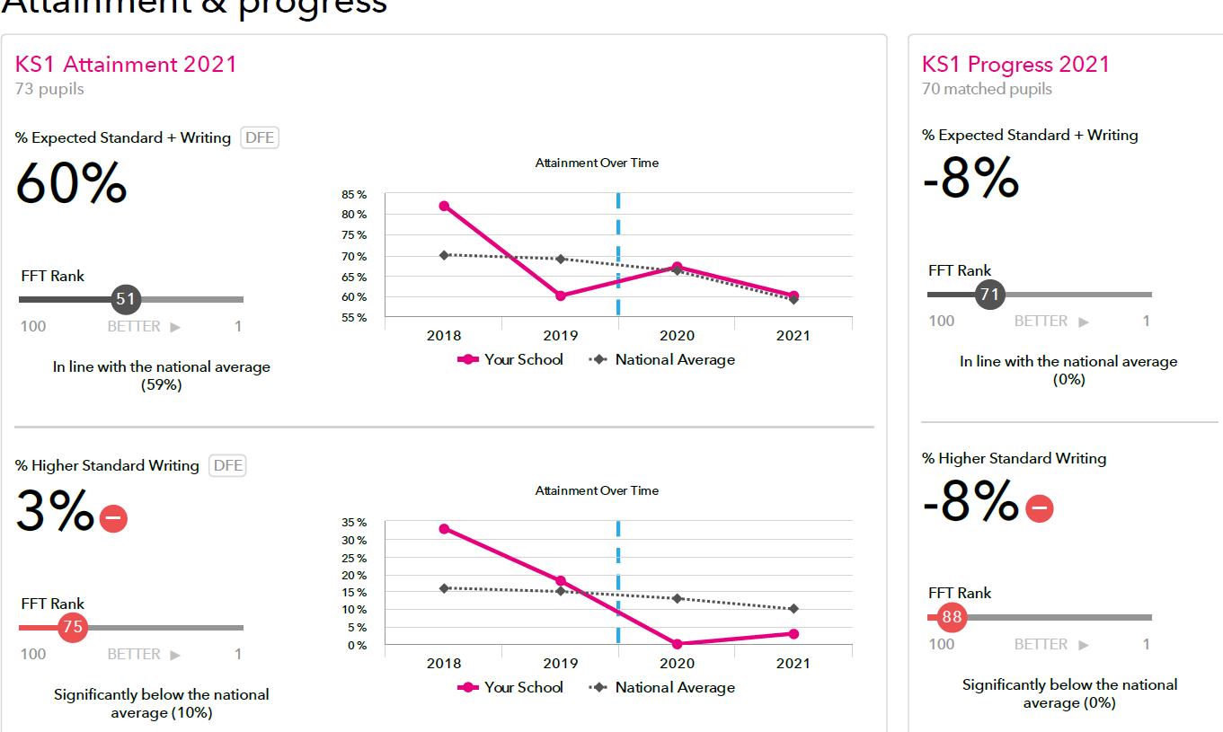

Areas for development are outlined within the School Development Plan rationale and the revised staffing structure to support catch up and tutoring has already been agreed and implemented. Year 3 will remain a high priority in terms of resourcing and support to ensure that this cohort of children are given every opportunity to overcome the impact of COVID on their educational success.

**Data analysis KS2**

Combined data outcomes for Year 6

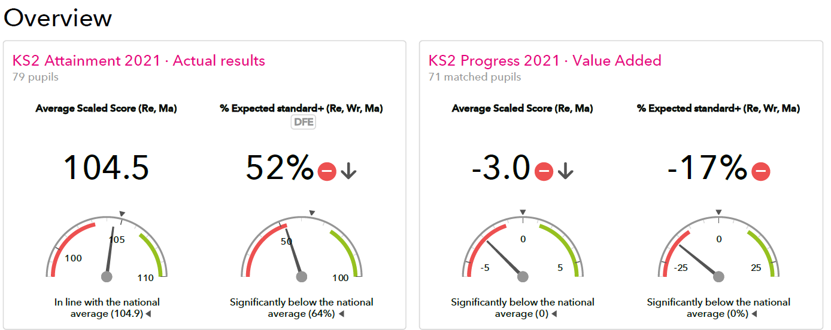

This is a very similar picture to KS1 with actual results broadly in line with national, but with the expectation from the pupils end of KS1 results that their outcomes should have been higher. However, the algorithm used to develop the expected outcomes is flawed as they had not expected a global pandemic. Schools, quite rightly, are therefore not being assessed on outcomes for 2021. The cohort was further weakened by a high percentage of SEND pupils 20/ 78 = 26%.

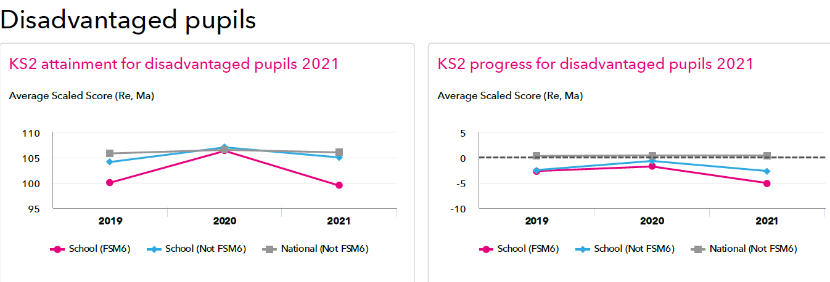

Our FSM6 children = 7 with 2 pupils also having significant SEND needs, both pupils were boys. The gap between FSM6 boys and non FSM6 was -13.3 with girls proving much better at -2.3. This gave an actual gap for FSM6 as a group at -5.1 which was significantly lower than 2020 when we were in line with national.

The results for individual subjects is detailed below and it was disappointing to see such a drop in attainment and progress as pre COVID we had started to see the fruition of our consistent teaching approaches. However, we are about to sit mock SATS this week and we shall be hoping to be seeing a significant rise in both attainment & progress in 2022. To date schools have not received any guidance on SATS for next year but I am expecting this soon after the half term.

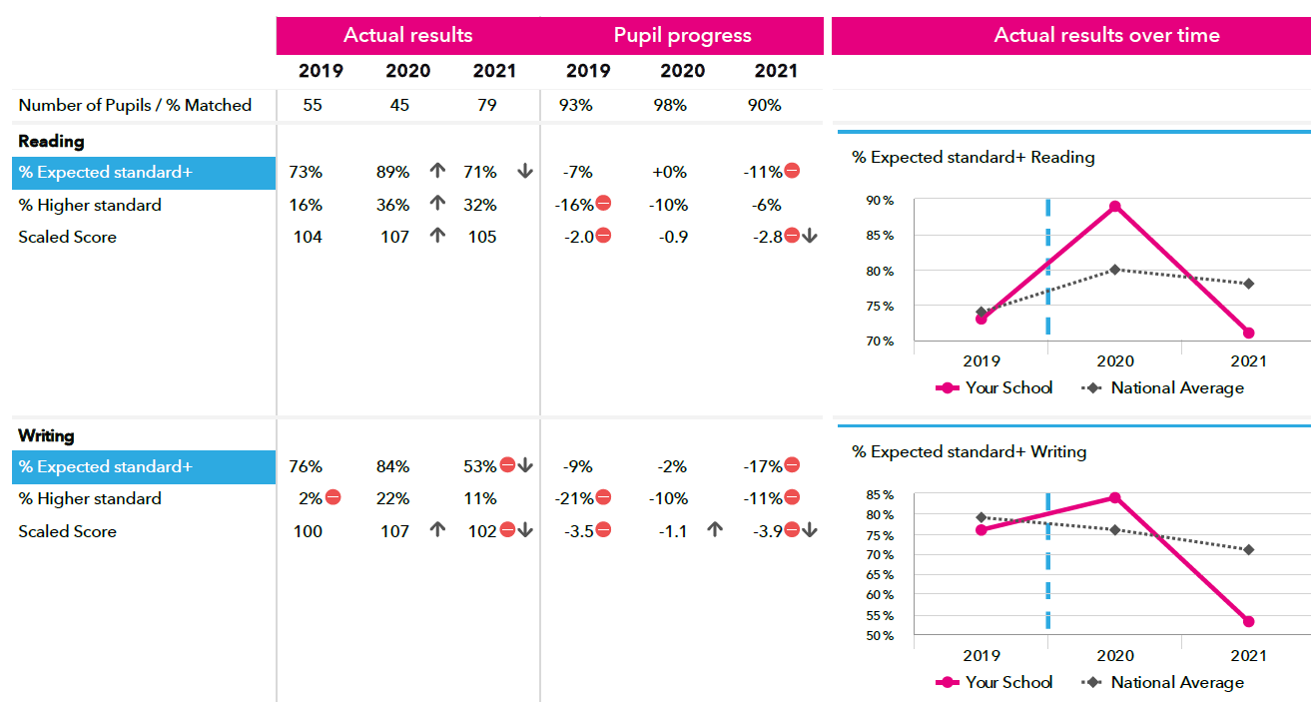

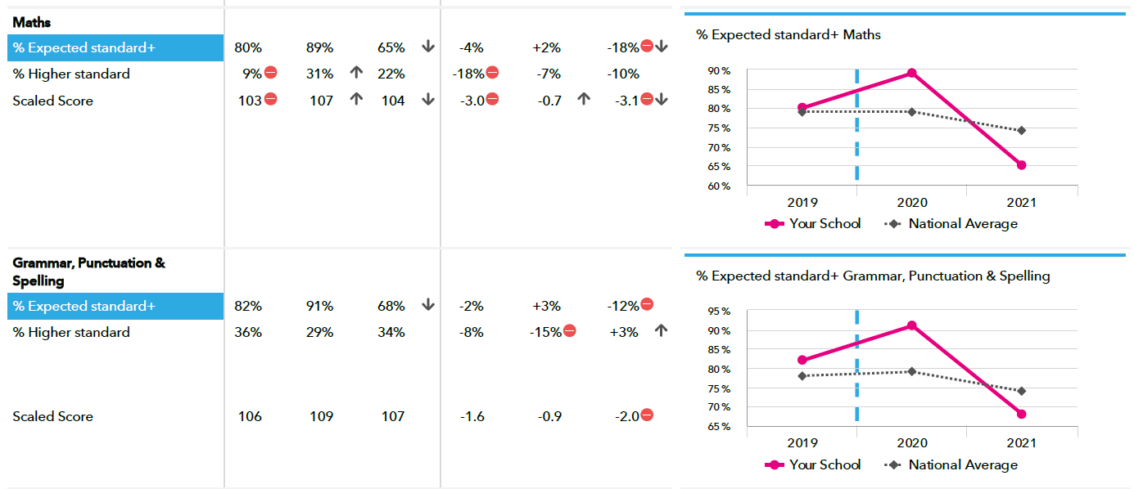

**Baseline Assessment**

All baseline assessments have now been completed within the six week statutory period and the head teacher’s declaration has been submitted. Staff from across the base were trained and the guidance resources used to inform them how to deliver to ensure consistency and accurate assessment.

I conducted 40% of all baseline assessments which allowed me to gain a good insight into the cohort and the accessibility of the baseline for our pupils. The teachers conducted tests with those children who required a more familiar adult. However, no child showed any sign of distress and appeared to thoroughly enjoy the opportunity.

The outcomes from the test are outlined below. The government are planning to use the outcomes to assess progress and this will take place from 2027.

|  |  |  |  |
| --- | --- | --- | --- |
| Baseline | Autumn Born | Spring Born | Summer Born |
| At risk | 6 = 21.5% | 8 = 27.5% | 15 = 52% |
| ARE | 9 = 47% | 3 = 16% | 7 = 37% |
| ARE+ | 13 = 45% | 8 = 27.5% | 8 = 27.5% |

**Parental engagement**

Recently I held a phonic session for our new reception parents which was very well attended. During the meeting we looked at how we teach phonics and had fun with decoding phonetically regular words. Parents were very enthusiastic about learning more and I have since uploaded further support for them from the Oxford Reading website. I have also ordered 48 Bags of sounds to sell with a 25% reduction and in only 2 days we have sold 39! This level of engagement is really exciting and I am keen to hold similar workshops moving forwards.

**The Reading Framework**

This has been read and considered by the English lead supported by Anne Duncan who will be discussing and reporting on this at the meeting and in her written and attached document. It would be useful if you read the document from the DFE in advance so that you are well informed and understand the reasons for the school’s way forward. We have already spoken and worked with our STEP Caroline Morgan on developments to date.

<https://www.gov.uk/government/publications/the-reading-framework-teaching-the-foundations-of-literacy>

**Phonic update**

With 83% new staff in Reception and Year 1 it is vital that further training is delivered to support our continued development in supporting early reading. In addition to training as a school we are considering how we will ensure that our phonic resources fully support a systematic phonic program from Jan 2022. The DFE released in summer 2021 that Letters and Sounds was no longer going to be updated as had previously been expected. Therefore, as a school we are auditing our resources to ensure that we are ready and suitably ready. It is important that we recognise that our phonics provision must support the following:

* give all children a solid base upon which to build as they progress through school
* help children to develop the habit of reading widely and often, for both pleasure and information

We have invested a further £3000 on reading books which align to the phonic progression within letters and sounds and are also using Bug Club as an additional vehicle to support reading at home.

Below is a little more background to help you understand the implications of the next steps for our school.

*BEWARE DO NOT throw out the baby with the bath water!*

*Update to Headteachers:*

Until recently, it looked as though the government were going to reinvest in the widely used Phonics programme, Letters and Sounds, in order to create a restructured and fully resourced version. The DfE originally commissioned Letters and Sounds, and published it back in 2007. Whilst the methodology of this programme is solid, the original resource was not updated alongside the National Curriculum in 2014. If you use Letters and Sounds, you will be familiar with the phases of phonics acquisition that children undertake for reading and spelling. However, whilst the first five phases remain broadly relevant, the current Primary English Curriculum identifies a small number of objectives for Y1 that are not covered in the Letters and Sounds phases usually taught in Y1. Moreover, Phase 6 has been entirely subsumed by the Y2 programme of study for phonics and spelling outlined in the National Curriculum. More graphemes have been added; some have moved year groups. So, whilst Letters and Sounds remains completely workable, it would be fair to say that a refresh was due.

* Over the years, you may have found yourself supplementing Letters and Sounds with resources from providers such as Smartkids, Phonics Play, Collins Big Cats or Twinkle. The DfE recently had this to say about the programme: “The 2007 Letters and Sounds handbook, published under the previous Government, has never been a full Systematic Synthetic Phonics (SSP) programme. For a number of years, effective teaching using Letters and Sounds has relied on schools themselves building a programme around the handbook.” In many respects, this is similar to other aspects of the curriculum: schools may buy into handwriting, spelling, reading and even planning schemes or resources to help them deliver the curriculum creatively and efficiently.
* On 30th March 2021, the Department for Education announced that it was not going to continue with its direct involvement in the restructuring of Letters and Sounds. They said, “This in no way reflects the quality of the work produced, but the Department’s current policy is that SSP programmes should be created by teachers and phonics experts. This means that the Department will not publish a full Letters and Sounds programme, nor an updated progression.” They are accepting submissions from publishers for full Systematic Synthetic Phonics (SSP) programmes to go into an updated catalogue of providers. Last year they commissioned a group of outstanding schools linked to  Little Sutton and Wandle English Hubs, and overseen by trusted phonics experts, to produce a more complete resource for Letters and Sounds. This included videos for home learning and training materials for English Hub partner schools. You may well have made use of the free video lessons available on the Letters and Sounds Website, during periods of lockdown during the pandemic. Earlier this month, Little Sutton and Wandle English Hubs announced that they were driving forward, along with their other phonics experts, to complete the fully revised Letters and Sounds SSP initially commissioned by the DfE. However, there are many other experts also submitting tenders. It is worth noting that the title Letters and Sounds is not trademarked, so there will be no “Collin the Caterpillar Cake” style court cases if anyone uses this familiar name. The only stipulation is that if publishers do use it, then it must be prefaced with their own name. Therefore, Wandle and Little Sutton are producing their resource under the (not so catchy) title of Little Wandle Letters and Sounds Revised SSP. This does not mean it is endorsed by the government or will be the phonics provider of choice moving forward.
* So what does this mean for your school? Perhaps nothing if you are happy that your programme is comprehensive, your training remains up to date, you are aware of any changes the national curriculum has made to Year 1 and 2 learning and very importantly, that your reading books all align with the Phonics Progression outlined in the Letters and Sounds document. Don’t forget that the revised HFL Guided Reading Toolkit shows you how to align your books with the phonics phases (much as publishers have realigned content to match phonics phases for L&S but retained bands to support progression resources). Herts for Learning Advisers were part of the original training and piloting programme for Letters and Sounds and still deliver up to date training to support schools.
* In summary, if you feel that Letters and Sounds is serving you well, and that you have built a ‘programme’ around it that offers support, guidance, resources and training, we can’t see that there is any reason to change it. But what if you don’t feel that your phonics programme is working for you? We would urge you to be cautious before throwing the baby out with the bathwater. The validation process will not be completed until Spring 2022. After this point, there will be a new catalogue of approved providers of SSP programmes. The ones who make the cut will need to provide a full resource of teaching materials, resources, texts and training so you will want to wait to ensure you are investing into quality materials. The government has outlined sixteen criteria for publishers who wish to tender applications over the next few months. Anything they produce will have to satisfy these [conditions](https://www.gov.uk/government/publications/phonics-teaching-materials-core-criteria-and-self-assessment/validation-of-systematic-synthetic-phonics-programmes-supporting-documentation). You may find it useful to study these, as well as the related footnotes in order to perform an audit of your own phonics provision in school. How far does it align with these criteria? Where might you need to shore things up? If your phonics outcomes are not as you hoped, how far do you analyse your own systems and teaching? When (if at all) did staff delivering phonics teaching last have official training?
* If, after all, you conclude that your own phonics programme does need a radical overhaul, take time to do your research and wait for the conclusion of the validation process. It might be unwise to rush into purchasing an expensive new product that does not ultimately receive official endorsement.

**Information for schools**

There is no statutory requirement for schools to choose one of the SSP programmes on the validated list. However, validation status indicates that a programme has been self-assessed by its publisher and judged by a small panel with relevant expertise and that both consider it to meet all of the [Department for Education (DfE) criteria](https://www.gov.uk/government/publications/phonics-teaching-materials-core-criteria-and-self-assessment) for an effective systematic synthetic phonics programme.

A complete systematic synthetic phonics (SSP) programme is one that provides:

* all that is essential to teach SSP to children in reception and key stage 1 years of mainstream primary schools
* sufficient support for children in reception and key stage 1 to become fluent readers
* a structured route for most children to meet or exceed the expected standard in the year one phonics screening check
* all national curriculum expectations for word reading through decoding by the end of key stage 1

Having read and considered all of the above and we are confident that we will be able to undertake an audit of our system and be able to confidently respond to the requirements set out within the governments guidelines within the given timeframe. I have also attached the check list against the self-evaluation guidance issued by Sharon Jones from Bracknell Forest Council.

As we progress through the checklist we shall update you accordingly.