**Curriculum GB Report**

**Ofsted changes for 2019**

The Ofsted Framework will be changing in September 2019 and below are overarching principles which Amanda Spielman is promoting. There appears to be a real awareness of the current challenges faced by schools nationwide and this is a pleasing move towards a more rounded approach to education.

Ofsted will consult on the introduction of a new judgement for ‘quality of education’. This will replace the current ‘outcomes for pupils’ and ‘teaching, learning and assessment’ judgements with a broader, single judgement.

The Chief Inspector also announced the 3 other inspection judgements that Ofsted will consult on:

* personal development
* behaviour and attitudes
* schools’ leadership and management

The ‘personal development, welfare and behaviour’ judgement in the current framework will be split into 2 distinct areas. This change recognises the difference between behaviour and discipline in schools, and pupils’ wider personal development and their opportunities to grow as active, healthy and engaged citizens.

An overall effectiveness judgement will continue to be awarded, and all judgements will be made using the current 4 point grading scale.

This new judgement will allow Ofsted to recognise primary schools that, for example, prioritise phonics and the transition into early reading, and which encourage older pupils to read widely and deeply. This breadth I believe will help governors to monitor a wider range of educational provision as well as always keeping an update overview on attainment for all pupils.

Our current school development plan along with the recent restructure on establishing the primary staffing model already provides a wealth of evidence to support the new way forward and our own appreciation as leaders of education that we must focus more than merely test results

Ofsted recognises that the most successful schools make sure that the curriculum is really well-suited to those individuals. Clearly Miss Cross will work with staff so that we build the curriculum around their needs and their interests of the children, but it is underpinned by a really good grounding in literacy and mathematics, particularly in terms of early reading. This has always been our mantra and therefore I feel that we are well placed to meet this focus.

Ms Spielman has said:

*For a long time, our inspections have looked hardest at outcomes, placing too much weight on test and exam results when we consider the overall effectiveness of schools. The cumulative impact of performance tables and inspections, and the consequences that are hung on them, has increased the pressure on school leaders, teachers and indirectly on pupils to deliver perfect data above all else.*

*But we know that focusing too narrowly on test and exam results can often leave little time or energy for hard thinking about the curriculum, and in fact can sometimes end up making a casualty of it. The bottom line is that we must make sure that we, as an inspectorate, complement rather than intensify performance data.*

*Because our curriculum research, and a vast amount of sector feedback, have told us that a focus on performance data is coming at the expense of what is taught in schools. Our new focus will change that, bringing the inspection conversation back to the substance of young people’s learning and treating teachers as experts in their field, not just data managers. I don’t know a single teacher who went into teaching to get the perfect progress eight score. They go into it because they love what they teach and want children to love it too. That is where the inspection conversation should start and with the new framework we have an opportunity to do just that.*

At the same time, Ofsted will challenge those schools where too much time is spent on preparation for tests at the expense of teaching, where pupils’ choices are narrowed, or where children are pushed into less rigorous qualifications purely to boost league table positions.

Responding to the suggestion that these changes should be postponed for a year, Ms Spielman said that she was confident that this will be the most researched, evidence-based and tested framework in Ofsted’s history, and that to delay would let children and teachers down. She also addressed concerns that Ofsted will have a preferred approach to the curriculum saying:

*We are not talking here about an Ofsted-approved approach. We are talking about an approach that leaves plenty of space for diversity, but nevertheless makes it possible to recognise and discourage things that* *just aren’t good enough. Our curriculum research showed quite clearly that it’s possible to acknowledge a range of successful curricular approaches – approaches that cross any perceived ideological divide.*

*With teacher workload and retention such pressing issues, I am firmly of the view that a focus on substance will help to tackle excessive workload. It will move inspection more towards being a conversation about what actually happens in schools. Those who are bold and ambitious and run their schools with integrity will be rewarded as a result.*

In January, Ofsted will launch a consultation on the new inspection framework. Unlike previous consultations, views will also be sought on each individual inspection handbook. Ofsted will consider all responses carefully before finalising the framework. Further details of the consultation and how to respond will be published early next year.

Whilst the new inspection framework won’t be out until the other side of the New Year it’s possible to start hazarding a guess at what it is likely to contain.  We now know that the curriculum will take centre stage in the new framework.  Below is recent release of the third phase of their curriculum research gives some pretty clear indicators of the main thrust of the inspection process.

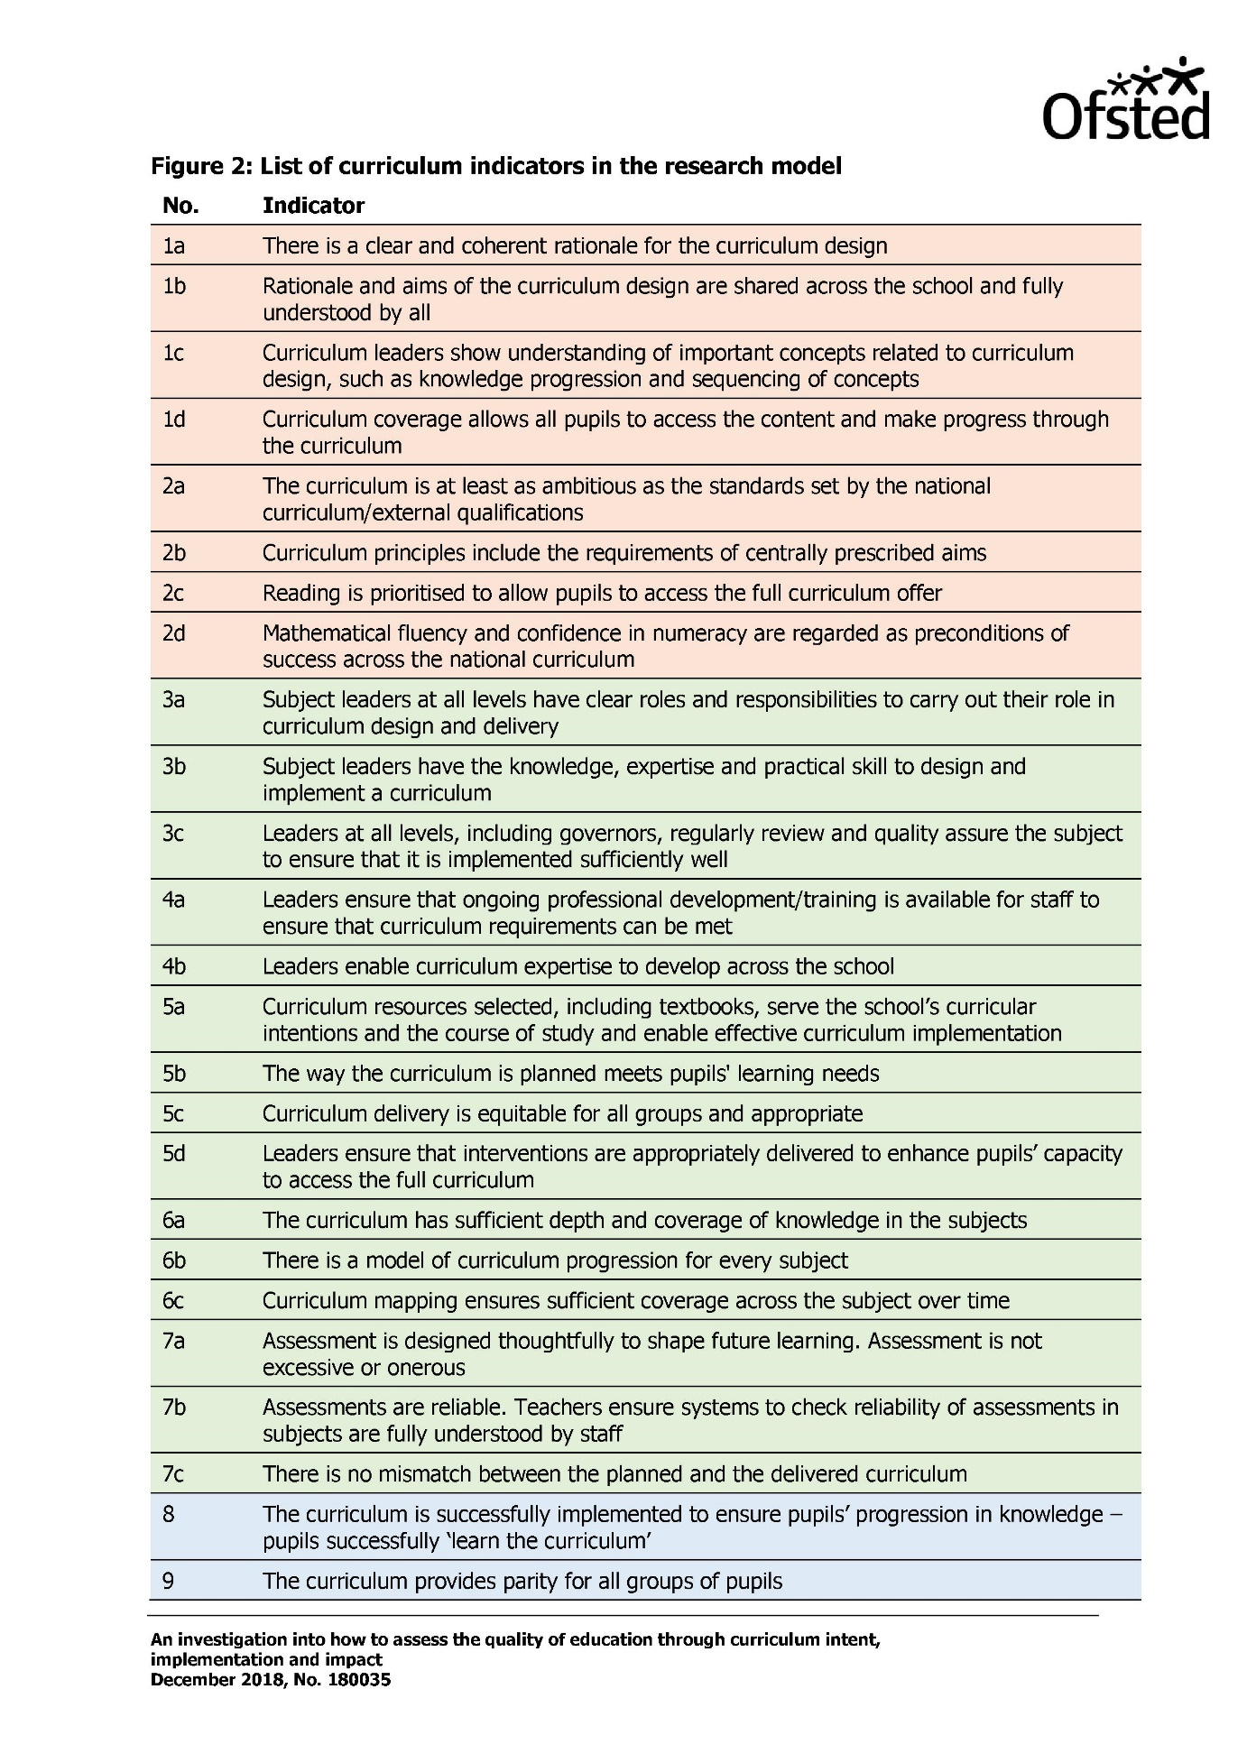

Year 6

After considerable underachievement during 2017 – 2018 the current Year 6 cohort are struggling to reach the expected level required of them if they are too achieve their SATS pass. Therefore an extensive range of provision has been put in place to try and overcome the legacy of the last academic year. This has achieved rapid progress, most notably in reading.

The percentage of pupils on track to achieve combined was 8% which is clearly unacceptable. On a second attempt in mid-December all results showed improvement with every child having made progress. Teachers felt genuinely more confident by their new results, although clearly there is much work required from January through until July to ensure that this cohort of pupils are secondary ready. The data below indicates the rapid progress made with 1.3 points progress being the overall picture.

To ensure that the excellent provision from the autumn term continued it was essential that the team and I met to devise a strategy for the coming two terms. The opportunity to continue to maximise the accelerated progress seen over the autumn term was essential.

On meeting and discussing the cohort’s progress parental engagement was seen as a major barrier and therefore we immediately tried to take action to inform and include our parents so that they feel more enabled to to support their child at home. In December we held three sessions all at various times in order to catch as many parents as possible, this included a late evening session at 6.30pm. The sessions were reasonably well attended and were very well received by those parents who attended.

At the meetings the parents were provided with the CPG revision books at a cost of over £1200 to the school. These books will be the basis of the homework for our Year 6 pupils so that we are preparing them as well as possible. In addition to the books we have been able to secure more quality first teaching by releasing Miss Attril from PPA cover so that for 2 days a week the children can continue to be split 4 ways to ensure that their individual needs are addressed as effectively as possible. Furthermore another regular supply teacher has been recruited who will also run maths booster sessions for a select group of pupils. Year 6 teachers will re-test the children again prior to the half term break to gain another updated insight into how well the children are retaining their knowledge.

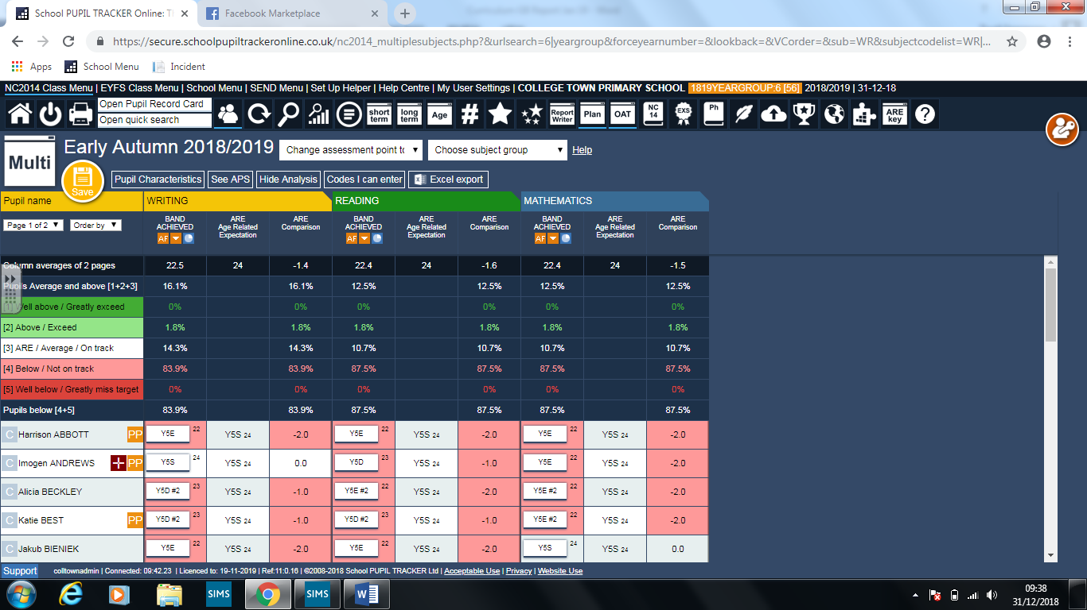

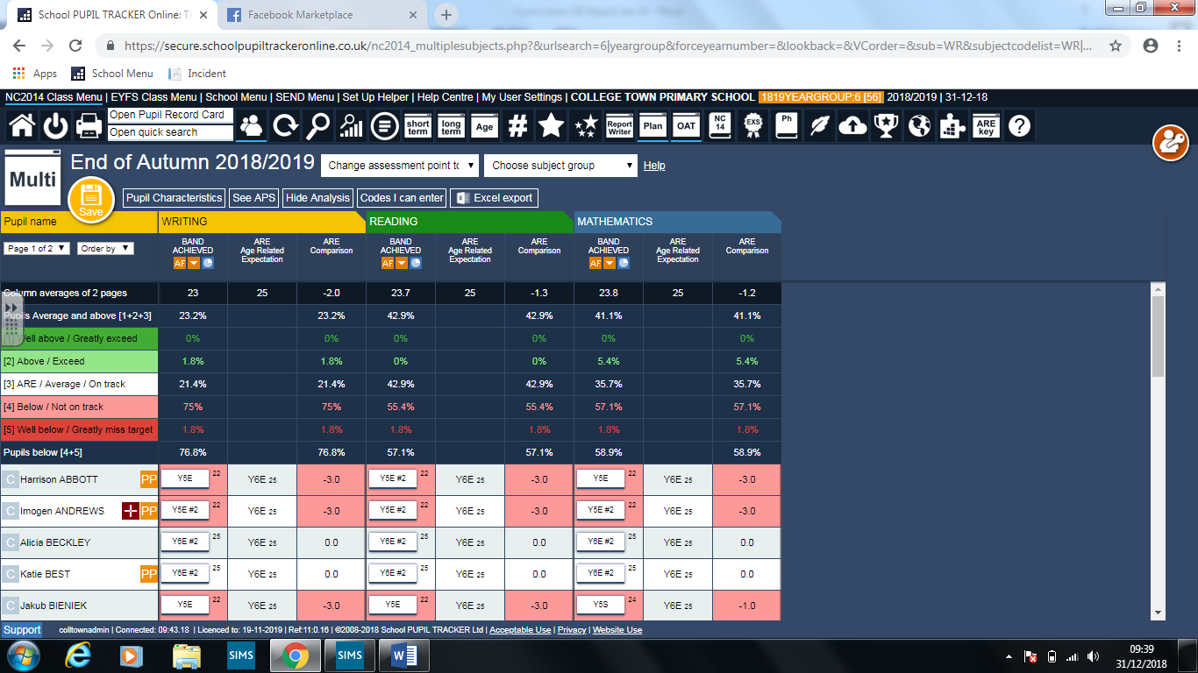

The data above demonstrates the progress made since September, but clearly the writing requires further support as the spelling and punctuation expected in Year 6 is not evident; additionally the pupils lack the ability to write in various genres. Teachers have adapted their planning accordingly so that these issues are addressed and it is expected that by February’s data submission writing will have made greater progress.

Reading has been widely promoted across Year 6 and at Christmas every child was given a book for Christmas. The books were selected from the top 100 book list to ensure that they were of a high quality. The children were all given the blurb for a selection of 10 books and they then had to select their favourite one. This was then the book they received. The children were unaware of why they were selecting the book other than that they had been tasked with giving an opinion as to why they would choose one book over another. The children were delighted and hugely enthusiastic when they received them and we hope that they have all read them over the festive break and gained a hunger to read more.

**SEND & PPG Year 6**

In Year 6 there is the highest percentage of children eligible for PPG. They account for 21.5% of the entire cohort.

This data set includes all SEND pupils who are also PPG. There are two pupils within this group who have needs which require EHCP and another who has had SEND support since KS1 and who had spent time in care and in a refuge due to DV within the home.

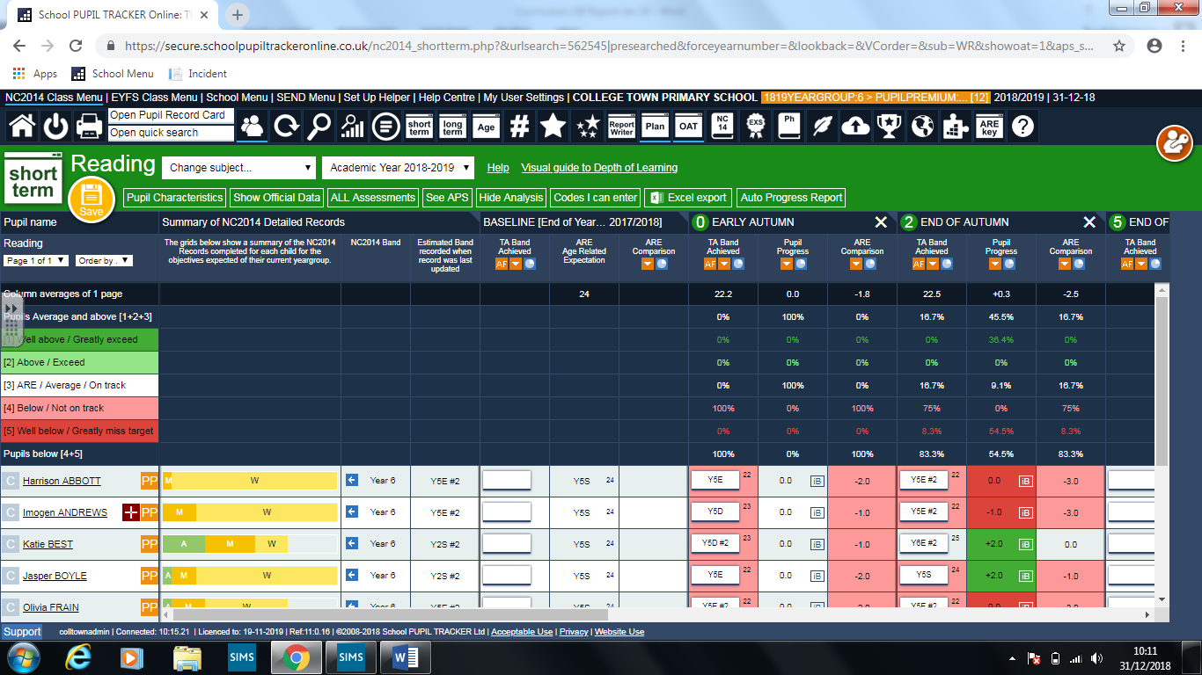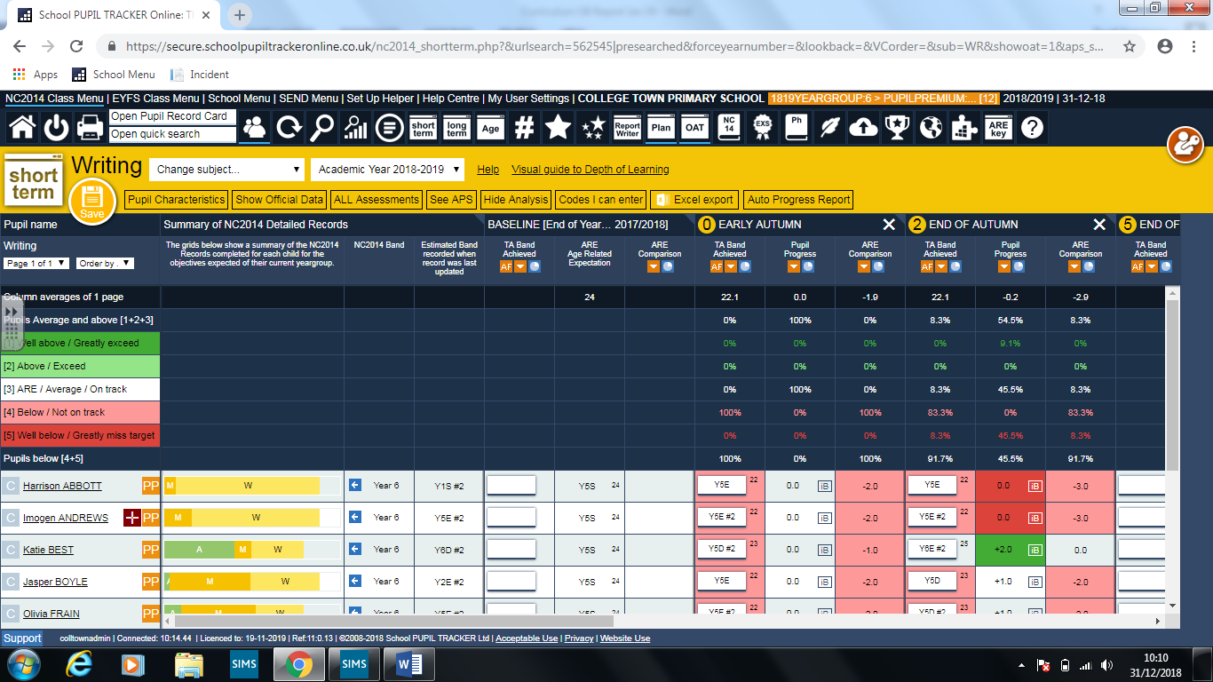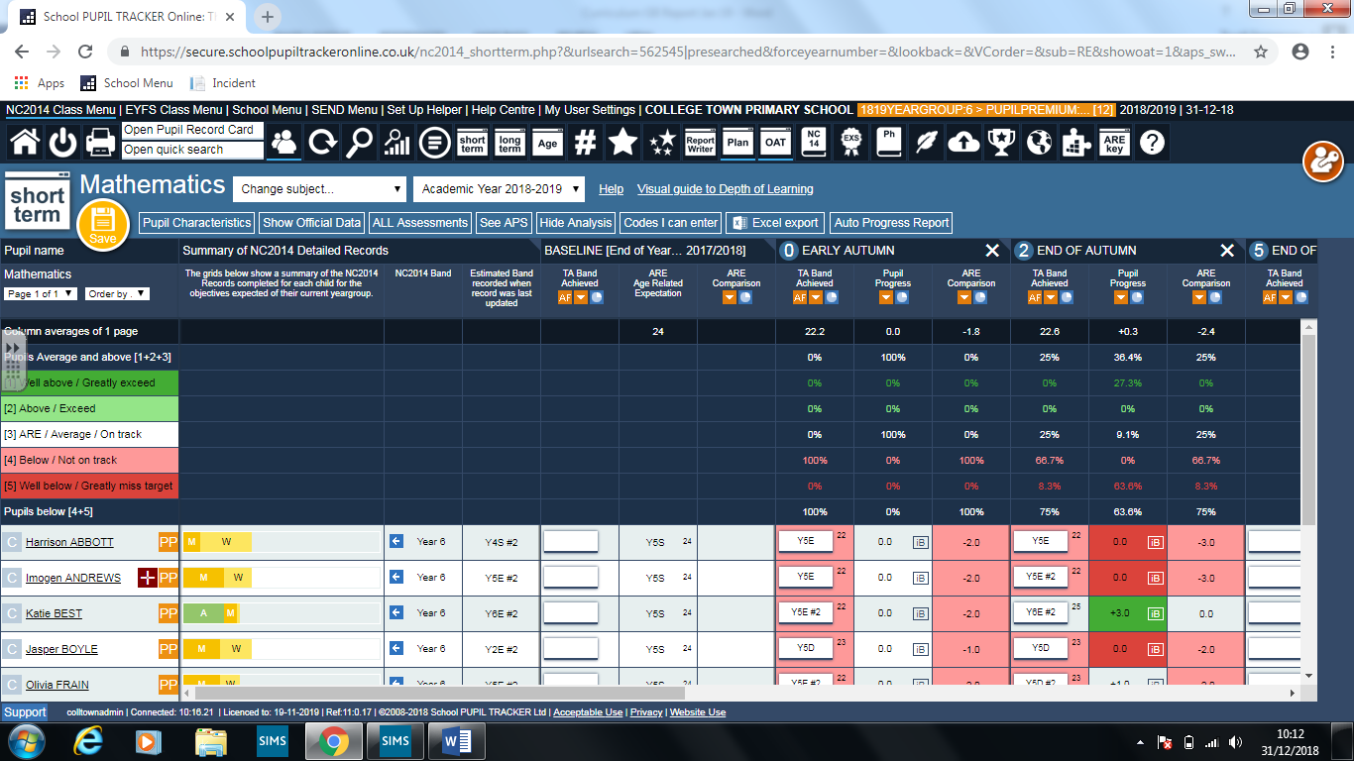

This data shows PPG pupils without SEND

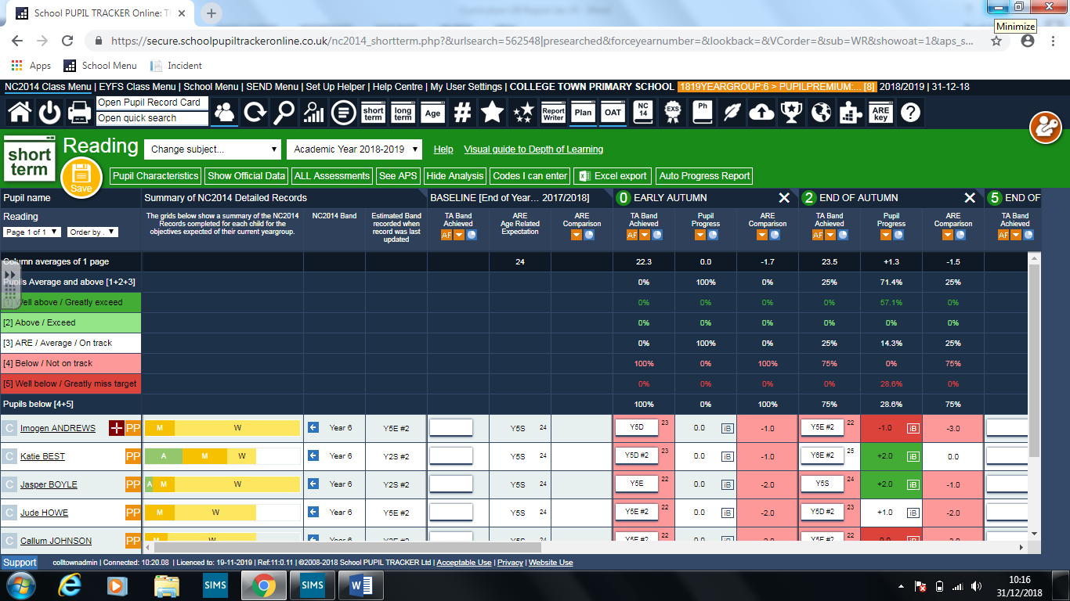

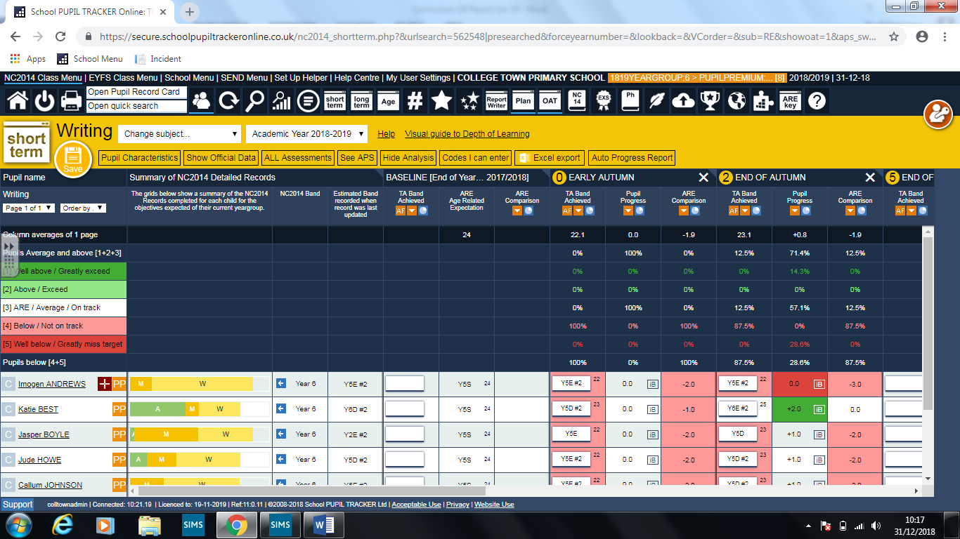

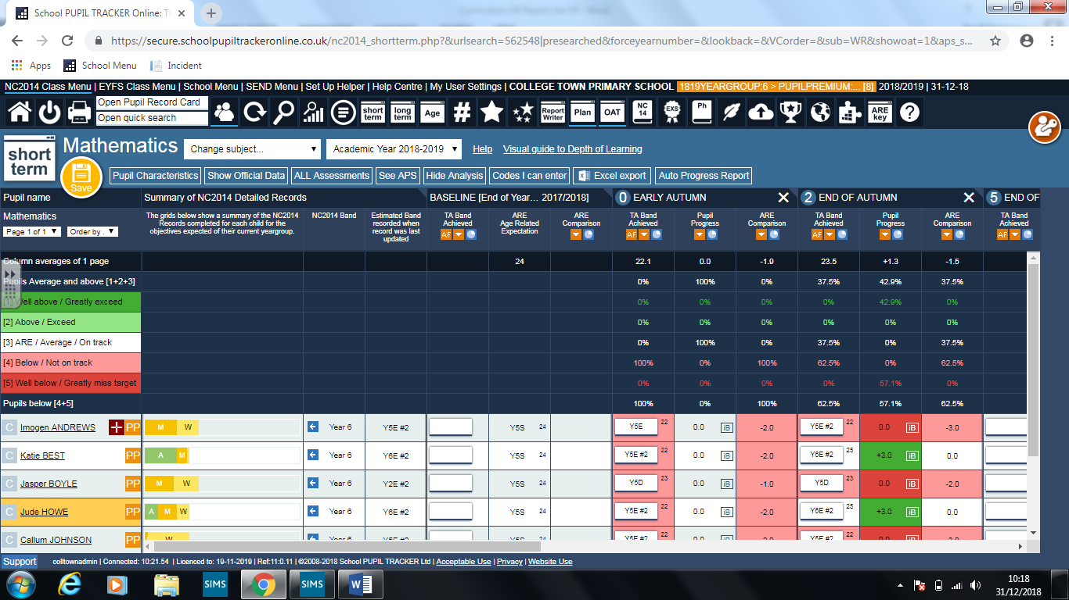

The progress for PPG children from reception to Year 5 is in line with all children at 1.0 point in all subjects.