Curriculum Governors Report – Jade Faircloth

End of Autumn Term Data

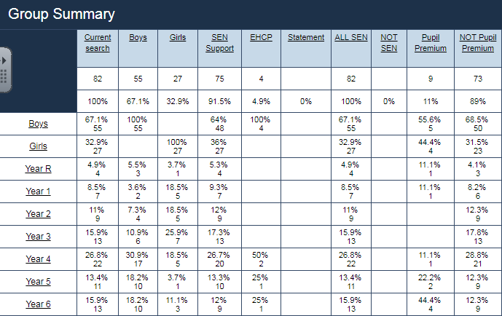

Monitoring

This term a significant proportion of my time has been spent setting up provision; timetabling, resources, activities and appropriate levels of support for 6 children who have the most significant level of need within the school. This has resulted in numerous parent meetings, Team around a Child meetings and referrals to numerous support services. As a result of this, 3 of the children currently have Education Healthcare plans in the application process.

In Year 6 there is 15.9% of children with SEN, I have set up and delivered a reading intervention to support children in Year 6. The results are as follows:

|  |  |
| --- | --- |
| Reading SATs Results October 2018 | Reading SATs Results December 2018 |
| 3 | 15 |
| 1 | 19 |
| 3 | 24 |
| 10 | 18 |
| 24 | 22 |
| 10 | 15 |
| 17 | 18 |

Children have made significant progress and I will now look at further children who will benefit from this intervention.

Due to inadequate teaching in Squirrel Class, and the volume of SEN (11%), I will be spending the majority of each day alongside Susan Tait teaching this class. I will be devising and delivering planning that is highly personalised to meet the needs of the children in the class, there will be 2 qualified teachers and a teaching assistant each days which means the ratio will be 1:5.

As well as supporting this class, I will be looking at data for children who are making slow progress within SEN Support. I will then be setting up interventions for Maths and Phonics. This will be delivered each morning by teaching assistants and I will monitor the progress of these children.

As a significant number of children identified as SEN Support are in Year 4- 28.6%, I will be focusing on planning scrutiny’s and book looks that look at differentiation in order to ensure that children are making adequate progress.

Learning Hub

This term has seen significant improvements and changes made within the Learning Hub, the room is now set up to appropriately engage the 6 children with significant levels of need. Teaching Assistants have been moved to work in the learning hub who have particular skills (ELSA- Emotional Literacy Support Assistant) and experience in working with children with SEND. Work is planned for and differentiated for the children accordingly and takes note of their skills. The children have protected play at break time and are well supported in their interactions with peers and other adults during periods of transition and when emotions may be heightened. –Despite this level of provision, 3 of the 6 children who can access this are no longer attending school either due to relocation or school refusal. 2 children are currently on a reduced timetable and will begin to increase their hours over the next term. 1 child uses this provision in the afternoon each day.

Training

I have recently undertaken modules on supporting children with Autism, attachment and trauma. In the next academic year, I will be completing Cognitive Behavioral Therapy alongside the therapeutic sports coach. Over the next term, I will be identifying areas for training-particularly around the Code of Practice, Dyslexia and Autism. I will be training both teachers and teaching assistants in order to improve our understanding and practice across the school.