English Governors Report – Natasha Startup

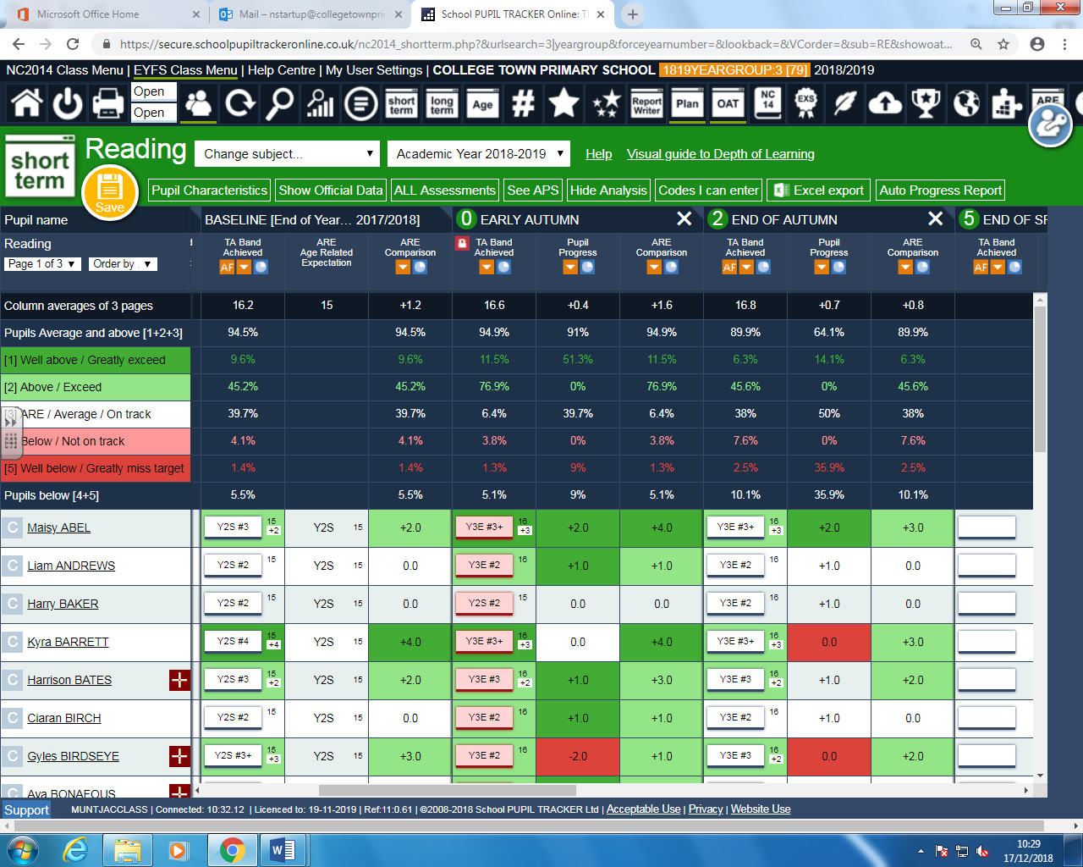Year 3: Reading

89.9% are ARE or above.

10.1% of children are below or well below:

* One is new to the school and EAL.
* Select children are having pre teaching done with reading and reading the upcoming pages.
* Children are hearing teachers modelling good expression and reading each day to children.
* Children are reading aloud every day.
* In the classroom, there is a wall of vocabulary which has been explicitly taught from Guided Reading books. Children refer to this in Guided Reading and English lessons.
* Children who are working above are supporting other children with pre-reading.
* During guided reading GDS children are planned for.
* Children are in mixed ability pairs to support with reading.

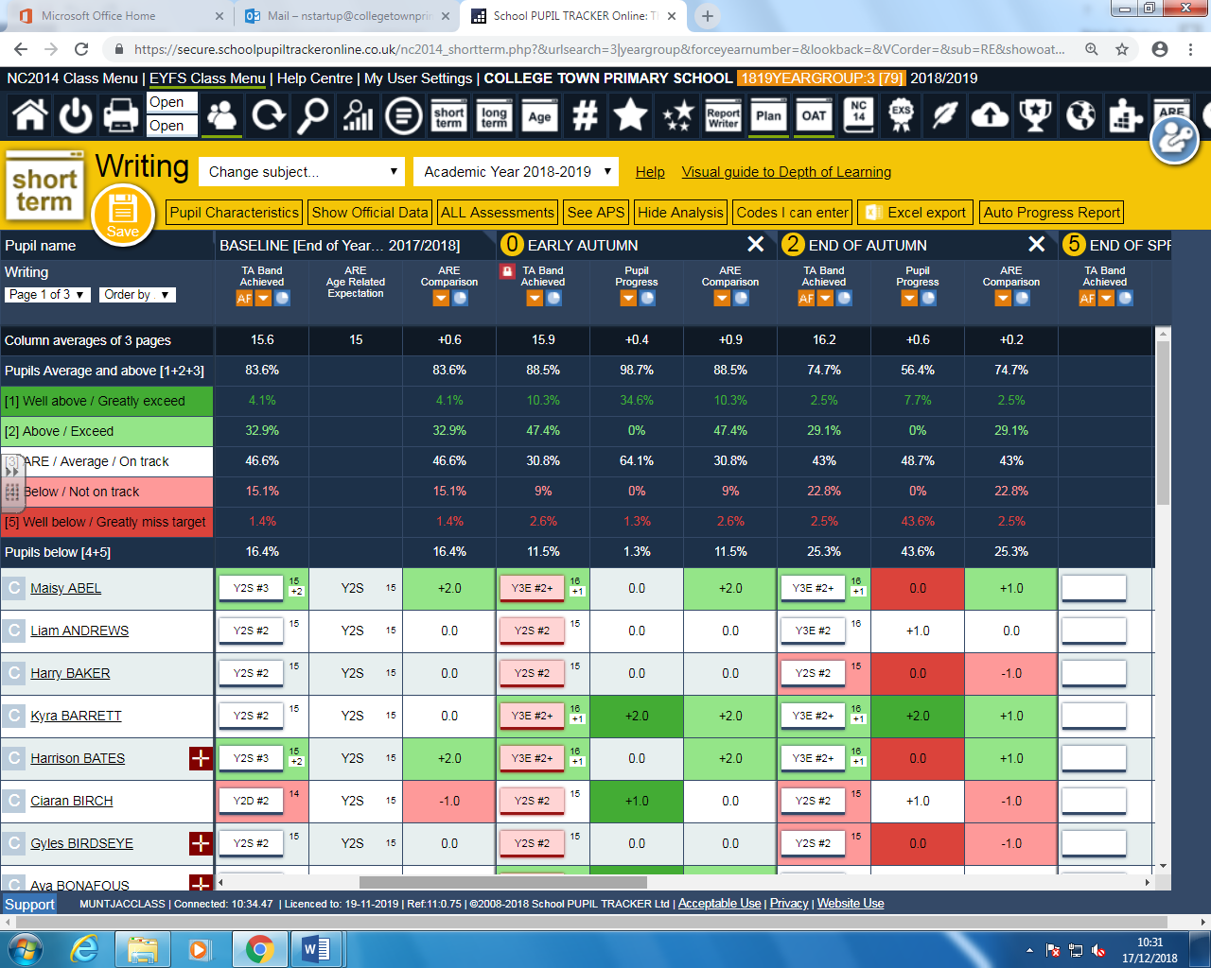Year 3: Writing

74.7% of children are ARE or above

25.3% of children are below or well below:

* These children are identified on planning to be supported.
* Select children are receiving Precision Teaching and personalised spellings are given weekly. These are identified from books and year 2 high frequency spellings to aid their writing.
* ‘Developing English sessions’ are taught daily to teach grammar and vocabulary explicitly. Identified on planning and linked to NC grammar objectives or areas of year group misconceptions. This is targeted at children working below, by picking up on basic punctuation.

Year 4: Reading

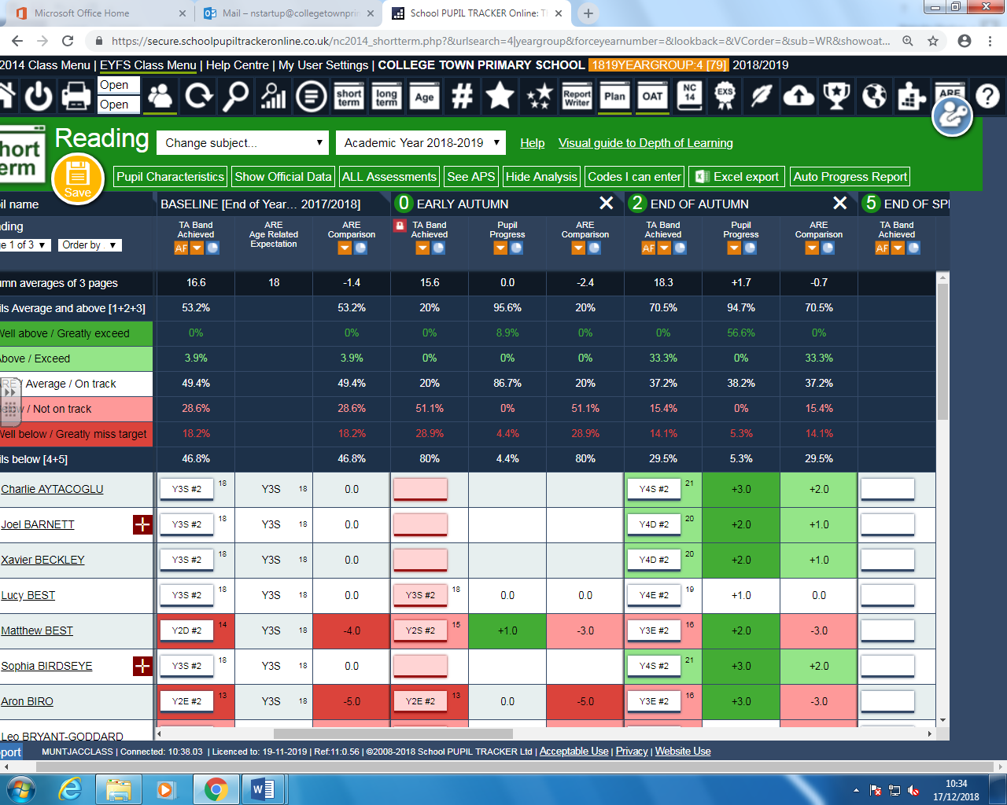

70.5% are ARE or above

29.5% are below or well below:

* Children have been streamed into differentiated classes.
* To support classes, children have differentiated reading books.
* High level of children with IEPs and EHCPs.
* To support planning, teachers have been working closely with the Teaching and Learning Practitioner.
* From Spring Term Teaching and Learning Practitioner is planning Guided Reading and English planning and sharing with the team.

Year 4 Writing 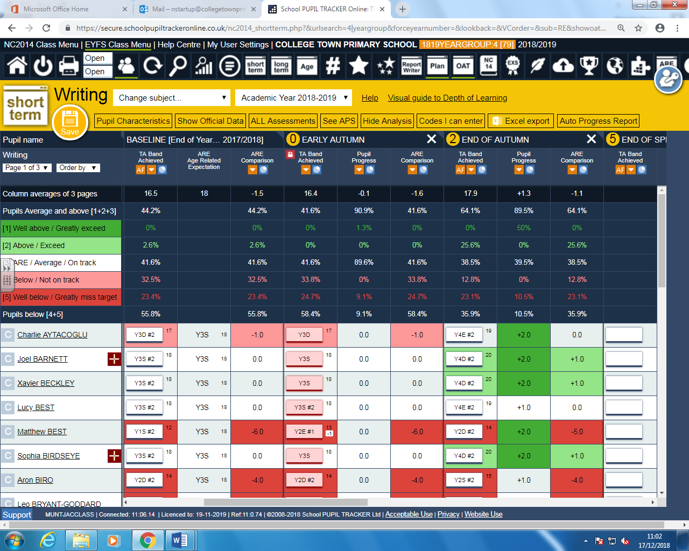

64.1% of children are ARE of above

35.9% of children are below or well below:

* 10 IEPS and 2 EHCPs in one class.
* The Teaching and Learning Practitioner has been working closely with planning.
* Within the lowest ability class children are clearly identified and planned for with differentiation in lessons.

Year 5 reading

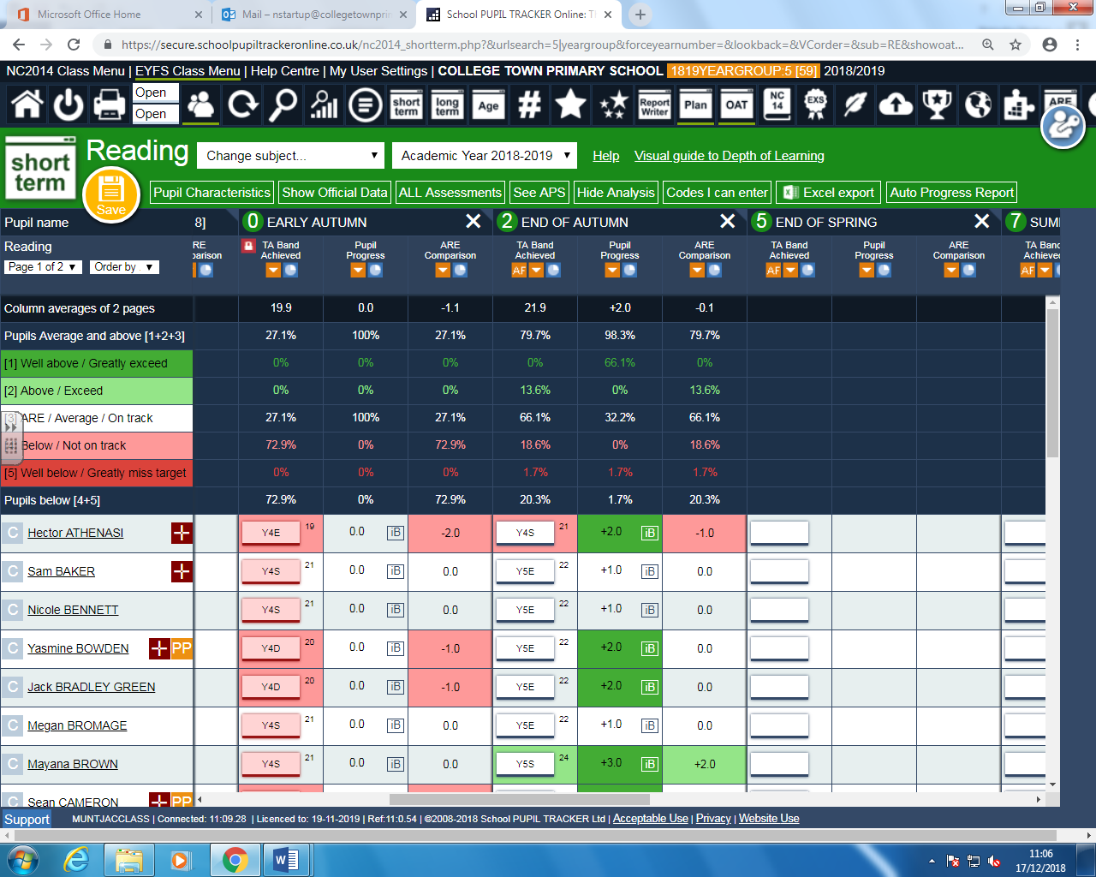

79.9% of children are ARE or above.

20.3% of children are below or well below.

* Since the introduction of whole class Guided Reading, children have made rapid progress.
* Attainment has been raised: in one term, children went from 27.1% of children being ARE or above to 79.7% ARE or above.
* Children are being read aloud to every single day and are reading aloud to practise this skill.
* Children have each got a copy of a high quality text to read.

Year 5 writing

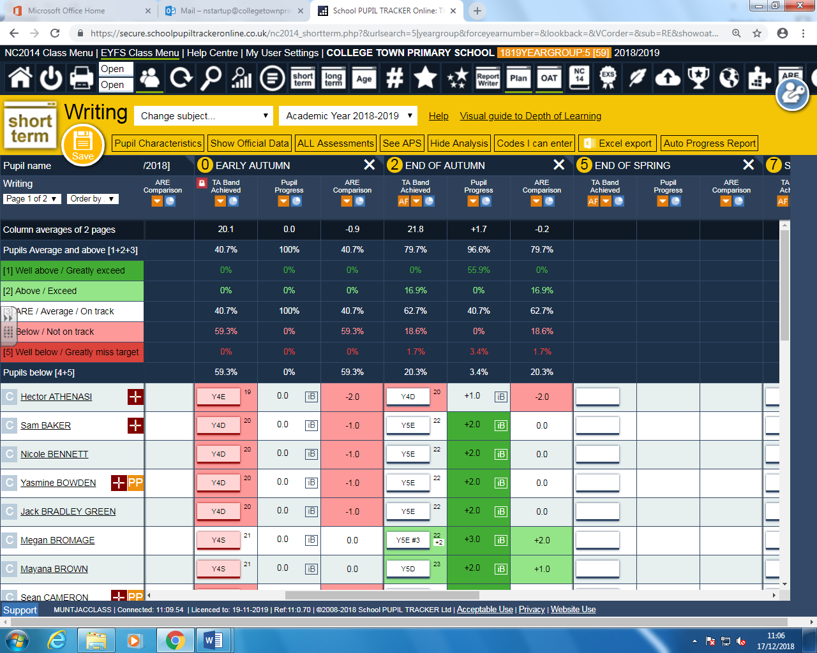

79.7% of children are ARE or above.

20.3% of children are below or well below.

* In one term, children went from 40.7% being ARE or above to 79.7%.
* Children are identified on planning.

Year 6 reading

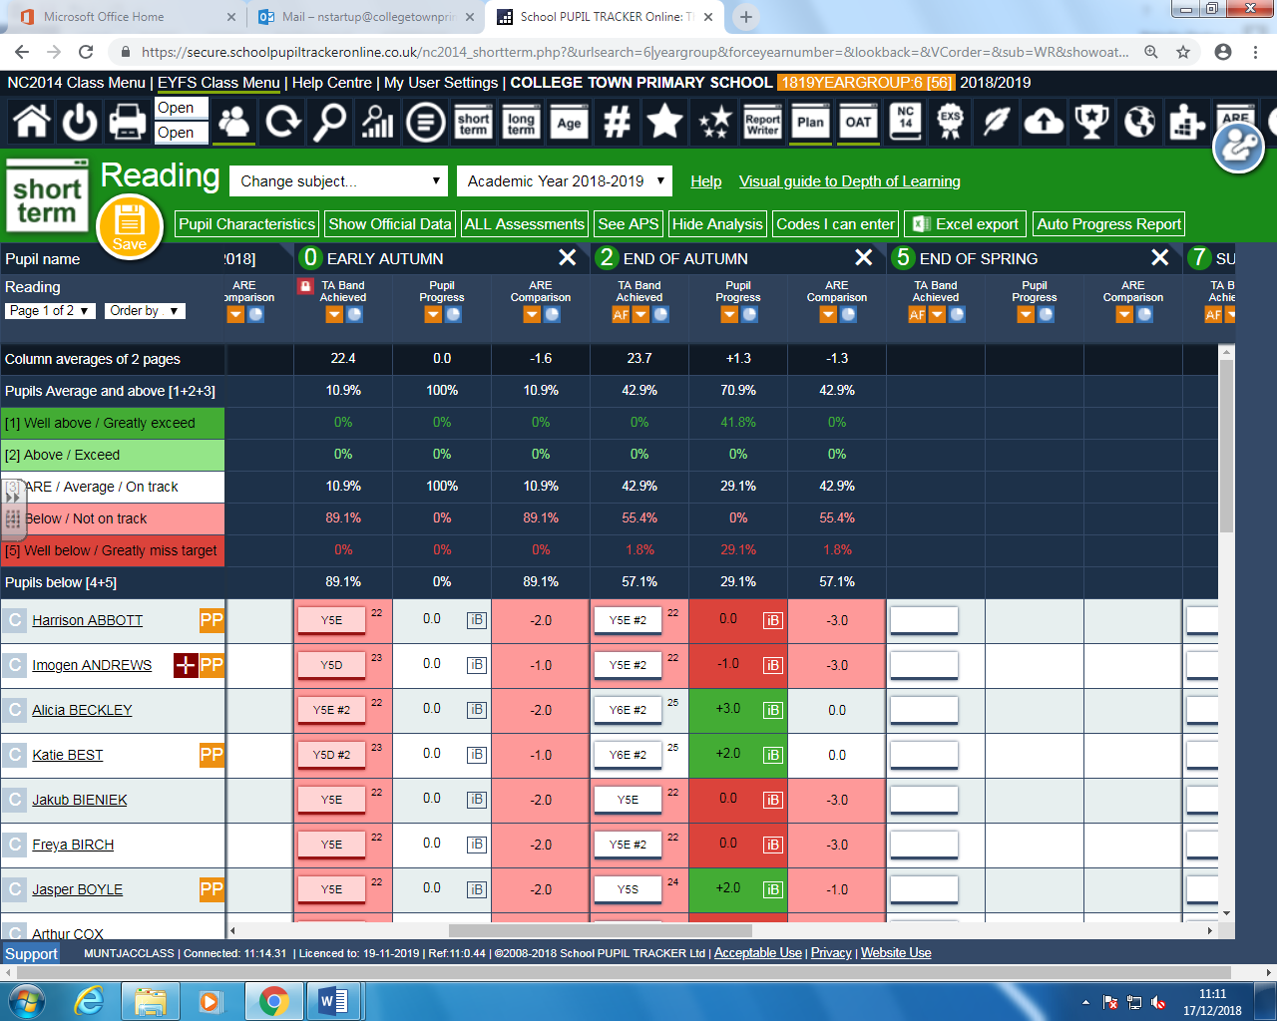

42.9% of children are ARE

57.1% of children are below or well below

* Reading shows the most rapid rate of progress in year 6.
* In one term, children went from 10.9% ARE and above to 42.9% at ARE.
* Each child has a copy of a high quality texts.
* Children are being read to and having the opportunity to read every single day.
* The lowest ability children have differentiated books and selected questions.
* Parents have been invited in on three occasions to engage parents to read/support children at home.

Year 6 writing

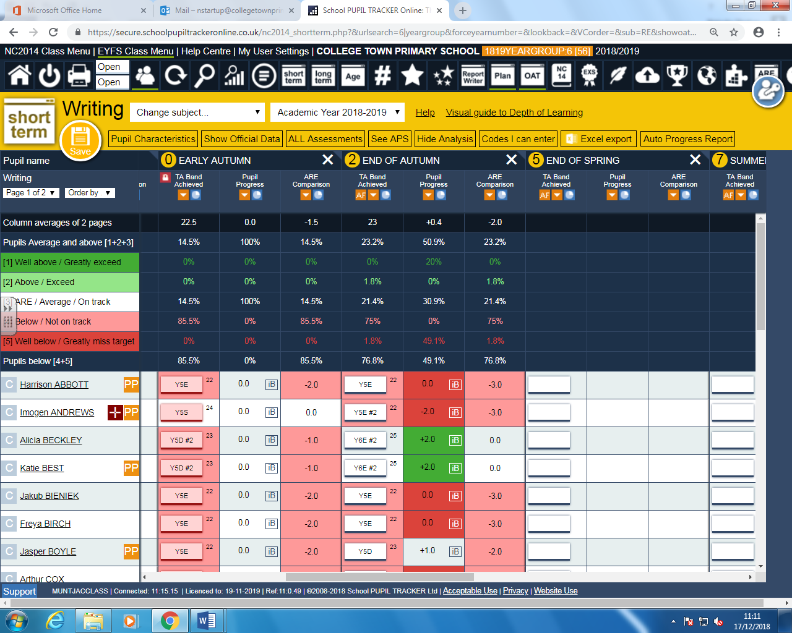

23.2% of children are ARE or above

76.8% of children are below or well below

* Identified that Year 6 are a priority in terms of making rapid progress to improve.
* Identified children have been attending a range of interventions, which will continue into the Spring Term.
* TA is scribing for the lowest ability children.
* There have been meetings to raise parental engagement.
* Each child have a copy of CPG Study books to engage parents in supporting their children.
* Children have been streamed into smaller classes and supported by an additional teacher and TA.
* Attended external moderation which showed grammar needs to be taught more explicitly.

Impact across the school

* This year I will be focusing on KS2 to ensure there are consistencies and the school has a foundation to build on. I will support KS1 next year as they are already established and I can support them in developing English and Guided Reading.

Monitoring and Training

* I have reviewed planning on a fortnightly basis on the school website.
* From monitoring Guided Reading planning, I have led a Guided Reading session to KS2 teachers identifying where we can improve.
* Vocabulary is a big focus in school and from noticing a lack of teachers explicitly teaching and introducing children to new vocabulary, I introduced 3 strategies for teachers to use in Guided Reading sessions.
* I have monitored Guided Reading planning and have noticed staff implementing these into sessions. Teachers have noted how children’s vocabulary is improving and this has been validated in the data results.
* The new whole school Guided Reading approach has had a positive impact on the school as children are being read to every day, where they are hearing a good model example and then having the opportunity to practise this daily.
* Teachers are also putting vocabulary on working walls and displayed around the classroom for children to use when writing.
* I have met with the Teaching and Learning Practitioner weekly to review how practice is developing across KS2.

Establishing up the Curriculum

* From coming into school in August, it was noticed how there was a lack of reading books. Since then, each year group in KS2 has class sets of high-quality books.
* For each half term, I have written overviews for each year group with genres to cover in English. I have also ordered books to use as a hook for each topic or sourced video links to use.
* Grammar objectives from the National Curriculum have been sent to each teacher so they are aware of what objectives they need to cover over the year. (from year 1-6)
* Audited the school thesauruses and dictionaries and found there was a lack of high quality resources for children to use to develop vocabulary. These have been ordered and differentiated versions distributed across Lower and Upper KS2.
* Regular professional discussions with teachers to support and develop their practice.
* Questions for before, during and after reading are on the website for parents to refer to when reading with their children.
* In the process of creating a College Town Primary reading spine with recommended reads for each year group, starting in nursery.
* There are long pieces of writing up from each year group in KS2 displayed around the school.
* Staff have been introduced to tools to help them push on children’s vocabulary and ideas – ‘Linoit’ enabling all children to access new vocabulary and develop language.

Moderation

* In school moderation showed how children are making progress and are writing for longer amounts of time.
* Teachers noted how the whole school Guided Reading was beginning to have an impact on the quality of pupil’s writing.
* Teachers are identifying needs and addressing these with the whole class feedback sheets.
* Teachers are thinking about the audience and purpose of tasks.
* Teachers noted they needed to be teaching grammar more explicitly.

Next steps:

I would like to do lesson observations/a learning walk of English during the Spring Term.

* Year 6 – raising the standards of writing.
* Keep in regular contact with year 6 teachers.
* Monitor planning to ensure differentiated and targeted children are being planned for, with appropriate challenge/support.
* Ensure vocabulary and grammar terminology is being taught and displayed.
* Ensuring teachers are explicitly teaching grammar.
* This will be done through monitoring planning to ensure it is being planned for.
* Book looks to ensure teachers are recording in books.
* Email out to staff so they are aware it needs to be in books. Give time for them to do before looking in books.
* Monitoring Guided Reading to ensure vocabulary is explicitly being taught
* Monitoring guided reading planning. Ensuring it is being thought through before teaching.
* Vocabulary should be displayed in the classroom. Complete a learning walk for guided reading/English and check this.