**Overview**

**T**his term has presented challenges. I have made it my priority to learn how to use and interrogate SPTO. Time was needed to learn and use the systems available. A key priority for me has been on ensuring that the children in my class started to make the accelerated progress that is expected of them.

**Monitoring**

Initially I had 9 classes to monitor. I carried out a review of English planning although this role was later taken over by the T&L coach and English Co-ordinator. I monitored planning formats and learning environments. After the resignation of the AH of Upper School, I have been re-assigned to lead Years 3, 4 and 5.

**Staffing**

There were new staff in Years 2 and 3. One member of staff struggled to meet the high standards expected and decided to leave at Christmas. In Year 4, one member of staff decided to retire with effect from January 2019. There have also been resignations of support staff and at times, morale has been affected. This has been addressed and I believe that moving forward, the high standards will become the ‘norm’. New staff in Years 5 and 6 have worked hard to establish routines and raise the expectations of behaviour. A focus for 2019 is to ensure that communication is improved. It is also my opinion that there should be a focus on ensuring staff-wellbeing.

**Behaviour**

Behaviour during transitions was quickly identified as being an area for focus. All staff have been expected to be on playground duty to eliminate low-level disruption. I believe that this has been addressed and I believe that from January the need for high levels of staffing will be reduced as the children are now clear about expectations. Teachers must continue to be vigilant and rigorous in enforcing the expectations.

**Teaching and Learning**

**Data Analysis**

**Year 3 Progress Report**

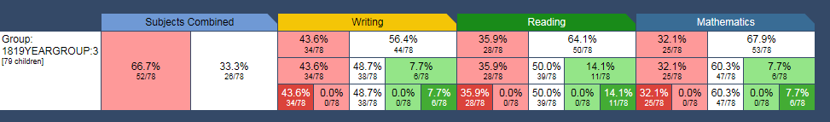

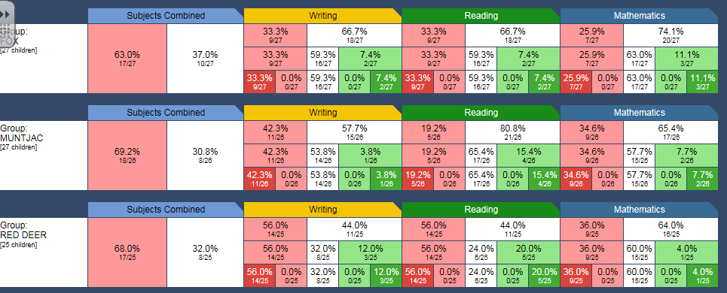

SPTO has been used to identify Intervention groups (reading and maths) that will begin in January 2019. Progress in Reading and writing in Red Deer are significantly below the parallel classes and so my monitoring will be focused on regular meetings with the Year 3 team to moderate together.

**Pupil Premium Year 3**

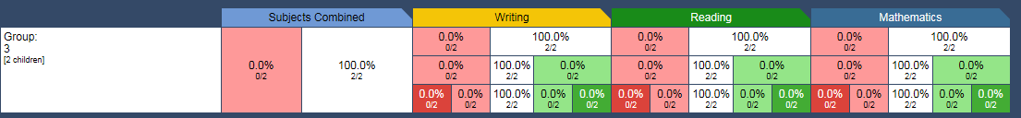

Progress of PP children in Year 3 is significantly better than their peers.

**YEAR 3 at ARE DECEMBER 2018**

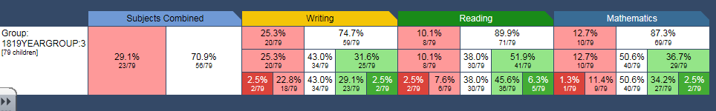

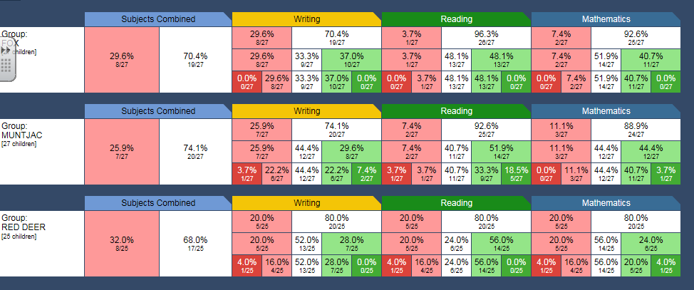

Year 4 Progress Report

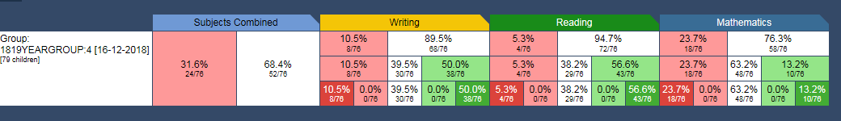

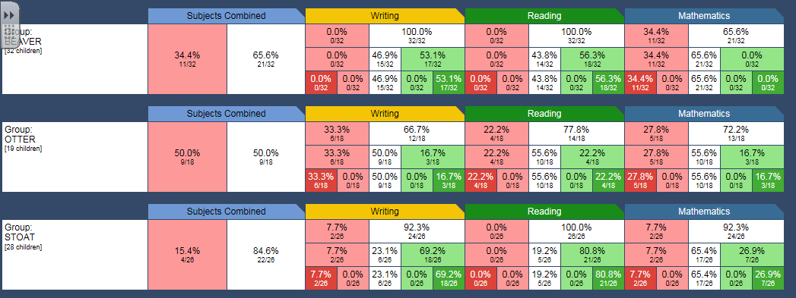Progress in Year 4 has been good. There are a significant number of children however who remain significantly behind there ARE (see report below). The T&L coach will be moderating these children against the Framework for Year 2. The children are being taught in Otter class. The majority of that class have IEPs. Progress in mathematics for the more able (Beaver class) is slower than for the rest of the cohort although this is because the children are working towards Greater Depth expectations. Intervention groups have been identified for those children who are at risk of not meeting ARE. These groups DO NOT include the children in Otter class who are significantly behind ARE. They are being challenged to meet Y3E/Y3D levels. This will close the gap although the children in this class will remain an issue for CTPS moving into Year 5 and beyond. Progress and attainment in mathematics remains a focus for Year 4.

**Year 4 Pupil Premium**

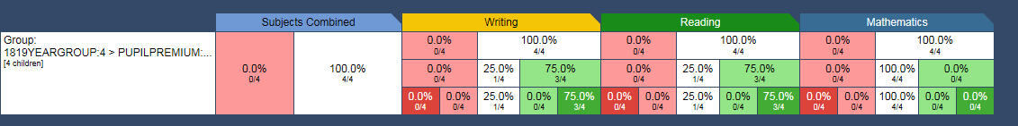

Progress of PP children in Year 4 is significantly better than their peers.

**Pupils at ARE DECEMBER 2018 Year 4**

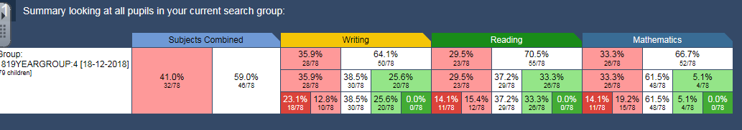

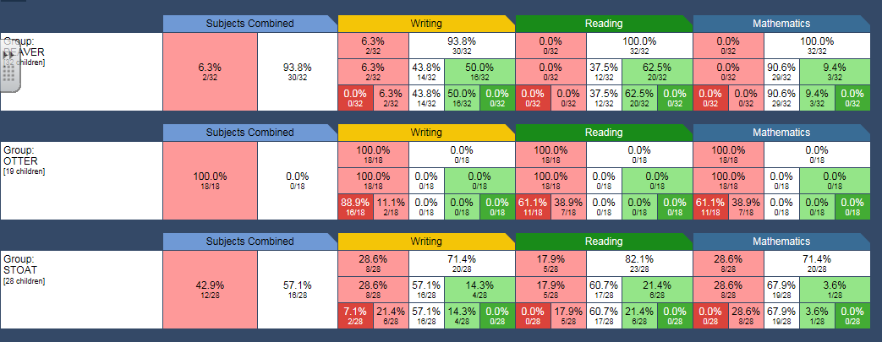

Note attainment in Otter class – 100% of children are not at ARE and will not meet ARE. The aim is to narrow the gap and ensure continued and sustained progress. The children who are not at ARE in the Year group analysis are predominantly in Otter class.

**Year 5**

**Progress Report**

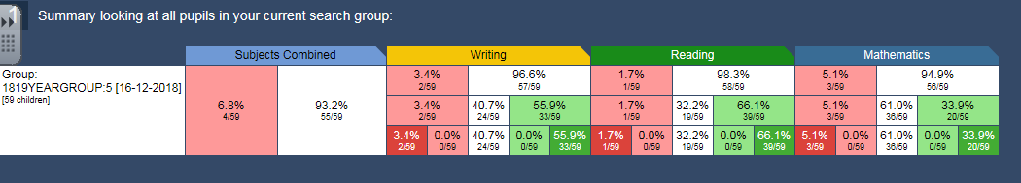

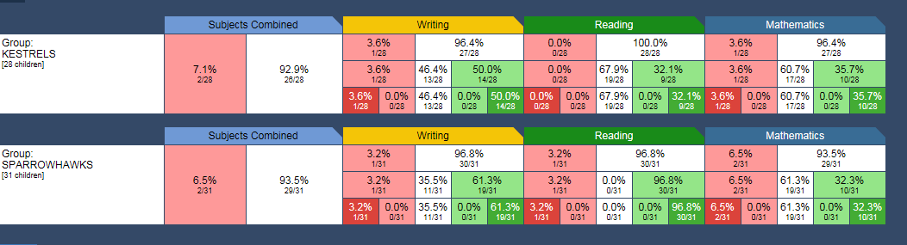

Year 5 Pupil Premium

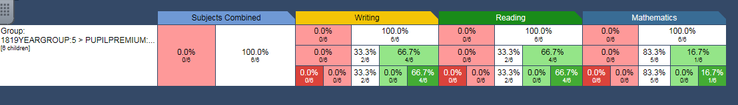

Progress of PP children is broadly in line with peers.

**Y5 at ARE DECEMBER 2018**

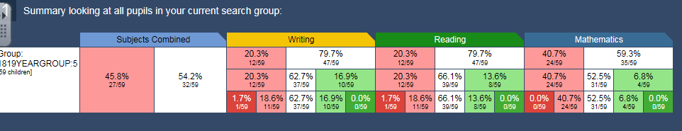

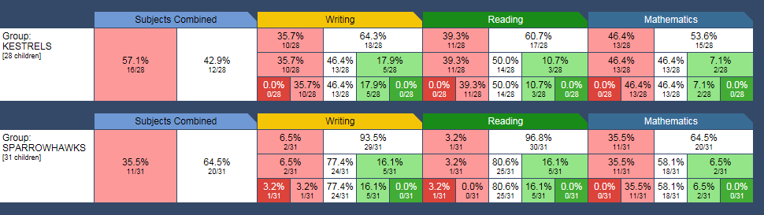

Intervention groups have been identified for children who are at risk of not meeting ARE.

Year 5 PP progress

|  |  |  |  |
| --- | --- | --- | --- |
|  | Writing | Reading | Maths |
| YB | 2 | 2 | 1 |
| SC | 2 | 2 | 1 |
| EC | 2 | 2 | 1 |
| MJ | 1 | 1 | 1 |
| AL | 4 | 2 | 1 |
| LS | 1 | 1 | 2 |
|  | 2 pts average progress Vs 1.3 year group- exceeding | 1.6 average points progress VS 1.7 year group **broadly in line** | 1.1 average pts progress Vs 0.9 year group- exceeding |

Year 4 PP progress

|  |  |  |  |
| --- | --- | --- | --- |
|  | Writing | Reading | Maths |
| PBJ | 2 | 2 | 1 |
| LC | 2 | 2 | 1 |
| IEN | 2 | 2 | 1 |
| TS | 1 | 1 | 1 |
|  | 1.75 average pts progress Vs 1.3 year group | 1.75 average pts progress VS 1.7 year group | 1 pt average pts progress VS 0.9 year group **broadly in line** |

Year 3 PP progress

|  |  |  |  |  |
| --- | --- | --- | --- | --- |
|  | Writing | | Reading | Maths |
| JK | 0 |  | 1 | 1 |
| LR | 1 | | 1 | 1 |
|  | 0.5 average pts progress Vs 0.6 year group. **Broadly in line** | | 1 pt progress vs 0.7 year group – exceeding | 1 pt progress average vs year group 0.8 - exceeding |