FGB Headteachers report – November 16th 2020
Contextual Data
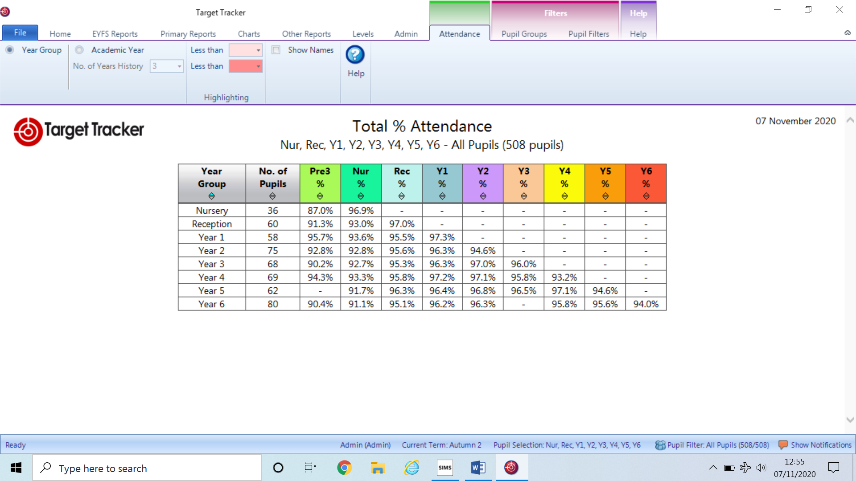

SAFEGUARDING
Child Protection = 0 previous 3 cases both previous have now stepped down to Child in Need
Child in Need = 6 live cases 1 prevbious CIN now closed to CSC
Ongoing initial/ follw up asessment =1
EWO = We are closely monitoring a child who has just joined our school as there is a concern over their low sattendance. An initial letter has already been sent and we shall work with the EWO should there not be a distinct impraovement. The EWO is aware that the school has raised concerns.
BULLYING = 1 currently under investigation. The school has deemed the actions of a child as bullying and is in close communication with both sets of parents. Mrs Mitchell has already conducted her first meeting and progress to date has been very good. It is the expectation that this situation will be closed by March 2021 if not before.
RACIST INCIDENT = 0

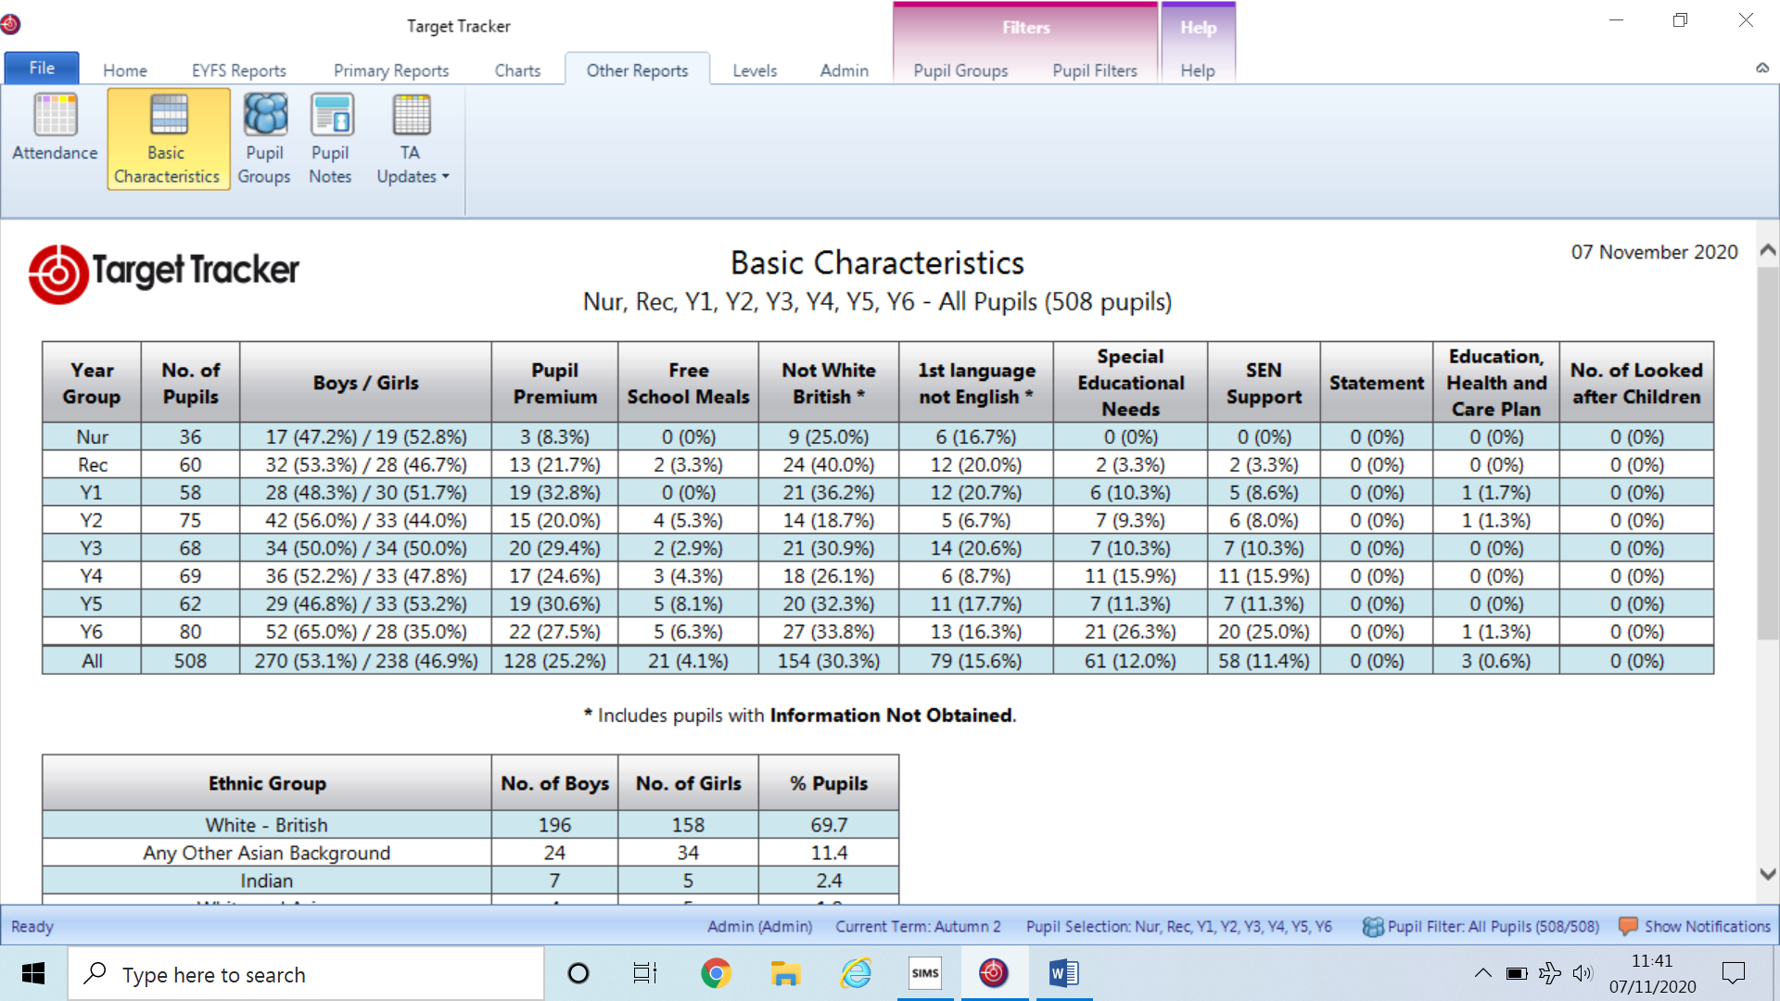
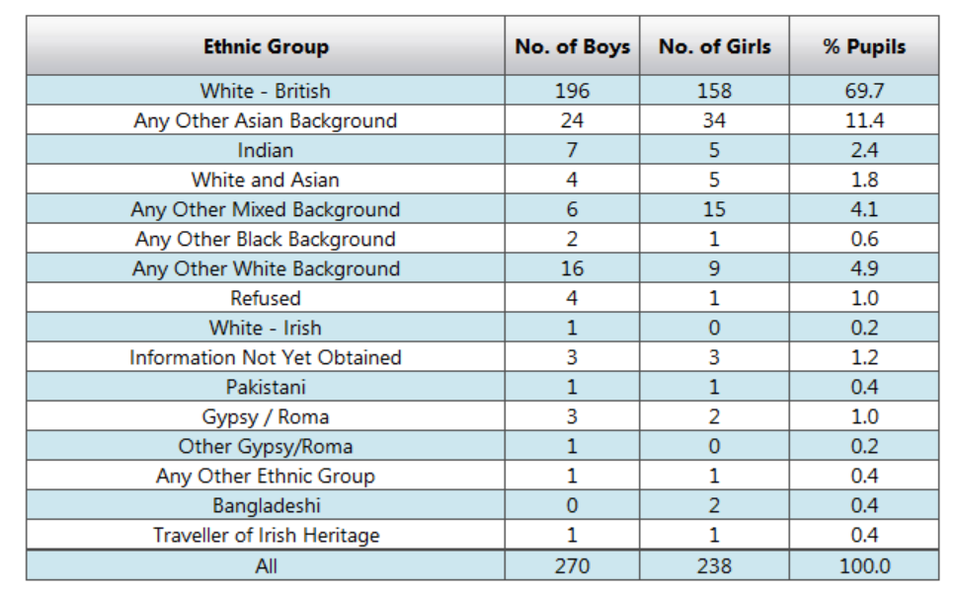
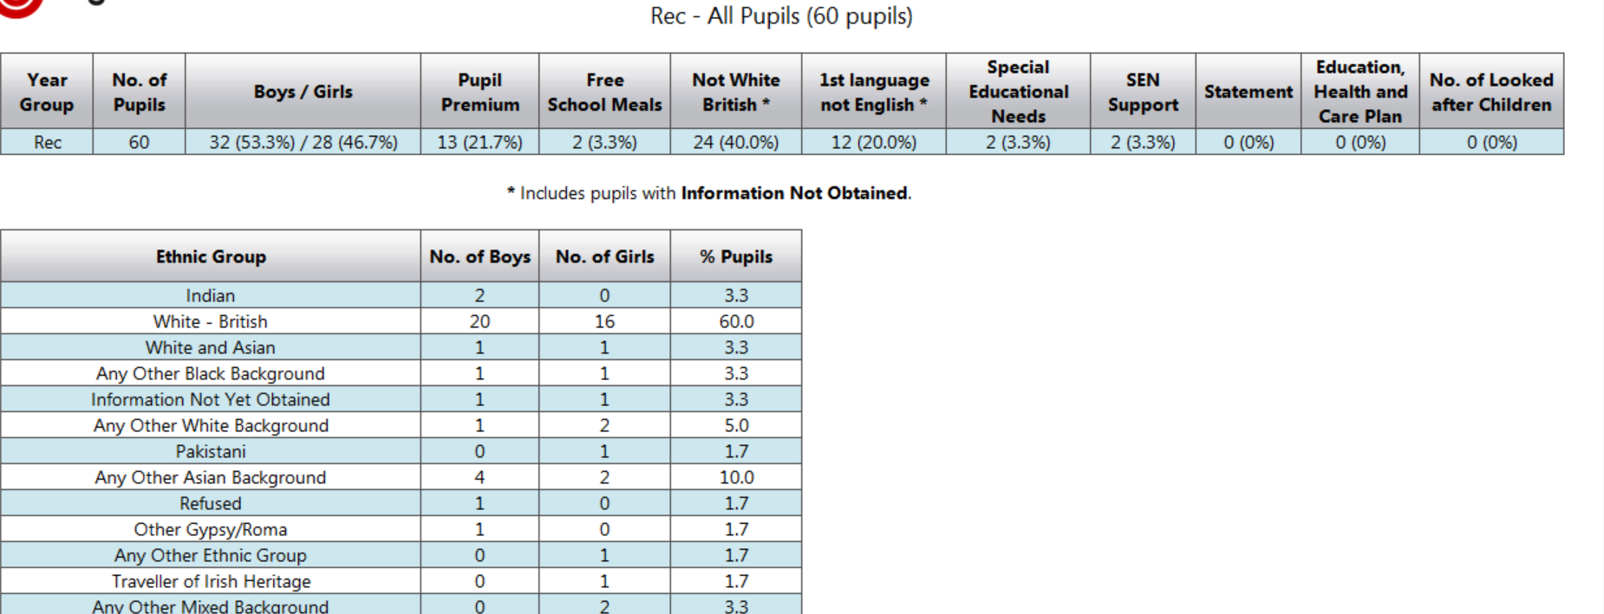

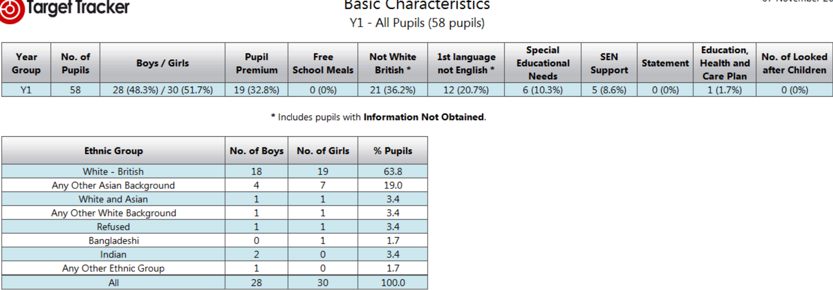
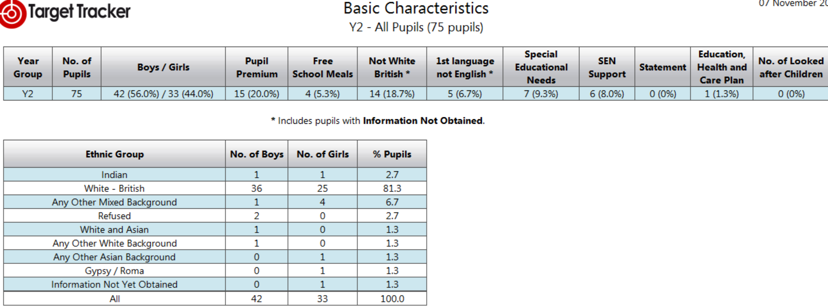

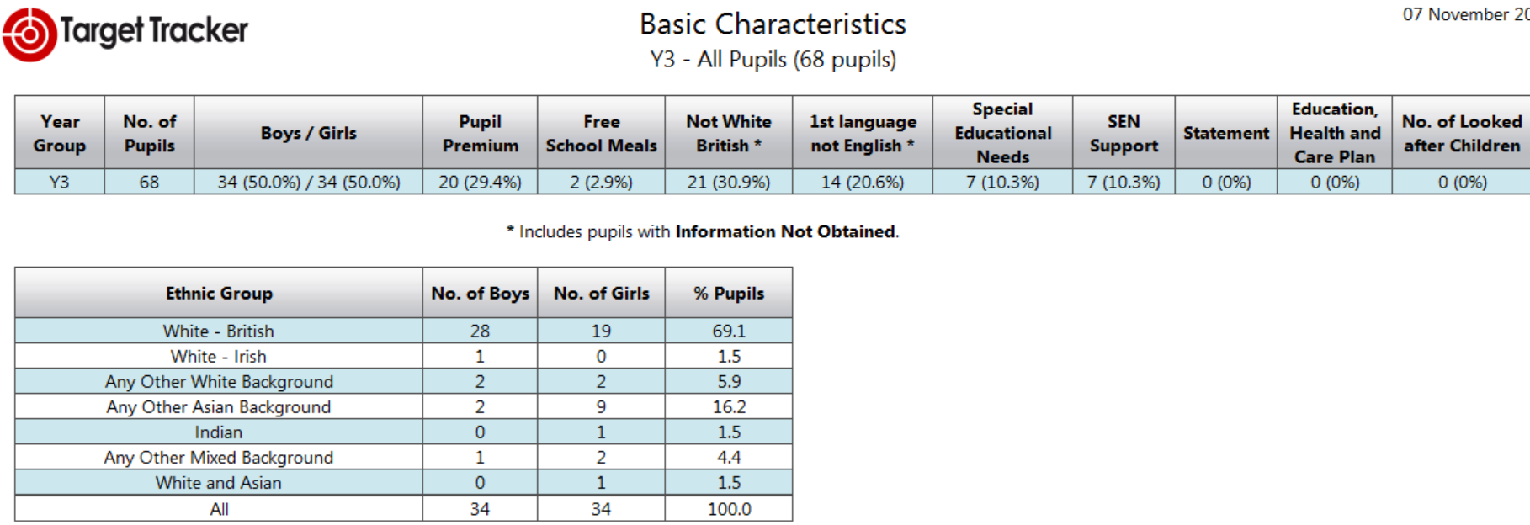
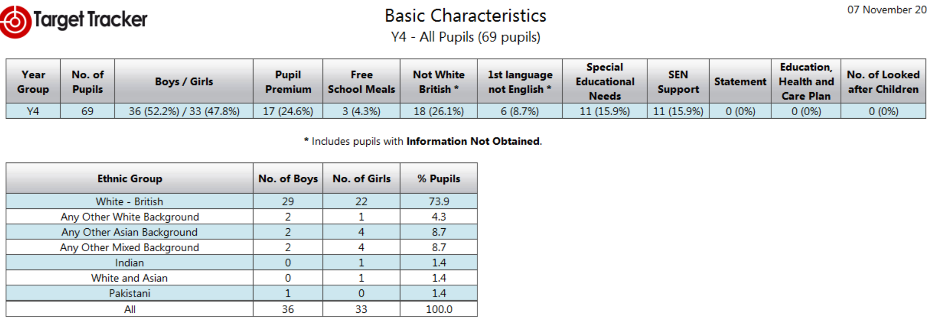
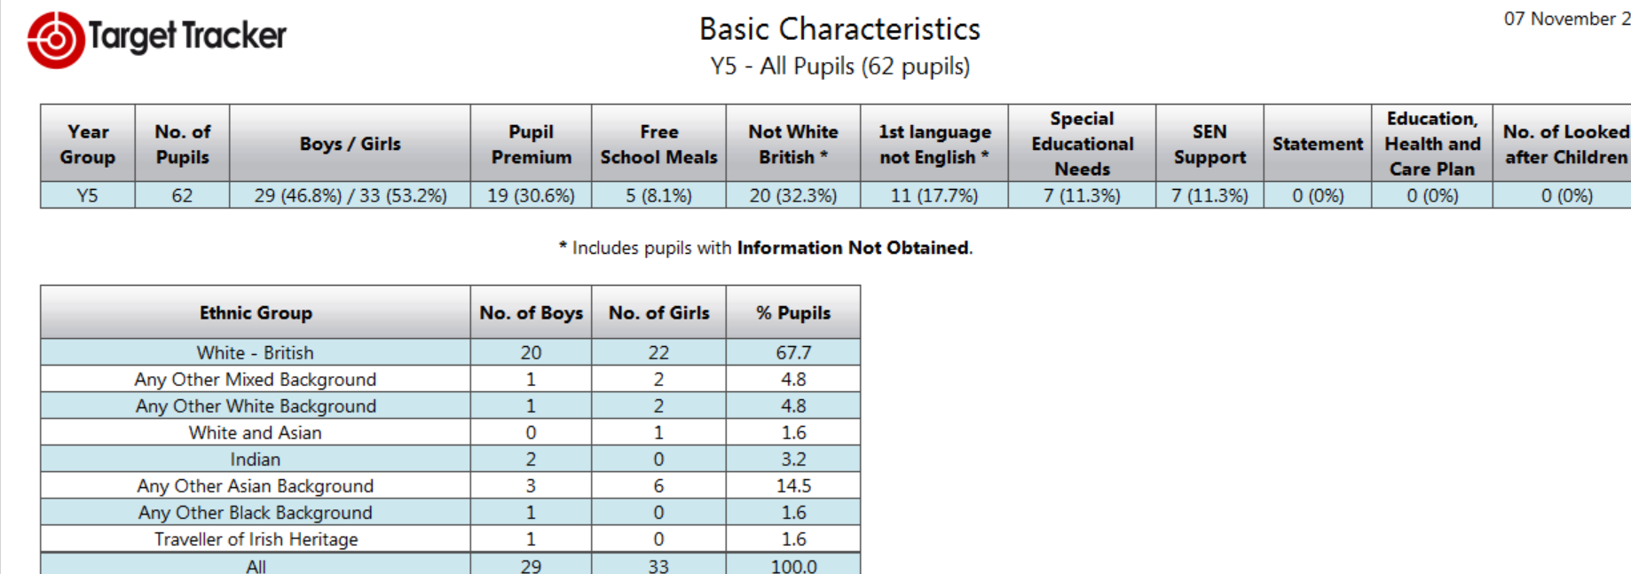
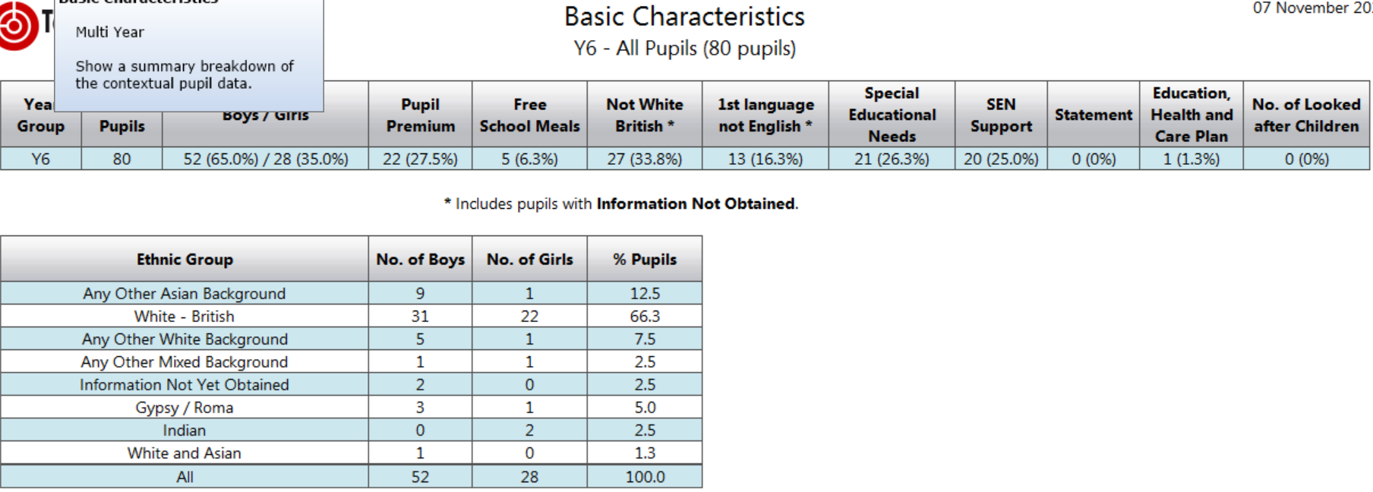

COVID-19 UPDATE
The school has seen testing escalate over the last week with two members of staff testing positive. The results were shared immediately with the DFE and PHE who advised and supported the school in dealing appropriately with such challenging circumstances. Despite the school having two positive results we did not need to take any further action due to the fact that the staff had not been in the school for over 48 hours. The LA was also informed and received email confirmation to evidence the communication made to staff.
The school has provided four test to staff and pupils where required to ensure that all of our community can access testing.
The risk assessment has been updated from Nov 9th and shared with staff. Rita and I spoke on the 9th to clarify new procedures and the LA has received our copy.
REMOTE LEARNING
As we move through the term we are increasingly needing to draw upon our remote learning package. You will know from our earlier conversations and documentation at our recent curriculum meeting that finding a practical system was incredibly challenging, this continues to be an ongoing issue. Many staff are not happy to be filmed on Teams and I have agreed that that there is no requirement for them to do so. I think if we are really going to seriously consider staff well-being and the stress related to remote learning then this must be appreciated and supported fully by the Governing Body.
Please do familiarise yourselves with the remote learning policy and the package of support offered. We were able to fully meet our duty by the 22nd October and our website was fully up and running by this date.

Catch Up funding programme
The additional sessions for Year 3 4 & 5 have already commenced and every child invite with the exception of one have attended all session. These sessions, as previously explained, will continue to run all the way through until the May half term. Throughout the year the assessment data will be used to track the impact that the additional support is having for these 36 children.
After Christmas Year 6 will also begin their additional sessions from 2.30 – 3.15 Tuesday, Wednesday & Thursday. This will run until the end of the first week in May ready for SATS week. Currently year 6 are having targeted gap filling streamed sessions three times a week as part of pupil progress directed sessions from 1265. Teachers and pupils have reported very positively regarding the engagement, so we hope that in December we will see the impact become apparent at our data assessment point.
Year 1 & 2 pupils have received a 4 book pack of additional maths home learning resources which should support the work going on in the school. In addition the Year 2 children at risk of failing their phonic test in November continue to be supported three times weekly and have also received CPG phonic books to practise at home.
Targets for July 2021

FSM = Free school dinners & Ever 6

EYFS

Targets for end of EYFS July 2021

 | Number of Pupils in cohort | Number of pupils achieving a GLD | % GLD
All | 60 | 42 | 70%
FSM | 2 | 2 | 100%
Non - FSM | 58 | 2 | 100%
SEN (EHCP and SEN support) | 3 (1 in FS1) | 0 | 0
Attainment gap between FSM +30%

Key Stage 1

All Pupils | Number of Pupils in cohort  75 | Reading |  | Writing |  | Maths
All Pupils | Number of Pupils in cohort  75 | No | % | No | % | No | %
% EPS+ |  | 42 | 56% | 40 | 53% | 46 | 61%
% GD |  | 8 | 11% | 6 | 8% | 6 | 8%
EXS+ |  | 50 | 67% | 46 | 61% | 52 | 69%

FSM Pupils | Number of Pupils in cohort  4 | Reading |  | Writing |  | Maths
FSM Pupils | Number of Pupils in cohort  4 | No | % | No | % | No | %
% EPS+ |  | 2 | 50% | 2 | 50% | 2 | 50%
% GD |  | 0 | 0 | 0 | 0 | 0 | 0

Non - FSM Pupils | Number of Pupils in cohort  71 | Reading |  | Writing |  | Maths
Non - FSM Pupils | Number of Pupils in cohort  71 | No | % | No | % | No | %
% EPS+ |  | 38 | 54% | 38 | 54% | 42 | 59%
% GD |  | 8 | 11% | 6 | 8.5% | 6 | 8.5%
EXS+ |  | 46 | 65% | 44 | 62% | 48 | 68%

SEN (EHCP and SEN support)  At risk | Number of Pupils in cohort  7 | Reading |  | Writing |  | Maths
SEN (EHCP and SEN support)  At risk | Number of Pupils in cohort  7 | No | % | No | % | No | %
% EPS+ |  | 2 | 28% | 0 | 0% | 2 | 28%
% GD |  | 0 | 0 | 0 | 0 | 0 | 0

Year 1 phonics = 75 %

Key Stage 2

66% boys  34% girls  25% SEND | Number of pupils in cohort  80 | Reading |  | Writing |  | GPS |  | Maths |  | Combined R,W and M
66% boys  34% girls  25% SEND | Number of pupils in cohort  80 | No | % | No | % | No | % | No | % | No | %
%EPS- |  | 49 | 61% | 43 | 54% | 47 | 59% | 49 | 61% | 42 | 52%
%GDS |  | 11 | 14% | 8 | 10% | 10 | 12% | 12 | 15% | 8 | 10%
EXS+ |  | 62 | 75% | 51 | 64% | 57 | 71% | 61 | 76% | 50 | 62%

KS2 - PPG

3 = SEND + 2= SEND 1 SCH MOVE  Plus CP  All 3 are new arrivals | Number of PPG pupils in cohort  5 | Reading |  | Writing |  | GPS |  | Maths |  | Combined R,W and M
 | Number of PPG pupils in cohort  5 | No | % | No | % | No | % | No | % | No | %
% EPS | 2 | 1 | 20 | 2 | 40 | 2 | 40 | 2 | 40 | 2 | 40%
% GD | 1 | 1 | 20 | 0 | 0 | 0 | 0 | 0 | 0 | 0 | 0%

KS2 Non - PPG

 | Number of Non PPG pupils in cohort  75 | Reading |  | Writing |  | GPS |  | Maths |  | Combined R,W and M
 | Number of Non PPG pupils in cohort  75 | No | % | No | % | No | % | No | % | No | %
% EPS |  | 45 | 60% | 41 | 55 | 42 | 56 | 44 | 58 | 38 | 51
% GD |  | 10 | 13% | 8 | 11 | 10 | 13 | 12 | 16 | 8 | 11
EX+ |  | 57 | 73% | 51 | 67% | 59 | 69% | 60 | 80 | 48 | 62%

KS2 – SEN (EHCP and SEN support)

25% SEND in cohort | Number of SEND  20 | Reading |  | Writing |  | GPS |  | Maths |  | Combined R,W and M
25% SEND in cohort | Number of SEND  20 | No | % | No | % | No | % | No | % | No | %
% EPS+ |  | 3 | 15% | 0 | 0 | 3 | 15 | 3 | 15% | 2 | 10
% GD |  | 0 | 0 | 0 | 0 | 0 | 0 | 0 | 0 | 0 | 0

