**Headteacher’s report for FGB May 17th 2021**

Regular and statutory safeguarding and contextual data

* Exclusions = none
* Bullying = none incidents = none
* Prevent referrals = none
* Racist incidents = none
* CP cases open to CSC = One case open due to a new family moving in. The case is expected to close 17th May
* CIN cases open = There are currently 5 families on CIN plans with a total of 7 children across the school. One case has now been closed.

The school has recently started to work with another local school school involving the managed move of a Year 2 pupil.

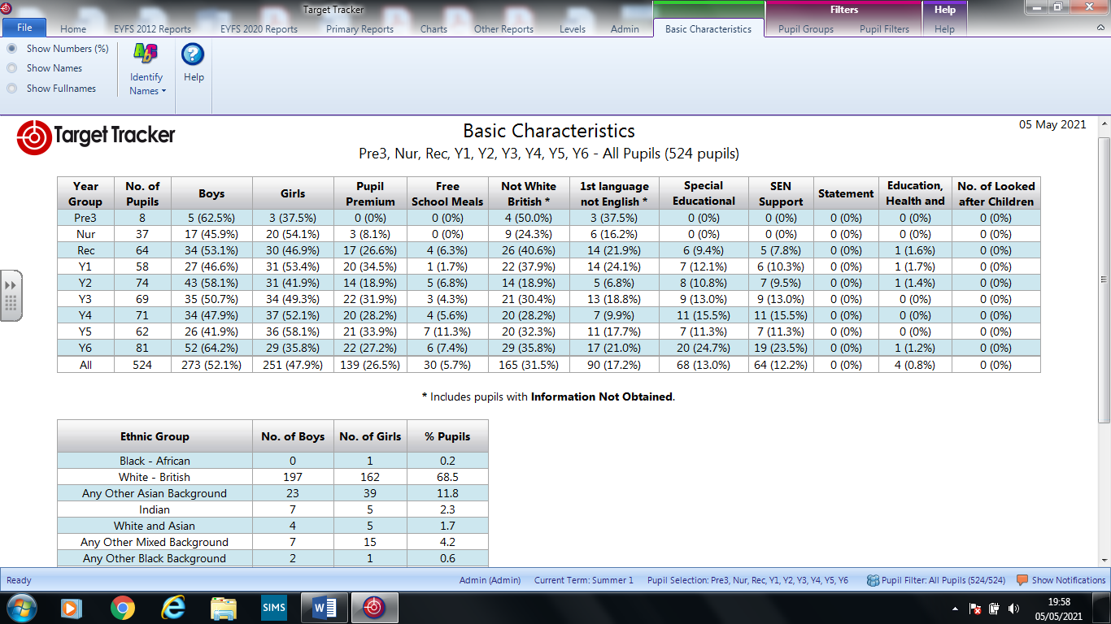

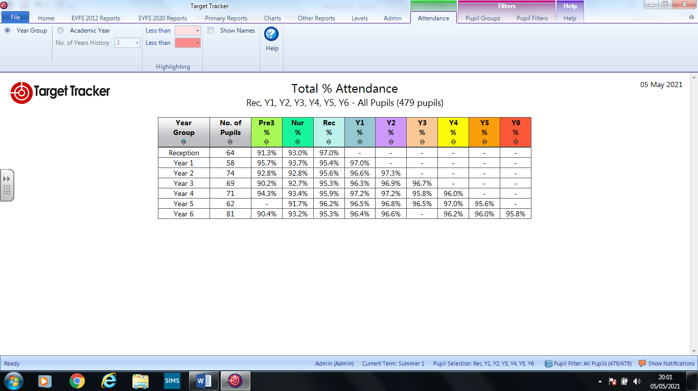

**Update on curriculum provision**

**Maths:**

Across the school each year group has been using the Ready to Progress resources which have been developed by the National Centre of Excellence for Teaching Mathematics. This resource highlights the key concepts which children require prior to them moving forward in their learning. On average each year group has a small group of 12 children who are working on the year below.

The explicit and well-structured materials have really supported te lowest children and they are all growing in confidence and ability. It is hoped that by May half term these children will return to their class for maths, but have an additional RTP session three times weekly to ensure key concepts are being continually revisited.

**Reading**

There has been monitoring of reading provision across the school by Mrs Duncan and Miss Startup, but the recent Year 6 closure has slightly delayed this as Miss Startup is having to self-isolate currently. However, on her return this will be picked backup with policy into practice being monitored in all year groups.

Currently all staff have had their learning environments assessed in terms of how well they promote a love of reading. Last week after returning from the Easter break staff have worked hard to re-vamp displays and reading is now more apparent across each year group. Mrs Duncan and Miss Startup are intending to continue this focus throughout the summer term.

**Sport**

It was felt that the third lockdown had been the hardest in terms of maintaining any social interaction for the children. The weather was cold and the days were short. The children had had little real opportunity to get out and be physical. This has led the school to delivering more sport and outdoor opportunities prior to the Easter break and for the summer term the school has developed after school sport clubs for Year 3 – Year 6.

These are provided free of charge to the children who wanted to attend and take up has been good with around 30% of each year group enjoying these sessions after school. Mr Norman, Mr Price and Mr Foster staff these sessions and the children are working on a range of track and field events with weekly times posted so that they can see their improvement. There will be winners in each category at the end of the programme.

**Changes to the EYFS from September 202**

The government says the changes will improve outcomes for all children, but particularly the language and literacy outcomes for disadvantaged children and reduce teacher workload.

I hope, and trust, that the Governing Body will be reassured by this as at CTPS this has always been the driving force behind our EYFS curriculum.

**What is changing?**

The DfE consultation in 2019 covered:

* proposed revisions to the educational programmes
* proposed revisions to the Early Learning Goals
* proposed changes to the assessment and moderation process for the Early Years Foundation Stage Profile
* and a proposed change to the safeguarding and welfare requirements to promote good oral health.

**The DfE says that the proposals are intended to:**

* make all 17 ELGs clearer, more specific and easier for teachers to make accurate judgements
* focus on strengthening language and vocabulary development to particularly support disadvantaged children
* strengthen literacy and numeracy outcomes to ensure all children have a good grasp of these areas of learning in preparation for year 1
* ensure the ELGs are based on the latest evidence in childhood development
* ensure they reflect the strongest predictors of future attainment.

**Educational programmes**

Following the consultation, the DfE said that it would make a number of changes to the reformed education programmes including:

* PSED will include additional information on self-care and healthy eating.
* Physical Development will be strengthened to include a greater focus on development from birth to reception and on the link between gross and fine motor skills.
* Literacy will include a stronger emphasis on pre-reception literacy learning, and the link between language comprehension and later reading and writing.
* Mathematics will include a greater detail on the importance of shapes, spatial reasoning and measure as part of early maths learning, and how children can foster a love of maths.
* Understanding the World will include wider experiences for children.
* Expressive Arts and Design will include a wider variety of ways children can develop their creative skills.

The Communication and language programme will remain as originally proposed.

**Early Learning Goals**

The proposed changes to the Early Learning Goals (ELGs) will also go ahead, largely as planned, with the following changes made:

* Communication and Language will include focus on adult-child interactions, and the word ‘accurate’ has been removed from the Speaking ELG when referring to tenses.
* Mathematics will include greater clarity to counting and comparing quantities in the Numerical Patterns ELG. Government will proceed with its focus on number and numerical patterns within the mathematics ELGs as the strongest predictor for later maths outcomes. This also reflects government’s continued commitment to strengthen the teaching of early numeracy so that all children, particularly those from disadvantaged backgrounds, are able to start year 1 with a strong and confident foundation in number. Practitioners and teachers will still be required to teach children about shape, space and measures, as part of a well-rounded curriculum, as set out in the revised mathematics educational programme.
* Understanding the World will include a change in relation to the Past and Present ELG to further clarify the expectation of children understanding the concept of ‘past’.
* Expressive Arts and Design will include reference to a greater variety of use of tools, materials and techniques that children will need to demonstrate for the Creating with Materials ELG.

The ELGs for Personal, Social and Emotional Development; Physical Development; and Literacy will remain as proposed.

**EYFSP moderation**

The proposal to remove the statutory duty for local authorities to moderate the EYFSP in 25% of schools each year will go ahead.

Schools will still be required to submit EYFSP data to their local authority and this will still be collected nationally.

**Exceeding judgement**

The government will proceed with plans to remove the “exceeding” judgement criteria from the EYFSP and says that this will “free up teachers’ time”.

Teachers will be expected to continue to identify and stretch more able children.

**Oral health**

A need to include oral health alongside the requirement to “promote the good health of children” will be added to the EYFS framework.

Individual settings and schools will need to determine how to meet this requirement and practitioners will not be required to assess this.

**Protected characteristics**

The DfE says that it will work with sector experts to review the EYFSP Handbook and ensure that it is clear on how practitioners should complete the Profile for children with SEND, EAL and who are summer-born, including signposting to additional advice and support where appropriate.

**What to use when**

The current version of the [EYFS Framework](https://www.gov.uk/government/publications/early-years-foundation-stage-framework--2) is still available for all other non-early adopter schools and providers to continue to use.

The[final new version that was published on 31 March 2021](https://assets.publishing.service.gov.uk/government/uploads/system/uploads/attachment_data/file/974907/EYFS_framework_-_March_2021.pdf) does not come into effect until 1 September 2021.

**Development Matters**

In September 2020 the Department for Education (DfE) published a revised version of [Development Matters](https://assets.publishing.service.gov.uk/government/uploads/system/uploads/attachment_data/file/971620/Development_Matters.pdf).

The new non-statutory guidance supports the delivery of the new EYFS framework that early adopter schools can use from September 2020.

From **September 2021 onwards**, early years providers and schools will need to use the [new version of the EYFS Framework](https://assets.publishing.service.gov.uk/government/uploads/system/uploads/attachment_data/file/974907/EYFS_framework_-_March_2021.pdf) when the reforms will be implemented nationally.

**Reception Baseline September 2021**

**What will be assessed**

The RBA will be an activity-based assessment of pupils’ starting points in:

* language, communication and literacy
* mathematics

The RBA will be a short task-based assessment. Pupils will use practical resources to complete these tasks and teachers will record the results on a laptop, computer or tablet. It will not be used to label or track individual pupils. Schools will be required to carry out the assessment within the first 6 weeks of pupils starting reception. No numerical score will be shared and the data will only be used at the end of year 6 to form the school-level progress measure. However, teachers will receive a series of short, narrative statements that tell them how their pupils performed in the assessment. These can be used to inform teaching within the first term.

**Measuring progress**

The new assessment will enable us to create school-level progress measures for primary schools which show the progress pupils make from reception until the end of key stage 2 (KS2). Unlike the current progress measure, this will give schools credit for the important work they do with their pupils between reception and year 2.

We will publish these measures for all-through primaries in the summer of 2028 for the first time. This will be when those pupils who entered reception in autumn 2021 reach the end of KS2.

**Assessment development process**

The National Foundation for Educational Research (NFER) has been contracted by STA to develop and deliver the assessment. This includes the trial, pilot, and early adopter phases.

The assessment was trialled in a nationally representative sample of schools between September and November 2018. This was followed by a large-scale, voluntary national pilot, which commenced in September 2019. Schools could also choose to participate in the RBA early adopter year in autumn 2020.

**Reception baseline and end of key stage 1 assessments**

The existing statutory end of key stage 1 (KS1) assessments - both national curriculum tests and teacher assessments - will become optional (that is, non-statutory) once the reception baseline is fully established.

**Reception baseline assessment framework**

The [RBA assessment framework](https://www.gov.uk/government/publications/reception-baseline-assessment-framework) provides an overview of what the assessment is and how it will be carried out.

**Covid-19 and School Closures**

We returned somewhat apprehensively on March 9th, not March 8th. This was due to ensuring that staff felt confident and safe to return. This is what was reflected in our risk assessment as you will recall from previous meetings.

At our last meeting, after only 10 days of being in school, all reports were mainly positive. While this remains the case with regard to the children’s well-being we have had to unfortunately close two year groups due to positive cases among both staff and pupils in Years 5 & 6. These closures fell only days after returning from the Easter break and was not what was anticipated at all. However, yet again teachers sprang into action and soon had the remote learning ready for the year groups which had had to close as a direct outcome from guidance via PHE & DFE. However, this was a significant blow to our school in terms of moving forward in a safe environment. Prior to this our positive cases had been minimal and this was a worrying point for us all.

The school received some challenging emails and difficult telephone conversations were had with parents. Indeed this resulted in the LA being involved due directly to the parent’s escalation. I am pleased to report to the GB that the LA fully supported the actions which I took and the parent has had the initial message reiterated to them. I was reassured by the LAs support as it demonstrates that our systems are effective and robust in managing these incredibly difficult times.

It was even more reassuring when I received confirmation from the LA that it had been the poor practice of the test and trace system which had ultimately led to infected pupils entering our school. Please see confidential element of this report

As you can imagine this has yet again highlighted the balancing act for schools. I have been constantly asked by the Rainbow group to re-start their group here, but following this incident I have responded this week with a no. I am simply not happy to place the education of our pupils at risk simply for a recreational activity. I will of course review this situation as the situation moves on.

**Transition from Year 6 into Year 7 Summer 2021**

This information was only received on May 6th which as you can appreciate has left the staff with a heavy workload as the initial return is required NO LATER than May 14th which is a huge ask for primary schools. The transition dates were also only known this week which has complicated our own timetables.

The Local Authority has facilitated a working party to explore ways to further improve transition between Year 6 and Year 7 and build on the good practice already in place across the borough. The content below highlights the thinking and suggestions for moving forward. However, there are still many unknown factors and the time is quickly slipping away from us. We will endeavor to provide the best transition for all of our pupils and will update the GB on this as we gain further detail.

Overall, there has been a high level of consensus that this is an area worth looking at further, to ensure that provision for these pupils, many of whom have been educated remotely for long periods over the past year, is as strong as possible.

There is a clear evidence base to show that primary to secondary transition is a critical moment in a child’s life. For some of our more vulnerable pupils, support lost to the Covid-19 crisis could lead to lasting disadvantage, and the importance of a good start to a pupil’s secondary school education cannot be over emphasised.

Feedback from school leaders so far suggests that provision for pupils’ pastoral needs is generally very strong, so a key focus of this group was to look at how to further develop transition to meet pupils’ academic needs in the current context. The areas the working party aimed to consider were as follows:

• The possibility of a consistent common transfer from to be used by all schools, and agreement about what it should include;

• Work to further improve curriculum continuity, particularly in the core subjects, to ensure that teachers are able to build on pupils’ prior learning;

• Consideration of whether Year 7 teachers in the core need more granular information about individual pupils’ achievements, even if only for those pupils most heavily impacted by the pandemic;

• Best practice models for sharing additional information beyond what is captured in the CTF, e.g. meetings between Year 6 teachers and secondary colleagues. Summary of the key points agreed by the transition working party with a consistent common transfer from to be used by all schools:

• There was a high level of agreement and strong will from the group that all schools should use the same consistent form to share information between Year 6 and Year 7, and that the model provided by The Brakenhale School (and agreed by secondary schools last year) was manageable, clear and contained the most salient information to support transition.

• Minor revisions to the form were suggested and agreed by the group.

• The form consists of two sections: The Student Profile Sheet and the Student Data Sheet. Secondary schools need the information on the Student Profile Sheet as early as possible to support transition initiatives for particular groups of pupils, and a deadline of the 14th May was agreed for this data. The working party agreed a deadline of the 11th June for the pupil attainment data required for the Student Data Sheet. It was agreed that this date was the best possible compromise to provide secondary schools with the information they need to support grouping, e.g. creating mixed ability tutor groups in time for transition days, and also to give primary schools as long as possible to arrive at accurate assessments.

• The group agreed that the most useful information to share regarding pupil attainment was pupils’ current actual attainment, using the following ‘codes’: BLW, WTS, WTS/EXS, EXS, EXS/GDS, GDS and should be the outcome of a range of triangulated assessment information, including, where appropriate, SATs papers.

• It will be important for secondary colleagues to be aware of those pupils whose academic attainment has been disproportionately impacted by the pandemic (i.e. more than the 2 average pupil), and whose current attainment may not be an accurate representation of their attainment in ‘normal’ circumstances. An additional column has been added to indicate where this is the case, and to add additional comments if needed.

• This information will be particularly important for grouping, interventions, target setting etc, as any early assessments undertaken at secondary school may also not result in accurate assessments of these pupils for a number of reasons.

• The form includes a tick box to indicate where a further discussion about an induvial pupil would be needed. It was agreed that this was a critical part of the process, so that conversations between key staff can focus on those pupils with the highest need.

• The group agreed that the inclusion of a column indicating whether pupils would benefit from summer school or not would be helpful, to avoid having to replicate this information. Secondary schools’ plans for summer school will vary in terms of their focus and which pupils they are hoping to target, so this information would need to be shared to support the completion of this column.

• The form also includes columns indicating which other pupils a child should be paired with and kept away from. In previous years, in some occasional instances, parents have been aware of what information has been shared with secondary schools, and when children have not been paired with their friends as indicated, this has been the cause of disappointment. The group agreed that it would be helpful if class teachers were clear that the final information shared with secondary schools should not be discussed. The same principle applies to the column indicating suitability for summer school. Completion of the form does not indicate a guarantee of a place. Actions to improve curriculum continuity:

• There was a high level of agreement that more could be done to improve curriculum continuity between Year 6 and Year 7, particularly in the core subjects, but that this should be the focus on a longer-term piece of work to be revisited in the autumn term in preparation for next year.

• The priority now is to ensure that secondary colleagues are provided with key information from their feeder schools about which aspects of the curriculum have been secured, which will need to be revisited and where there are significant gaps, so that the curriculum in Year 7 can be adapted accordingly.

• This information would be very useful to support transition in the core subjects, but also across the wider curriculum where appropriate.

• The group agreed that it would be good practice for primary schools to share documents outlining this curriculum information with the secondary schools, and that the format of this information should be at the discretion of the primary school, in order to minimise the impact on workload. Consideration of whether Year 7 teachers in the core curriculum are able to access more detailed information about the attainment profile of the most vulnerable pupils/ those most heavily impacted by the pandemic:

• The group also discussed whether there was more that could be done to support the academic transition of the 20% lowest attaining pupils or those whose learning had been most significantly impacted by the pandemic, particularly in English and mathematics, and whether more granular information about these pupils’ attainment could be shared.

• The group was very mindful of the impact on teacher workload, and agreed that the further discussions held about key pupils were a key vehicle for sharing this information. For those pupils who are identified as requiring a further discussion, it was felt that the sharing of 3 academic information needed to be included as well as pastoral and wider issues. Information about these pupils’ key curricular gaps, along with subject specific strategies that have been particularly helpful in Year 6 could then be shared with subject leaders and teachers in the relevant subjects so that time would not be lost assessing subject specific needs.

• Members of the group noted that primary schools already share the reports that are sent home to parents. For priority pupils, these hold valuable information that should be shared with class teachers.

• A number of secondary schools in previous years have asked for a ‘best piece’ of writing to be sent to the school, and this has been stuck in English books. This approach could provide Year 7 teachers with valuable additional information about pupils’ attainment in writing, and ensure high expectations. In neighbouring authorities, some schools upload this piece of work to the school’s MIS so that teachers across the curriculum can get an insight in to what pupils are capable of. Discussion of wider effective practice to support transition:

• Members of the group discussed the value of onsite visits by secondary colleagues to primary schools, and in some cases, even where visits are taking place before the 21st June, felt that this would be possible. This will vary from school to school, in line with individual schools’ Covid risk assessments.

• Colleagues also noted the advantages of remote visits. The ease and efficiency of online meetings last year meant that multiple key staff from the secondary school were able to attend meetings with primary colleagues to discuss priority pupils, e.g. the Head of Year 7, SENDCo, DSL, PPG leader etc.

• Transition days are set to go ahead this year on the 30th June/1st July. Although these dates normally occur on the same Wednesday and Thursday at the end of June each year, it was agreed that primary schools would welcome the confirmation of these dates as early as possible to support their planning.