**COVID-19 Update & FGB/Staffing report**

**September 21st FGB & Staffing Teams Meeting**

Total Pupils in School 518 (this incl. Nursery)

-          52.3% male – 47.7% female

-          3.89% FSM

-          23% PP

-          15% EAL

-          16% SEN

Reception = 60 (32 boys, 28 girls)

Nursery = 32 (16 of each)

Year 1 = 60 (30 boys, 30 girls)

Year 2 = 79 (44 boys, 35 girls)

Year 3 = 69 (34 boys, 35 girls)

Year 4 = 69 (36 boys, 33 girls)

Year 5 = 62 (28 boys, 34 girls)

Year 6 = 83 (53 boys, 30 girls)

Safeguarding

3 CIN open cases with 1 CP case currently still open. However it is expected that at conference the CP will be downgraded to CIN as the progress for this family has been good

Over the summer ALL staff were directed to undertake the following reading with an accompanying video to help further. All staff are required to sign that they have read the documentation and regular ongoing training will be provided via emails and our safeguarding boards around the school. This is in addition to the compulsory child protection training.

<https://assets.publishing.service.gov.uk/government/uploads/system/uploads/attachment_data/file/892394/Keeping_children_safe_in_education_2020.pdf>

**Full Re-opening measures from September**

**Managing absence – COVID-19**

The new measures around test and trace places the school in a vulnerable position with regard to staffing capacity. The system demands those notified to immediately self-isolate following notification from PHE if they have had close contact with someone who then tests positive. This could potentially be people unknown to the member of staff. I have attached the briefing which I attended on Thursday 10th September which provides greater clarity on this situation which is most useful.

In addition to the test and trace potentially limiting staffing capacity it is also highly likely that the increasing spread of COVID19 will at some point present itself within our high risk setting. At this point we will work in collaboration with PHE. It is vital for you to understand, and appreciate that it will be PHE who lead on the investigation and guide us on how to react to the outbreak. Therefore decision making will be left to the PHE, not the headteacher / school.

It is important that the GB recognise that the school is unable to predict, or indeed inform, either yourselves or the school’s parent population regarding how the school will manage an outbreak. This is due to the complexity of each investigation where EVERY case will be dealt with differently and will be dependent on certain criteria.

From the two recent school based outbreaks in our local area it appears that Year group lockdown will be the most common as we are all aware that minimising lockdowns is the overall aim of our government. Obviously at this point the school will lose all of the staff from the contaminated year group and this will reduce overall capacity due to staff working across different year groups to provide cover at various points throughout the week.

Currently this impact would be evident in all year groups with the exception of EYFS & Year 4. This is an important consideration as it would also have financial implications as supply would be required more frequently to cover PPA and NQT release. Where staff work across year groups to provide 1-1 support for children with additional this would limit the support that the school could provide and could reduce the quality of provision for all children.

**Staff return following full reopening**

The school has welcomed back the vast majority of staff, including two members who had decided to take unpaid leave during the summer term due to their anxiety around the virus. As part of the reopening face shields were purchased for all staff and they were able to decide if they wished to use one. I believe this has been particularly beneficial to some staff with high anxiety and several staff members wear their shield throughout the day, others using at a key times.

Unfortunately, over the summer break I also received two resignations from teaching assistants and a lunchtime controller. This was clearly going to present significant challenges in the new term and an immediate need to recruit was essential.

The recruitment initiative was partially successful with two successful appointment being made in August. However, it was unfortunate that despite recruiting two candidates the second later declined after they realised the pay implications. Further recruitment was initiated and interviews were held in early September. We are confident that the post has now been filled, although until they appear in school I won’t be totally convinced!

Lunchtime controllers were interviewed at the beginning of term with two successful appointments being made. This will help enormously as the timetable over the lunch period is very complex and requires full staffing to run smoothly.

**Managing the transition from partial opening to full opening**

We were very well placed in July to fully reopen in September as we had already had the opportunity to test many parts of the proposed September plan. The guidance which was expected on August 24th eventually arrived at 10pm on Friday 28th August, which was not entirely helpful as you can imagine. There was very little change and generally the theme remained the same which did mean minimal changes were necessary. The exception to this was around face masks, and this was further complicated by the fact that primary & secondary were entirely opposite messages. Our final reopening risk assessment was completed and shared with staff and the Chair of Governors prior to opening.

We were always realistic and knew that there would be some challenges once we had to undertake staggered entry and exit for every year group. So…. the challenges:

* Social distancing at each of the gates
  + It became apparent, as we partially reopened in June, that despite the government’s continual message on social distancing that there a few parents and carers who simply appeared not to adhere to this. This caused unrest and anxiety within other parents who would ring and raise their concerns. With the entire school returning this behaviour remained evident. This coupled with trying to bring in 90 children, in a relatively small area, was proving a challenge. Therefore we made adjustments to our internal systems allowing a more steady flow of children from Year 5 and Year 3 as these particular years’ groups appeared to be the worst. At home-time parents are also now becoming more accustomed to both the timings and procedure and overall we are pleased.
* Siblings with same times
  + This has been addressed by staff from KS1 & KS2 collecting various children from all around the school and taking them to the stated class where they are dismissed with their sibling. The same provision is provided to sibling in the morning too where children in year groups which start later are given free access to our Wake Up Club. This procedure was probably the most testing, although we now seem to have a system which is working. Should we have staff shortages, a very real reality, this will be a pressure point.
* Child minders
  + This was partially developed prior to the end of term, but has been refined further to provide a smoother and clearer procedure for everyone. All child minders have been provided with a sheet which is completed and returned to the office each week. This allows clarity for teachers as they are aware on Monday each week which children will be being collected. To enable this to run smoothly the school has had to extend one teaching assistants working hours by 2.5 hours per week.
* Children with additional needs
  + The school continues to make reasonable adjustments for children with additional needs:
    - Drop off in car park
    - 1-1 walk in
    - Later/earlier arrival & exit
* Lunchtimes
  + Packed lunches are no longer having to eat in their classrooms as the KS1 & KS2 hall have adequate space to cater for the majority of children.
* Settling new starters
  + Mrs Collin and I have delivered two separate sessions to our new Reception children’s parent as they missed the usual June Welcome Evening. Sessions were well attended and allowed questions to be addressed. They all seemed happy and are all looking forward to their children starting. I felt this was really positive considering where we are in this pandemic.
  + Mrs Collin has also been busy welcoming new starters to other year groups. As usual we had an influx, but especially to Year 1. In total we welcomed 24 new pupils to CTPS. This procedure was extremely lengthy with only 3 families maximum admitted each hour to ensure the safety of both staff and families.
  + From the 21st September we will also see our new Reception start who will all arrive via gate 2 over a 20 minute period. However. It will not be until September 28th when they begin full-time until we can fully assess the effectiveness of their drop off & pick-up arrangements.
* Managing Close Contacts
  + All class teachers have produced class seating which are now placed on the admin driver so that they can be easily accessed by leaders in the event of a positive COVID 19 test. This easily allows the PHE to ascertain close contacts. This has also been implemented in dining halls too.

**Supporting well-being**

The children have returned amazingly well. They are settled wonderfully and are demonstrating an excellent attitude towards their learning. There have been minimal tears and walking around the school, has been a delight. The staggered starts and exits have played their part here as the children are in smaller groups and the feeling is calmer than the usual free-for-all at previous playtimes.This has been so evident, along with the forward facing desks that if this situation ends some aspects of these enforced changes may well remain.

The school had been due to welcome Miss Purdy into school last summer to support the Year 3 cohort to become more proficient in developing a range coping strategies. This was postponed due to lockdown, but will now be starting on September 16th in Year 4. The afternoon sessions will focus on building self-esteem and during the morning she will provide high quality teaching support to the children too.

The children throughout the school are also having more frequent playtimes to really help them to reconnect with their previous friendship groups as well as allowing our children to get to know their peers more easily.

The Play therapist has returned too and Mrs Williams has been able to start her ELSA sessions. We are delighted that we have been able to implement this provision so rapidly, but do also recognise that this will not be possible should staffing shortages be seen.

In class the teachers are holding assemblies as well using Jigsaw, our PSHE curriculum, year group and celebration assemblies will also be held in both school halls. Celebration assemblies will be held in year group pods, although parents unfortunately will not be invited as before. Golden lunch will now run throughout the school as over the last two years it has become apparent that even Year 6 children would like to do this! I felt VERY flattered, but perhaps it’s just the food and biscuit they are after. ☺

**EYFS, KS1 & KS2 Data 2019-2020-** Please see Governor Zone for full dashboards

The data for last year is not going to be used by any visitors we may have although it is essential that we understand, especially our KS1 return. As you are aware our KS1 data is particularly low and this is due to the simple fact that there was no assessment since February half term. Therefore assuming SATS and of year results for 6 months ahead was an impossible tasks. This was further compounded by us not having any idea how or when these children would return and the potential regression they could have displayed. Due to these compromised results we are considering how to achieve a more realistic projection for these children and it could well be that SATS are delivered after the October break. While this will not change our FFT it will allow the school to have a better grip on the potential of this year group.

The KS2 data story is a very different picture. As you are aware we had constantly assessed and reviewed pupil progress since September 2019 to maximise every child’s potential. The additional work delivered over the February half term further strengthened the school’s ability to have confidence in accurately assessing where every pupil should have ended their primary education had we not been forced to close. These projections were further ratified when the children returned in June as there appeared to be minimal slippage and pupils were still confidently producing a good standard of work across core areas of learning.

**Attendance**

The school has been successful in supporting all of our pupils in returning with confidence this September. Only one child remains at home due to COVID19 and parents have expressed their deep concerns around their child’s health which has been life threatening at points. It is hoped that after February half term that they will return. This position has been discussed with the School Standards and effectiveness Partner (STEP). 2 children (siblings in Yr6 and Yr2) have been removed from the school roll to be home educated due to their parental concerns surrounding Covid19.

Despite the success in children returning our attendance figures have already seen a significant reduction due to children and families self-isolating waiting for test results. To date (15.9.20) all tests have been negative. This year the usual school drive around attendance will not be in place as clearly these are not usual circumstances and attendance, while important, must be in line with safe practices underpinned by the national COVID19 guidance.

**Proposed HMI visits Autumn term**

The purpose of these one day visits from the HMI are to reassure parents around the safety of schools around the country. They will look at safeguarding along with the curriculum in place. They will use the information gained to inform the secretary of state. Some 1200 schools are expected to receive a visit and school s will be notified via the telephone. As we are approaching our 5 year window I would not be surprised if we were to receive such visitors.

**Assessment and testing**

As we are all aware SATS / Phonic tests were not administered last academic year for very obvious reasons. However, as we return to our new normality testing will be a feature of this autumn term with phonics being administered to our current Year 2 pupils. The testing process will be internal and schools are now reporting their results to the LA who will in turn report to the DFE. Any previous test can be chosen by the school as there is not an official 2020. The benchmark will remain at 32 for a pass. Any child who does not achieve this will need to retake the test in June as they would have in previous years. Tests from previous years can be used and the choice of paper rests with the school. We are delivering this test in November after the children have had a sustained period of learning and sharing results with parents so that any additional support can be delivered in a collaborative manner between home and school.

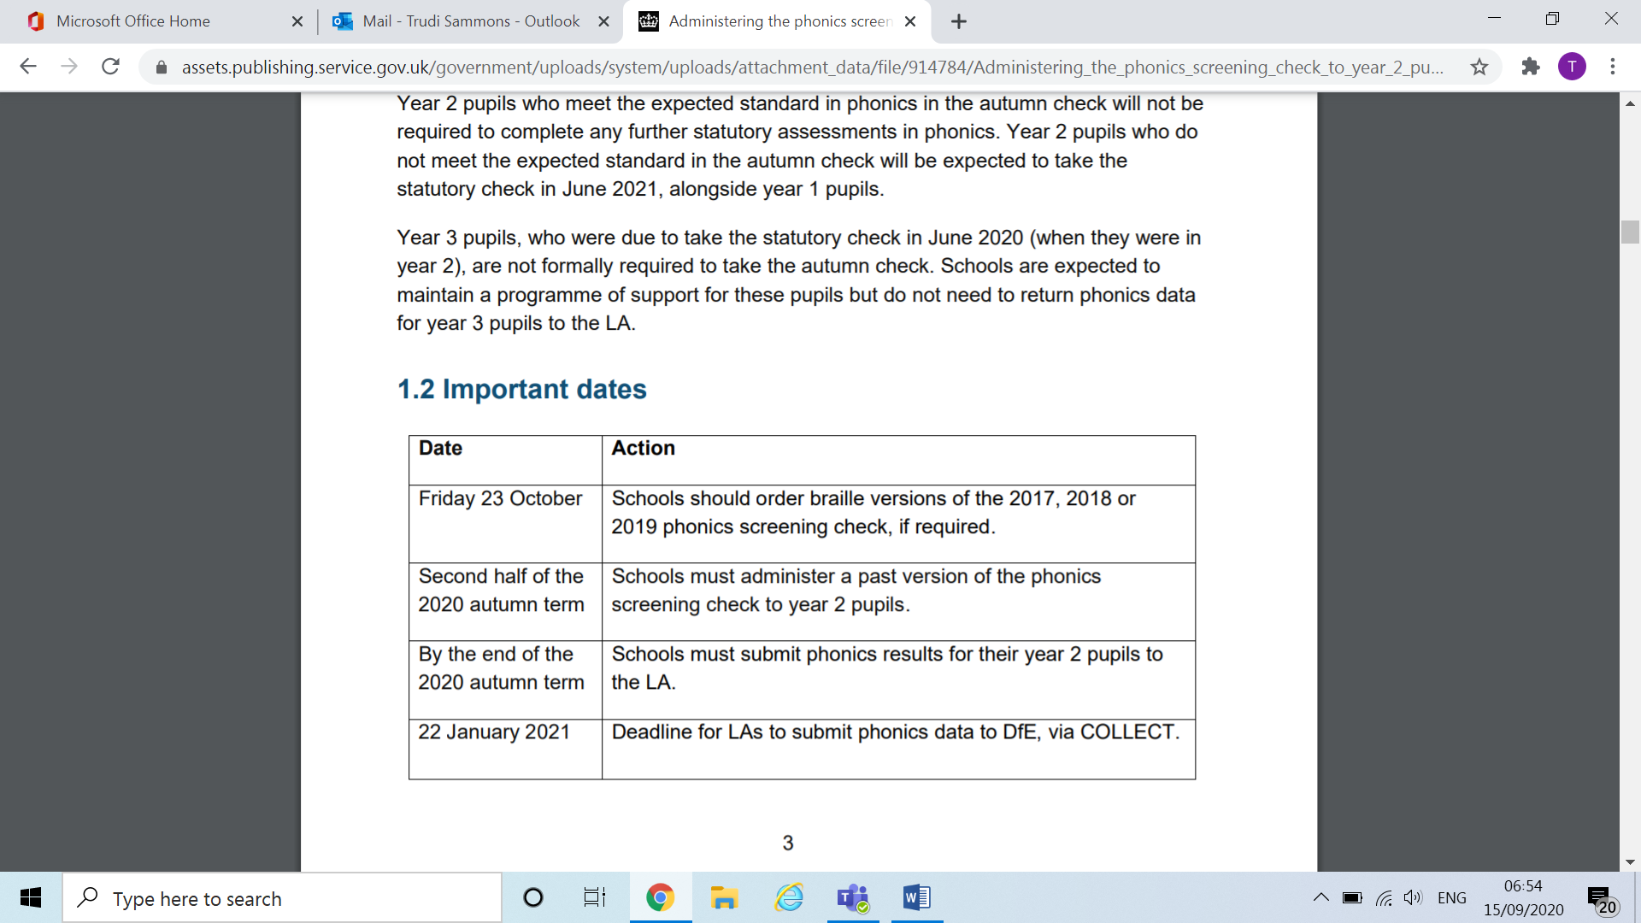

### **The Engagement Model – SEND -Update for the 2020/21 academic year**

Due to the coronavirus (COVID-19) pandemic, the 2020/21 academic year will be a transitionary year for the assessment of pupils working below the standard of national curriculum assessments and not engaged in subject-specific study. The transitionary year to allows schools time to prepare for, and start embedding, the engagement model.

This means, in the 2020/21 academic year, schools will have a choice to use either:

* the engagement model for the assessment of pupils working below the level of the national curriculum and who are not engaged in subject-specific study
* [P scales](https://www.gov.uk/government/publications/p-scales-attainment-targets-for-pupils-with-sen) 1-4 for a further year.

There will be a flexible approach for the submission of teacher assessment outcomes at the end of key stages 1 and 2. Schools that have used the engagement model will be able to report against it, and schools that need more time to implement this change will continue to have the option to assess against P scales 1 to 4, for one final year.

**How will pupils be assessed?**

The engagement model has 5 areas of engagement:

* exploration
* realisation
* anticipation
* persistence
* initiation

The areas allow teachers to assess pupils’ engagement in developing new skills, knowledge and concepts in the school’s curriculum by demonstrating how pupils are achieving specific outcomes. They represent what is necessary for pupils to fully engage in their learning and reach their full potential.

**How should schools use the engagement model?**

The engagement model does not replace existing planning and assessment systems and schools will have autonomy over how it will be implemented.

The model encourages schools to measure each pupils’ progress independently, according to their individual profile of needs. It can also be used as a baseline tool to track and support ongoing progress.

**Catch-Up funding**

The school will be gaining a total of £39,200 throughout 20-21. The funding will be split over two payments, the first payment of £22,868 will be paid in this financial year, with a further £16,332 in the next financial year April – July. The funding is to be used directly to support the disruption caused by the lockdown and consequently the interruption to teaching and learning.

The school is currently base-lining every class across the school to ascertain cohort gaps and any particular individuals where specific support is required. The Education Endowment Fund have produced a useful toolkit for schools to use when considering how best to use this funding and SLT are currently developing this plan.

While some development around identification of need is required Year 4 are already having some specific well-being support delivered at a cost of £4568. Mrs Duncan’s increased working pattern is also being funded via this support (£1000 per month extra) to ensure quality first teaching across the school is present in every class. It is envisaged that these additional hours will be in place until at least May 2021.

**NQTS**

All three of our new NQT teachers have expressed how much they enjoyed their first few days and all have been working incredibly hard with Anne and their respective colleagues. To ensure that they are all successful moving forward it is imperative that as a school we remember that they missed a significant part of their training and therefore there will be costs incurred to ensure they have adequate release for additional training.

Face-to-face meetings are still not happening within education and therefore training will be either virtual or internal. Anne will be developing individualised programs for each teacher to ensure that they receive a personalised and useful training schedule.

All NQTs have also been observed within the first two weeks with SLT being pleased by all three observations. Clearly there is development work, but already effective relationships have been developed between the teacher and the children which is vital.

**Class sizes in Reception and Year 1**

Currently we are sitting on 60 in both of these year groups. Due to infant class size law this places the school in an incredibly vulnerable position with regard to staffing costs. Under our current system year groups are having to remain isolated from each other and therefore making a mixed R/1 class would not currently be possible.

We are hopeful that before December we will see the odd RMA posting in Year 1 and Reception, but clearly this is no guarantee. We also are awaiting the return of Mrs Harding from maternity in December too and this would provide a teacher for 2 days. This along with our regular supply teacher, Mrs Susan Tait, could provide the remaining three days should be become necessary. We will keep a watchful eye on this situation and continue to consider the best way of accommodating an extra class should this situation arise.