Staffing and Full Governoring Body Report February 8th 2021

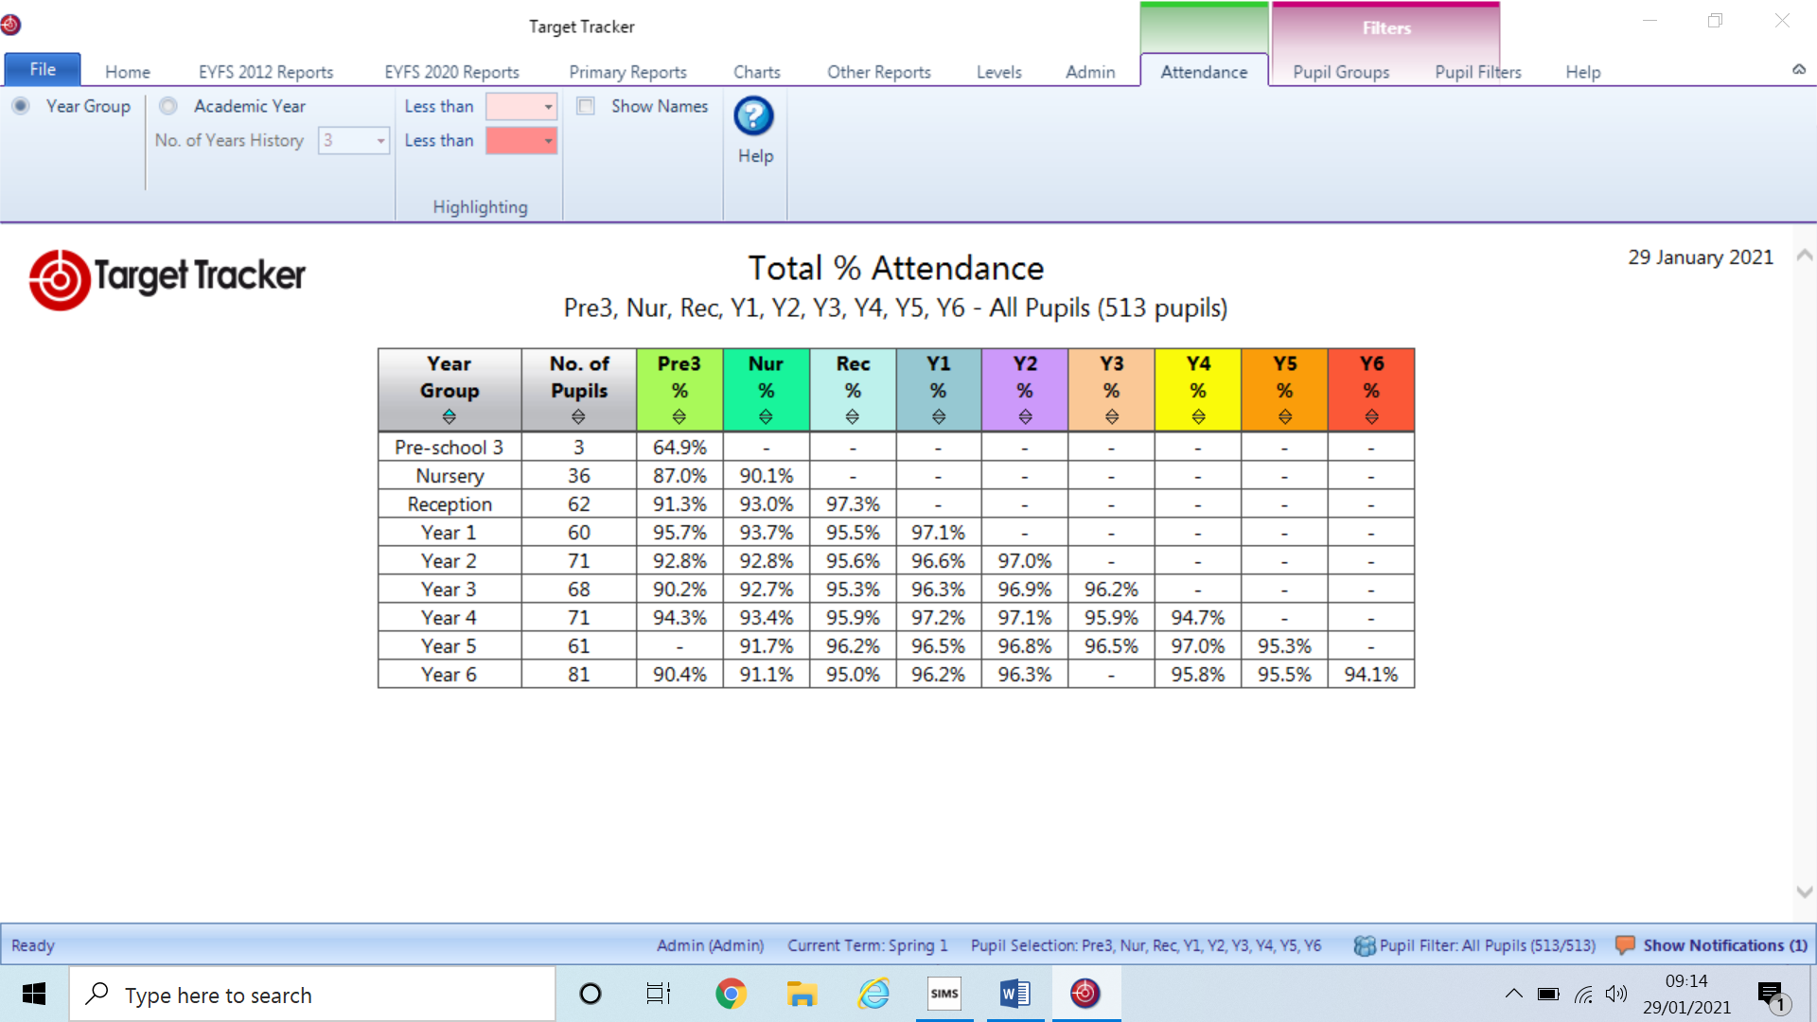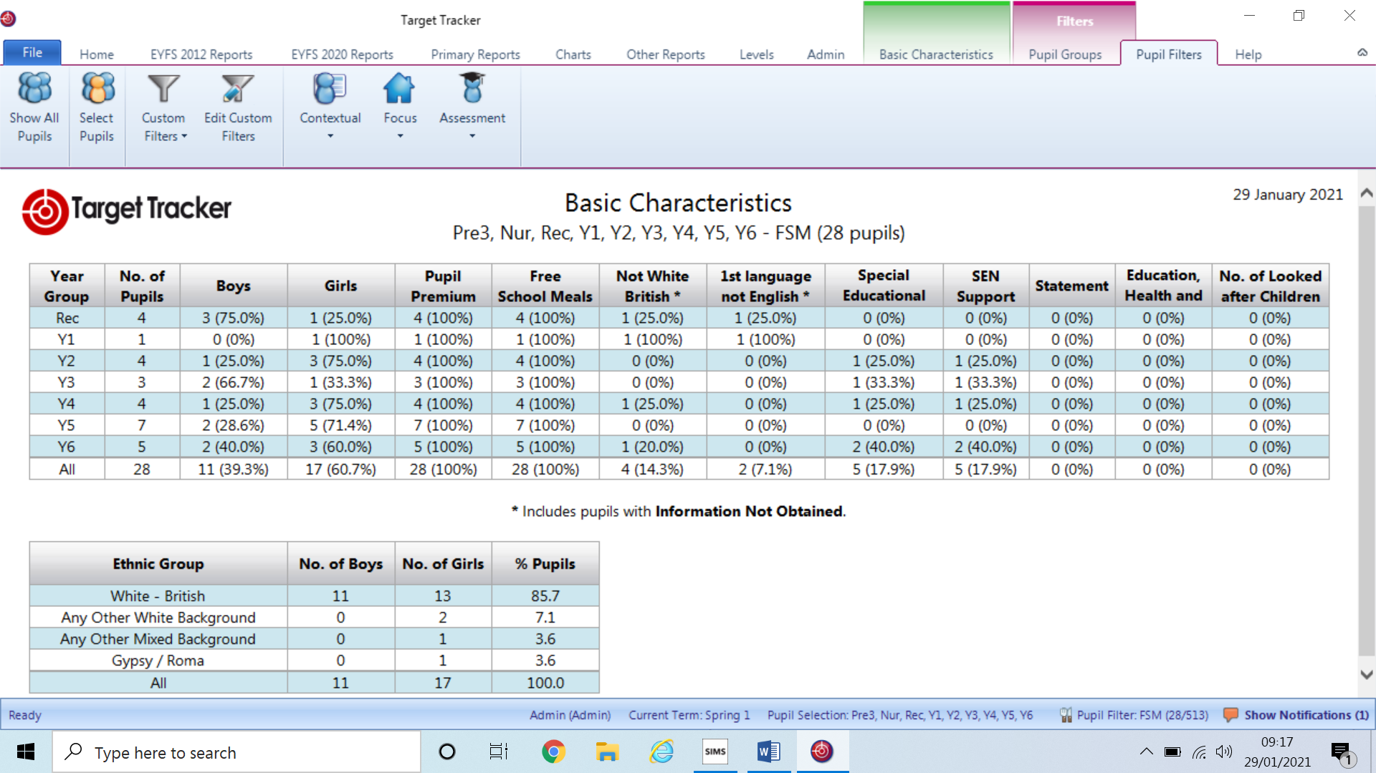

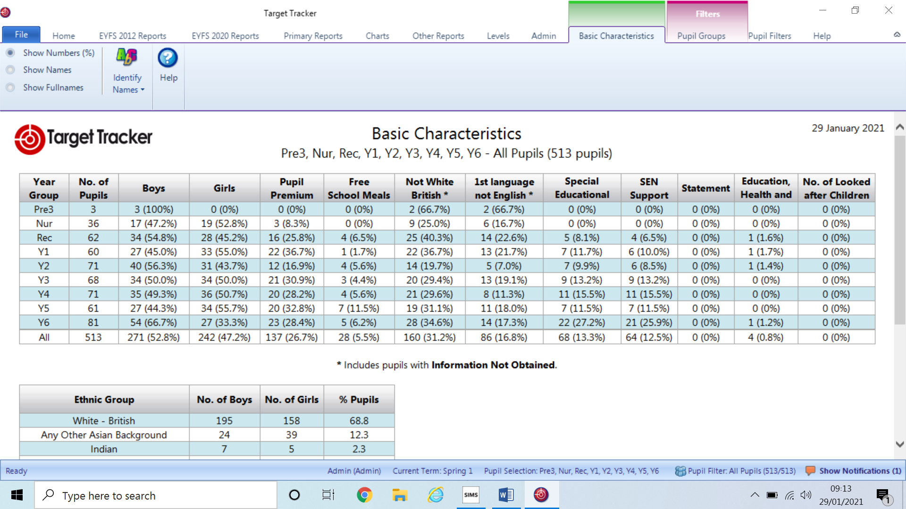

School closure on the first Monday came as a result of the increasing union pressure, staff who were rightly concerned about their safety supported the union’s stance, leading to the school closure. This was swiftly overridden by Boris’ new national lockdown that same evening. However, since January 4th there has been no additional guidance given to schools regarding numbers in pods etc. as there had been previously during the last lockdown. We have since updated the risk assessment 4 times since January 4th to accommodate ongoing changes such as testing and self-isolation period.

The pressure from the DFE around this lockdown has really been felt by us all. Statements encouraging parents to report their school if they were unsatisfied with their remote learning offer or key workers groups has been incredibly undermining especially in the face of no guidance and a key worker list which entitles almost everyone! The school in the last lockdown catered on average for 20 children each day. This time around we have 130 on site each day with stringent social distancing among all children and staff from different pods. The school has been fortunate as we have had not had such complaints raised regarding remote learning and we have mostly been able to accommodate pupils as required. However, these demands really have added to unnecessary stress to us all at a time when moral and energy is already very low. Administration staff are continuing to battle through ever increasing forms with little joined up thinking from DFE/LA.

As you can quite clearly establish the new year did not start well for anyone, although after a couple of incredibly turbulent weeks we now seem to have reached a place, where although far from ideal, we are at least in a position from which we are able to educate and support the vast majority our pupils.

This has been enabled not by chance or good luck, but from the thorough and reflective practice we have embarked upon since September in preparation for such an eventuality. Leaders had responded quickly and effectively to guidance from the DFE around the requirement for a robust remote learning policy. You will of course recall that as school we presented this to the Curriculum Governors on October 22nd and following discussions and approval it was accepted and immediately uploaded onto to our school website within the given timeframe.

Throughout the Autumn term we had to draw on our policy as year groups and individuals were struck down with COVID or were required to self-isolate. This adversity was not wasted, and following each bubble lockdown policy into practice was evaluated and refined. It was evident that staff confidence required additional support and this was the driving focus in the latter part of the Autumn term in terms of professional development. Staff received training and were required to upload their remote learning under each tier to ensure that the school was consistent and that staff were all equally skilled in delivering our approach as articulated within our policy. From feedback gained from the teachers during this lockdown this approach has been identified as having been incredibly beneficial in supporting them step confidently into unchartered territory.

The success of our delivering remote learning has also been acknowledged and appreciated by our parents and below are a just a few of the very many comments that we have received. The first is one which went directly to Ofsted!

|  |
| --- |
| **To:** Compliments <enquiries@ofsted.gov.uk> |
|  |
| **Subject:** College Town primary school |

***I wanted to let you know how amazing College Town primary school in Sandhurst, Berkshire have been.  
The head (Miss Sammons) and all the teachers have been so supportive and when my daughter was struggling with her online learning (maths) her teacher set up a one up one meeting to talk her through it.  
We have two online meetings a day and teachers reply to their emails within minutes.***

***A huge thank you, Mrs Sammons, for your letter to families today. It actually brought tears to my eyes. Everyone has their own battles to fight, and I doubt anyone is finding this experience a walk in the park. A little bit of kindness goes such a long way, and I think more people need to remember this right now. I am sure there will always be people with problems to report, but I sincerely hope that the parent population is wholeheartedly grateful for what you are doing. We certainly are. And I am extremely relieved to know your staff are now better protected. Some comments I have read seem to forget that a school is not just a facility - that it is made of people, with families and vulnerabilities of their own. Hats off to you for your stance on these things, you stood out from the crowd for all the right reasons***

***Dear Mrs Sammons***

***Ifelt I had to send a quick email to you, to express our thanks to yourself and all your staff for the last 9+months, and indeed the next few weeks / months as we go into another Lock Down !***

***It is a worrying time for all, and as a parent it has been a comfort to be informed and kept in touch with the school plans going forward, albeit you yourself only finding out at the last minute.***

***For Ben being in Year 6, it is very strange times and it was good to hear from Mr. Tatum’s and his reception meeting on teams this morning, being very supportive and encouraging.***

***I appreciate there must be a lot of work going on behind the scenes, and with plans changing at the last minute it must be a struggle to keep up. However, I am sure you are doing your very best in these fast moving / changing times.***

***Once again,  many thanks to you and your staff, who are very much appreciated.***

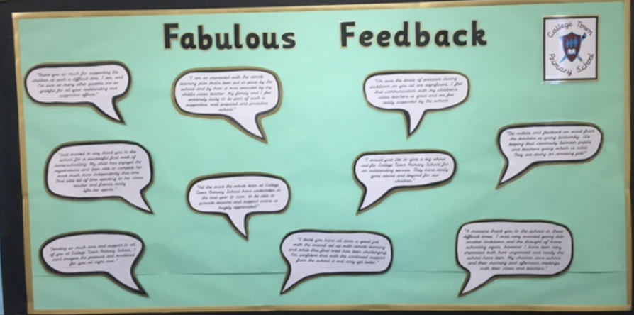

Staff really have been uplifted by these comments and I am sure it will make you all confident that we are supporting the children and their families during these testing times.

With regard to the curriculum provision, both virtual and face-to-face since January an extensive provision map along with the quality and monitoring of provision was presented to the Curriculum GB on January28th and documents are available for your scrutiny on the governor zone.

Obviously, the biggest question on my mind currently is how as a school we will be identifying, supporting and ensuring that educational disadvantage is rapidly and effectively addressed. It is clear that many children will not have covered the scope of curriculum which they would have normally. Therefore after Easter, assuming we are all back in school, assessments in the core areas of reading, spelling and mathematics will be commence following the May half term from Year 2 upward. In Year R and Year 1 assessments will of course be taking place although not in the same formal way. All national assessments have been cancelled, but it is our intention to deliver SATS to Y2 & Y6 with Year 1 also undertaking their phonic test. This will be a useful exercise in determining groupings for 2021-2022.

As there is likely to be a wider than normal ‘gap’ between learners across the school it is highly likely that as a school we look to structure core classes according to amount of prior learning gained, lost or still required. This will support the delivery of an effective education for all children and allow resources to be targeted to ensure those with most need receive the most support.

Equally, our more able children are continuing to demonstrate that despite the limitations of remote learning their underlying ability and level of understanding enables them to still work confidently and independently, building on their firm foundations. To ensure that these children remain challenged and engaged their curriculum must have enough depth to continue supporting their vigour for learning.

**February half term**

* All schools will close as usual over the half term. We are also not expected to stay open for vulnerable pupils and children of critical workers. This has been well received by all staff who despite having only recently returned after the new year are already exhausted.
* The school will engage in contact tracing if pupils or staff test positive after developing symptoms **less than 48 hours** after you break up for half term
* I will again be responsible as a point of contact over the half term period, to be notified and respond to, positive cases. The DfE has said that staff undertaking this role both at Christmas and now over the half term are entitled to receive time off during term time to compensate for this.
* Testing will be paused from Wednesday 10th and will resume on Sunday 14th ready for our return on Feb 15th
* The LA will continue to use funds from the [Covid Winter Grant Scheme](https://www.gov.uk/government/publications/covid-19-free-school-meals-guidance/covid-19-free-school-meals-guidance-for-schools" \l "support-for-families" \o "Covid Winter Grant Scheme" \t "_blank) to provide families with meal support and as a school we shall be adding a £5 top-up to the £15 voucher.

Returning to school

* Schools and colleges will get at least two weeks’ notice before pupils return to the classroom in order to give pupils, parents and teachers time to prepare, the Education Secretary has said.
* Speaking to the media this morning, Gavin Williamson made clear that in order to give schools, pupils and parents time to get ready for the return to school, they would all be given two weeks’ notice ahead of them opening to more pupils. Schools and colleges have been closed to all but children of critical workers and vulnerable pupils since early this month.

Speaking to Sky News Gavin Williamson stated: What we’ll be wanting to do is give schools as much notice as possible so teachers can get ready, children can get ready and parents need to know in order to manage their lives. So we want to give all schools a clear two weeks’ notice period. One of the key criteria is whether the pressure on the NHS has started to lift, that’s why we had to take the national decision in the national interest, one that I never wanted to take to see schools closed again.

**Ofsted – see attached questions**

* Ofsted will be enforcing the requirement for schools to provide high-quality remote learning. It'll inspect schools of any grade if it has serious concerns about the quality of remote provision
* Non-graded monitoring inspections [started](https://www.gov.uk/government/news/ofsted-inspections-to-be-done-remotely-until-half-term) from 25 January for 'inadequate' and some ‘requires improvement’ schools. They'll be carried out remotely until after the February half term, and will [focus on](https://www.gov.uk/guidance/january-2021-maintained-schools-and-academies#monitoring-inspections) how well your pupils are being educated (they'll no longer focus on school improvement as previously planned).
* Early years assurance inspections [are paused](https://schoolleaders.thekeysupport.com/school-evaluation-and-improvement/inspection/after-inspection/coronavirus-ofsted-inspections-spring/?marker=content-body) until after the February half term, but Ofsted will still continue with regulatory work
* Ofsted has published guidance on [what's working well in remote education](https://www.gov.uk/government/publications/whats-working-well-in-remote-education/whats-working-well-in-remote-education), research on [remote education](https://www.gov.uk/government/publications/remote-education-research/remote-education-research) and an [impact assessment](https://www.gov.uk/government/publications/ofsteds-phased-return-to-inspection/ofsteds-phased-return-to-inspection) on the Public Sector Equality Duty (PSED) in relation to its phased return to inspection

**All monitoring inspections will focus on:**

* discussing with school leaders and those responsible for governance the actions being taken to provide education in the current circumstances
* how effectively leaders are adapting the existing curriculum to meet current challenges; inspectors will discuss with leaders what they had achieved by the start of the pandemic, where they are currently with curriculum planning and how they are getting back on track; this includes discussing whether any actions have been reasonably delayed or altered by COVID-19 restrictions
* how effectively leaders are providing education remotely
* how effectively leaders are providing education for vulnerable pupils and for other pupils attending school on site
* leaders’ plans to support pupils with special educational needs and/or disabilities, whether they are in school or being educated at home
* examining whether those responsible for governance are making an effective contribution to leaders’ actions in providing the best possible education for all pupils in the current circumstances; this includes examining the decisions leaders have taken about the curriculum
* considering the impact of the support and challenge provided to the school around their curriculum and current education provision, including from any external partners

**Activities**

During the notification call with the headteacher, the lead inspector will discuss the type of inspection activities needed to gather evidence for the monitoring inspection.

During the monitoring inspection, inspectors will:

* meet (remotely or in person, as appropriate) the headteacher and other senior leaders (including, where appropriate, the CEO of the MAT/their delegate or equivalent) to establish a purposeful and productive working relationship and discuss the action being taken to provide education in the current circumstances
* hold meetings (remotely or in person, as appropriate) with representatives of the local authority/proprietor/trust, the chair and members of the governing board, or, where appropriate, the chair of the board of trustees to establish what action is being taken to provide education in the current circumstances
* gather any other evidence needed. It will usually be necessary for inspectors to ‘visit’ (by, for example, joining an online lesson) and/or review some remote learning in order to understand how education is being provided by the school. Inspectors may also, where they consider it necessary for the inspection, have discussions with staff and pupils (remotely or in person) about their work and their experiences. They may also review minutes of governing body meetings
* consider the views expressed through the Ofsted staff questionnaire
* consider the views expressed on Ofsted Parent View
* feed back (remotely or in person) to the headteacher and discuss the next steps

Cameras will normally be used in remote meetings. When observing remote education, inspectors will ask the school whether cameras should be used. Inspectors will not record calls and will ask that the school, and individual staff and pupils, do not do so either.

Where inspection takes place on site, we have taken advice from Public Health England about how to carry out our inspection activities safely. It will still be appropriate to carry out most inspection activity because inspectors will continue to take appropriate precautions. The precautions that are needed will vary from school to school and activity to activity, but inspectors will always ensure that they are acting safely and within the clear guidance given. As is usual with monitoring inspections, we will not be carrying out our deep-dive methodology.

Inspectors will ensure that all activities are carried out within the COVID-19 guidelines. The lead inspector’s initial call with the school will include a discussion of the relevant COVID-19 restrictions, how inspectors can work effectively within the protective measures leaders have in place and what impact the restrictions have had on the school and its work.

**Considering leaders’ actions**

Monitoring inspections are not full inspections. Inspectors will not apply the whole education inspection framework or come to any graded judgements.

Inspectors will look at whether leaders’ actions are effective in providing education during the current circumstances. To do this, they will need to understand the school’s existing curriculum and how this is being reviewed or amended to provide education both in school and remotely.

Inspectors should understand the barriers leaders face in being able to provide education in the current circumstances. Inspectors will not evaluate leaders’ actions during the spring and summer terms 2020. They will be interested, however, in how the pandemic has affected the school, especially in terms of leaders’ curriculum thinking.

By getting a clear enough view of the school’s existing curriculum, inspectors can support the school to reflect on what they are teaching pupils currently, including through remote education. Pointing out weak intent or ill-focused actions will help leaders to provide the best possible learning at the current time, and how they can, in time, return successfully to the full curriculum. Inspectors will be sensitive to the school’s context, especially the challenges presented by managing COVID-19. They will support schools to prioritise the right actions.

In looking at the curriculum for early years provision, inspectors should consider the limitations the pandemic may have caused and whether the school has relied on any disapplication of requirements, in line with [the DfE’s disapplication guidance](https://www.gov.uk/government/publications/early-years-foundation-stage-framework--2/early-years-foundation-stage-coronavirus-disapplications#disapplications-for-the-early-years-foundation-stage-section-1).

**Arriving at final judgements**

In arriving at a final judgement, inspectors will consider the extent to which leaders’ actions are helping or hindering the provision of education to all pupils at the current time.

The lead inspector will make a single overarching judgement. This will be either of the following:

* Leaders and those responsible for governance are taking effective action to provide education in the current circumstances.
* Leaders and those responsible for governance are not taking effective action to provide education in the current circumstances.

This is not a graded judgement and will not change a school’s current grade.

Inspectors will not judge whether local authority action plans or school improvement plans are fit for purpose or, in the case of schools that require special measures, whether newly qualified teachers (NQTs) can be appointed. Schools must seek approval in writing from the relevant Ofsted regional director if they wish to appoint NQTs during this period, stating the reasons for the request.

**Safeguarding**

Where inspectors have concerns about safeguarding arrangements, it is highly likely that the inspection will move on site or that the inspection may be declared incomplete and completed at a later date when on-site inspection is possible. In these cases, inspectors will make a judgement about the effectiveness of safeguarding in the school when on site. If part or all of the monitoring inspection is carried out on site for other reasons, inspectors may still make a judgement about the effectiveness of safeguarding in the school, at the regional director’s discretion.

**Feedback**

During the inspection, the lead inspector will provide feedback to leaders about what they are finding. At the end of the inspection, they will give more detailed feedback. The policies on final feedback are set out in the [section 8 inspection handbook](https://www.gov.uk/government/publications/section-8-school-inspection-handbook-eif). Feedback will always be completed remotely for remote inspections. For on-site inspections, attendance at the final feedback meeting may need to be limited or carried out remotely due to COVID-19 restrictions.

**After the inspection**

**Reporting on monitoring inspections**

Reporting will largely follow the policies set out in the [section 8 inspection handbook](https://www.gov.uk/government/publications/section-8-school-inspection-handbook-eif), except as set out below.

**Arrangements for publishing the report**

Within 18 working days of the end of the inspection, a letter will be written to the school, setting out in a draft report what inspectors found. This will have been quality assured. They are able to share the draft report or findings with other public bodies.

The school will have 5 working days to comment on the draft report, process and findings. Ofsted will consider all comments and they will respond to the comments when they share the final report with the school within a maximum of 30 working days after the visit, although it will likely be much sooner.

If the school wishes to submit a formal complaint, it will have until the end of the fifth working day after receiving the final report to do so.

**Post-inspection surveys**

Following the inspection, Ofsted will ask schools for feedback about the process through a survey. They will provide details about how schools can share their views when we send the final report.

**Quality assurance**

We will monitor the quality of the inspection through a range of formal processes. We may visit some schools or remotely monitor evidence to quality assure the inspection. We will quality assure evidence bases and report.

**The evidence base**

The evidence base for the inspection will be retained in line with Ofsted’s retention and disposal policy. This is normally for 6 years from when the report is published. We may decide that retaining it for longer is warranted for research purposes.

**Privacy notice**

During an inspection, inspectors may collect information about staff and pupils by talking to them, visiting lessons (whether in person or remotely) and by looking at documents and other recorded information. If inspectors consider it necessary to speak to pupils on monitoring inspections that are carried out remotely, we recommend that schools set up these meetings (in the same way we recommend that schools set up the other meetings in the inspection) and that schools obtain parental agreement.

**Staffing**

Due to the ongoing pressure within school currently a survey developed at the request of, but outside of the leadership team was sent to teachers. The results were incredibly useful in terms of validating and identifying barriers and strengths within the team. As the survey was anonymous we are not able to speak 1-1 with staff, but are able to underpin any future developments with the results in mind. Please follow the link to see the full survey and responses. The response rate was also very high ensuring results are representative of the staff’s feelings. <https://www.surveymonkey.com/results/SM-BSVHZXN57/>

Nursery staffing after March 8th – possibly/after Easter (44)

The Nursery has been fully open under the new January lockdown which has added to the pressure for the staff working in the unit. One staff member is currently not in school due to anxiety around COVID and if our numbers increase as is expected we shall need to relocate teaching support staff from KS1/KS2 to ensure that the ratios are sufficient.

This will be achievable as Year 5 are extremely low on numbers with only 20 or below across all three classes/. Therefore the support will be taken from Year 5 to cover in Nursery which ensures financially we are being prudent.

The teaching support staff have provided an excellent level of support within each of the in school bubbles. There has been provision made across the school for all teaching assistants to have a minimum of 3 hours per week WLB. This will remain in place up until the end of February. This has been well received by all and ensures that they realise how much their input is valued by us all.

Proposed INSET Days 2021 – 2022 for ratification

Sept 1st as set by BFC June 6th 2022 20th, 21st & 22nd July – Off set throughout the year with one day being a WLB for staff with no requirement to be on site. The remaining off set hours of twelve will be used to assist pupils ‘catch up’ after the considerable disruption to their learning.