College Town Infant & Nursery School

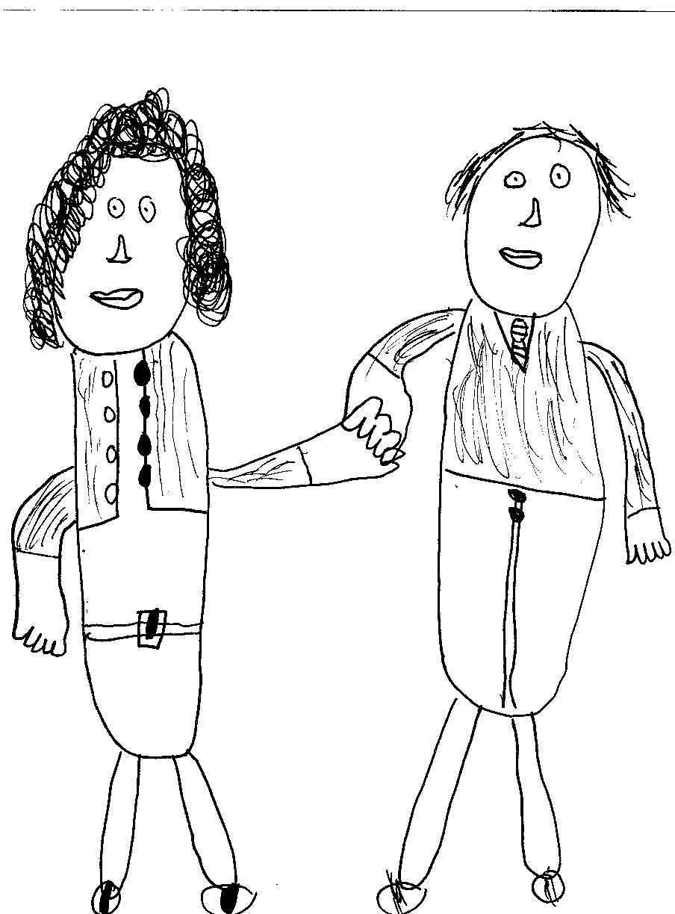

Quality Education in a Caring, Happy Environment

AGENDA FOR THE FULL GOVERNING BODY MEETING

19th March 2018 at 5pm

1 | APOLOGIES | RC
3 | APPROVAL OF MINUTES OF LAST MEETING | ALL
4 | MATTERS ARISING | RC
5 | DECLARATIONS OF INTEREST | ALL
6 | HEADTEACHER’S REPORT  - STAFFING & STANDARDS | TS
7 | CURRICULUM REPORT | EB
8 | CLERKS BRIEFING | JF
9 | CHAIRS BRIEFING | RC
10 | GOVERNOR MONITORING & TRAINING | RC
11 | SCHOOL NAME APPROVAL | ALL
12 | INVESTMENT OF GOVERNMENT – RECONSTRUCTION ACTION | ALL
13 | PART 2 MINUTES  - PROPOSED STAFFING STRUCTURE  - APPT OF HEADTEACHER | TS
14 | ANY OTHER BUSINESS | RC
15 | DATE OF NEXT MEETING –

