**Governor Report March 2018**

EYFS Data

You will remember in my previous report, that the Reception data was looking very low and required a lot of input from me. We asked the Reception team to submit their data again before February half term and this is as follows:

|  |  |  |  |  |  |
| --- | --- | --- | --- | --- | --- |
| **Reception** | **Making Relationships** | **Self confidence** | **Managing Feelings** | **Moving and Handling** | **Health and self care** |
| Pupils average and above 1,2,3 | 84.3% | 77.1% | 89.6% | 98.6% | 94.3% |
| **(1) Well above/Greatly exceed** | 0% | 0% | 0% | 0% | 0% |
| **(2) Above/Exceed** | 8.6% | 11.4% | 15.7% | 14.3% | 10% |
| (3) ARE/ Average/ On track | 75.7% | 65.7% | 72.9% | 84.3% | 84.3% |
| **(4) Below/ Not on track** | 12.9% | 21.4% | 11.4% | 1.4% | 4.3% |
| **(5) Well below/Greatly miss target** | 2.9% | 1.4% | 0% | 0% | 1.4% |
| Pupils below 4+5 | 15.7% | 22.9% | 11.4% | 1.4% | 5.7% |
|  | | | | | |
|  | **Listening and Attention** | **Understanding** | **Speaking** | **Reading** | **Writing** |
| Pupils average and above 1,2,3 | 72.9% | 74.3% | 70% | 70% | 62.9% |
| **(1) Well above/Greatly exceed** | 0% | 0% | 0% | 0% | 0% |
| **(2) Above/Exceed** | 21.4% | 22.9% | 25.7% | 30% | 25.7% |
| (3) ARE/ Average/ On track | 51.4% | 51.4% | 44.3% | 40% | 37.1% |
| **(4) Below/ Not on track** | 24.3% | 24.3% | 28.6% | 28.6% | 37.1% |
| **(5) Well below/Greatly miss target** | 2.9% | 1.4% | 1.4% | 1.4% | 0% |
| Pupils below 4+5 | 27.1% | 25.7% | 30% | 30% | 37.1% |
|  | | | | | |
|  | **Numbers** | **Shape, Space and Measure** | **People and Communities** | **The World** | **Technology** |
| Pupils average and above 1,2,3 | 80% | 78.6% | 75.7% | 72.5% | 88.6% |
| **(1) Well above/Greatly exceed** | 0% | 0% | 0% | 0% | 0% |
| **(2) Above/Exceed** | 28.6% | 14.3% | 38.6% | 39.1% | 28.6% |
| (3) ARE/ Average/ On track | 51.4% | 64.3% | 37.1% | 33.3% | 60% |
| **(4) Below/ Not on track** | 18.6% | 20% | 22.9% | 26.1% | 11.4% |
| **(5) Well below/Greatly miss target** | 1.4% | 1.4% | 1.4% | 1.4% | 0% |
| Pupils below 4+5 | 20% | 21.4% | 24.3% | 27.5% | 11.4% |
|  | | | | | |
|  | **Media and Materials** | **Being Imaginative** |  |  |  |
| Pupils average and above 1,2,3 | 85.7% | 94.3% |  |  |  |
| **(1) Well above/Greatly exceed** | 0% | 0% |  |  |  |
| **(2) Above/Exceed** | 4.3% | 17.1% |  |  |  |
| (3) ARE/ Average/ On track | 81.4% | 77.1% |  |  |  |
| **(4) Below/ Not on track** | 14.3% | 2.9% |  |  |  |
| **(5) Well below/Greatly miss target** | 0% | 2.9% |  |  |  |
| Pupils below 4+5 | 14.3% | 5.7% |  |  |  |
|  |  |  |  |  |  |

This set of data is what you would typically expect at this time of year. In some areas of learning there are quite a few children working below the expectation so in our EYFS meetings I will focus on these children and the provision that they are receiving. I will monitor planning to ensure that they are being planned for and assessed correctly and accurately. Writing is our lowest area of learning for children on track to meet the expectation. Last year we achieved 77.6% and the national was 72%, writing is statistically the lowest area of learning, however I will monitor this area of learning carefully to ensure that we exceed last year's percentage. We recently met in EYFS to moderate writing and discussed for quite a long period of time the expectation of the early learning goal and how we could meet this. As a result, the teachers are going to change and improve some of their practice in order to provide the children with more opportunities to practise writing. Reading has improved as a result of our change in timetable and expectations of the teachers. There are still improvements being made and I will continue to work with the staff which should see an improvement in the 70% on target.

Good Level of Development

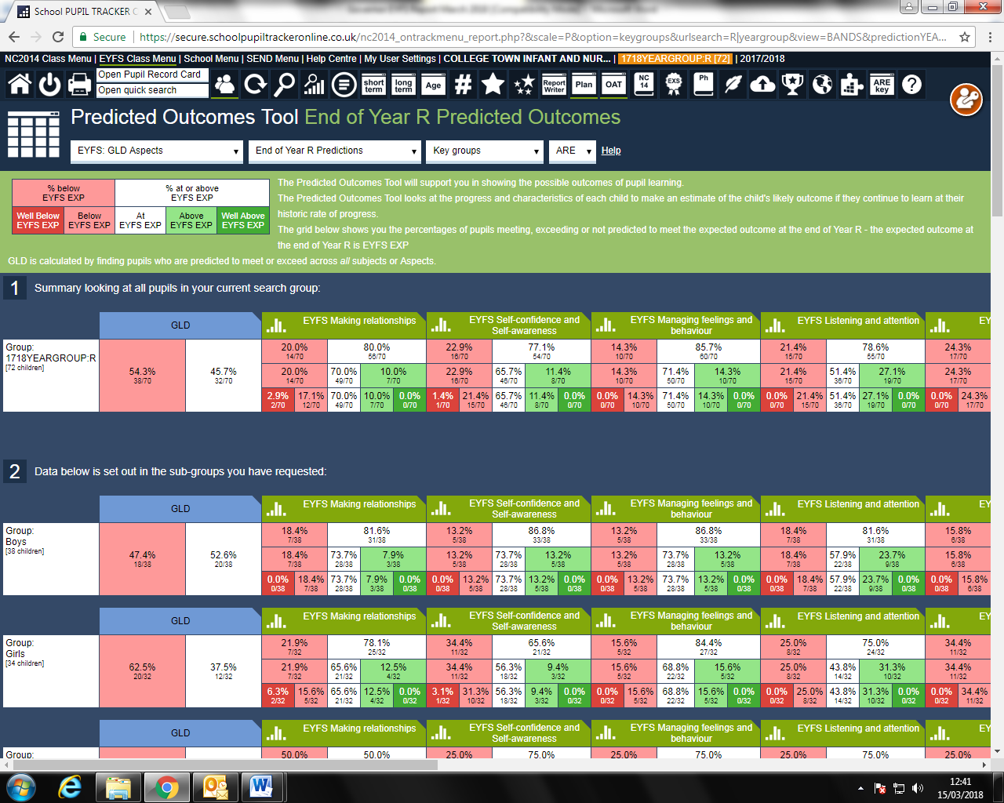

This is currently what our good level of development looks like in Reception. This is submitted in June, so the final percentage will be higher than this as the children continue to work towards the Early Learning Goals. Last year we achieved 72.4% with a good level of development. We are expecting to exceed 72% this year. I have recently provided the teachers with an overview of the slow movers and children at risk for not reaching good level of development; we are going to focus on these children in our INSET sessions to ensure they are getting the provision that they need.

KS1 Data

|  |  |  |  |
| --- | --- | --- | --- |
| **Year 1** | **Reading** | **Writing** | **Maths** |
| Pupils average and above 1,2,3 | 53.2% | 43.6% | 41.8% |
| **(1) Well above/Greatly exceed** | 0% | 0% | 0% |
| **(2) Above/Exceed** | 17.7% | 5.1% | 3.8% |
| (3) ARE/ Average/ On track | 35.4% | 38.5% | 38% |
| **(4) Below/ Not on track** | 46.8% | 56.4% | 58.2% |
| **(5) Well below/Greatly miss target** | 0% | 0% | 0% |
| Pupils below 4+5 | 46.8% | 56.4% | 58.2% |
|  | | | |
| **Year 2** | **Reading** | **Writing** | **Maths** |
| Pupils average and above 1,2,3 | 88% | 74.7% | 86.7% |
| **(1) Well above/Greatly exceed** | 10.7% | 4% | 0% |
| **(2) Above/Exceed** | 33.3% | 29.3% | 41.3% |
| (3) ARE/ Average/ On track | 44% | 41.3% | 45.3% |
| **(4) Below/ Not on track** | 10.7% | 24% | 12% |
| **(5) Well below/Greatly miss target** | 1.3% | 1.3% | 1.3% |
| Pupils below 4+5 | 12% | 25.3% | 13.3% |

As you can see our Year 1 data is looking particularly low. This is mainly due to the provision in Hedgehog Class, the children in hedgehog class have made 1.2 points progress whilst the rest of the school have made 1.5 progress or better. It is expected that all children will make 3 points progress at the end of the academic year. Trudi and I have recently worked with the STEP to analyse our data and we have identified some target children in Year 2. We will be monitoring these children carefully to ensure that they reach the end of key stage expectation.

EYFS Moderation

We have been notified that we will be moderated in the EYFS this year. The EYFS team and I are working well together to moderate our judgements and notice any gaps there may be in our assessments. I have been asked to join the EYFS moderation team this year, and in the summer term will shadow a moderator, before completing moderations in other settings next year.

30 Hours in Nursery

The 30 hours in Nursery has continued to be popular. In January, 11 children joined us in Nursery taking us to 47 children in total, one child will be joining us at Easter taking us to 48. Quite a few of the January intake have been asking for additional hours and Emma Marshall one of our lunchtime controllers has agreed to work in Nursery on our busy afternoons. This has meant that the families who have asked for additional hours have had these confirmed.

Students

Gill Salter has returned to us after a successful year 6 placement. She is now working with Jade Faircloth in Reception and after Easter will be working with Sam Leighton in Rabbit Class. We have had two final year students in Year 2 from Reading University and they have had a very successful placement. They have reported to Trudi and I that they have felt extremely welcome and supported at our school.

Hedgehog Class

I have been working closely with Ashley Nuttall and Susan Tait who have taken on the responsibility of Hedgehog Class. We have scheduled additional adults in the class to hear the children read and to support the children who require additional support. Hedgehog class will continue to be a focus with plans in place to support these children.