**Governing body Report July 2nd 2018**

**Headteacher’s report**

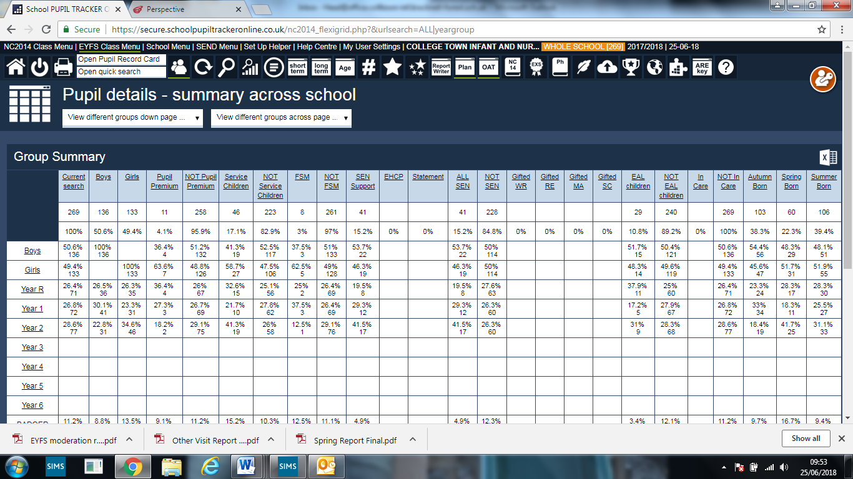

**Safeguarding concerns:**

There have been no racist incidents reported

July 2nd saw a 5 day fixed term exclsion

There have been no bullying cases reported

There is currently one child in the school o Child Protection Plan and this has now been stepped down to Child in Need from June 22nd 2018

**Assessment**

EYFS had a successful moderation visit demonstrating the internal rigour of our own assessment procedures all assessments were agreed by the team. The report is attached.

The teachers responsible for delivering the phonic screening check all watched the video and read the associated guidance. The LA did not include our school in their monitoring visits, although the school was rigorous in ensuring all necessary arrangements were in place.

The children in Year 1 have all taken their phonic result and the threshold mark of 32 has remained unchanged. This has given the school a pass rate of 77.5%. The Year 2 retakes was also delivered and the result was 77.8%. The 2 pupils who did not pass are both SEND and progress has been made by both pupils.

Compared to last year’s results this represents a decrease of 7.5% in Year 1 and 10% in Year 2. The school was very aware that the children coming through from Reception last year included a larger percentage of children with additional needs and a lower literacy readiness from the previous cohort. In Year 2 we received two new children (25%) as each child % value = 12.5% who had no previous phonics teaching as were not in the English education system.

To ensure that Reception are Year 1 ready we are currently daily 20 minute phonic sessions preschool for 12 pupils who are not at the expected standard. The parents have also attended a workshop and will also be attending a follow up session where home learning for the summer will be provided. This will hopefully ensure that they are more prepared by September.

Declaration forms have been submitted to the DFE for SATS, EYFS & Phonic screening. The LA has also received uploaded data within the outlined timeframe. This year we will also be uploading to FFT as they are then able to provide end of year data profiles in advance to the usual Autumn Term outcomes.

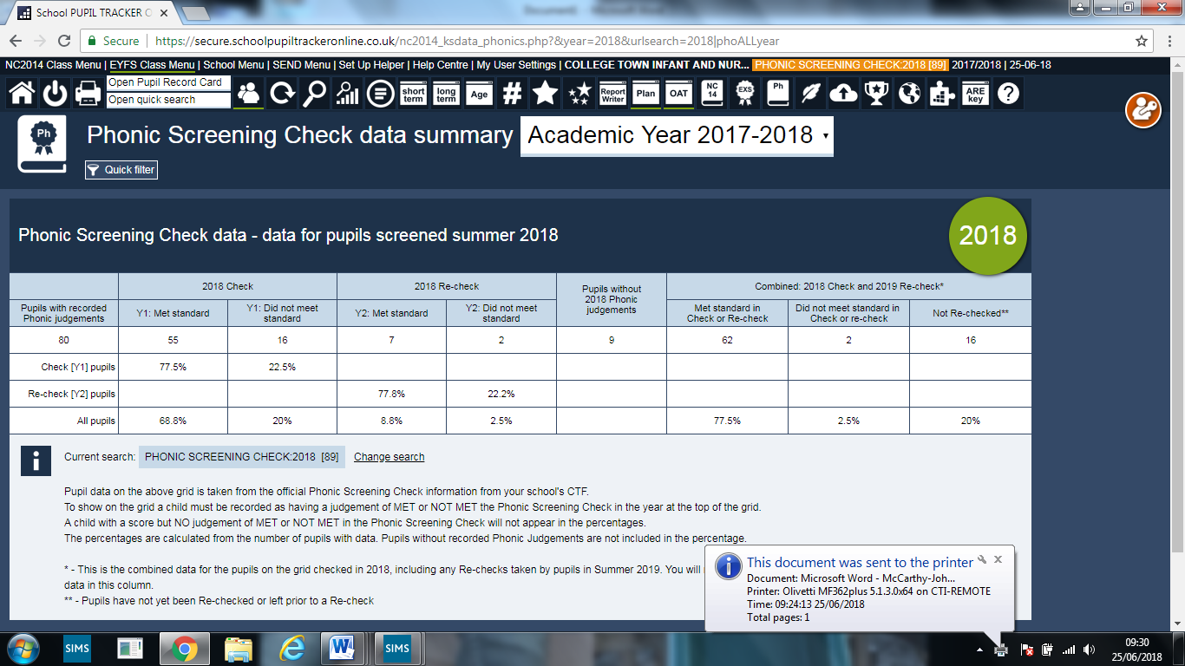

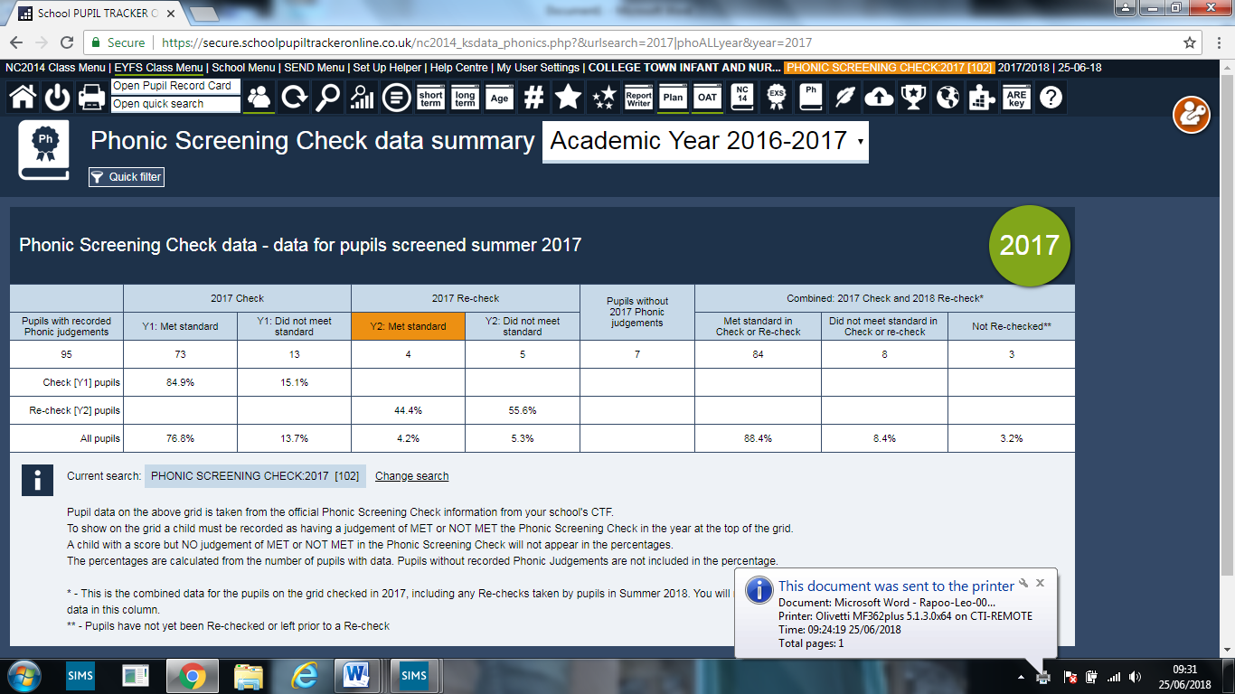

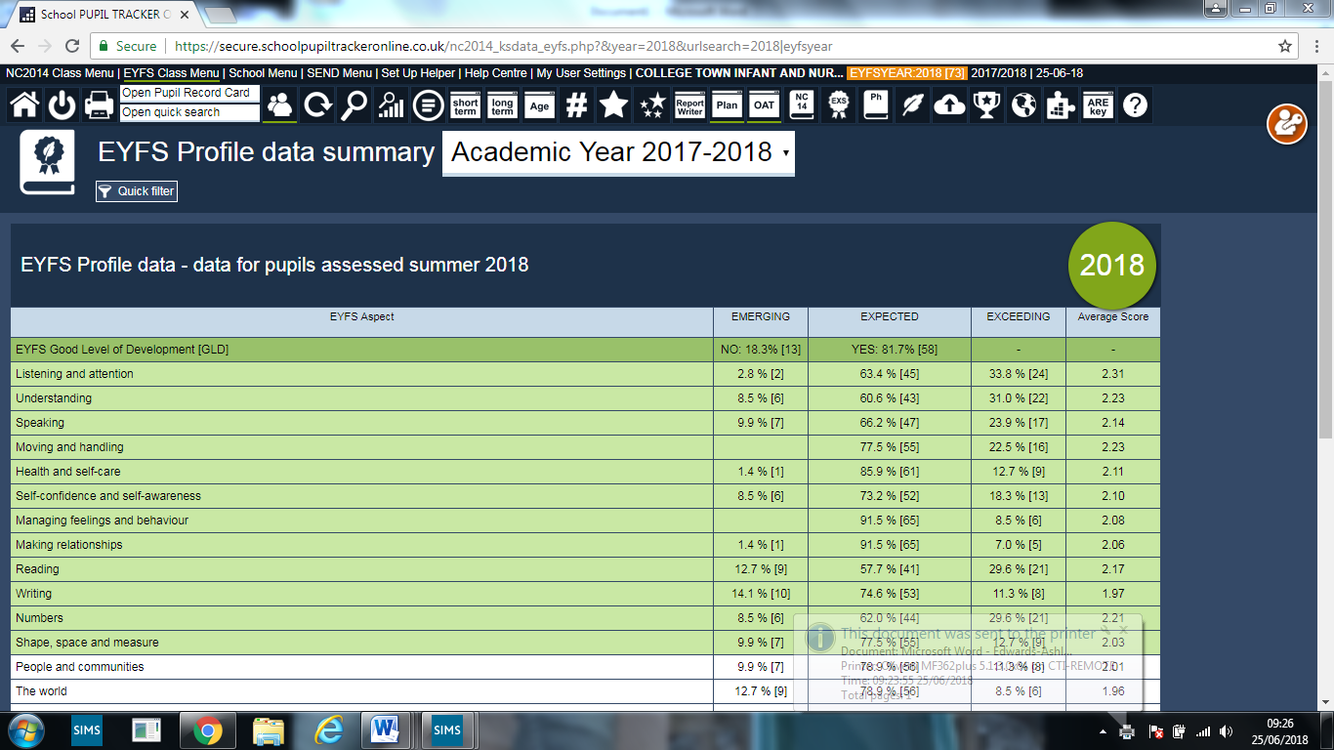

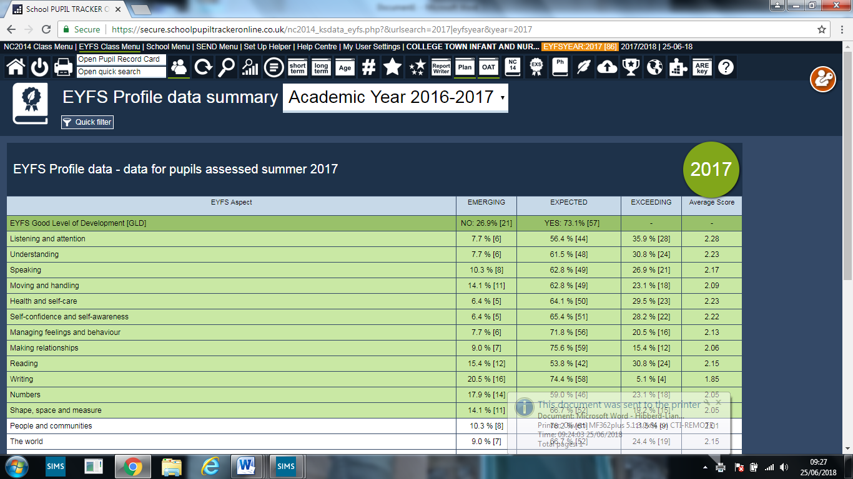

The school judges teaching and learning to be good with 40% outstanding. Please see EYFS moderation and Spring reports for validation.

Teachers directed Time -Please read the attached 1265

Changes – Pupil Progress groups apply every teacher

**Staffing**

Interviews are to be held before the end of tern to appoint a temporary teaching assistant for a child entering with SEND in Year 5. The post will be for 12 months initially.

The school is also recruiting several dinner ladies too as we have lost three due to redeployment.

The Moving on afternoon for children on July 6th is also the induction day for our new staff – please see attached schedule.