Governors Report, 2nd July 2018

Progress in Nursery

It is expected that the children will make 3 points progress in a year.

|  |  |  |  |
| --- | --- | --- | --- |
|  | December | March | End of Year |
| Making Relationships | +1.6 | +2.9 | +4.2 |
| Self Confidence | +1.2 | +2.1 | +3.3 |
| Managing Feelings and Behaviour | +1.1 | +2.2 | +3.4 |
| Moving and Handling | +0.9 | +2.0 | +3.1 |
| Health and Self Care | +0.8 | +2.2 | +3.4 |
| Listening and Attention | +1.2 | +2.4 | +3.5 |
| Understanding | +1.2 | +2.4 | +3.6 |
| Speaking | +1.0 | +2.4 | +3.5 |
| Reading | +0.9 | +1.9 | +3.3 |
| Writing | +0.9 | +2.1 | +3.3 |
| Numbers | +1.3 | +2.7 | +3.6 |
| Shape, Space and Measure | +1.3 | +2.6 | +3.6 |
| People and Communities | +1.3 | +2.6 | +3.7 |
| The World | +0.9 | +2.1 | +3.1 |
| Technology | +0.9 | +2.1 | +3.2 |
| Exploring Media and Materials | +1.3 | +2.6 | +3.7 |
| Being Imaginative | +1.2 | +2.1 | +3.6 |

Nursery Pupil Premium

|  |  |  |  |  |  |  |  |
| --- | --- | --- | --- | --- | --- | --- | --- |
| Child | PSED | PD | CAL | Lit | Math | UW | EAD |
| 1 | +3.0 | +3.0 | +3.0 | +3.0 | +4.0 | +3.0 | +3.0 |
| 2 | +4.3 | +3.5 | +4.3 | +4.5 | +5.5 | +4.3 | +6.0 |

Child 1 entered Nursery working at the expected level and has progressed well. Child 2 entered Nursery working well below the expected level and is currently working with SALT.

Reception

**EYFS Profile Summary: Good Level of Development**

|  |  |  |  |  |
| --- | --- | --- | --- | --- |
| **Pupil Group** | **GLD** | **Not GLD** | **Average Score** | **Average Total** |
| All Children 1718YEARGROUP:R | 81.7% [58] | 18.3% [13] | 2.12 | 35.96 |
| Boys | 83.3% [30] | 16.7% [6] | 2.16 | 36.75 |
| Girls | 80.0% [28] | 20.0% [7] | 2.07 | 35.14 |
| Pupil Service Premium | 84.2% [16] | 15.8% [3] | 2.07 | 35.11 |
| NOT Pupil Service Premium | 80.8% [42] | 19.2% [10] | 2.13 | 36.27 |
| Pupil Premium | 75.0% [3] | 25.0% [1] | 2.15 | 36.50 |
| NOT Pupil Premium | 82.1% [55] | 17.9% [12] | 2.11 | 35.93 |
| Service Children | 86.7% [13] | 13.3% [2] | 2.04 | 34.73 |
| NOT Service Children | 80.4% [45] | 19.6% [11] | 2.13 | 36.29 |
| FSM | 50.0% [1] | 50.0% [1] | 1.82 | 31.00 |
| NOT FSM | 82.6% [57] | 17.4% [12] | 2.12 | 36.10 |
| SEN Support | 25.0% [2] | 75.0% [6] | 1.71 | 29.13 |
| EHCP | 0.0% [0] | 0.0% [0] | 0.00 | 0.00 |
| School Action | 0.0% [0] | 0.0% [0] | 0.00 | 0.00 |
| School Action Plus | 0.0% [0] | 0.0% [0] | 0.00 | 0.00 |
| Statement | 0.0% [0] | 0.0% [0] | 0.00 | 0.00 |
| EAL children | 81.8% [9] | 18.2% [2] | 1.94 | 33.00 |
| Not EAL children | 81.7% [49] | 18.3% [11] | 2.15 | 36.50 |
| In Care | 0.0% [0] | 0.0% [0] | 0.00 | 0.00 |
| Not In Care | 81.7% [58] | 18.3% [13] | 2.12 | 35.96 |
| Autumn Born | 95.8% [23] | 4.2% [1] | 2.21 | 37.50 |
| Spring Born | 76.5% [13] | 23.5% [4] | 2.11 | 35.94 |
| Summer Born | 73.3% [22] | 26.7% [8] | 2.04 | 34.73 |
| Autumn Entry | 79.7% [47] | 20.3% [12] | 2.11 | 35.81 |
| Spring Entry | 91.7% [11] | 8.3% [1] | 2.16 | 36.67 |
| Summer Entry | 0.0% [0] | 0.0% [0] | 0.00 | 0.00 |

As you can see our GLD (achieving expected or higher in PSED, CAL, PD, Literacy and Maths) has increased this year. Last year GLD dropped to 73.9% due to a high SEN cohort. This year, we have worked hard to improve the personalised provision that we provide for the children as you know from previous reports. We have worked hard to moderate our assessments to inform our planning. We have been moderated by Bracknell Forest this year and they found our judgements to be accurate.

Reception Progress

|  |  |  |  |
| --- | --- | --- | --- |
|  | December | March | End of Year |
| Making Relationships | +1.1 | +2.3 | +3.3 |
| Self Confidence | +1.0 | +2.4 | +3.5 |
| Managing Feelings and Behaviour | +1.1 | +2.3 | +3.2 |
| Moving and Handling | +1.2 | +2.6 | +3.6 |
| Health and Self Care | +0.9 | +2.3 | +3.1 |
| Listening and Attention | +0.9 | +2.7 | +3.8 |
| Understanding | +1.2 | +2.4 | +3.7 |
| Speaking | +1.3 | +2.6 | +3.8 |
| Reading | +0.8 | +2.0 | +3.3 |
| Writing | +1.0 | +2.0 | +3.0 |
| Numbers | +0.9 | +2.3 | +3.6 |
| Shape, Space and Measure | +1.1 | +2.2 | +3.2 |
| People and Communities | +0.8 | +2.7 | +3.3 |
| The World | +0.8 | +2.5 | +3.3 |
| Technology | +0.9 | +2.5 | +3.3 |
| Exploring Media and Materials | +0.8 | +2.6 | +3.3 |
| Being Imaginative | +1.2 | +2.7 | +3.3 |

Year 1

Phonic Screening

Phonic Screening took place the week beginning Monday 11th June. The pass mark was released on 25th June as 32/40.

This year, 76.4% (55 children) met the standard and 23.6% (17 children) did not meet the standard.

For the Year Two rechecks, 77.8% (7 children) met the standard and 22.2% (2 children) did not meet the standard.

Our three PP children in Year 1 met the standard this year.

2016-2017- 84.9% met the standard

Progress

|  |  |  |  |
| --- | --- | --- | --- |
| Whole Year Group | December | March | End of Year |
| Writing | +1.0 | +1.8 | +2.9 |
| Reading | +0.6 | +1.5 | +2.8 |
| Spoken Language | +0.7 | +1.6 | +3.1 |
| Maths | +0.6 | +1.4 | +2.7 |

|  |  |  |  |
| --- | --- | --- | --- |
| Hedgehog Class | December | March | End of Year |
| Writing | +1.1 | +1.9 | +2.8 |
| Reading | +0.8 | +1.7 | +2.7 |
| Spoken Language | +1.1 | +2.2 | +3.0 |
| Maths | +1.0 | +1.9 | +2.9 |

|  |  |  |  |
| --- | --- | --- | --- |
| Mole Class | December | March | End of Year |
| Writing | +1.0 | +1.9 | +3.3 |
| Reading | +0.2 | +1.2 | +2.9 |
| Spoken Language | +0.1 | +1.1 | +3.1 |
| Maths | +0.1 | +1.1 | +2.6 |

|  |  |  |  |
| --- | --- | --- | --- |
| Rabbit Class | December | March | End of Year |
| Writing | +1.1 | +2.0 | +2.3 |
| Reading | +0.8 | +2.6 | +2.6 |
| Spoken Language | +1.1 | +3.2 | +3.3 |
| Maths | +0.8 | +2.4 | +2.4 |

Year 1 Pupil Premium

|  |  |  |  |  |
| --- | --- | --- | --- | --- |
| Child | Writing | Reading | Language | Maths |
| 1 | +3.0 | +3.0 | +3.0 | +3.0 |
| 2 | +4.0 | +3.0 | +3.0 | +3.5 |
| 3 | +5.0 | +3.0 | +3.0 | +3.0 |

Year 2

It is expected that the children will make 3 points progress in a year.

|  |  |  |  |
| --- | --- | --- | --- |
|  | December | March | End of Year |
| Writing | +1.1 | +2.2 | +3.4 |
| Vocab, Grammar, Punctuation | +1.2 | +2.5 | +3.9 |
| Reading | +1.7 | +2.6 | +3.7 |
| Spoken Language | +1.1 | +2.3 | +3.4 |
| Maths | +1.3 | +2.3 | +3.6 |
| Science | +1.1 | +2.0 | +3.2 |
| Computing | +1.0 | +1.8 | +3.0 |
| Art and Design | +1.1 | +2.1 | +3.1 |
| Geography | +1.1 | +2.3 | +3.2 |
| History | +1.2 | +2.1 | +3.2 |
| Music | +1.0 | +2.0 | +3.0 |
| P.E. | +1.1 | +2.0 | +3.0 |

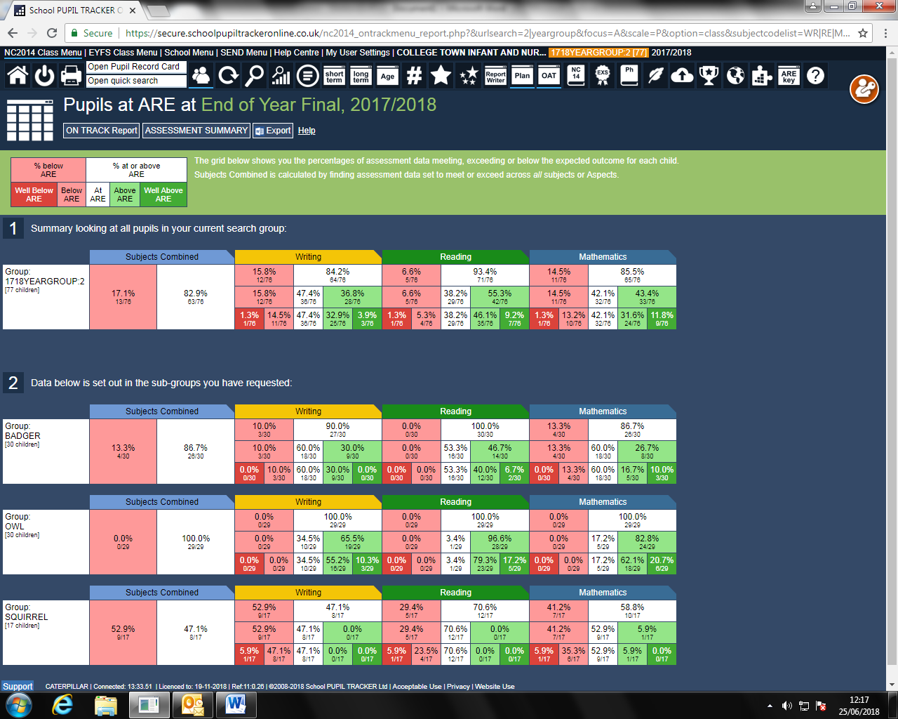Children in Year 2 Working at ARE or Above





Year 2 Pupil Premium

|  |  |  |  |  |  |  |
| --- | --- | --- | --- | --- | --- | --- |
| Child | Writing | Vocab | Reading | Language | Maths | Science |
| 1 | +3.0 | +3.0 | +3.0 | +3.0 | +3.0 | +3.0 |
| 2 | +4.0 | +4.0 | +4.0 | +3.0 | +4.0 | +3.0 |