**Full Governing Body Report Feb 2020**

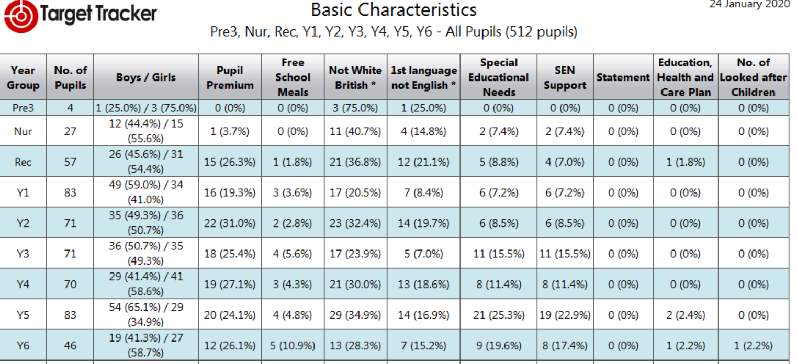

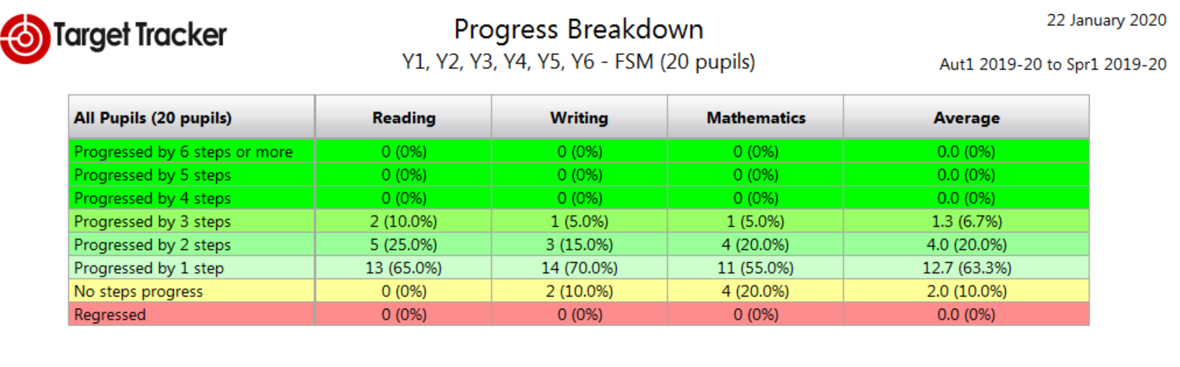

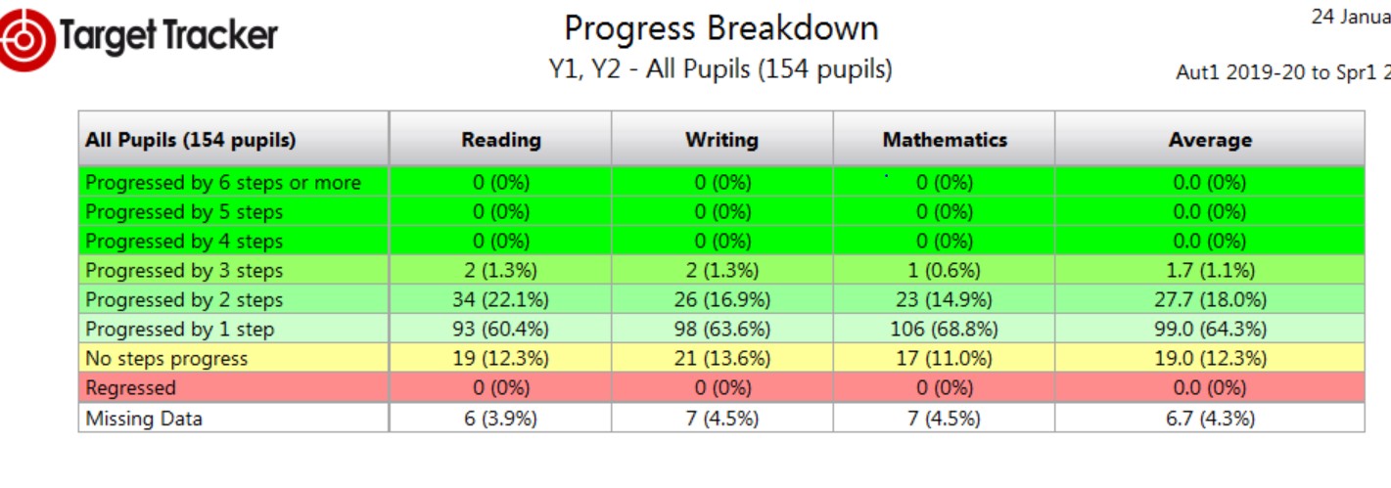

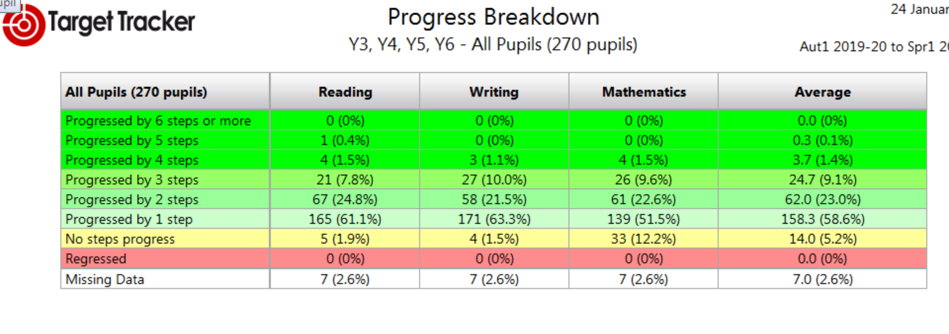

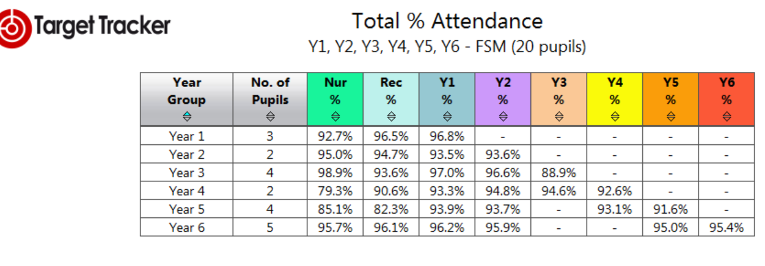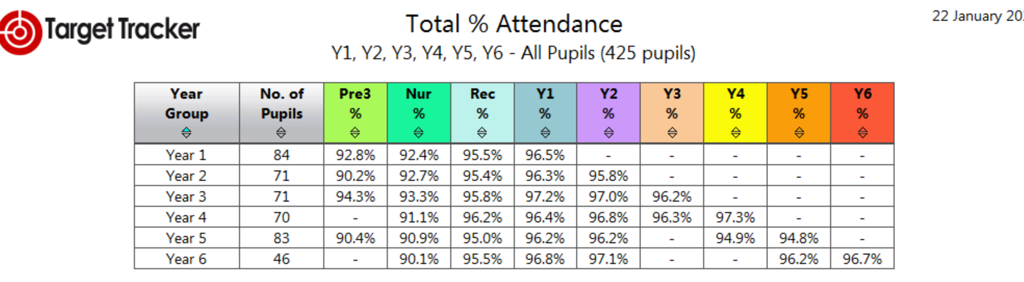

**Safeguarding information**

Exclusions= 0 this term

Child Protection 3

Child in Need Plan 2

MASH referrals = 1

1 ongoing Prevent monitoring case – not yet with Channel

1 incident of Cyber Bullying under investigation and monitoring in place

Health & Safety – Please see the BFC accident and incident report

**The Quality of Education**

We are aware the focus from Ofsted now sits firmly with school’s ability to provide a curriculum which demonstrates in practice the school’s own vision statement. Therefore with our own statement one would expect to see high expectations, aspirations and equity throughout the three key stages with appropriate challenge and support to ensure every pupils achieves their very best. This clearly must include SEND and other vulnerable groups.

As you are aware teachers were given additional CPD time in the last academic year to further develop the curriculum for each subject area, as a result the school has now successfully developed our intent within each subject area and created a skills progression documents to sit alongside each of these areas. This is paramount as there is an emphasis on the curriculum being knowledge-rich, but without the pupils simply memorising facts.

This year it is important that this intent is now implemented to secure a high quality education. Therefore the offset INSET days are being productively used throughout this term and next to provide subject leaders with the time to create their development and action plans. There will of course be additional costs involved in resourcing the new curriculum as books within our inherited junior school were either pre 1980 or not existent. As the focus on reading is quite rightly on reading there will be a further significant investment into resourcing books to encourage and motivate our pupils to continue to develop and broaden their experience of an area that they are studying. Last year you will recall the school spending in the region of £8,000 on guided reading books for KS2, this year it will be to support the wider areas such as geography or art.

This focus on reading was further highlighted at a recent reading event that myself and two other staff attended. Ofsted’s focus on reading is very clear, in fact they have given reading gets its own bullet point: *‘Inspectors will make a judgement on the quality of education by evaluating the extent to which a rigorous approach to the teaching of reading develops learners’ confidence and enjoyment in reading. At the early stages of learning to read, reading materials are closely matched to learners’ phonics knowledge’*.

The reading focus is repeated both under the Impact heading and in the handbooks (where there is also a special mention for maths, clarifying that in good schools learners will be *‘able to apply mathematical knowledge, concepts and procedures appropriately for their age.’*).

**Implementation – What Inspectors Will Be Looking For**

Under the Implementation heading, we see attention being drawn to how teachers and other teaching staff do their job and how leaders support them, particularly regarding subject knowledge, presentation of material, assessment, feedback, responsive teaching and recall of material. Therefore our next is to ascertain where our teachers are in regard to their own implementation. This has been developed within the SLT and there is now a very clear picture of where support is required to ensure good or better teaching throughout our school.

Currently there is a focus of support is:

* EYFS & Yr1 related to environment and phonics
* Y3 & Y4 the focus is on developing mathematical modelling and questioning to ensure pupils progress and are more able to apply a secure level of reasoning around numbers.

The SLT supported further by the Maths Lead Paul Tatum have worked with to develop an individual teacher profile and areas which are strengths shall be shared with others throughout the school; equally areas less strong will be developed through team teaching and coaching with senior staff. The curriculum GB were given details on the nature of support in more detail and will relay this to all Governors.

**IT**

As with reading books our IT is also not sufficient to teach effectively. Therefore as discussed when setting the budget new surface go tablets have now been purchased to further enhance our current system. We had tried to upgrade the old children’s laptops, but they simply were not adequate. We hope to have these up and running in early March. This will provide all children with greater access both for actual skills based learning with the computing curriculum, but also for additional research.