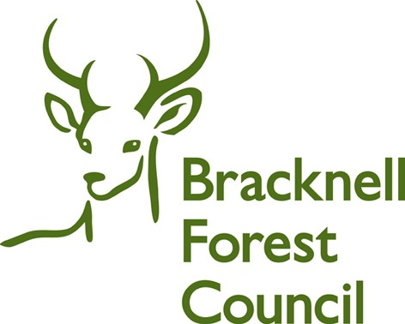

**Bracknell Forest Council**

**Approaches to School Place Planning**

**May 2022**

The following options for the future strategic approach to planning for school places have been considered based on an officer assumption of the need for sufficient overall headroom of up to 5% overall capacity to allow for the reasonable expression of parental preference:

**Approach 1 Local Leadership and Management Solutions**

Council Officers will work with Headteacher, Governors and Trustees to help identify and support local solutions to local challenges seeking best education outcomes and value for children and young people. Local leadership and management solutions could include using PAN outside traditional forms of entry of 30 for example, hard federation; use of mixed age classes etc. This option could be considered in consultation with each governing body/academy trust.

**Approach 2 Numbers on Roll (NOR)**

To propose reductions for larger 3 Form Entry (FE) and 2FE schools to reduce in size where their Year R NOR falls below an FE threshold. For example, if a 90/3FE school NOR fell below 60 then the school would reduce their Published Admission Number (PAN) to 60/2FE. These schools could be reduced in size without detriment to parental preference or to the school organisation or funding, which would already have been reduced to support the lower pupil numbers. This option could be considered in consultation with each governing body/academy trust.

**Approach 3 Protection of 1FE schools**

Unless there are overwhelming education grounds, there is support to protect our smaller 30/1FE schools who are less able to withstand rising surpluses of places because of their already reduced financial viability. If surplus places continue to rise and smaller schools are not protected, then this could ultimately result in school closures. Whilst allowing school closures would minimise the financial burden arising from surplus school places, this could be avoided if nearby larger schools were reduced in size.

Where it can be shown that the larger school is drawing pupils from the catchment of the smaller school the Council could engage with the larger school to explore the possibility of reducing their PAN. There would need to be a proviso that both schools have the same Ofsted grades otherwise this could prejudice parental preference. This option could be considered in consultation with each governing body/academy trust.

**Approach 4 Invite schools where appropriate to consider PAN reductions**

This was done as part of the Primary School Headteacher Workshops held in November 2021, however no schools volunteered to make new PAN reductions. Whilst surplus places remain, we should however keep the door open for schools to volunteer to make PAN reductions in the future should they wish to do so. This option could be considered in consultation with schools.

**Approach 5 Academies and Local Authority Maintained Schools**

To note that where the Council’s approach affects academies, PAN reductions will be requested from the Trust. Maintained schools could in theory be directed to make required PAN reductions, but the Council would prefer however to request rather than direct in this matter. Direction unless for overwhelming education reasons could be seen as treating state-maintained schools differently and in a divisive manner.

**Approach 6 Subsidising Smaller Schools**

It would be possible to subsidise smaller 30/1FE schools which had significant surpluses of places. If surplus places continued to rise however, the cumulative financial burden on other schools could eventually become unbearable and so above options should be considered before agreeing to any subsidies, so this is not currently an attractive approach.

**Approach 7 Do nothing**

Doing nothing is not really an option because it conflicts with the Council’s statutory duty to provide sufficient pupil places. The likely impact of doing nothing in a time of reducing primary pupil number would be for smaller schools to experience growing difficulties in achieving financial viability to the detriment of education standards. The Council must act to provide a sufficient balance of school capacity is available to meet the current and anticipated levels of need. This approach has therefore been ruled out.

**Approach 8 Reduce Capacity at all Schools**

Reducing PANs at all schools would be treating all schools the same but this would adversely affect smaller 1FE primary schools obliging them to move to mixed age teaching or even to close. The 1FE model is already less financially viable than 2 or 3FE schools so reducing pupil numbers at 1FE schools would create significant difficulties for school managers. The preferred approach is to look for reductions at larger 2FE & 3FE schools only, so this approach is not recommended.

**Approach 9 Designated Area-Based Approach**

To consider PAN reductions at all 2FE and 3FE schools where more than 50% their intake year comes from outside the DA. This would mean reducing capacity of popular schools to benefit less popular schools. This would be difficult to justify to parents and so is not recommended.

**Approach 10 Surplus Places Approach**

To consider reductions at larger 2FE and 3FE schools whose intake year surplus of places exceeds 25%. For example, a 90/3FE school with less than 67 pupils in YR would reduce to 60/2FE. It could be argued however that the school is part full rather than part empty and this approach would also mean taking away places that parental preference might otherwise have taken up. This approach is not recommended.