**Full Governing Body Summer term**

**Headteacher’s Report**

**Contextual data**

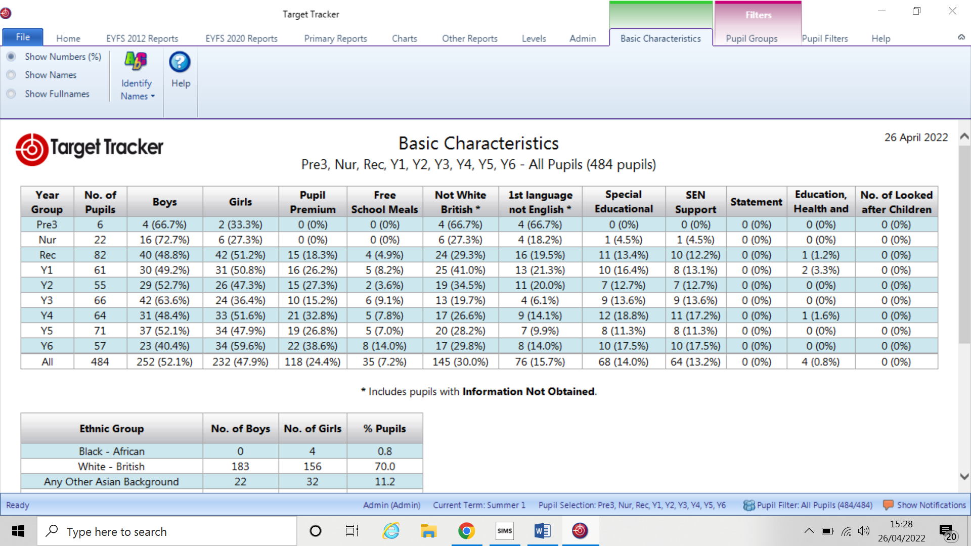

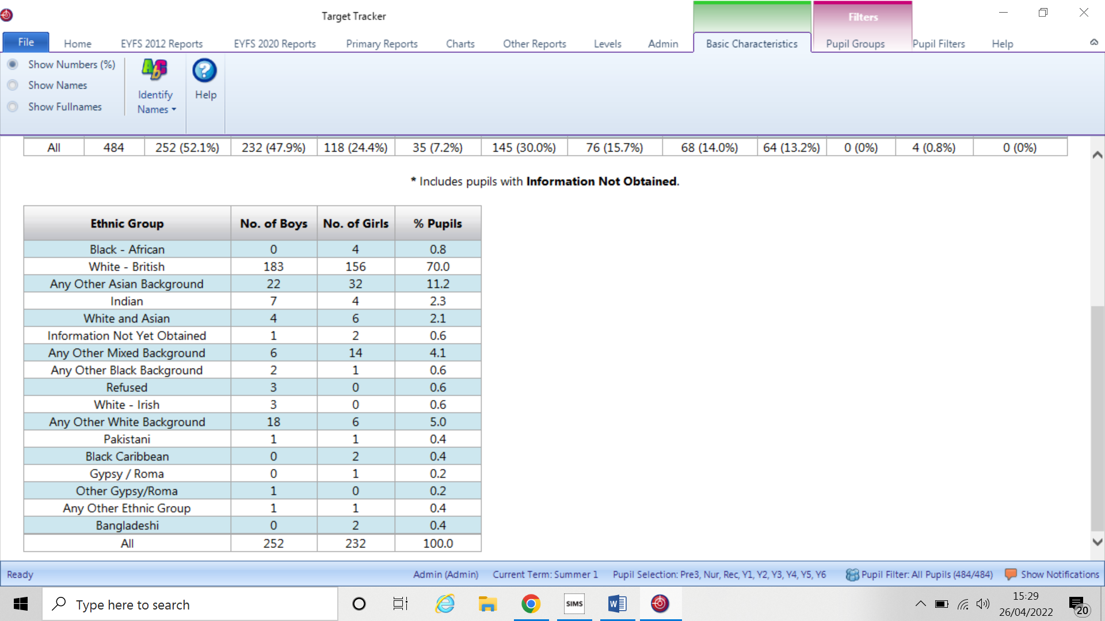

**Please see attached PDF data for KS1 & KS2 age related expectation as of Spring 2**

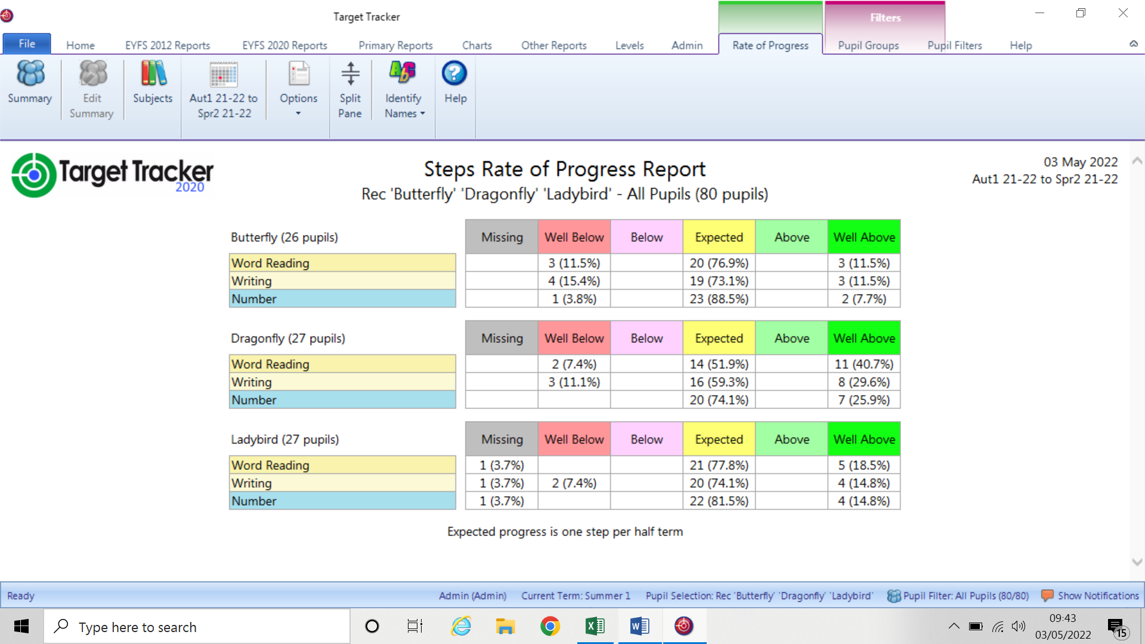

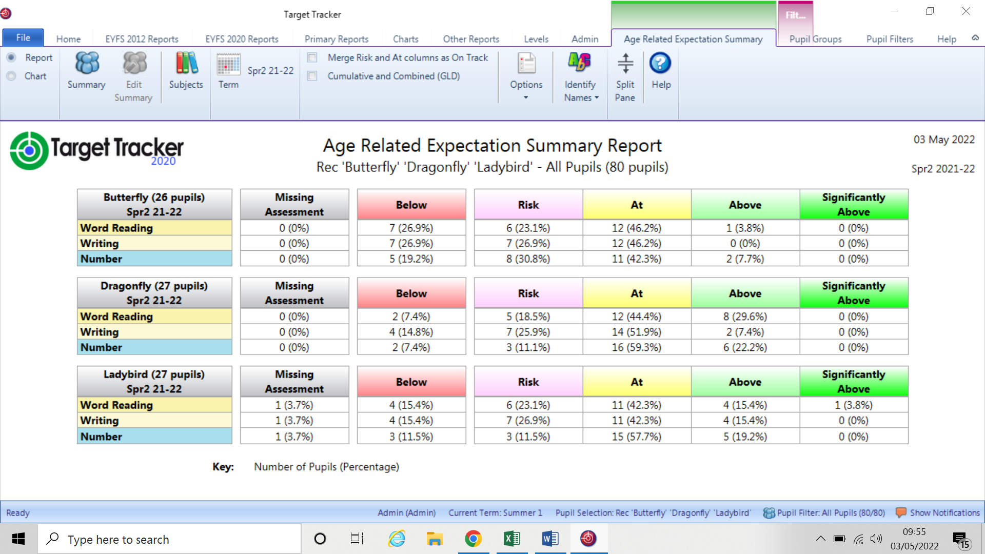

**Data commentary**

The chart above reports on pupil progress from Aut 1 – Spr 2. Missing data is due to new children arriving mid-year and therefore were not here in Aut 1.

From the three classes there are two with higher SEND needs and it is these pupils who are not making the expected progress of one step per half term. Those children are receiving additional and different provision and are making steady progress although due to their needs this is not at the rate expected for those pupils without SEND. This is also reflected in the second chart where the pupils in the below box are those with SEND.

The At Risk pupil group is higher than we would expect at this point in the year as we are expecting to achieve around 70% GLD and teachers were confident at their performance reviews that they were on track to meet their class targets. There is additional support being provided for these children with a strong emphasis on word reading and blending. Number across the cohort is on track currently with 70% achieving ARE at the end of Spring 2.

The very high rates of staff absence throughout December – April has significantly compromised the school’s ability to provide consistency in intervention work and more general daily TA support. This has inevitably had a negative impact as the planned provision has not been able to be actioned and consequently planned opportunities have not come to fruition.

Since returning from the Easter break the school continues to plan for additional capacity as absence rates are still higher than we would expect. Therefore we are deliberately over staffing so that we can at least remain with every class having a teacher with minimal disruption to PPA as well.

The distribution chart for EYFS demonstrates good progress in personal and social development, physical development and maths, but it is evident that it is the literacy development which requires further improvement to secure good outcomes for our end of year data.

**KS1 & KS2**

Year 1 is looking particularly weak as a cohort and Mrs Duncan has been supporting the teachers within this year group to help them consider the planning, delivery and outcomes to promote pupil progress. The pupils within this year group have had the benefit of being in small classes and we had hoped that this, along with two newly recruited experienced KS1 teachers would have supported the children in making good progress despite the disruption to their EYFS year. We shall continue to work with Year 1 staff so that the children’s progress is continually monitored ensuring the best possible progress before they enter Year 2.

All other year groups are looking on track although once again we see writing significantly below reading in years 3, 4 and 6. Moderation sessions are planned in mid may for year 6 and Mrs Nixon will also be doing some internal moderation to ensure assessments are accurate across all year groups.

Phonics assessments undertaken just prior to the Easter break suggest that we are in a strong position to achieve 82% or above and we shall continue to monitor some identified pupils in receipt of additional support following our assessments. Parents of the children at risk have been spoken to by their class teacher and suggestions regarding how they can best support at home have been shared allowing their parents.

Also included with the data is the most recent benchmark from Juniper Education. This is supplied free to the school from target tracker and does provide a good insight into national and LA data.

**SATS arrangement**

The test papers have been received, checked and securely stored ready to access on Monday March 9th for KS2 and Monday May 16th for KS1. The LA has notified the school that they have recruited a standards officer who will be visiting schools prior to, and during SATS to check on both paper security and the delivery arrangements. All access arrangements have been shared with the GB previously, but the school has now had to request a change for one pupil due to an unavoidable appointment. This change has been confirmed and agreed by the standards and assessment gateway. We look forward to welcoming the members from the GB into school during SATS and thank you for your time.

**The Green paper**

**New national standards for SEND provision in schools**

The government is proposing new national standards for SEND to make provision more consistent across the country. These standards would span from the early years through to further education, and apply across education, health and care.

The standards would:

* Set out a consistent approach to identifying and assessing pupil needs
* Set out what support is available for different pupil needs, and what type of setting (mainstream or specialist) should meet these needs
* Clarify when pupils need an education and health care (EHC) plan
* Clarify the role of different education and service providers (e.g. health and social care) in EHC needs assessments
* Clarify who should fund different forms of support
* Standardise processes for accessing SEND support and reviewing EHC plans (see more below)
* Set out how settings should collaborate with pupils, parents and carers so they can be more involved in decision making
* Set out consistent transition arrangements for pupils to move between schools, phases and into adult life

Once the standards have been established, the government plans to review and update the SEND Code of Practice to reflect the changes.

**Local SEND partnerships**

The government wants to create local SEND partnerships that would apply the new national standards (see above) in a way that takes into account local factors, like geographical context and the needs of local communities.

The partnerships would bring together:

* Local authorities (LAs)
* Education providers (including schools, alternative and specialist provision, multi-academy trusts and early years settings)
* Health and care providers
* Other partners (e.g. youth justice)

**Local inclusion plans**

The partnerships would work with parents and carers to assess existing local provision and pupil needs and, based on these, produce a strategic 'local inclusion plan'. These plans would:

* Set out how the local area (including education providers) will meet the national SEND standards
* Inform the local offer and explain what provision and services will be available
* Take into consideration local factors, like transport arrangements, when setting out the local provision

EHC plans: a standard digital format, and a 'tailored list of settings' for parents

The government is proposing a standardised, digital EHC plan template to:

* Help create consistency for pupils across the country
* Reduce bureaucracy for schools who receive pupils from multiple LAs
* Improve data collection
* Make plans easier for relevant people to access
* Provide a more holistic picture of the pupil (by e.g. including photos and videos)

**Annual review process to also be standardised, including:**

* Standards on documenting and celebrating pupil progress
* A requirement to discuss whether the pupil should receive targeted support instead of an EHC plan
* Changing the timescale for LAs to issue draft plans following annual reviews (from the current 4 weeks) – currently the DfE hasn’t stated what time frame it proposes, but will consult on this 'shortly'

EHC plans: parents to get 'tailored list of settings' to help them decide on their child's provision

To support parents and carers to 'express an informed preference of a suitable placement' for their child, they'll get a 'tailored list of settings' that are deemed appropriate for the pupil's needs. The list would be based on the local inclusion plan and would include mainstream, specialist and independent settings.

As before, the setting named on a pupil's plan has a legal duty to admit them.

LAs to get powers to direct admission to academies

For cases where academies refuse to admit pupils that have their school named on their EHC plan, LAs are to be given a ‘backstop’ power to direct academies to admit pupils. Currently, LAs have this power when it comes to maintained schools, but for academies, the power lies with the secretary of state.

**Staff training to identify SEND earlier and improve SENCO skills**

**Early years staff to be upskilled**

The government is to provide training for 5,000 SENCOs in early years settings to help them more accurately identify where a child might have SEND.

This is part of a push to identify SEND earlier - the government plans to integrate assessment for SEND into the Early Years Foundation Stage progress check for 2-year-olds, and the Healthy Child Programme development review.

The government will also review the level 3 early years educator qualification and increase the number of SEND-qualified level 3 practitioners in early years settings.

For more details, see page 39.

**A new National Professional Qualification (NPQ) to replace NASENCos**

The new NPQ would:

* Focus on improving SENCOs' leadership skills
* Replace the NASENCo - all SENCOs who haven't previously completed the NASENCo would need to complete the NPQ

The government proposes to tighten the time frame within which SENCOs must complete the qualification - in addition to the 3-year window for new SENCOs to achieve their NPQ, they'll need to be in the process of gaining the qualification when they start the job.

Alternative provision (AP) to become an integral part of local SEND systems

Under government proposals, the new local SEND partnerships (read more about these above) would be required to plan and deliver an AP service focusing on:

* Early intervention (rather than relying on long-term placements)
* Supporting pupils to stay in, or return to, mainstream school whenever appropriate

To do this, AP schools would offer interventions and education based on a 3-tier system:

1. **Targeted support in mainstream schools** - including 'on call' advice, coaching, delivering self-regulation classes for small groups, or 1-to-1 support
2. **Time-limited placements in AP** for pupils who need more support
3. **Transitional placements** for pupils who will not return to their previous school, but need support for their transition to a new school or post-16 setting

To support delivery, the government will fund a £70-million SEND and AP change programme to test and refine its proposals and support local SEND systems.

**Multi-year budgets for AP and a framework to monitor pupil movements**

**AP funding system to shift from per-pupil funding to multi-year budgets**

Each local SEND partnership would agree on a budget (ideally covering at least 3 years) for their AP service and outline the interventions that AP schools in their area would offer. LAs would distribute this funding to schools.

The government hopes that having stable funding will give AP schools more security. It plans to consult on this proposal as part of wider funding consultations (see more about funding reforms below).

In addition, the government says it'll invest £2.6 billion, over the next 3 years, to deliver new places and improve existing provision for pupils with SEND or who need AP.

For more details, see page 61.

**Statutory framework for pupil movements to be introduced**

To make sure pupils move into and out of AP in line with their own interests (rather than that of the school), the government is proposing to:

* Review how pupils move around the school system (including off-site direction and unregulated managed moves)
* Introduce a statutory framework for all pupil movements

The government plans to also issue a call for evidence on the use of unregistered AP before summer 2022 on:

* How unregistered provision should operate
* Whether such settings should be limited to part-time provision only as a re-engagement tool that complements education in registered schools

**Funding reforms**

**Standardised national framework of 'banding' and 'price tariffs' for high-needs funding**

These would match the needs and types of education provision set out in the national SEND standards:

* Bandings would cluster specific types of provision and be aligned to need
* Tariffs would set rules and prices on different types of provision to:
  + Control the high cost of provision
  + Clarify to providers how much they can expect to be paid for their specialist support or services
  + Enable those commissioning the support or services to get an idea of how much they'll need to pay

The government expects this new framework to be complex to develop, so it'll propose pilot approaches before rolling it out nationally.

**DfE to enter into new funding agreements with LAs**

These agreements would stipulate how high-needs budgets are spent to ensure value for money and that the new national SEND standards are met. The DfE would intervene (e.g. through an improvement plan) if it finds that LAs aren't meeting the conditions of these agreements.

**Greater accountability in an academy-based system**

**All special schools and APs to join an academy trust**

In the [schools white paper](https://schoolleaders.thekeysupport.com/administration-and-management/government-policies-and-legislation/changes-and-challenges-education/schools-white-paper-summary/?marker=content-body), the DfE set out its vision for all schools (including special schools and AP) to be part of, or in the process of joining, a trust by 2030.

AP schools will be able to choose whether to join a trust of specialist schools, or a 'mixed' trust that provides mainstream and special provision.

**New 'regions group' to oversee trusts and LAs**

The group, set up by summer 2022, will:

* Bring together functions currently held by the DfE and the Education and Skills Funding Agency (ESFA)
* Act as a risk-based regulator for trusts and have oversight of LAs - this includes bringing together existing requirements into a set of statutory academy standards
* Hold LAs and trusts to account for delivering the new national SEND standards. The group will have power to intervene if trusts don't achieve expected standards

**New 'national SEND delivery board' to oversee changes to the system**

Following the consultation on this green paper, the government plans to publish a delivery plan setting out its response and how it'll implement changes to the SEND system. To oversee this, it's proposing to create a 'national SEND delivery board' that would bring together:

* Government departments
* Parents
* Representatives of local government, education, health and care

**Tools to monitor performance of SEND and AP provision**

**New local and national 'inclusion dashboards' for SEND provision**

The dashboard would capture the following metrics:

* **Outcomes and experiences** (e.g. attainment and absence rates, tribunal appeal rates, proportion of pupils with SEN excluded from school)
* **Identification of need** (e.g. proportions of children with different types of needs, percentage of pupils with EHC plans, timelines of EHC plan assessments)
* **Value for money**(e.g. schools' high-needs spending, high-needs budget surpluses or deficits)

The government would use these metrics to monitor progress over time and help it get a full picture of how local areas are performing.

**School performance tables to be updated with 'contextual' data**

The DfE is to update its Compare School and College Performance service to include contextual data in addition to results data. It hopes this will make it easier to recognise what schools are doing to include pupils with SEND.

**New national performance tables for AP**

This framework would assess the success of AP settings and be based on 5 'key outcomes':

* Effective outreach support
* Improved attendance
* Reintegration into mainstream settings
* Academic attainment, with a focus on English and maths
* Successful post-16 transitions

**The White Paper**

**New attainment targets**

There will be no changes to the National Curriculum until at least 2024.

The white paper sets out new attainment targets, aimed to help pupils across the country achieve in school. It highlights literacy and numeracy as key tenets of achievement.

**Attainment interventions**

'Parent pledge' requirements

Schools will be required to inform parents if their child is falling behind in English and maths, and detail the progress they're making. This will be monitored by Ofsted.

Schools are expected to provide ‘evidence-based support’ when pupils fall behind. They should:

* Monitor pupils' progress in English and maths using robust assessment
* Have a response system, including adjusting classroom practice and providing additional support for children who need it

Targeted support for all pupils should complement support for pupils with special educational needs and/or disabilities (SEND).

**Pupil premium spending**

The DfE is developing a ‘menu’ of approaches for pupil premium spending. This is designed to help schools make decisions about how best to support pupils, especially with numeracy and literacy skills.

The Key are going to be updating guidance on targeted support and assessment from the DfE and Ofsted when they're available.

**Tutoring to continue as a central intervention**

Schools will be expected to use tutoring as a ‘staple offer’ for intervention and are expected to make tutoring available to every pupil who needs it.

Tutoring will be a ‘core academic option’ that schools can spend pupil premium funding on.

You'll continue to have the flexibility to:

* Use your own staff
* Hire in new staff, or
* Use accredited external organisations

New curriculum resources

A new 'arms-length' curriculum body is to be established. Schools will be able to access a digital curriculum and online resources for every subject. The resources are designed to reduce workload, so teachers ‘can concentrate on delivering lessons’ and spend less time creating new resources.

The curriculum body will work with Ofsted and the Education Endowment Foundation (EEF) to ensure high quality and relevant resources.

It will also provide resources that go beyond the National Curriculum to help you stretch more able students.

**New expectations on attendance**

Schools expected to provide a 32.5 hour school week

This applies to mainstream state-funded schools. It's not a statutory requirement, although Ofsted will consider it as part of its 'quality of education' judgement.

Schools are encouraged to provide 2 ‘substantive’ sessions each school day. It's likely this is a requirement for hours on the school site rather than learning hours, and therefore the time can be spent in break or form time or on extra-curricular activities, although this won't include after-hours activities. Further updates on this are expected.

It is expected for schools to meet these hours from their existing budget by September 2023 at the latest.

**CTPS current hours on site**

Reception 8.50 – 3.10 = 31 hours and 40 minutes

KS1 8.55 – 3.15 = 31 hours and 40 minutes

KS2 8.50 – 3.20 = 32 hours and 30 minutes

It is clear that reaching the target would be easy as it would simply mean that all children came into school at the same time. Timings have historically been staggered by 5 minutes for helping parents to get from one class to another where they have more than one child in our school. However, there are many schools where all children enter and exit at identical times. Moving forward this will need to become our practice.

**Reception allocation**

The school has now received the pupil allocation for September and we are expecting 58 pupils. Historically this number reduces by two or three due to moves and diverts. Therefore we will be reducing the classes from three to two. Should we go over the 60 then the Nursery will start a mixed class as their numbers for next year are also reduced.

On May 5th I attended a BFC Headteacher’s meeting regarding surplus school places. I have attached the planning proposals and will discuss these in more detail verbally at the meeting.

**Staffing**

Currently there is an updated advert for a new school Business Manager although we are not confident that recruitment is going to be successful. Locally there are other schools in a very similar position and it would appear that there is a very real possibility of not being able to secure a position in time for September. However, currently Mrs Wadsworth is up skilling the finance assistant as well myself to ensure that the school can function from September in the interim period until we are able to recruit. I have had several conversations with other schools in similar positions and there are thoughts regarding whether it would be possible to share a SBM. However, we would of course, prefer to recruit our own, but if needs must then this could be a consideration.

There have been two resignations from teachers for September one for relocation and the other for a new challenge. There is still a possibility that other resignations could come prior to May 31st as I know that one staff member is actively looking for promotion. However, during performance reviews no one else suggested that they were considering a change, therefore I feel confident that one further resignation would be the limit. I currently have generated a staffing model for 2022-2023 based on my current knowledge, although should a resignation be received I would still have the capacity to remain fully staffed without the need to recruit.

We shall be looking to recruit 2 – 3 new teaching assistants due to the relocation of two teaching assistants who are based at the RMA. There is also the possibility of needing to recruit 1 or 2 SEND teaching assistants as there are two educational health plans currently being reviewed by BFC. Should these be agreed then additional staffing will be required. Adverts will be placed in June for posts to hopefully recruit prior to the summer break.