**Full Governors Report**

**Child protection**

Two families remain on the child protection, both have scheduled reviews in December.

Threre are no families on a Child in Need plan as the previous families have now been clodsed to Children’s Social Care (CSC).

There are also three families who are currently under going an assessment under section 47 and we are awaiting the outcome of these. *A Section 47 enquiry means that CSC must carry out an investigation when they have 'reasonable cause to suspect that a child who lives, or is found, in their area is suffering, or is likely to suffer, significant harm'1. ... The aim is to decide whether any action should be taken to safeguard the child.*

**Exclusions –** There have been 2fixed term exclusion - 1 Year 1 and 1 in Yr 4

**Bullying** 1 incident currently under investigation.

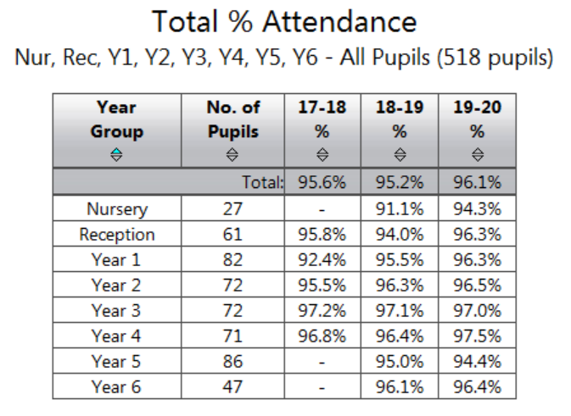

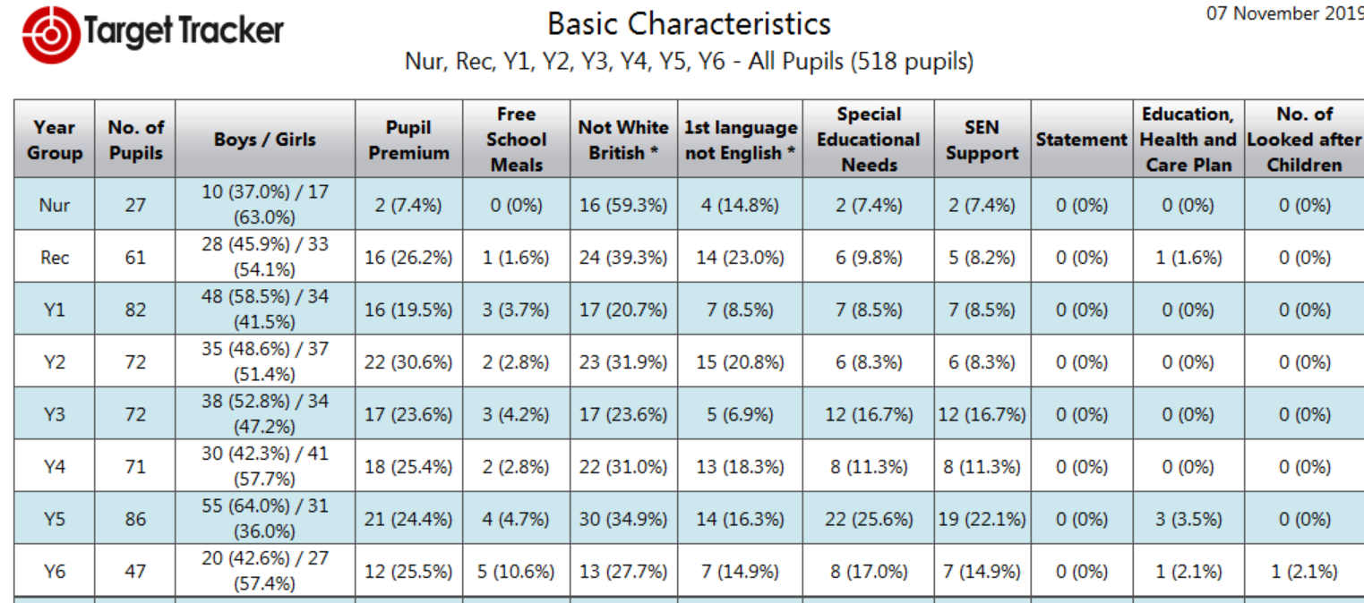

**Staffing**

The school, has had several new children arrive with complex needs and as a consequence additional support is now required to enable these children to settle and access their learning. Mrs Faircloth has applied for additional emergency funding for these children as well as starting the educational health plan process for several of them too. This has clearly added to her workload and the workload of the teaching staff as teaching support has been reduced. However, we are confident that by December we will have recruited or extended hours to plug the gaps across the school.

Mrs Drury has only one week remaining prior to her starting her maternity leave and Miss Nuttall is currently using her Keeping in Touch days to support transition as well as allowing her time to catch up with school improvement directives. In addition to Mrs Drury we are also going to be losing Mrs Harding in December asshe too will be leaving to start her maternity leave.

In September it had been planned that Mrs Harding was going to be teaching in Year 2 although due to her absence Mrs Faircloth took over this role. To ensure continuity for the children Mrs Faircloth will remain in this position with Mrs Harding covering PPA and DLT across the school. This has been communicated to parents and carers successfully as many parents are delighted to have Mrs Faircloth teach their children.

In Year 1 Ms. Baker remains signed off and this is going to be reviewed later in November. However to provide quality teaching Mrs Britton will be taking the class for three days and overseeing the Nursery for two. On Thursday & Friday she will be supported by Mrs Jo Mitchell a supply teacher. This model will remain in place until we have more information on Ms. Baker and her return.

**CPD**

Mr Paul Tatum is applying to the Forest Learning Alliance to join the National Qualification for Senior Leaders. Mrs Duncan will act as his mentor if he is successful in his application. This will allow Mr Tatum to further develop his knowledge and understanding of leadership and further strengthen our school’s leadership.

Mrs Helen Reed is enjoying her ELKLAN course where she is developing her knowledge and understanding of speech and language delays and impairments in young children. It is very much hoped that on completion she will then hold session for other teaching assistants so that she can share her knowledge and up-skill other staff across our school.

Suzanne Blake and Clair Ross are approaching the end of their Teaching Assistant qualification and have enjoyed the learning involved.

Three new lunchtime controllers and Mr Norman is continuing to support the induction of our new staff until December.

**Supporting other schools**

Mrs Britton is continuing to develop her role across Bracknell Forest and has recently supported Binfield Primary and will be revisiting before Christmas. Her target school this year will be working with Meadowvale Primary in helping them to further develop their Early years provision and planning. Mrs Faircloth will also be continuing to support schools throughout the year in her role as Leading SENCO.