**Full governing Body**

|  |  |  |
| --- | --- | --- |
| **ATTENDANCE 2018-2019** | % | Action from attendance meetings |
| ALL CHILDREN | 96.8 | The Educational Welfare Officer visited on November 8th and met with our Attendance and Welfare Lead Mrs Collin. It was pleasing to learn that they were unable to make any further recommendations to our current practice.  Mrs Collin’s and I met prior to the half term break and the following actions below were the outcomes from our meeting.   * Sent 2 letters to FS2 non statutory children regarding concerns about their attendance * Sent 1 letter to Yr2 child re low attendance * Sent 2 letters to Yr 4 children  re low attendance * Sent 2 letters to Yr 6 children re low attendance   Sent 2 letters out regarding persistent lateness.  As a result of 1 of these letters an alternative arrangement has been put in place to avoid future lateness. This provision is allowing the parent to access the Wake up Club at no cost to ensure that the child is able to arrive promptly as the family also have to take another child to a different school which leads to gthe lateness. |
| Boys | 96.6 |
| Girls | 96.9 |
| Pupil Premium | 92.9 |
| NOT Pupil Premium | 97 |
| Service Children | 97.4 |
| NOT Service Children | 96.6 |
| FSM | 94.3 |
| NOT FSM | 96.9 |
| SEN Support | 94.6 |
| EHCP | 93.2 |
| ALL SEN | 94.5 |
| NOT SEN | 97.2 |
| EAL children | 98 |
| NOT EAL children | 96.6 |
| In Care | 95 |
| NOT In Care | 96.8 |
| Autumn Born | 96.7 |
| Spring Born | 97.2 |
| Summer Born | 96.5 |

**School statistics & Health & Safety**

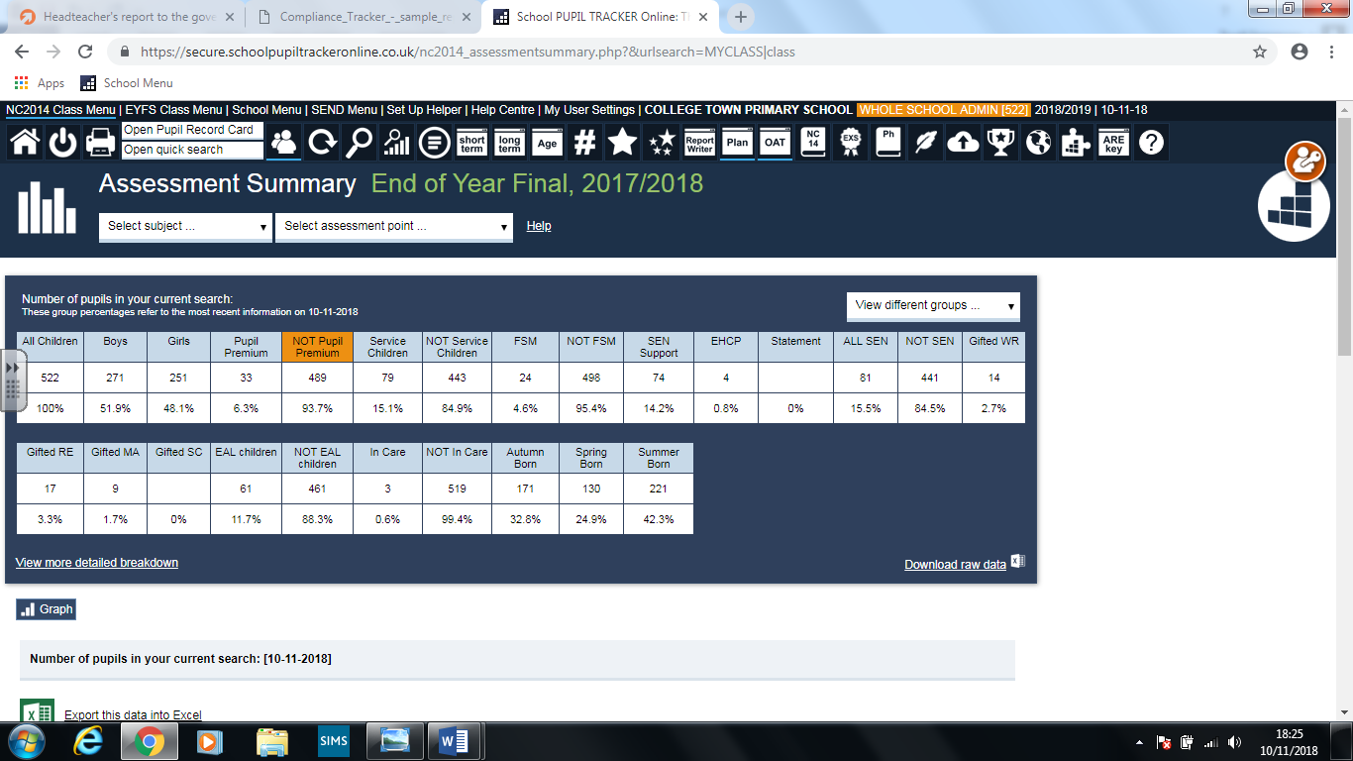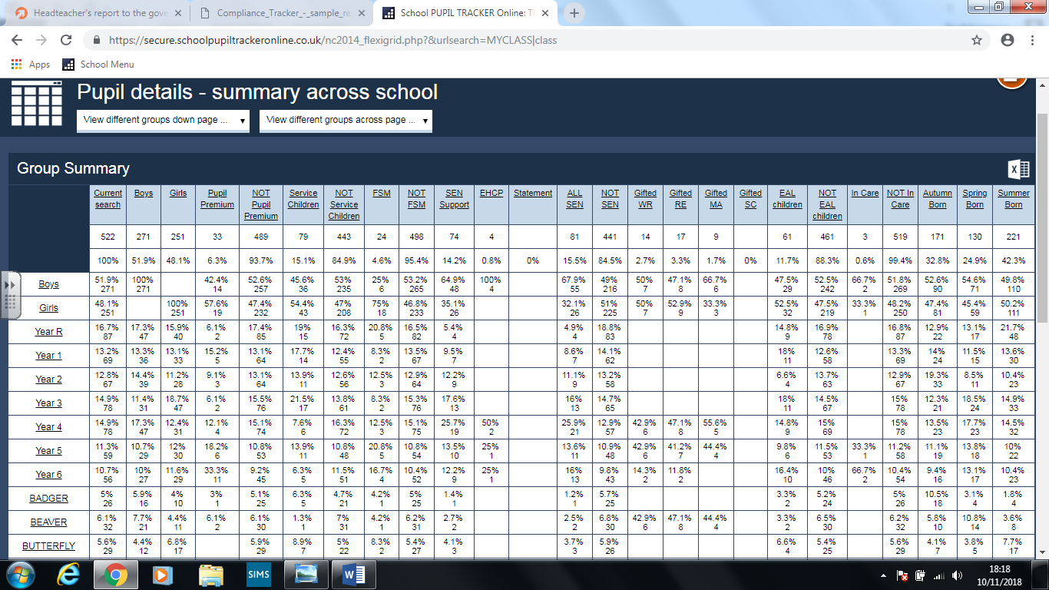

**Exclusions:**

One 3.5 days

2 internal exclusions

**Health & Safety Reports**

Andy Anderson from BFC has advised schools to record pupil behaviour which is dangerous either to themselves or others via the new online reporting system. The system moving forward to ensure that both the children and staff are properly supported and as now been update to include other categories such as threating behaviour and verbal assault. We have currently used this for two incidents involving the same child, but it is clear that there is going to be an increasing amount. There is also a section for children who run from the site which we had previously been dealing with. However, I am pleased to report that the provision ad support for this child is now enabling them to remain on site.

The online reporting system is not for general use in terms of children’s arguments and Mr Norman is awaiting further clarity from Andy so that staff can be fully briefed as there is some confusion and over reporting of incidents which are not appropriate. ThE Extract below was received from Andy Anderson on Monday 12th November and has now been explained to all staff.

**Reference reporting school incidents.**

Basically report all accidents / incidents involving **ADULTS** (Staff, contractors, visitors etc.) including:

•        Violent incidents

•        near misses

•        racial abuse

•        sexual abuse

•        verbal abuse etc.

**Accidents / Incidents involving PUPILS:**

Report all incidents where a child has been significantly injured e.g. head injuries, dislocations, fractures or where a child is taken to hospital. Also report child on child

•        Violent incidents

•        Racial abuse

No need to report the majority of playground slips, trips and fall that results in only very minor injuries (bums and scrapes). No need to report children arguing with each other (unless racial or physical violence.)

There has been some tension around managing pupil conduct among staff and I am aware that these two incidents have both been logged with the member of staffs union. This has been addressed by relocating the member of staff in an area of the school where the children are far less threatening, aggressive or disobedient. The member of staff has decided to take up the opportunity to work in Year 1.