**Staffing Report May 2019**

**Training**

There has been an unscheduled closure day for children on May 23rd which has proved to be incredibly useful as we have been able to secure Target Tracker training for the whole day. This would have otherwise had to be built into the first few weeks in September which would not have been ideal.

Also on the training day it will mean that we are able to have a staff training lunch with everyone in school; something which is rarely, if ever, possible. We would welcome curriculum governors to join us that day if they would like to get a better understanding of the new Target Tracker system. It would also enable governors and staff to get to know one another better. There are only 2 spaces as there is a maximum number of 25 for training. I will wait to see on Monday 20th who from curriculum GB would like to and be available to attend from 9.30 – 1pm.

This is the link to the site where you can find further information on the system prior to the school using it in September. <http://www.eesforschools.org/targettracker/>

Mrs Beamish has been accepted onto the Reading University SENCO course and was very grateful for the support demonstrated by the governors in part funding her fees.

As the school moves towards the end of the year we have decided that next year the school will be ready to accept students once again from the local universities. Reading University has already contacted us and we have submitted our request for the next academic year. We know that supporting trainee teachers is critical in developing future teachers and it can also be instrumental in retaining current staff, as many relish the opportunity to mentor students in their own classroom. It can also be a very useful recruitment opportunity too.

**School-to-school support work**

The school has been very busy in other schools with our three moderators out regularly for the local authority. In addition Miss Batten, our EYFS SLE, has already started to work with the LA in her new role and will be working alongside Sharon Jones to support the development of EYFS practice throughout the local areas. There is further work already scheduled in partnership with the Forest Learning Alliance for the next academic year.

I and several team members are currently supporting a school where there are a multitude of areas requiring improvement. To date we have supported safeguarding in its broadest sense, as well as providing additional human resources to support and address behaviour challenges.

**Recruitment and Retention**

Our recent newly appointed teaching assistants are settling in to the school very well and their induction to date has been well planned and enabling them to fully understand their role. It has been useful that there has been a cross-over period to further facilitate a thorough induction to the day-to-day role.

We have now lost Miss Parsons from Year 3, but Laura Harding has settled into her new role very well and the class is settled. Miss Leach, who recently took over from Miss Nuttall, continues to thrive and is ably supported by Mrs Duncan and Miss Startup. At this point it would be appropriate to mention to that Miss Nuttall gave birth to healthy baby girl, named Iris, who has already visited the school and delighted the children in Fox Class. Miss Nuttall intends to return to school in the Spring term of 2020 and will keep the school posted on the exact date nearer the time.

The internally advertised Assistant Head for Teaching & Learning was successfully received with two applications, although one did not entirely meet the person specifications. Therefore we will be interviewing one candidate, Mr Peaple, on June 12th. Rita has agreed to participate in the interview and presentation process and following this we very much hope to appoint. Once all posts are filled the staff will be informed of the changes to the leadership structure which will come into effect for September 2019 and the rationale how this will further improve our school.

|  |  |
| --- | --- |
| **ATTENDANCE 2018-2019** | **PERCENTAGE** |
| ALL CHILDREN | 95.6 |
| Boys | 95.6 |
| Girls | 95.6 |
| Pupil Premium | 95 |
| NOT Pupil Premium | 95.8 |
| Service Children | 95.8 |
| NOT Service Children | 95.6 |
| FSM | 92.7 |
| NOT FSM | 95.8 |
| SEN Support | 94.3 |
| EHCP | 96.8 |
| ALL SEN | 94.4 |
| NOT SEN | 95.8 |
| EAL children | 95.8 |
| NOT EAL children | 95.6 |
| NOT In Care | 95.6 |
| Autumn Born | 95.3 |
| Spring Born | 96 |
| Summer Born | 95.6 |

**FGB Report Headteacher May 2019**

**Whole school attendance with group attendance**

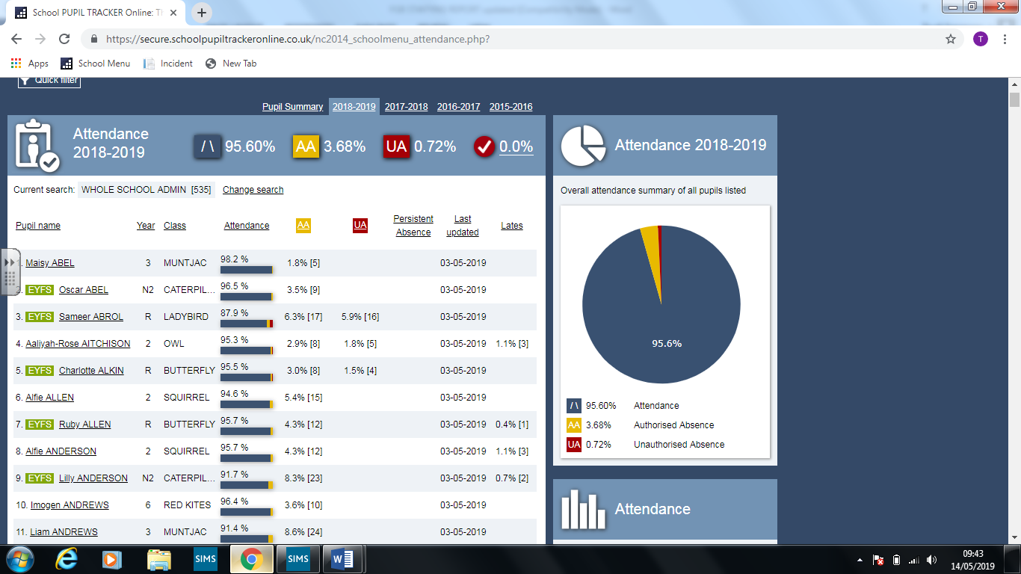

**Whole school pupil profile**

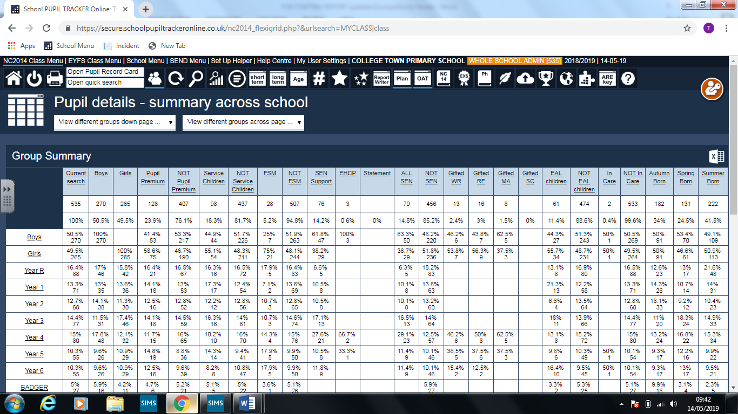

**Safeguarding cases currently open at CTPS**

**Bully reported = 0**

**Racist incidents reported = 0**

**Child in Need = 1**

**Child Protection =0**

**No Exclusions**

**Safeguarding Audit**

The school recently undertook a safeguarding audit and instead of simply assuming that the policies in place were understood and adhered to by all staff we actually decided to test out our policy into practice around safeguarding. The audit included questionnaires to pupils, staff interviews and a general delve into files.

I am pleased to say that in the vast majority of our day-to-day practice we are fully meeting the requirements to ensure the safety of all of our pupils. However, as you would expect, the deeper you dig there is always something which requires attention to promote best practice. The one aspect where the office had become less consistent was the keeping of student files. These should all be kept separate under our policy, but some had slipped through. This has now been completely addressed and our records for all children are accurate and stored as per policy. This was probably to be expected considering the upheaval involved in joining the school in September.

The area where there was most concern was that around pupils’ feeling listened to at school. There was strong body of evidence that teachers and other fulltime staff certainly took the time to listen, although the one group which was not thought to listen were the lunchtime staff. This we found interesting as we know only too well how challenging it is to recruit effective lunchtime staff. We are also very mindful that our induction for these staff is not as thorough in terms of behaviour management as it has been historically. Therefore extensive training has booked for June 3rd & 10th to support our lunchtime staff develop more effective relationships with our children. The training is based on how to build and develop positive relationships with children to improve the quality of care at lunchtime.

Despite there being a few areas which were not as good as they could have been we were pleased as a school that all staff knew their responsibilities and who and how to report concerns. We felt that overall the level of safeguarding was at least good with a high level of staff awareness around what their roles and responsibilities were. The updated safeguarding board acts as an ongoing training update to all staff and Designated Leads presentation notes are also now circulated to all SLT members so that all senior leaders are familiar with changes.

I have attached the pupil outcomes from the questionnaire and letters sent to each phase/ year group. I will provide additional feedback verbally on these and the children’s responses at the meeting.

Finally, I would also like to extend my thanks to Cheryl, our GB Safeguarding lead, who joined the audit and was an active part of the process. This collaborative working helps enormously to ensure that there was a shared understanding between the school and the Governing Body as safeguarding is everyone’s responsibility.

**Sex and Relationship Policy – to be approved – verbal update**

**SATS Year 6**

The SATS were successfully delivered last week and the previous mock papers suggest that the combined score is unlikely to be above 52%. However, the reading demonstrated a high increase with the cohort achieving 64%. Obviously the test papers for 2019 will be different, although it would seem unlikely that a different paper could throw the figures off massively. So all we can do now is wait until July 10th for all to be revealed! I do know, with a high degree of certainty, that our results are greatly improved from the end of September when the combined was 8%

**Key Groups: Progress in Writing [WHOLE SCHOOL ADMIN] 2018/2019 [14-05-2019]**

|  |  |  |  |
| --- | --- | --- | --- |
| **Key Groups:** | **End of Autumn** | **Spring Half Term** | **End of Spring** |
| **ALL CHILDREN** | **0.9** | **1.7** | **2.1** |
| **Boys** | **0.9** | **1.6** | **2.1** |
| **Girls** | **0.9** | **1.8** | **2.2** |
| **Pupil Premium** | **0.8** | **1.6** | **2.0** |
| **NOT Pupil Premium** | **0.9** | **1.7** | **2.2** |
| **Service Children** | **0.7** | **1.5** | **2.0** |
| **NOT Service Children** | **0.9** | **1.7** | **2.2** |
| **FSM** | **1.1** | **1.7** | **2.2** |
| **NOT FSM** | **0.9** | **1.7** | **2.1** |
| **SEN Support** | **0.7** | **0.9** | **1.9** |
| **EHCP** | **-1.7** |  | **2.0** |
| **ALL SEN** | **0.6** | **0.9** | **1.9** |
| **NOT SEN** | **0.9** | **1.8** | **2.2** |
| **Autumn Born** | **0.9** | **1.6** | **2.1** |
| **Spring Born** | **1.0** | **2.0** | **2.2** |
| **Summer Born** | **0.9** | **1.6** | **2.1** |

**Key Groups: Progress in Mathematics [WHOLE SCHOOL ADMIN] 2018/2019 [14-05-2019]**

|  |  |  |  |
| --- | --- | --- | --- |
| **Key Groups:** | **End of Autumn** | **Spring Half Term** | **End of Spring** |
| **ALL CHILDREN** | **0.8** | **1.4** | **2.0** |
| **Boys** | **0.8** | **1.3** | **2.0** |
| **Girls** | **0.9** | **1.5** | **2.1** |
| **Pupil Premium** | **0.9** | **1.2** | **1.9** |
| **NOT Pupil Premium** | **0.8** | **1.5** | **2.1** |
| **Service Children** | **0.9** | **1.1** | **1.9** |
| **NOT Service Children** | **0.8** | **1.5** | **2.1** |
| **FSM** | **0.9** | **1.9** | **2.0** |
| **NOT FSM** | **0.8** | **1.4** | **2.0** |
| **SEN Support** | **0.7** | **0.7** | **1.8** |
| **EHCP** | **1.0** |  | **1.7** |
| **ALL SEN** | **0.7** | **0.7** | **1.8** |
| **NOT SEN** | **0.8** | **1.5** | **2.1** |
| **EAL children** | **1.1** | **1.7** | **2.2** |
| **Autumn Born** | **0.7** | **1.4** | **1.9** |
| **Spring Born** | **0.9** | **1.6** | **2.1** |
| **Summer Born** | **0.8** | **1.3** | **2.1** |

**Key Groups: Progress in Reading [WHOLE SCHOOL ADMIN] 2018/2019 [14-05-2019]**

|  |  |  |  |
| --- | --- | --- | --- |
| **Key Groups:** | **End of Autumn** | **Spring Half Term** | **End of Spring** |
| **ALL CHILDREN** | **1.0** | **1.6** | **2.2** |
| **Boys** | **1.0** | **1.4** | **2.2** |
| **Girls** | **1.1** | **1.9** | **2.2** |
| **Pupil Premium** | **0.9** | **1.3** | **2.1** |
| **NOT Pupil Premium** | **1.1** | **1.7** | **2.3** |
| **Service Children** | **0.9** | **1.2** | **2.1** |
| **NOT Service Children** | **1.1** | **1.7** | **2.3** |
| **FSM** | **1.0** | **1.6** | **2.1** |
| **NOT FSM** | **1.0** | **1.6** | **2.2** |
| **SEN Support** | **1.1** | **1.2** | **2.1** |
| **EHCP** | **2.0** |  | **3.0** |
| **EAL children** | **1.3** | **2.1** | **2.5** |
| **Autumn Born** | **0.9** | **1.5** | **2.2** |
| **Spring Born** | **1.1** | **1.8** | **2.4** |
| **Summer Born** | **1.1** | **1.7** | **2.2** |

**Mock SATS**

The Year 6 children undertook their last set of tests in early May and the results, whilst not stunning, do demonstrate very good progress from their starting point of 8% combined in late September. The results are now indicating that our expected combined will be somewhere around 52%. Despite every effort we are still unlikely to be in the 60% region which is required in order for us to be at National average.

Reading results produced the highest scores with the cohort achieving 69% with 64% achieving the expected level for SPAG. It remains the mathematical paper which consistently pulls down the combined score. This as a cohort produced the lowest overall figure of 54%.

Clearly we used previous papers and these could prove to be either more or less challenging than those the children will sit for 2019. However, they will all be requiring certain elements and therefore I would imagine that the papers will be broadly in line with those the children have already experienced. I am not at all surprised by the mathematical results as the difficulty of the questions is very demanding. However, next year we should be in a more favourable position as the Year 5 children have received quality teaching throughout the year, unlike the current Year 6 pupils.

**YEAR 2 MATHS PROGRESS**

Year 2 continue to make good progress and Mrs Faircloth has continued to provide a highly structured environment for those children with additional needs within the cohort. This has enabled them to engage in their learning despite it not yet being at the age related expectation. The SATS data suggests that we shall be broadly in line with the national average across all subjects with greater depth for reading remaining high.

YEAR 2 Key Groups: Progress in Writing [1819YEARGROUP:2] 2018/2019 [14-05-2019]

|  |  |  |  |
| --- | --- | --- | --- |
| **Key Groups:** | **End of Autumn** | **Spring Half Term** | **End of Spring** |
| ALL CHILDREN | 0.7 | 1.7 | 1.8 |
| Boys | 0.6 | 1.7 | 1.7 |
| Girls | 0.7 | 1.7 | 1.9 |
| Pupil Premium | 0.5 | 1.2 | 1.2 |
| NOT Pupil Premium | 0.7 | 1.8 | 2.0 |
| Service Children | 0.4 | 1.1 | 1.0 |
| NOT Service Children | 0.7 | 1.8 | 2.0 |
| FSM | 0.7 | 1.3 | 1.7 |
| NOT FSM | 0.7 | 1.7 | 1.8 |
| SEN Support | 0.2 | 0.5 | 0.7 |
| ALL SEN | 0.2 | 0.5 | 0.7 |
| EAL children | 1.0 | 2.0 | 2.0 |
| NOT EAL children | 0.6 | 1.7 | 1.8 |
| NOT In Care | 0.7 | 1.7 | 1.8 |
| Autumn Born | 0.7 | 1.9 | 2.1 |
| Spring Born | 0.6 | 1.7 | 1.7 |
| Summer Born | 0.6 | 1.4 | 1.4 |

YEAR 2 Key Groups: Progress in Reading [1819YEARGROUP:2] 2018/2019 [14-05-2019]

|  |  |  |  |
| --- | --- | --- | --- |
| **Key Groups:** | **End of Autumn** | **Spring Half Term** | **End of Spring** |
| ALL CHILDREN | 0.4 | 1.4 | 1.9 |
| Boys | 0.2 | 1.3 | 1.8 |
| Girls | 0.7 | 1.7 | 1.9 |
| Pupil Premium | 0.2 | 0.7 | 1.2 |
| NOT Pupil Premium | 0.5 | 1.6 | 2.0 |
| Service Children | 0.2 | 0.4 | 1.1 |
| NOT Service Children | 0.4 | 1.6 | 2.0 |
| FSM | -0.3 | 1.0 | 1.3 |
| NOT FSM | 0.4 | 1.5 | 1.9 |
| SEN Support | 0.6 | 1.2 | 1.5 |
| ALL SEN | 0.6 | 1.2 | 1.5 |
| EAL children | 0.5 | 1.0 | 2.0 |
| NOT EAL children | 0.4 | 1.5 | 1.9 |
| NOT In Care | 0.4 | 1.4 | 1.9 |
| Autumn Born | 0.2 | 1.5 | 1.8 |
| Spring Born | 0.5 | 1.5 | 2.1 |
| Summer Born | 0.5 | 1.4 | 1.9 |

Year 2 Key Groups: Progress in Mathematics [1819YEARGROUP:2] 2018/2019 [14-05-2019]

|  |  |  |  |
| --- | --- | --- | --- |
| **Key Groups:** | **End of Autumn** | **Spring Half Term** | **End of Spring** |
| ALL CHILDREN | 0.5 | 1.6 | 1.8 |
| Boys | 0.5 | 1.6 | 1.7 |
| Girls | 0.5 | 1.6 | 1.8 |
| Pupil Premium | 0.5 | 1.1 | 1.4 |
| NOT Pupil Premium | 0.5 | 1.7 | 1.9 |
| Service Children | 0.5 | 1.0 | 1.3 |
| NOT Service Children | 0.5 | 1.7 | 1.8 |
| FSM | 0.3 | 1.7 | 1.7 |
| NOT FSM | 0.5 | 1.6 | 1.8 |
| SEN Support | 0.2 | 0.7 | 0.9 |
| ALL SEN | 0.2 | 0.7 | 0.9 |
| NOT SEN | 0.5 | 1.7 | 1.9 |
| EAL children | 0.7 | 1.7 | 2.0 |
| NOT EAL children | 0.5 | 1.6 | 1.7 |
| NOT In Care | 0.5 | 1.6 | 1.8 |
| Autumn Born | 0.5 | 1.9 | 1.8 |
| Spring Born | 0.5 | 1.6 | 1.8 |
| Summer Born | 0.5 | 1.2 | 1.7 |

**Trips**

Reception have visited Marwell Zoo

Year 1 have visited Wisely

Year 2 will be visiting Portsmouth

Year 4 will be visiting Ufton Court

Year 5 are hoping to visit Englefield Park

Year 6 have their residential on July 8th until Friday 12th