

**Attendance Policy**

**BEFORE & AFTER SCHOOL CLUB POLICY**

|  |  |
| --- | --- |
| Approved Date | September 2021 |
| Approved At | Governors |
| Date of Next Review | September 2022 |
| Statutory | NO |
| Adopted from Bracknell Forest | NO |

**This policy has due regard to the requirements of the Equality Act.**

**COLLEGE TOWN PRIMARY SCHOOL**

**BEFORE & AFTER SCHOOL**

**CLUB POLICY**

**Availability**

College Town Primary School Before & After School provision is available to pupils of the school from FS2 to Year 6.

Places are allocated on a first come basis and when all the places are filled, a waiting list will be established with the following priority order:

1. Siblings of children already attending
2. Existing users who require the additional sessions
3. New users mid-term

**Hours of Operation, Access & Provision**

Before School

8am until start of school day. Please arrive promptly for the start of the session.

There are two sessions run simultaneously, one for FS2 and KS1 children and one for KS2 children. Each session is run by two members of staff.

Children need to be dropped at the front office and parent/carers may park in the front car park if required. Please be very careful when entering and exiting the car park as it is very busy at this time.

After School

From the end of the school day until 6pm.

The club will be based in the Recreation room (to the right of the main entrance to KS2 building) although the children will have supervised access to the hall and outside areas as well.

The club is run by four experienced staff members including the club leader and is overseen by the Senior Leadership Team.

Activities based on the needs and interests of the children are planned and include various sporting activities, arts and crafts, quiet times, dvds, books, games, story times, homework assistant etc.

A snack and drink will be provided during the session.

When collecting your child/ren please phone the After School Club on arrival at the gate on 07784920297. Parents/carers who are driving can drive down and park in the school car park at the back and collect the children from the front door of the KS2 building. Parents/carers collecting by foot need to wait at the gate and the children will be walked down to you.

**Booking Procedures**

Bookings are made online via the schools School Gateway App. See appendix A for instructions on how to download and use the app.

Places are limited so early booking is advised.

Sessions will be released on a termly basis and parent/carers of children currently attending the club will be informed and given priority access to the booking system. Booking will then be opened up to the whole school.

Bookings need to be made in advance to secure your place. If there is availability bookings can be made on the day but the booking needs to be made before your child attends the session. Emergency admissions will be at the discretion of the school.

Payment for each session is taken at the time of the booking. Payment is made by paying money onto your account on the Gateway App but your booking is not secure until you book the session day. Please see Appendix A for instructions or contact the office with any queries.

Payment can be made via childcare vouchers. Please contact the school office to discuss.

**Charges and Cancellation**

The Before School Club costs £2.50 per session per child.

The After School Club cost £12.00 per session per child including a light snack:

There will be a discretionary charge of £2 per every ten minutes, for children picked up late after 6.00 pm.

**Cancellation** fees will apply as follows:

More than 7 days notice - no charge

Less than 7 days notice - half sessional fees will be charged

Less than 48 hours notice - full sessional fees will be charged

The above cancellation fees will be waved for any sessions missed due to illness of more than 2 days.

**Contact Details**

Please contact the school on 01276 31933 during school hours from 8am to 4pm.

The After School Club can be contacted on 07784920297 between 3pm and 6pm.

**THIS POLICY IS STRICTLY ADHERED TO**

Appendix A



The clubs tab will list all clubs your child can attend.

For Wake Up Club click on this tab

**Club bookings on School Gateway**

(Child’s Name)

(Child’s Name)

To book sessions for clubs please select the clubs tab

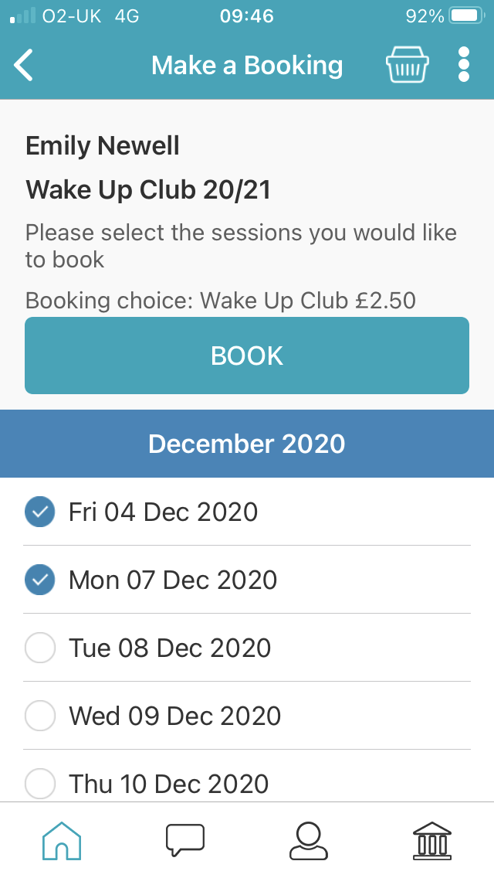

(Child’s Name)

Once you have selected the days you would like to book, select the book button

Select which days you would like to book. You can book sessions   
up-too 12pm the day before

Please select here to make a booking

Here you can see all your booking information for Wake Up Club

(Child’s Name)

College Town Primary School

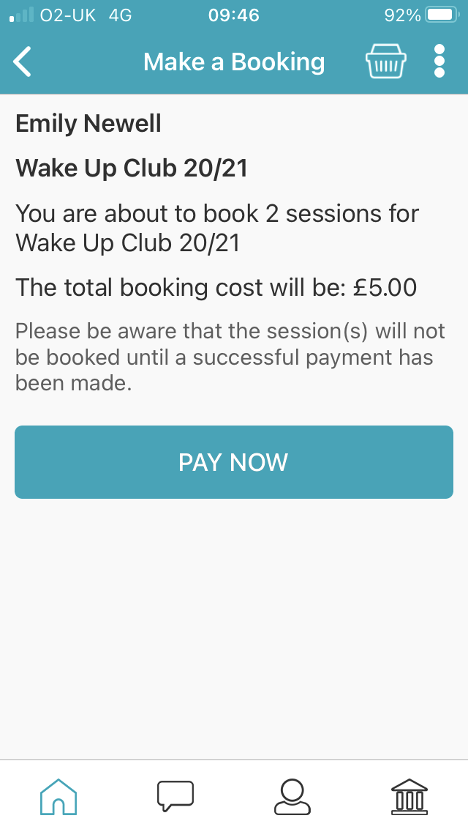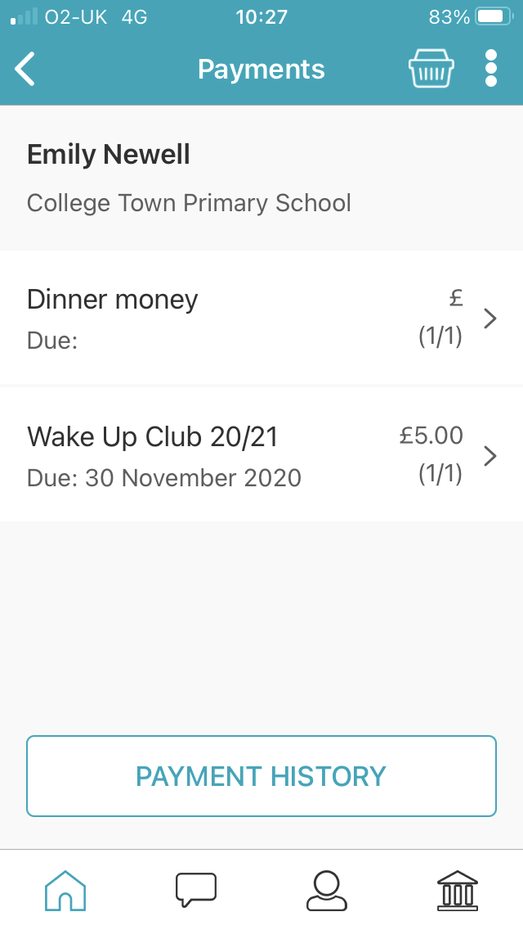

(Child’s Name)

Here shows how many sessions you have booked with the total of the booking cost.

Please select Pay Now

(Child’s Name)

This payment page shows all payment that can be made under your child’s name

Payment needs to be made to   
secure Wake Up Club.

Select here

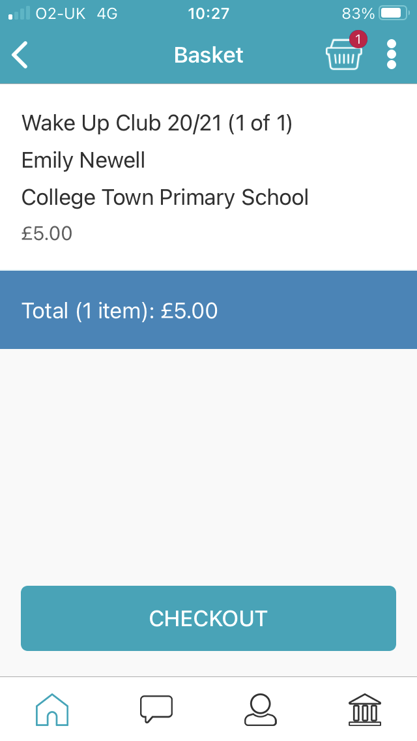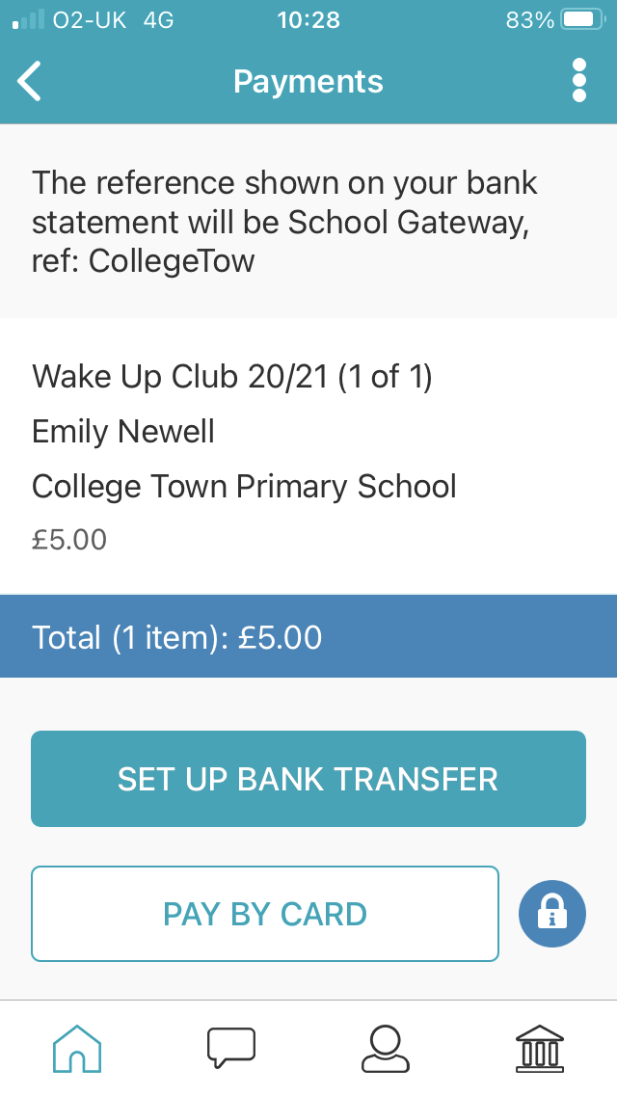

(Child’s Name)

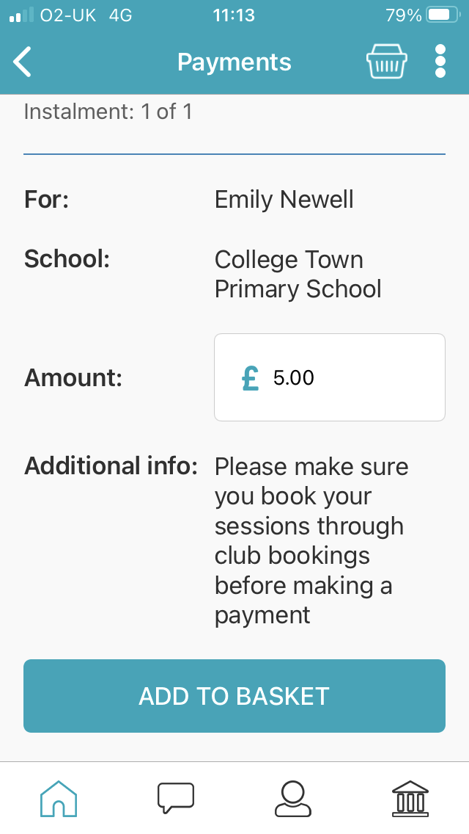

(Child’s Name)

This shows the total amount which needs to be paid to secure  
sessions.

Select here to add to basket

Additional information is to inform you that you have to book sessions through club bookings on the main menu as this step by step is   
showing you

(Child’s Name)

Selecting check out in your basket page will then take you to a payment page

You can then make   
payment by bank transfer or pay by card