**Headteacher’s report**

**Full governing Body September 20th 2021**

The school has 1 family on a child protection plan

The school has 4 families on a CIN

There 5 children are receiving play therapy

There is 1children receiving ELSA in KS1

There are 5 children receiving ELSA in KS2

No exclusions

No bullying

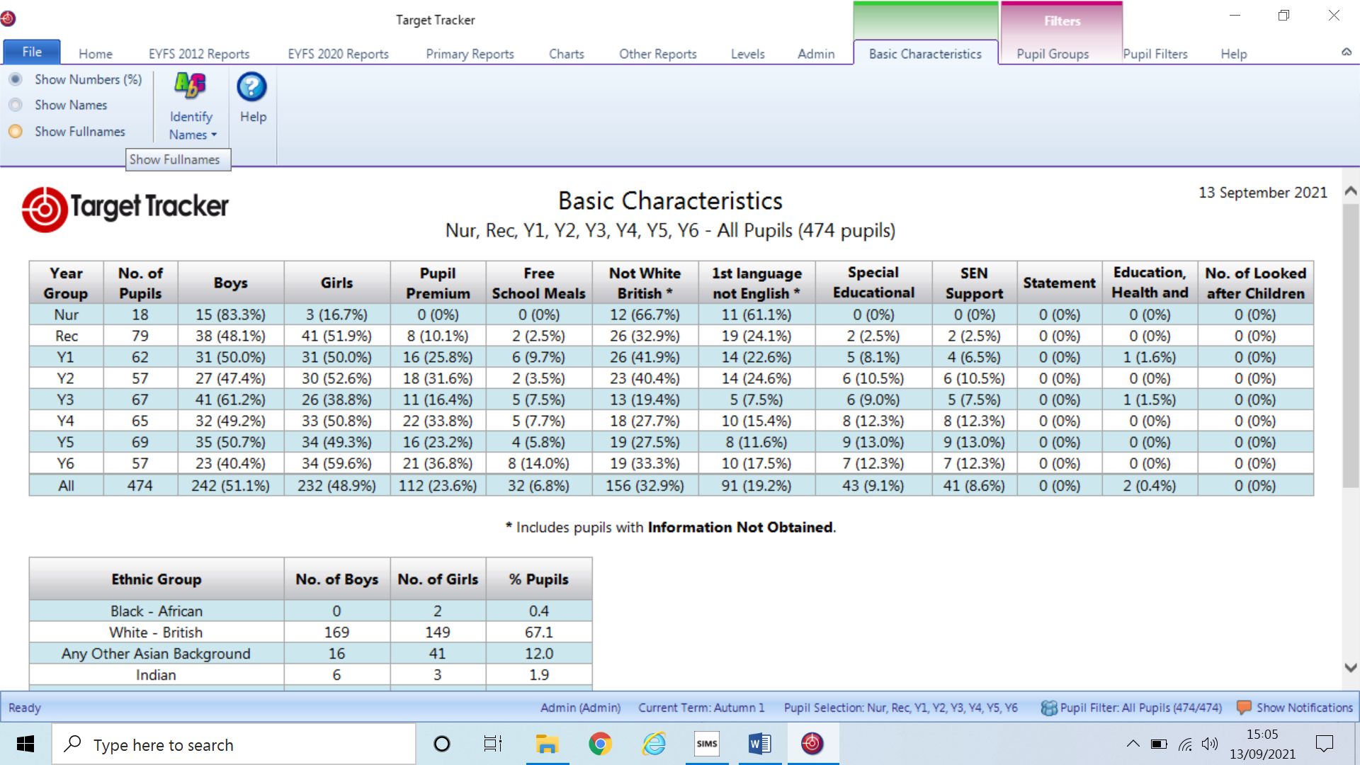

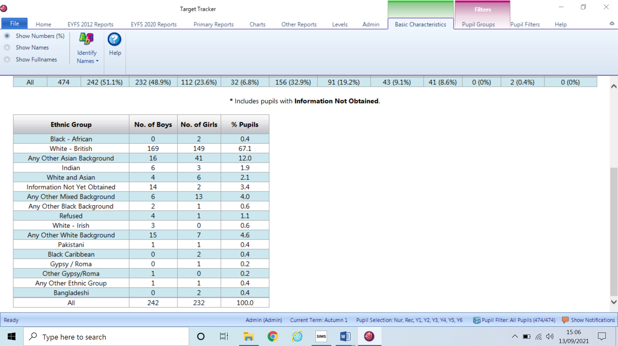

**Attached documents for pre meeting reading:**

**FAP**

**Safeguarding Policy**

**Behaviour Policy**

**ECT Induction Policy**

**COVID Outbreak Management Plan**

**CPOMS**

**STEP Summer report**

**SDP 2021**

**EYFS Data**

**KS1 group**

**KS2 group data**

**INSET Day**

The new academic has started off very positively with whole staff H&S and emergency first aid delivered on the INSET day. The day was well attended by all staff and it was delightful to once again enjoy lunch with all of the staff without the previous restrictions. Teachers also had planning time in the afternoon with their year group, which was essential with the eight new teachers the school has employed this year.

**COVID update**

Guidance to schools, as has been the usual story, was again slow and non-specific. Such guidance has led to many schools nationally taking very different approaches even within a few miles of each other. Such disparity does of course cause confusion for parents and staff about what is allowed as schools have each decided upon their own restrictions.

Here at College Town the restrictions are based around the initial fundamental principles of:

Environmental cleanliness, hand & respiratory hygiene, adequate ventilation and vulnerable workers.

There is no longer any requirement for face masks, social distancing or mixing of groups. Obviously these new freedoms are a step in the right direction, but we shall be employing some measures to further reduced transmission and keep staff and other stakeholders safe. By doing so we reduce the very real risk of an outbreak whereby the result could impact negatively once again on the education of our pupils.

Within the DfE’s contingency framework they suggest measures to be considered within each setting to reduce transmission, these are:

Residential trips, open days, taster days, parental attendance in settings and live performances in settings.

As an outcome from considering the risks within our setting we shall only be holding meetings within the setting when it is not possible to do undertake these using another system such as Teams or School cloud. Exceptions will be made where we feel it is important to actually have face-to-face meetings such as SEND conversations, safeguarding concerns and year group meetings for Reception and Year 6.

Where large group meetings are held they will be for a maximum of 20 minutes in a well-ventilated large area such as the school hall. When meetings are likely to exceed 15 those attending are welcome to wear a face covering, although we are not going to insist as this is no longer a mandatory requirement within England. Staff delivering such sessions will be at least 3 metres away from the front row throughout the meeting as a further precaution.

Attached to this report are the documents received from BFC and PHE in supporting schools to manage the ongoing situation safely for all. In addition the outbreak management is also attached. Once this has been seen and discussed at GB we shall be uploading to the swebsite for our parents and carers. The plan does provide consistency across all BFC schools which will hopefully reduce any frustrations in the event of closure or limited access.

**Wraparound Care**

The new after school provision has started successfully and with our Reception children soon to be full time it looks like it is set to grow in numbers. Throughout the summer Mr Norman and I carefully planned the provision and timetabling to ensure that the environment was conducive in providing a calm and purposeful atmosphere with clear behaviour expectations and boundaries. Mr Norman and his team have quickly established these with the which is great to see.

The Wake-Up Club has now split into a EYFS/ KS1 (4-7 years) & KS2 (7-11) and BOTH are well attended. The new garden area developed over the summer as an additional resource for the children at before and after school provision has certainly been a hit with the children and it is lovely that they have this freedom. Indeed, one pupil told me how much she loved the garden as she lives in a flat and doesn’t have a garden. I then knew that the decision was a very worthwhile one!

Football, judo and gymnastics are now all back up and running with high numbers of children attending. The school really is back to life!

**Re-establishing high standards**

During the last 18 months it has been necessary at times be more lenient in terms of uniform due to the difficulty in obtaining items during lockdowns. However, as we are no longer facing any such challenges and therefore as a school we really are pushing for parents to follow the uniform policy.

It had become very noticeable over the last year that PE kit was becoming full of football strips and unicorn leggings rather than our specified black and white attire. School uniform was being replaced with various coloured tops and trainers as school shoes had all become acceptable on the grounds of COVID, but now we have reset our expectations and these have been clearly explained to the children and the parents.

Staff are monitoring the uniform and PE kits and those deviating receive a letter home to remind them of the acceptable items. As you are all aware any child in financial difficulty is not required to purchase uniform as we cover the cost, therefore there is no reason why any child should not be wearing the agreed uniform.

The school has, and will continue to meet the needs if children with severe sensory issues where particular clothing causes discomfort, although we would still expect the individual to wear comfortable clothing which still follows the school’s colour scheme both for PE and general uniform.

Staff have also received our dress code to remind them about the standard of dress we expect as there had also been some relaxation here too. During the last 18 months it was totally acceptable, but now we want to pick up where we left off in February 2019!

The new reception children have all now started and the transition has proved successful. The new class arrangements are also working and in these early days we are working closely on evaluating the new practice and making the necessary small changes to further enhance the children’s experience.

**Staffing & Induction**

As you are aware the school recruited eight new teachers along with five new teaching assistants. Al have settled in well and are being carefully inducted in line with our policy. Mrs Duncan is working closely with Mrs Wadsworth to ensure that policies and procedures are followed so that our new staff are aware of where to find the information they require to be an effective and confident staff member within the school setting.

Mrs Duncan has already set up training schedules with each of the ECTs and attached to this report is her outline for the year.

**Safeguarding**

**Fair access Protocols**

The new updated policy has been submitted for GB approval.

The staff have received the new updated Keeping Children Safe in Education document and are required to sign that they have read this and understand the new considerations around sexual harassment within school.

Part 1: safeguarding information for all staff

All school staff working directly with children are expected to read at least this section. Staff who don't work directly with children on a regular basis can instead read a condensed version of part 1 (located in annex A).

Safeguarding and promoting the welfare of children is **everyone's** responsibility.

All staff should make sure that any decisions made are in the**best interests of the child.**

**All** staff should:

* Provide a safe environment in which children can learn
* Know about (and feel confident to use) school safeguarding systems, including:
  + Policies on child protection, pupil behaviour and staff behaviour (your code of conduct)
  + Your safeguarding response to children who go missing from education
  + The role and identity of your designated safeguarding lead (DSL) and any deputies

You may recall that two years we first considered buying CPOMS as a MIS for safeguarding. After training and discussions we took the decision to buy the system. However the training was never rolled out to staff due to COVID. This training has now taken place and the system will now be used by our staff overseen by SLT. Attached is the outline of the system and how it supports safeguarding reporting within our school.

**Reception Baseline - How it works – When we do it**

We need to carry out the assessment within the first 6 weeks of a pupil joining our reception (now from September 2021 onwards).

This is regardless of when they join the class, unless they have been assessed previously.

It's carried out 1-to-1 and takes up to 20 minutes per pupil to complete. There's no need to prepare pupils for the assessment.

The assessments must be administered by one of the following:

* A reception teacher
* A reception teaching assistant
* A suitably qualified practitioner (e.g. early years lead or SENCO)

They should be familiar to the pupil, and be fully trained and familiar with the materials.

Mrs Faircloth, the teachers and I will be administering the assessment and teachers have all had initial training on the system.

The assessment consists of:

* A series of practical tasks using physical resources (including oral responses, pointing, and ordering or moving objects)
* An online system that provides administrative instructions for each task
* An online scoring system for the person carrying out the assessment to complete as the pupil engages with the tasks

Each task is made up of a small number of activities with varying marks, and the practitioner makes a 'yes/no' decision for each one.

The assessment is 'routed', meaning the system won't present pupils with too many activities that they're unlikely to be successful in. This means:

* Not all pupils will be asked to complete all the activities
* Some pupils will finish the assessment sooner than others

The assessment is designed to allow pupils with special educational needs (SEN) or disabilities, and/or pupils with English as an additional language (EAL) to participate in the standard format. Modified resources are available for pupils with a visual impairment.

The school will recieve a series of 'narrative statements', describing how each pupil performed. These can be used to inform teaching within the first term.

However, we won't get the raw score that pupils receive. These will be kept in a national pupil database and will only be used to create a cohort-level progress measure for your school at the end of Key Stage (KS) 2.

There is no pass mark.

**What's being assessed**

Pupils' starting points in:

* Language, communication and literacy, including:
  + Early vocabulary
  + Phonological awareness
  + Early comprehension
* Maths, including:
  + Early numbers
  + Early calculation (i.e. early addition and subtraction)
  + Mathematical language
  + Early understanding of patterns

Once this baseline assessment is fully established, the government will make SATs and teacher assessments at the end of KS1 non-statutory from September 2022 (at the earliest).

It won't affect the Early Years Foundation Stage [(EYFS) profile](https://www.gov.uk/government/publications/early-years-foundation-stage-profile-handbook) assessment, which will remain statutory.

The reception parent meeting will cover this and they will receive the DFE’S information leaflet too.

**OFSTED - What are the changes for September 2021?**

* Ofsted's transitional period will last until March 2022 at least
* COVID-19 adaptations in your school
* A new section on harmful sexual behaviour in the School Inspection Handbook (paragraphs 306 to 310)
* Extended inspection intervals of up to 6 terms for the first inspection following the pandemic
* Removal of the risk assessment process for the first inspection following the pandemic for formerly exempt schools
* New section on careers information, education, advice and guidance (CIEAG) in the School Inspection Handbook (paragraphs 256 to 259)
* Section 8 inspection handbook changes
* Early Years Foundation Stage (EYFS) changes
* Ofsted won't use teacher-assessed grades from 2020 and 2021
* Inspectors will look at how your school uses tutors, if it has deployed them to support education recovery
* Ofsted will look at how your school supports staff teaching outside of their subject expertise
* References to early career teachers (ECTs) instead of newly-qualified teachers (NQTs)

The majority of this guidance is set out in the [School Inspection Handbook](https://www.gov.uk/government/publications/school-inspection-handbook-eif), unless specified (e.g. the Early Years Inspection Handbook or section 8 handbook).

Ofsted transitional period until March 2022 at least

* The transitional period refers to Ofsted's [curriculum transition arrangements](https://educationinspection.blog.gov.uk/2020/02/13/curriculum-transition-extended-for-a-year/), which were put in place to help schools transition to the 2019 framework. These arrangements were previously extended to July 2021
* Ofsted will review these transitional arrangements and statements in March 2022
* During the preparation phone call, the lead inspector will ask your headteacher about the specific [impact of COVID-19](https://schoolgovernors.thekeysupport.com/school-improvement-and-strategy/inspection-evaluation/routine-ofsted-inspections-autumn-2021-impact-covid-19/?marker=content-body) on your school community and how your headteacher has responded, including any specific plans they have for the transitional period

See paragraph 7 and footnote 3, and paragraph 9 of the School Inspection Handbook linked above.

Mention of the transitional period within grade descriptors

* 'Good' leadership and management:
  + 'Leaders have a clear and ambitious vision for providing high-quality education to all pupils. This is realised through strong, shared values, policies and practice. This vision has been maintained throughout the pandemic and beyond/during the transitional period'
  + 'Leaders engage with their staff and are aware and take account of the main pressures on them. They are realistic and constructive in the way they manage staff, including their workload. This includes managing staff workloads proactively in response to COVID-19 and beyond/during the transitional period'

See below paragraph 323 of the inspection handbook linked above.

The updated School Inspection Handbook for September 2021 includes the curriculum transition statements in the 'good' grade descriptors for curriculum intent that were also present in the previous handbook. See below paragraph 225 of the handbook.

COVID-19 adaptations in your school

Inspectors will look at how:

* Your school's decisions about remote education have led to changes or adaptations to its curriculum
* Your school has adapted its school development plans as a result of COVID-19, including the rationale for any new or modified school improvement priorities

Inspectors will also bear in mind that your school might only be part way through the process of adopting or redeveloping its curriculum.

They'll evaluate your school's curriculum intent 'favourably' if:

* Your school leaders have an accurate, evaluative understanding of current curriculum practice in your school
* Your school leaders have identified appropriate next steps (taking into account any impact of COVID-19 ) to improve your school's curriculum quality and develop curriculum expertise across your school

See paragraphs 14, 23 and 205 of the School Inspection Handbook linked above.

Harmful sexual behaviour

Following Ofsted's review of sexual abuse in schools and colleges (see [our summary](https://schoolgovernors.thekeysupport.com/curriculum-and-pupils/pastoral-care/safeguarding/ofsted-review-sexual-abuse-schools-summary/?marker=content-body)), Ofsted has added a new section on harmful sexual behaviour. Harmful sexual behaviour includes sexual harassment, online sexual abuse, sexual violence and sexualised language.

Ofsted will consider how you address it in your school

Inspectors will consider how your school handles allegations and instances.

They'll also check that:

* Your school has appropriate school-wide policies and sanctions in place
* Your school's policies are reflected in your school's curriculum (see the [‘relationships, sex and health education’ section](https://www.gov.uk/government/publications/school-inspection-handbook-eif/schools-inspection-handbook-for-september-2021#RSE) of the School Inspection Handbook)
* Your school's staff have appropriate knowledge of part 5 of the government’s [‘Keeping children safe in education’](https://www.gov.uk/government/publications/keeping-children-safe-in-education--2) guidance
* Your school supports all pupils to report concerns about harmful sexual behaviour freely
* Your school takes concerns seriously and deals with them swiftly and appropriately, and pupils are confident this is the case
* Your school keeps comprehensive records of all allegations

**Inspectors will look at how your school leaders work to prevent harmful sexual behaviour in your school**

This might be through a whole-school approach that includes:

* An effective behaviour policy
* Pastoral support
* A carefully planned relationships, sex and health education (RSE) curriculum (read about [how Ofsted will assess RSE](https://schoolgovernors.thekeysupport.com/school-improvement-and-strategy/inspection-evaluation/inspection-framework/how-ofsted-will-assess-rse-primary/?marker=content-body) in primary schools – we're working on creating a secondary version in due course)

Your school leaders are also expected to be alert to factors that can make pupils more vulnerable, such as:

* Mental ill health
* Domestic abuse
* Pupils with additional needs
* Groups at greater risk of exploitation and/or who feel unable to report abuse (e.g. girls and LGBT children)

Inspectors will also seek to understand how your school identifies and addresses any barriers that could prevent a pupil from making a disclosure, such as communication needs.

Your school leaders should assume that harmful sexual behaviour is happening in your school

Even when there are no specific reports, your school should put in place a whole-school approach to address them.

This is set out in [‘Inspecting safeguarding in early years, education and skills settings’](https://www.gov.uk/government/publications/inspecting-safeguarding-in-early-years-education-and-skills).

Your school leaders are also expected to:

* Understand how to handle reports where incidents are reported, and train staff accordingly (this includes teachers delivering relationships, sex and health education)
* Have good awareness of the signs that a child is being neglected or abused, as described in [‘What to do if you’re worried a child is being abused’](https://www.gov.uk/government/publications/what-to-do-if-youre-worried-a-child-is-being-abused--2)
* Be confident about what to do if a child reports they have been sexually abused by another child
* Make sure pupils are taught about safeguarding risks, including online risks
* Support pupils to understand what makes a healthy relationship, both online and offline

**Inspectors will make sure allegations are reported to the appropriate authority**

However, they won't investigate allegations of harmful sexual behaviour themselves.

Your school's processes will impact safeguarding and the 'leadership and management' judgement

This means if your school's processes are not adequate, your school's safeguarding is likely to be considered ineffective. This in turn is likely to lead to an inadequate leadership and management judgement.

Inspectors may also use your school's processes as evidence when considering personal development, and behaviour and attitude judgements (particularly in respect of pastoral support and pupils feeling safe respectively).

See paragraphs 306 to 310 of the [School Inspection Handbook](https://www.gov.uk/government/publications/school-inspection-handbook-eif).

More support from The Key

See our articles on:

* [Summarising sexual violence and sexual harassment between children](https://schoolgovernors.thekeysupport.com/curriculum-and-pupils/pastoral-care/safeguarding/sexual-violence-and-sexual-harassment-between-children-summary/?marker=content-body)
* [Your role in preventing peer-on-peer abuse](https://schoolgovernors.thekeysupport.com/curriculum-and-pupils/pastoral-care/safeguarding/governors-role-preventing-peer-on-peer-abuse/?marker=content-body)

**Inspection intervals extended by up to 6 terms**

Section 5 inspections

'Good' and 'outstanding' schools

Maintained schools that become academies

'Requires improvement' schools

Schools causing concern

Academies judged to have serious weaknesses

**Staffing**

While we are busy inducting our new staff we are also busy planning how to cover two maternity leaves, both of these are in the same class! We shall be requiring a part-time (3days) two term temporary maternity post from January through until the end of July. Parents will be informed within the next few weeks.

One of our long standing lunchtime supervisors is still signed off following a critical illness, although they are hoping to return soon which is great news. However, I have also received a resignation from another meaning that recruitment is required again!

Performance management of teachers is set to start soon with my own being planned for after the October break. Our school STEP will again provide the external support for the GB to carry out this review and to set new targets for the coming year.

The pupil data provided within this report will not be published and there are no performance tables again this year. The data provided is to help us:

* Compare pupils' performance across pupil groups (e.g. pupils with SEN, those who receive pupil premium, etc.)
* Consider the impact of COVID in the data as it is not possible to compare the school's performance with previous years as they are not in anyway the same and therefore trends are highly unlikely tio provide any reliable source of evidence.

Part 2

**TBC**