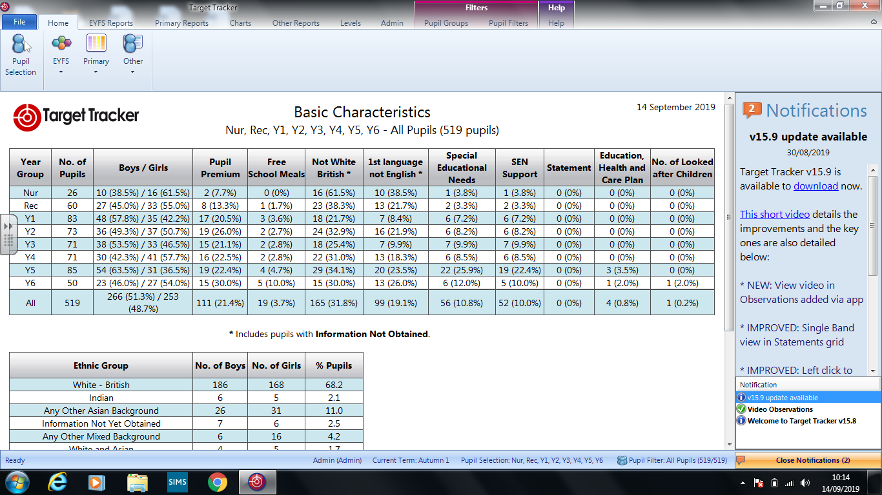

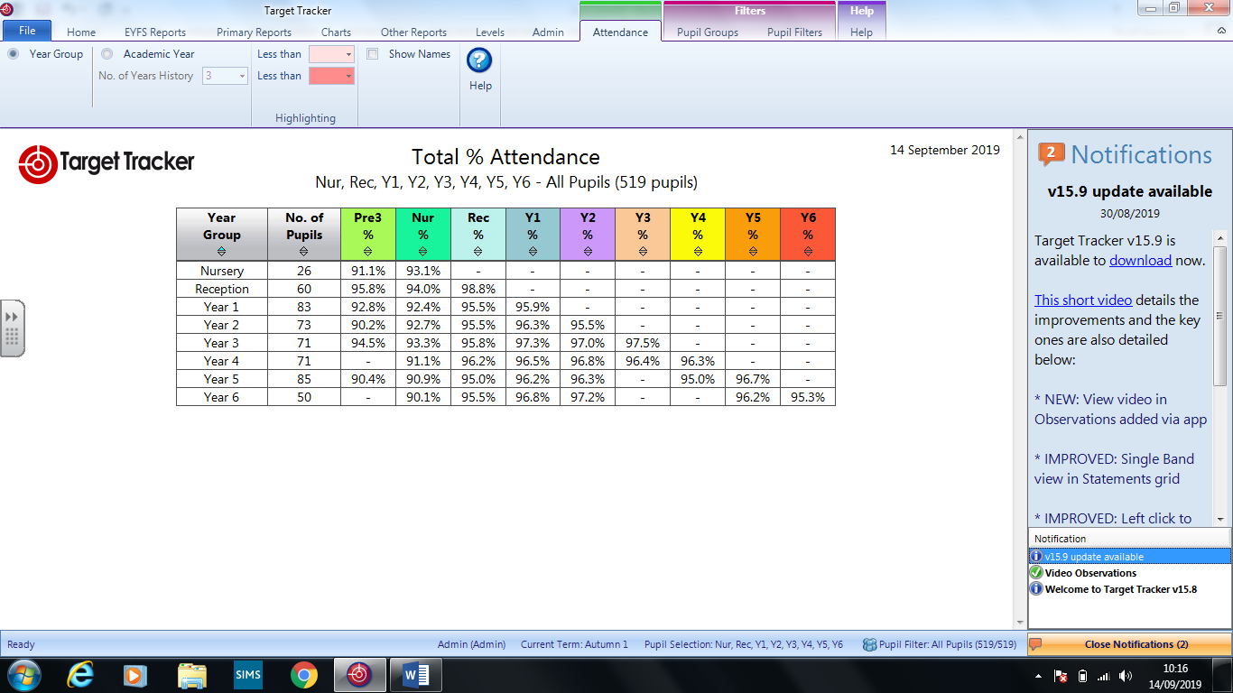

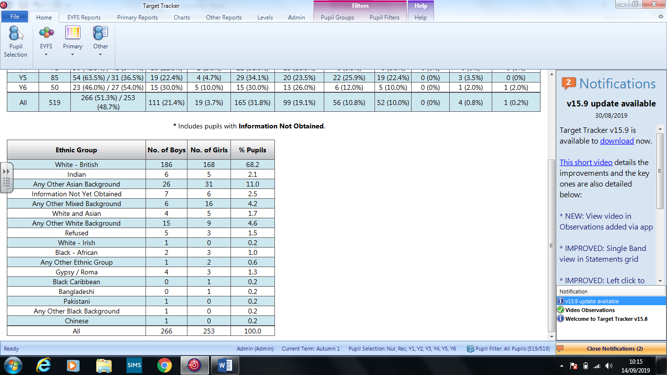

There is one new child who is currently on a child protection plan in Year 3. I have attended the initial transition conference (child handed over from West Sussex LA) and the child has settled well into school.

This now brings the total of pupils on a child protection plan to 2. Both are new families to the area and our school.

2 other children remain on a child in need plan

Mrs Collin or I attend all core and conference meetings.

There have been no exclusions in these first few weeks and behaviour is good across the school.

The school received 27 new children over the summer holidays across most year groups. This was particularly evident in Year 3 where 10 new children were expected. However, currently only 6 have started in this year group to date and 2 children have also left over the summer which was not expected. We are also expecting another 4 children to leave before Christmas. This will retain class sizes of around 33.

Up until Christmas the Year 3 children are being taught for 80% of the week in three learning groups where each group only has a maximum of 24 pupils. Mrs Gaylard is currently the additional teacher in Year 3 and supports one of the learning groups. The classes will remain as two registration forms so long as numbers after Christmas numbers are not exceeding 36 per class. Should we receive more Year 3 pupils then Mrs Gaylard will be required to take full class responsibility for one of the learning groups and this will become the third class in Year 3. However, I rather feel that the numbers will lessen over time as we are aware that several RMA children are due postings with their families. This will then reduce the numbers and make class sizes manageable as two from February half term. I shall of course update each term on this changing profile.

Mrs Harding has not returned to wok following the summer break and has been signed off sick until the Week beginning October 8th. This has meant that Mrs Faircloth is now teaching Monday and Tuesday to provide Squirrel class with continuity. Although Mrs Harding is expected to return to work it will only be for a few weeks up until Christmas and therefore the impact will be minimal for the children. Mrs Sudan Tait has kindly returned to provide three days of supply cover as both Mrs Gaylard and Mrs Faircloth were scheduled to cover PPA for other staff members.

The first safeguarding team meeting was held on September 7th and as an outcome staff will be receiving regular updates from Fiona Mitchell regarding children, practice and information to assist supporting Keeping children Safe in Education. Staff have received a the NSPCC briefing paper on the key updates to statutory guidance for schools in England September 2019 The Department for Education (DfE) has published an updated version of the statutory guidance Keeping children safe in education (DfE, 2019a), which revises the 2018 guidance. This came into force for schools in September 2019. It sets out what schools and colleges in England must do to safeguard and promote the welfare of children and young people under the age of 18. The LA has sent the model Safeguarding Policy out to schools and the policy for ratification today includes all the updated areas.

|  |  |
| --- | --- |
|  | **Sig above national (+10%)** |
|  | **Above national** |
|  | **Broadly in line (+/- 4%)** |
|  | **Below National (-5-9%)** |
|  | **Sig below national (-10%+)** |

**College Town Primary School Outcomes Overview 2017-19**

**EYFS**

|  |  |  |  |
| --- | --- | --- | --- |
|  | % Reaching GLD | | |
| 2017 | 2018 | 2019 |
| School | 73(-9) | 82 (+9) | 82(=) |
| National | 71 | 72 | 72 |
| Difference | +2 | +10 | +10 |

**Phonics**

|  |  |  |  |
| --- | --- | --- | --- |
|  | % Reaching Expected Standard | | |
| 2017 | 2018 | 2019 |
| School | 88(+2) | 76 (-12) | 79(+3) |
| National | 81 | 83 | 82 |
| Difference | +7 | -7 | -3 |

**Key Stage 1**

% Reaching Expected Standard

|  |  |  |  |  |  |  |  |  |  |  |  |  |
| --- | --- | --- | --- | --- | --- | --- | --- | --- | --- | --- | --- | --- |
|  | Reading | | | Writing | | | Maths | | | RWM | | |
|  | 2017 | 2018 | 2019 | 2017 | 2018 | 2019 | 2017 | 2018 | 2019 | 2017 | 2018 | 2019 |
| School | 73 (-13) | 93(+20) | 78(-15) | 66(-9) | 84(+18) | 60(-24) | 75(-5) | 86(+11) | 71 (-15) | 63(-11) | 83 (+20) | 56(--27) |
| National | 76 | 76 | 75 | 68 | 70 | 69 | 75 | 76 | 76 | 64 | 65 | 65 |
| Difference | -3 | +17 | +3 | -2 | +14 | -9 | 0 | +10 | -5 | -1 | +18 | -9 |

% Reaching Greater Depth

|  |  |  |  |  |  |  |  |  |  |  |  |  |
| --- | --- | --- | --- | --- | --- | --- | --- | --- | --- | --- | --- | --- |
|  | Reading | | | Writing | | | Maths | | | RWM | | |
|  | 2017 | 2018 | 2019 | 2017 | 2018 | 2019 | 2017 | 2018 | 2019 | 2017 | 2018 | 2019 |
| School | 46(+6) | 55 (+9) | 38(-17) | 30(+4) | 37 (+7) | 18(-19) | 34(+2) | 43 (+9) | 22(-21) | 28(+3) | 30 (+2) | 16(-14) |
| National | 25 | 26 | 25 | 16 | 16 | 15 | 21 | 22 | 22 | 11 | 12 | 11 |
| Difference | +21 | +29 | +13 | +14 | +21 | +3 | +13 | +21 | = | +17 | +18 | +5 |

**Key Stage 2**

% Reaching Expected Standard

|  |  |  |  |  |  |  |  |  |  |  |  |  |  |  |  |
| --- | --- | --- | --- | --- | --- | --- | --- | --- | --- | --- | --- | --- | --- | --- | --- |
|  | Reading | | | Writing | | | Maths | | | GPS | | | RWM | | |
|  | 2017 | 2018 | 2019 | 2017 | 2018 | 2019 | 2017 | 2018 | 2019 | 2017 | 2018 | 2019 | 2017 | 2018 | 2019 |
| School | 55(-15) | 75 (+20) | 73(-2) | 64(-1) | 77 (+13) | 76(-1) | 53(-3) | 69 (+16) | 80( +11) | 60(-12) | 77 (+17) | 82(+5) | 44(+4) | 61 (+17) | 64 (+3) |
| National | 71 | 75 | 73 | 76 | 78 | 78 | 75 | 76 | 79 | 77 | 78 | 78 | 61 | 64 | 65 |
| Difference | -16 | = | = | -12 | -1 | -2 | -22 | -7 | +1 | -17 | -1 | +4 | -17 | -3 | -1 |

% Reaching Greater Depth

|  |  |  |  |  |  |  |  |  |  |  |  |  |  |  |  |
| --- | --- | --- | --- | --- | --- | --- | --- | --- | --- | --- | --- | --- | --- | --- | --- |
|  | Reading | | | Writing | | | Maths | | | GPS | | | RWM | | |
|  | 2017 | 2018 | 2019 | 2017 | 2018 | 2019 | 2017 | 2018 | 2019 | 2017 | 2018 | 2019 | 2017 | 2018 | 2019 |
| School | 16(+4) | 23 (+7) | 15 (-18) | 6(-12) | 13 (+7) | 2(-11) | 6(-1) | 19 (+13) | 9 -10) | 15(+1) | 30 (+15) | 36 (+6) | 2(-2) | 5(+3) | 0(-5) |
| National | 25 | 28 | 27 | 18 | 20 | 20 | 23 | 23 | 27 | 31 | 34 | 36 | 9 | 10 | 11 |
| Difference | -9 | -5 | -12 | -12 | -7 | -18 | -17 | -4 | -18 | -16 | -4 | = | -7 | -5 | -11 |

**Key Stage 1-2 Progress**

|  |  |  |  |  |  |  |  |  |
| --- | --- | --- | --- | --- | --- | --- | --- | --- |
| Reading | | | Writing | | | Maths | | |
| 2017 | 2018 | 2019 | 2017 | 2018 | 2019 | 2017 | 2018 | 2019 |
| -2.6 | -1.8 | -2.06 | -2.1 | -1.6 | -3.51 | -4.2 | -2.4 | -3.05 |

**Outcomes for Disadvantaged Pupils**

|  |  |  |  |  |  |  |
| --- | --- | --- | --- | --- | --- | --- |
|  | 2017 | | 2018 | | 2019 | |
|  | Disadvantaged  (3) | Non-Disadvantaged  () | Disadvantaged  (4) | Non-Disadvantaged  () | Disadvantaged  (3) | Non-Disadvantaged  () |
| **EYFS - % achieving GLD** | **67** | **73** | **75** | **82** | **100** | **82** |
|  | 2017 | | 2018 | | 2019 | |
|  | Disadvantaged  (2) | Non-Disadvantaged  () | Disadvantaged  (3) | Non-Disadvantaged  () | Disadvantaged  (4) | Non-Disadvantaged  () |
| **Phonics - % achieving expected standard** | **100** | **88** | **100** | **75** | **75** | **80** |

**Key Stage 1**

|  |  |  |  |  |  |  |  |  |  |  |  |  |
| --- | --- | --- | --- | --- | --- | --- | --- | --- | --- | --- | --- | --- |
|  | Reading | | | | Writing | | | | Maths | | | |
| Disadvantaged  School | | | Non-disadvantaged  National  2019 | Disadvantaged  School | | | Non-disadvantaged  National  2019 | Disadvantaged  School | | | Non-disadvantaged  National  2019 |
| 2017  () | 2018  (3) | 2019  (3) | 2017  () | 2018  (3) | 2019  (3) | 2017  () | 2018  (3) | 2019  (3) |
| **% achieving the expected standard** | 40 | 100 | 100 | 78 | 40 | 66.7 | 100 | 73 | 40 | 100 | 100 | 79 |

**Key Stage 2**

|  |  |  |  |  |  |  |  |  |  |  |  |  |  |  |  |  |  |
| --- | --- | --- | --- | --- | --- | --- | --- | --- | --- | --- | --- | --- | --- | --- | --- | --- | --- |
|  | Reading | | | | | | | | Writing | | | | | Maths | | | |
| Disadvantaged  School | | | | | | | Non-disadvantaged  National  2019 | Disadvantaged  School | | | | Non-disadvantaged  National  2019 | Disadvantaged  School | | | Non-disadvantaged  National  2019 |
| 2017  (8) | | 2018  (9) | | | 2019  (12) | | 2017  (8) | | 2018  (9) | 2019  (12) | 2017  (8) | 2018  (9) | 2019  (12) |
| **% achieving the expected standard** | 50 | | 56 | | | 58 | | 78 | 63 | | 78 | 67 | 83 | 38 | 56 | 67 | 84 |
|  | | GPS | | | | | | | |
| Disadvantaged  School | | | | | Non-disadvantaged  National  2019 | | |
| 2017  (8) | | 2018  (9) | 2019  (12) | |
| **% achieving the expected standard** | | 38 | | 66.7 | 75 | | 83 | | |

**Key Stage 1-2 Progress**

|  |  |  |  |  |  |  |  |  |  |
| --- | --- | --- | --- | --- | --- | --- | --- | --- | --- |
|  | Reading | | | Writing | | | Maths | | |
| 2017 | 2018 | 2019 | 2017 | 2018 | 2019 | 2017 | 2018 | 2019 |
| Disadvantaged () | **+1.2** | **-5.7** | **-1.96** | +0.1 | **-1.8** | **-2.70** | **-2.7** | **-4.8** | **-3.79** |
| Non-Disadvantaged () | **-3.4** | **-1.1** | **-2.09** | **-2.5** | **-1.6** | **-3.77** | **-4.5** | **-2.1** | **-2.81** |

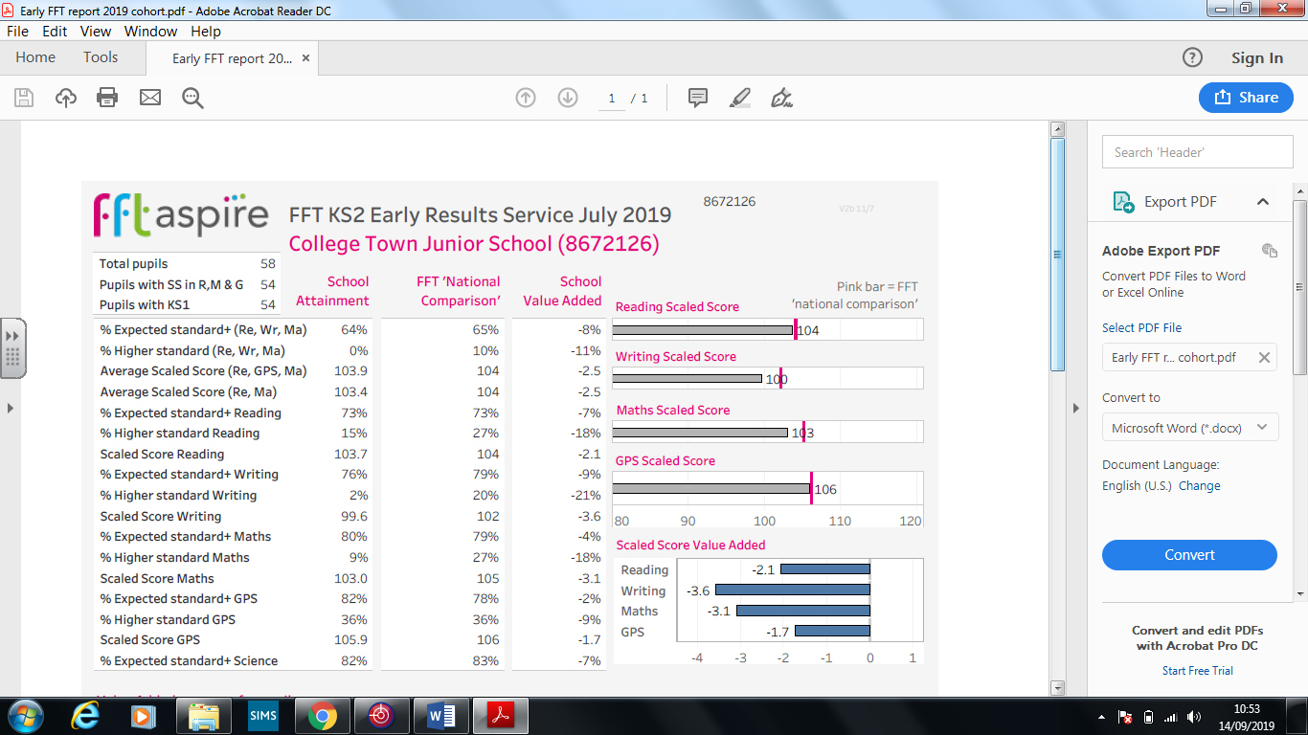

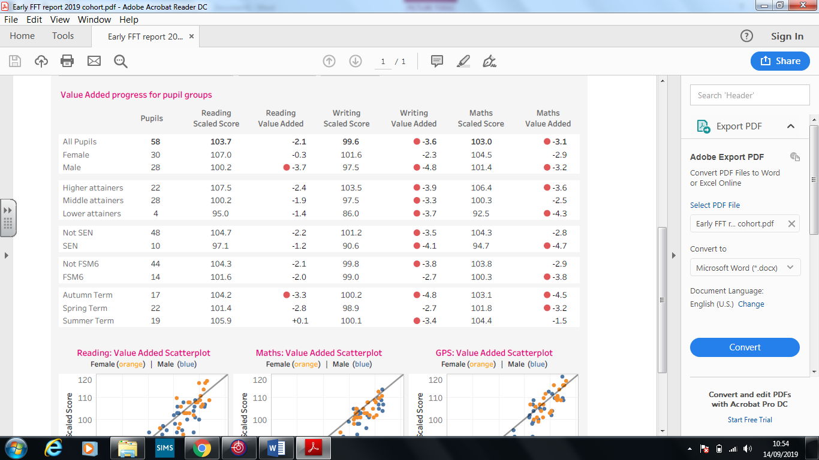

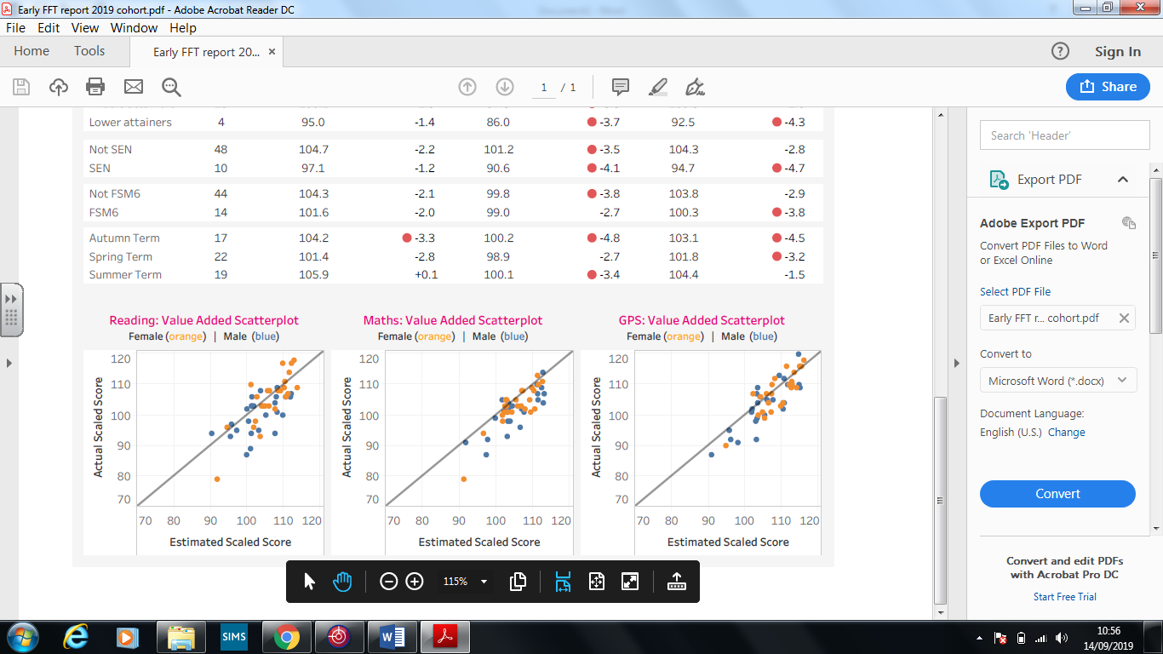

**SDP**

**Objective 1: Improve pupil outcomes by raising standards and ensuring progress in core areas of the curriculum for all groups of pupils**

* To further improve pupils’ attainment in writing across the school ensuring that the vast majority of pupils achieve ARE and maintain good rates of progress, 2019 1.5% Greater depth target 2020 & 2021 to be in line with national and local averages
* To further improve pupils’ attainment in mathematics across the school ensuring that the progress measures are reduced from -3.5 (2019) to -1.5 2020 and by 2021 be at 0 or +

**Objective 2: Improve the impact of mathematical teaching on learning & pupil progress**

* Ensure all teaching is at least good and a significant proportion (50%) is outstanding
* Develop further the impact of the teacher’s planning of maths for pupils’ learning outcomes, progress and achievement
* Develop the progress and application of learning for pupils with additional needs (SEND)

**Objective 3 Improve the use of formative and summative assessment information so that progress and the proportions of pupils meeting the standard are accurately measured (summative) and so that pupils are clear as to the next steps in their learning (formative)**

* Ensure the school’s own assessment and moderation is used consistently throughout the school for reading, writing and mathematics to accurately reflect pupils’ progress and attainment
* Develop and refine the assessment of all core subjects in line with the KS1 & KS2 end of year expectations
* Develop and refine the use of formative and summative assessment in Foundation subjects with the introduction of target tracker

**Objective 4: Improve key aspects of leadership, management and governance**

* Build and develop the quality of senior leaders throughout the new primary to effectively support the critical work and responsibilities of the GB
* Build and develop the role and effectiveness of middle leaders in the new primary so that they are enabled to develop and drive a purposeful and engaging curriculum
* Develop and enable teachers to become confident and effective subject leaders

**(SDP 2019 – 2021 for ratification)**

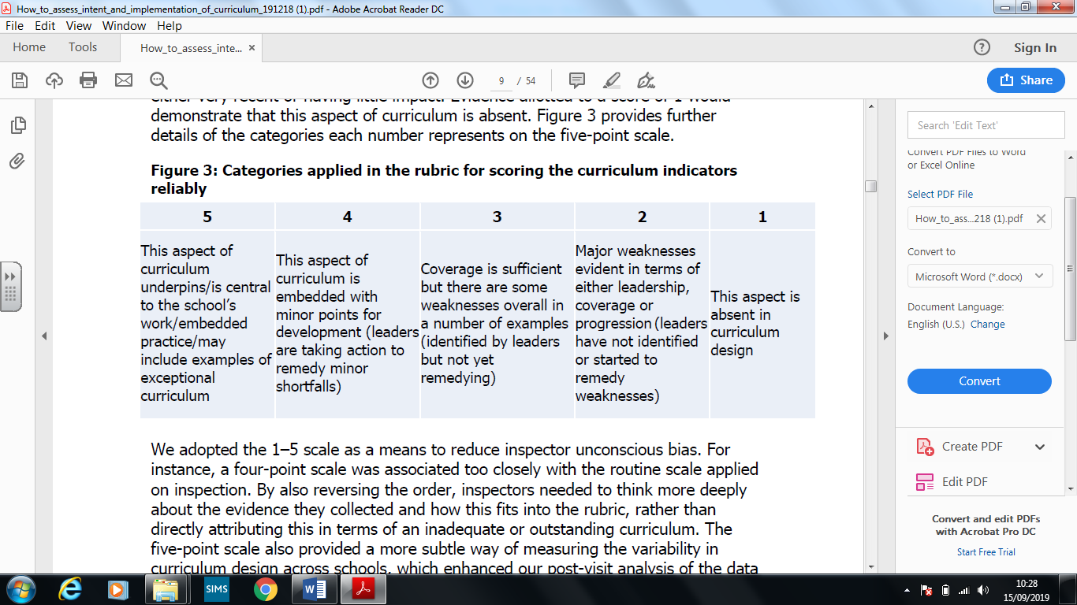

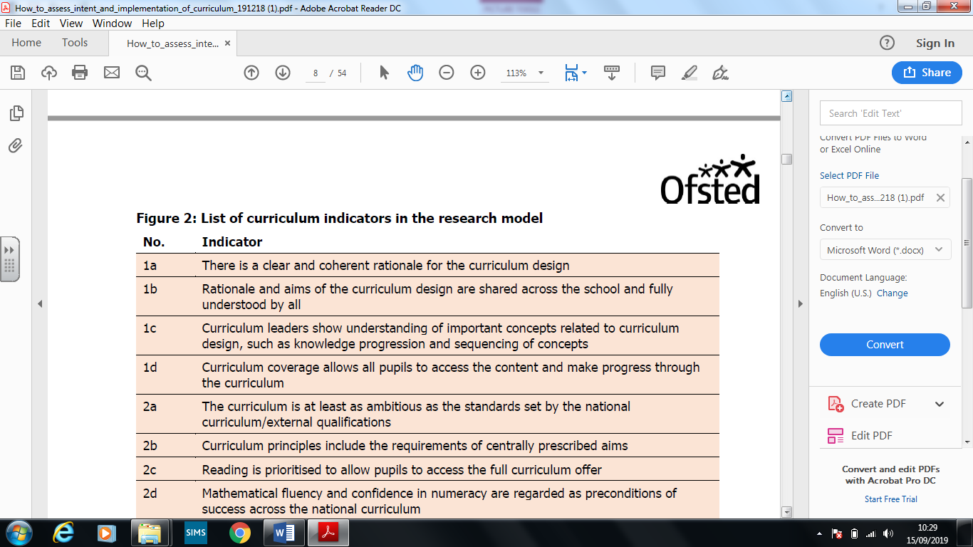  
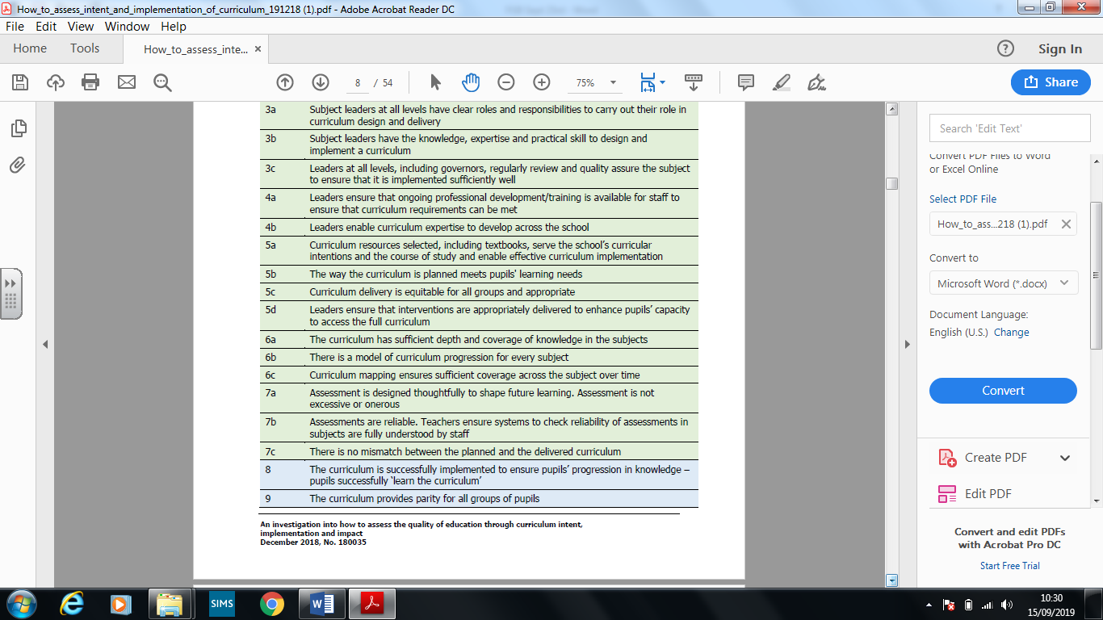

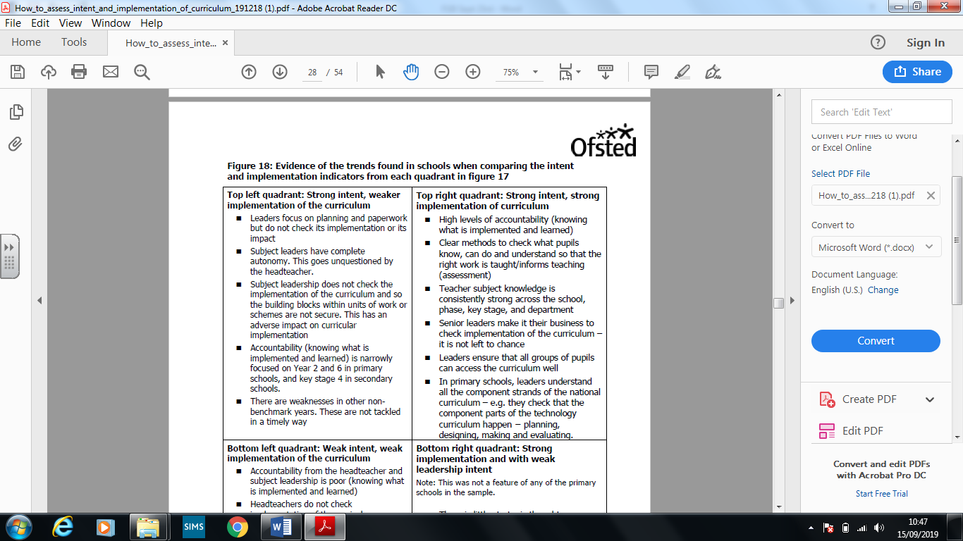

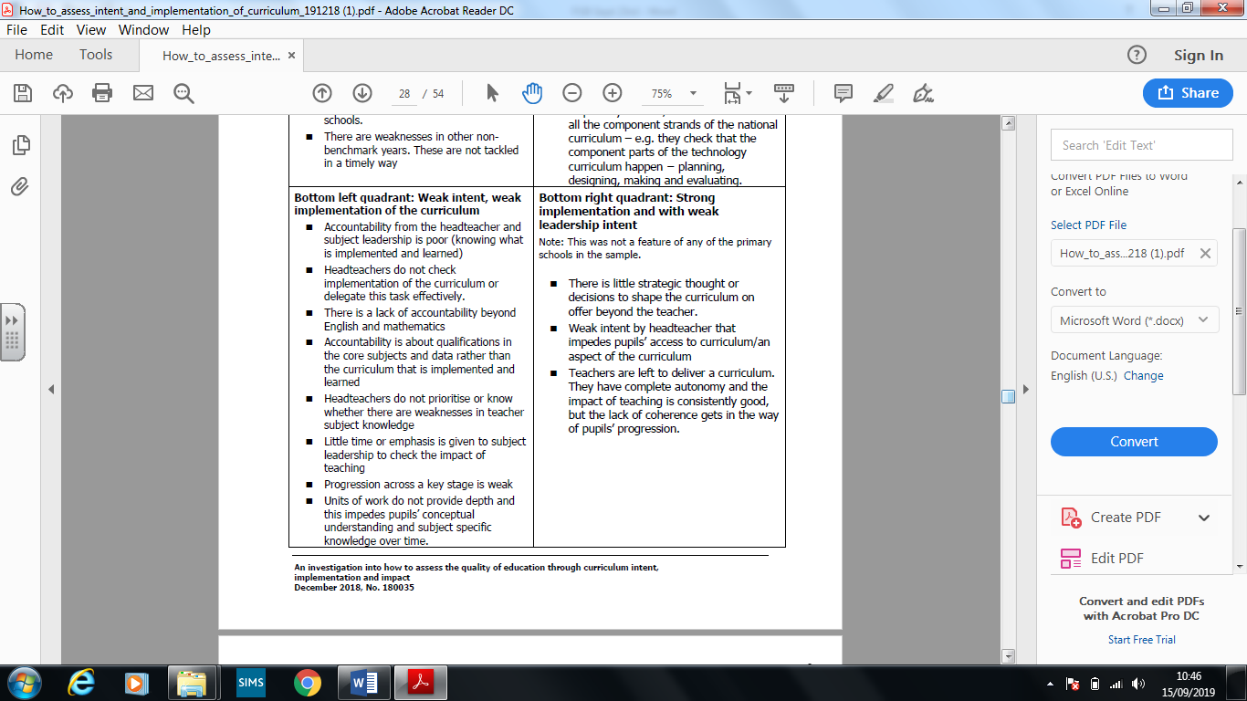

Performance Management

All staff other NQTs will have performance targets involving the development of the curriculum with a specific focus on the subject area that they are leading. To enable teachers adequate directed time the 1265 hours have been revised and the off -set INSET sessions (18 hours) will be used to develop their areas. This will enable the school to have a robust system of distributed leadership by July for our curriculum. All teacher performance reviews and new targets will be completed by the statutory deadline of 31st October.

Using the time from the INSET sessions ensures that as a school due regard s given to teacher workload. To develop curriculum expertise consider CPD time has been allocated and the staff will have access to the usual primary CPD sessions delivered throughout the year by the LA.

Target tracker

All pupils are now on the systems and training for staff was delivered in May. Further sessions will be allocated for staff to get to grips with the system although it appears an easier system than the SPTOP previously used. The assessment policy has been updated to support the new system and is attached for approval. The assessment system provides updates for parents which will ensure a clear understanding for parents as to where their child/ren are in relation to national average/ expectations.

Overleaf are a few examples of the reports which can be used for parents, staff and to present to the GB.

**Individual Pupil Report – This will be sent home in January 2020**

