

HEALTH AND SAFETY POLICY

Approved Date | Sept 2018
Approved At | FGB Sept 2018
Reviewed by governors | Sept 2019
Date of Next Review | Sept 2020
Statutory | YES
Adopted from Bracknell Forest | NO

HEALTH AND SAFETY POLICY

Statement of Health and Safety Policy

This statement is issued in accordance with the Health and Safety at Work Act (1974). It supplements the statements of Health and Safety Policy which have been written by Bracknell Forest Borough Council and by the Education Department. The general aims of these policy statements are accepted and the arrangements set out below are designed to implement the general aims at College Town Infant and Nursery School.

GENERAL POLICY ON HEALTH AND SAFETY

It is the policy of the Governing Body, so far as is reasonably practicable, to:

- Establish and maintain a safe and healthy environment throughout the school.

- Establish and maintain safe working procedures among staff and pupils.

- Make arrangements for ensuring safety and absence of risks to health in connection with the use, handling, storage and transport of articles and substances.

- Ensure the provision of sufficient information, instruction and supervision to enable all employees and pupils to avoid hazards and contribute positively to their own health and safety at work and to ensure that they have access to health and safety training as appropriate or as and when provided.

- Maintain any place of work under the control of the Governors and Head of the Establishment in a condition that is safe and without risk to health and to provide and maintain means of access to and from that place of work that are safe and without risk.

- Review Emergency Plan for procedures to follow in case accident or threat of health or safety to children, staff, parents and carers.

- Teach safety as part of childrens’ learning where appropriate.

- Provide and maintain adequate welfare facilities and to make recommendations to Bracknell Forest Borough Council as appropriate.

RESPONSIBILITY OF THE GOVERNORS AND HEAD OF ESTABLISHMENT

- The Governors and Head are responsible for implementing this policy within the school. In particular they will:

- Monitor the effectiveness of the health and safety policy and the safe working practices described within it and shall revise and amend it, as necessary, on a regular basis.

- Prepare an emergency plan outlining evacuation procedures and arrange for periodic practice evacuation drills.

- Make arrangements to draw the attention of all staff employed at the school to the safety policies and procedures and of any relevant safety guidelines and information issued by the Authority, e.g. Broadmoor Escape Procedures (see Appendices).

- Make arrangements for the implementation of the Authority’s online accident reporting procedure and draw this to the attention of all staff at the school as necessary.

- Accident books are kept in medical bags. Any near miss incidents or accidents requiring medical attention must be reported to the main office to ensure that the leadership team ensure that the correct procedure according to BFC is followed.

- Any head injury is reported to the main office to ensure that pa\rent are informed. The child goes home with the duplicate report for any minor or major incident or head injury. These MUST be written in professional language and provide adequate detail.

- Make arrangements for informing pupils, students and other users of the school of relevant safety procedures.

- Liaise with the site controller to arrange for the withdrawal, repair or replacement of any item of furniture, fitting or equipment identified as being unsafe.

- Report to the Education Property Management Section at Bracknell Forest Borough Council any defect in the state of repair of the buildings or their surrounds which is identified as being unsafe and make such interim arrangements as are reasonable to limit the risk entailed.

N.B The Governing Body will deal with all aspects of building maintenance which are under their direct control. Regular walk rounds are undertaken with the Site controller.

- Report to the Chief Education Officer any other situation identified as being unsafe or hazardous and which cannot be remedied within the financial resources available to them.

- Monitor, within the limits of their expertise, the activities of contractors (in liaison with the staff of the Bracknell Forest Borough Council Property Department in respect of building contractors and the Contract Services Management Unit in respect of cleaning, catering or grounds maintenance contractors), hirers and other organisations present on site, as far as is reasonably practicable.

Identify any member of staff having direct responsibility for particular safety matters (e.g. subject leader, teacher with specific management responsibilities, site manager/controller).

DUTIES OF THE PERSON RESPONSIBLE FOR THE MANAGEMENT OF HEALTH AND SAFETY

(In consultation with the Governor Body)

- Assist the Headteacher in the implementation, monitoring and development of the safety policy within the school.

- Monitor general advice on safety matters given by the Authority and other relevant bodies and advise on its application to the school.

- Co-ordinate arrangements for safe working practices related to design and making widely known within the school.

- Investigate any specific health and safety problem identified within the school and take or recommend (as appropriate) remedial action.

- Arrange and regularly review risk assessments at least annually, to identify unsafe working cases on health and safety grounds. This should be on a temporary basis subject to further consideration by the Governors.

- Carry out regular safety inspections of the school and its activities and eliminate potential hazards and make recommendations on methods of resolving any problems identified.

- Ensure that staff with control of resources (both financial and other) give due regard to safety needs.

- Co-ordinate arrangements for the dissemination of information and for the instruction of employees, students, pupils and visitors on safety matters and to make recommendations on the extent to which staff are trained.

N.B. The above role must not be confused with that of the Health and Safety Representative at the school which is a Trade Union appointment to enable the representation of staff interests in health and safety matters.

RESPONSIBILITIES OF STAFF TOWARDS PUPILS AND OTHERS IN THEIR CARE

All staff are responsible for the health and safety arrangements in relation to staff, children and volunteer helpers under their supervision. In particular, they will monitor their own teaching and learning and take all reasonable steps to:

- Exercise effective supervision over all those for whom they are responsible, most importantly the children.

- Be aware of and implement safe working practices and to set a good example personally.

- Identify actual and potential hazards and introduce procedures to minimise the possibility of mishap.

- Ensure that any equipment or tools used are appropriate to that use and meet accepted safety standards.

- Provide written job instructions, warning notices and signs as appropriate.

- Ensure that regular safety inspections are undertaken.

- Provide appropriate protective clothing and safety equipment as necessary and ensure that these are used as required.

- Minimise the occasions when an individual is required to work in isolation, particularly in a hazardous situation or on a hazardous process.

- Evaluate promptly and where appropriate, take action on criticism of health and safety arrangements.

- Provide the opportunity for discussion of health and safety arrangements.

- Investigate any accident (or incident where personal injury could have arisen) and take appropriate corrective action.

- Provide for adequate instruction, information and training in safe working methods and recommend suitable ‘off the job’ training.

N.B. When any members of staff consider that corrective action is necessary but that this lies outside the scope of their authority they should refer the problem to their own immediate line manager/team leader, then the Headteacher.

RESPONSIBILITIES OF ALL EMPLOYEES – H&S non negiotables

All employees have a responsibility under the Act to:

- Take reasonable care for the health and safety of themselves and of any person who might be affected by their acts or omissions at work.

- Co-operate with the Chief Education Officer and others in meeting statutory requirements.

- Not interfere with or misuse anything provided in the interests of health, safety and welfare.

- Make themselves aware of all safety rules, procedures and safe working practices applicable to their posts; where in doubt they must seek immediate clarification from their line manager/team leader.

- Ensure that tools and equipment are in good condition and report any defects to the co-ordinator.

- Use protective clothing and safety equipment provided and ensure that these are kept in good condition.

- Ensure that offices, general accommodation and kitchen areas are kept tidy.

- Ensure that any accidents, whether or not an injury occurs, and potential hazards are reported to the Headteacher.

WHENEVER AN EMPLOYEE IS AWARE OF ANY POSSIBLE DEFICIENCIES IN HEALTH AND SAFETY ARRANGEMENTS, HE/SHE MUST DRAW THESE TO THE ATTENTION OF THE HEADTEACHER

Note the following:

- It must be realised that newly appointed employees could be particularly vulnerable to any risk and it must be ensured that all relevant health and safety matters are drawn to their attention at an early stage during their induction programme.

- Whilst it is a management responsibility to instruct all employees in safe working procedures in relation to their posts and work places, employees may from time to time find themselves in unfamiliar environments. In such cases, the employee concerned should be particularly alert for hazards, and whenever possible, ensure they are accompanied by a person familiar with the environment or that they are advised of specific hazards.

- All volunteer helpers will be expected to meet the standards required by employees.

RESPONSIBILITIES OF PUPILS

All children are expected to:

- Exercise personal responsibility for the safety of themselves and others.

- Observe standards of dress consistent with safety and/or hygiene (this would preclude unsuitable footwear, unsuitable earrings (studs and small sleepers permitted), and other items which would be considered dangerous).

- Observe all the safety rules of the school and in particular the instructions of the teaching staff in the event of an emergency.

- Use and not wilfully misuse, neglect or interfere with things provided for safety purposes.

N.B. The Governors and Head of Establishment will make pupils (and where appropriate the parent/carer) aware of these responsibilities through direct instruction, notices and the school handbook.

THE INVOLVEMENT OF TRADE UNIONS

Recognised Trade Unions may appoint safety representatives and the name(s) of the person(s) so appointed are posted.

The functions of a safety representative, as agreed by the Authority and the Trade Unions are to:

- Keep him/herself informed of legal requirements on health and safety at work and the Authority’s arrangements meeting these.

- Keep him/herself informed of any hazards at College Town Primary School and the measures by which they may be minimised or eliminated.

- Undertake termly safety inspections of the school at agreed times and draw any defects to the Headteacher’s attention.

- Inspect a potential hazard, new piece of machinery, work process, the scene of an accident as required and recommend any corrective action necessary to the Headteacher.

- Report any continuing health and safety problems to the Chief Education Officer. Problems and matters of general interest can also be reported to the Trade Union Panel of the Education Department Safety Committee. (If necessary, advice on how to make this contact can be obtained from the departmental safety officer).

SECURITY/VISITORS

Regular visitors and other users of the premises (e.g. contractors and delivery personnel) must be required to observe the safety rules of the school.

- All visitors/parent helpers should report to the School Office and where necessary (in direct contact with children) to hand in mobile phones; these will be collected on leaving. All visitors will be signed in and given a ‘Visitor’ ID badge or helper badge. They will sign out on leaving. The exception to this rule will be where parent/carer requires a quick (less than five minutes) word with the teacher at the beginning or end of the school day. Regular parent helpers are required to complete a DBS check which the School Business Manager will update and maintain.

- All staff should question unidentified persons on site, or, if apprehensive, summon a senior member of staff through the use of the red triangle. (kept in every classroom)

- The intruder warning on the main reception door operates throughout the school day.

- All gates (except those for vehicular and one pedestrian access) to be securely closed during the duration of the school day and locked during weekends and holiday periods.

- Teaching staff on playground duty should check that the pedestrian gate is securely shut at the beginning of and throughout break times.

- No child is to leave the premises during the working day without the parent/carer filling in a yellow permission slip signed by the office staff and handed to the teacher.

- All staff should be familiar with the Broadmoor Escape procedures.

LETTINGS

The Governors and Head of Establishment must ensure that:

- The means of access and exit are safe for the use of hirers and that all equipment made available to and used by the hirers is safe (this would include any equipment supplied by the hirer). If the Headteacher knows of any hazard associated with the above s/he should take action to make hirers aware of it.

- Fire escape routes and exits are clearly marked for the benefit of unfamiliar users of the building, particularly during the hours of darkness.

- Hirers of the building are briefed about the location of emergency telephones, fire escape routes, fire alarms and fire fighting equipment. Notices regarding emergency procedures should be prominently displayed.

- Hirers using any equipment or facility provided by the school are familiar with its safe use and if necessary, briefed accordingly.

- It is the hirer’s responsibility to ensure that equipment brought onto or used on the school site is safe and fit for the intended purpose.

- Arrangements are made for checking the security and condition of the premises and equipment used after vacation by the hirer or her/his staff.

EMERGENCY PLAN

In the event of an emergency the schools Emergency Plan will be put into place, see separate document.

FIRE AND EVACUATION PROCEDURES

The School’s procedures for fire and emergency evacuation is prominently displayed throughout the school

Arrangements for updating these procedures and displaying them are as follows:

- Procedures are displayed in every room in the school and are updated inspected and reviewed annually.

- The log book for the recording and evaluation of practice and evacuation drills is available at the School Office.

FIRE PREVENTION EQUIPMENT

Arrangements are made to regularly monitor the condition of all fire prevention equipment through the Governor Sites/Building Committee. This would include the regular visual inspection of fire extinguishers and the fire alarm system.

BROADMOOR ESCAPE

The Local Authority operates a cascade system to inform schools of an escape from Broadmoor (See Broadmoor Emergency Procedures flow char.) College Town Primary School is the last school on the cascade list and it is therefore our responsibility to contact Forestcare to inform them that we have received the notification.

All staff should familiarise themselves with the Broadmoor Alarm Procedure guidance to Parents. In the event of the alarm sounding the school will operate as normal. All parents will be contacted to inform them of the escape. No child will be allowed to leave the school premises unless collected by a parent or responsible adult known personally to the school staff, or in exceptional circumstances, a responsible adult known personally to the child.

FIRST AID AND ACCIDENT REPORTING PROCEDURES

Reference should be made to Bracknell Forest Borough Councils Health and Safety Department’s Policy Guidance.

First Aid

Staff are trained in basic emergency first aid and this training is updated at whole school INSETs every few years.

The names of the Appointed First Aider at Work for Adults and qualified Paediatric First Aiders can be found in the staff room. There is one appointed first aider for adults and a number of qualified paediatric first aiders working across the school.

First aid is available in every class, the medical room and the main office. Lunchtime controllers all carry first aid bags during the lunch period to carry out first aid as required. Members of staff also carry a first aid bag on the playground during playtime to deal with minor issues outside.

The arrangements for first aid for sports, outdoor pursuits and field trips are that first aid kits are to be taken and necessary first aid is administered by the teaching staff present.

Gloves are to be worn at all times. All staff should be aware of procedures to be followed concerning body fluids and risks associated with HIV and AIDS.

N.B. Any employee rendering first aid to the best of their ability is indemnified by Bracknell Forest Borough Council.

Incident Reporting

The Headteacher is responsible for administering the incident reporting procedure.

Minor Incidents
All minor incidents/bumps/scrapes are recorded by the staff in the duplicate books in the first aid bags. The top copy is sent home to the parent/carer and the bottom copy is kept in the book for monitoring purposes. Staff need to report all bumps to the head and more serious scrapes, bruises, lumps etc to the office. The lunchtime controllers complete a form at the end of lunchtime and return it to the office informing them of all bumps to the head, major scrapes and bruises.

The office will send a text to the parent/carer for all minor bumps to the head. For more major bumps to the head where a lump/bruise forms the office will contact the parent by telephone. Similarly the parents will be telephoned in the case of large scrapes, serious bruises.

Once a medical book is complete it is returned to the office and a new one issued. All medical books will be kept as defined by the Records Management Policy. The Health and Safety Officer will review the medical logs on a regular basis for any trends.

Major Incidents/Near Misses
The Headteacher is responsible for the notification of serious accidents causing death or major injury and dangerous occurrences or any near misses.

- All accidents, no matter how minor that occurs to members of staff, visitors or contractors are reported to the office using the Schools Incident Report Form.
.
- All completed paper incident report forms must be passed to the Health and Safety officer to assess the incident and carry out any actions/risk assessments deemed necessary.

- Any recommendations or actions already carried out as a result of the incident should be added to the form by the Health and Safety officer, filed for reference for the reviewing manager.

- The reviewing manager reviews the incident and adds any notes to the form. Having completed the review the form will be submitted by the Health and Safety officer by internal post to the councils H&S officer.

- The reviewing manager will note any actions that are to be carried out and ensure that these are put in place within a reasonable timescale.

Accidents to children must be reported in the same way as those to employees and visitors. However, only those accidents to children which are as a result of the schools undertaking, (i.e. as a result of the conditions of the premises, equipment or plant or lack of supervision) need to be reported to the office and recorded online. Those accidents to pupils arising out of activities not connected with the schools undertaking (i.e. activities in the playground such as collisions, slips and trips etc.) need to be recorded in the medical logs.

Major Accidents

Any fatality, major injury, reportable disease or dangerous occurrence must be reported immediately by telephone to the Incident Contact Centre (0845 300 9923) and the Director of the Environment Department (01344 3514000) followed up with a completed F2508. For more detailed information see Section 2 (1) – Accident Reporting Procedures in the Corporate Health, Safety and Welfare Manual of Guidance (yellow binder) which is kept in the school office

OFF SITE ACTIVITIES

All staff should refer to the Off-Site Policy.

HEALTH MATTERS

- Children who are unwell should not attend school.

- When a child becomes ill during the course of the day, s/he should be taken to the school office. After consultation with the parent/carer, the child may be sent home.

- The school will administer medication following the schools Administration of Medicines Procedure. Parents are required to complete a form for all medicines to be administered either long or short term and the forms are filed for retention. Epipens, inhalers etc. are kept in a medicine box in the child’s classroom and taken out as required. All other medicines are kept in the locked fridge in the school office and children come to the office to receive their medication.

- Children suffering from asthma are allowed free access to inhalers. These are kept in each classroom in the medication box.

- Children with headlice: all children in the same class should be given a note to take home at the end of the day, alerting the parent/carer and asking to check the heads of family members.

The Health Authority currently recommends intensive combing treatment and/or a chemical lotion.

- Where a teacher is concerned about any child’s health they should speak to a senior member of staff or the school nurse.

HEALTH AND SAFETY POLICY

NUT ALLERGY GUIDELINES (ANAPHYLAXIS)

- The local Education Authority Health & Safety Officer must be informed if a child is identified as having Anaphylaxis (Nut Allergy).
- At a specially convened meeting between
i) the child’s parent or carer
ii) the LEA Health and Safety Officer
iii) the Headteacher and teaching staff
information will be given about the child’s allergy and strategies or guidelines agreed about their treatment at school.
- All staff who volunteer to administer emergency treatment if needed will have regular (annual) access to training detailing the symptoms and treatment of Anaphylaxis.
- If emergency treatment is administered, then an Accident Report form must be completed
- one copy to be kept at school
- one copy to be sent to the LEA Health & Safety Officer
(NB: Any claim of malpractice of emergency treatment would not be against the individual but against the County Council.)
- The child’s parent/carer is responsible for supplying and renewing Epi-Pens kept at school. Ideally, there should be two Epi-Pens kept at school in clearly defined areas, safely stored but not locked away.
The Epi-Pen should be kept in a zip bag with the child’s name clearly marked on it.
Inside: a photo of the child; instructions for use; details of symptoms
- After administering a dose of adrenaline using an Epi-Pen, it must be handed to the Paramedic for disposal or at a later date given to the School Nurse.
- There will be a photo of the child and instructions for emergency treatment of Anaphylaxis kept in the class register.
- Nut based food products are not allowed in school. This includes sandwich fillings and cereal bars in lunch boxes.

LUNCHTIME HEALTH & SAFETY GUIDELINES
Dinner Controllers

- Dinner controllers will be trained by the Supervisor to allocate roles to staff.
- A rota is drawn up by the Supervisor to allocate roles to staff:
- This will be regularly reviewed and updated (to suit events, i.e. staff shortages, wet play, new intakes of children)
The Supervisor will advise you what to do in the event of change.
- All controllers should speak to the children quietly and calmly; in return children will show respect to their peers. Try not to forget the words please and thank you.
- Be aware of children who are alone in the playground – talk to them and try to find them a friend. Encourage year 2 children to be kind to each other and to set a good example. Only shout in order to prevent an accident. Politely approach any adult who enters the playground and ask if you can assist them. If you are concerned, inform the Supervisor, Head or member of SLT immediately.
- Children must not be taken out of school without reporting and receiving approval of the Headteacher (a yellow permission slip is issued by the Office and should be handed to the Supervisor)
- It is very important that everyone wears their overall and badge as identification.
- Try to avoid supervising your own children in order to be fair to them and yourselves.
- Children are used to walking quietly in an orderly line with their teachers, so they do know how and you must insist that they continue to do this at lunch time – praise and encourage good behaviour.
- Do not discuss individual children with anyone outside the school. Report any serious concerns to the Supervisor who will inform the Headteacher.
- Remember to listen to children who think they have a problem – what seems small and silly to us can be crucial to them. Always listen to both sides of stories when there is an argument/incident.
- Refer to the School Code of Conduct. All children are aware that it should be followed at all times.

College Town Primary School
Earring Disclaimer

I …………………………………………………………………………………, being the parent or legal guardian of ………………………………………………………………. , hereby accept full responsibility for any injury caused to my child due to them wearing earrings. I also accept full responsibility for the loss of any earring worn by my child.

I have had brought to my attention the dangers of my child wearing earrings at school and realise that even under the most careful supervision, children sometimes get involved in rough and tumbles, with the risk of the earring becoming caught and the ear lobe being torn.

I understand that during P.E. earrings are not to be worn and must be removed by the child for the session or more preferably arrive at school on PE days with no earrings. The removal of earrings prior to your child arriving at school also reduces the risk of earrings becoming lost. If a child comes to school on PE days with earrings in their ears they will be required to remove them. Where children are unable to remove their own earrings they will be required to tape them with medical tape.

Where children do have pierced ears there are a few rules designed for your child’s safety:
- Only SMALL SLEEPERS OR SIMPLE STUDS may be worn as there is less risk of injury than with a loop style.
- Earrings should be removed for PE, or covered with tape if removal is not possible.
- During the initial period following piercing where the removal may not be suitable the earrings may be covered by medical tape.

I agree to fully indemnify Bracknell Forest Borough Council and any school my child attends whatever its maintained status and any agents or employees of the council or school against any such injury.

Signed:………………………………………………………………
(Parent or Legal Guardian)

Date: ………………………………………………………………

Date Ears Pierced:……………………………………………….

COLLEGE TOWN PRIMARY SCHOOL

MANAGEMENT OF ANAPHYLAXIS

 Never leave the child alone
 Call for assistance
 Keep calm and reassure the child
 If the child is breathless, allow him to sit up and attempt to keep him calm
 If the child is feeling faint, dizzy or apprehensive, lie him flat with raised legs.
- If collapsed and unconscious, protect the airway; check for a pulse
- If pulse is absent commence cardiopulmonary resuscitation

- Trained person to administer Adrenaline, (Epipen/Anapen)
- REMEMBER TO NOTE THE TIME GIVEN
- Should the child’s symptons have been mistaken, the adminstration of Adrenaline should cause no ill effects to the child

- Contact Ambulance Service (999), state that: “Child with known allergy has had an Anaphylactic reaction and has been given Adrenaline”
- Give the name, address and postcode of the school
- Give details of access to the school

- Inform the child’s parent/carer as soon as possible, and inform the child’s GP (by letter)
- Give used Epipen to Ambulance staff
- Inform School Health Sister
- Complete Accident report form for the Health and Safety officer in the Education Department
Ensure parent/carer replaces Epipen/Anapen before the child returns to school

COLLEGE TOWN PRIMARY SCHOOL

SIGNS AND SYMPTONS OF A SEVERE
ALLERGIC REACTION

 Feeling faint or dizzy

 Sweating

 Headache

 The sensation of a lump in the throat

 Hoarseness

 Difficulty with breathing – indicating swelling of vocal cords leading to obstruction of airway

 Swelling around the lips and eyes

 Rash or production of hives

 Possible diarrhoea and vomiting

 In severe reactions

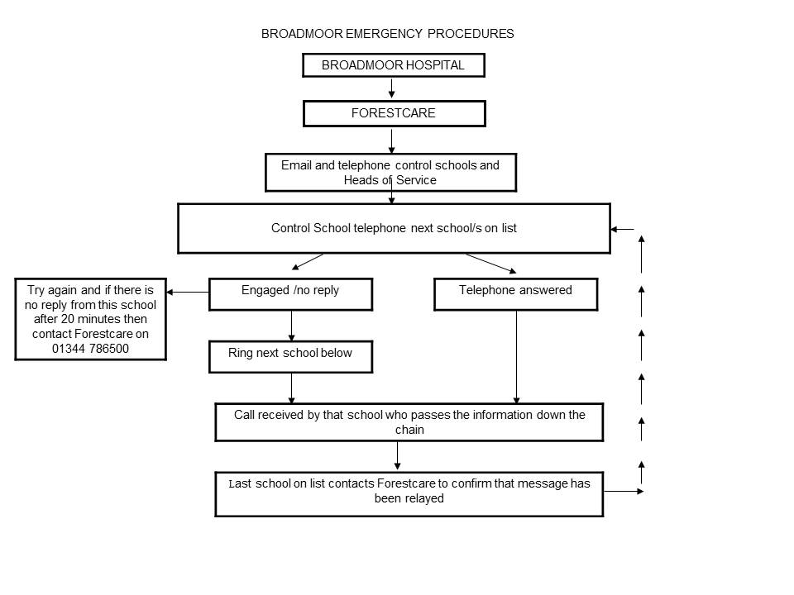
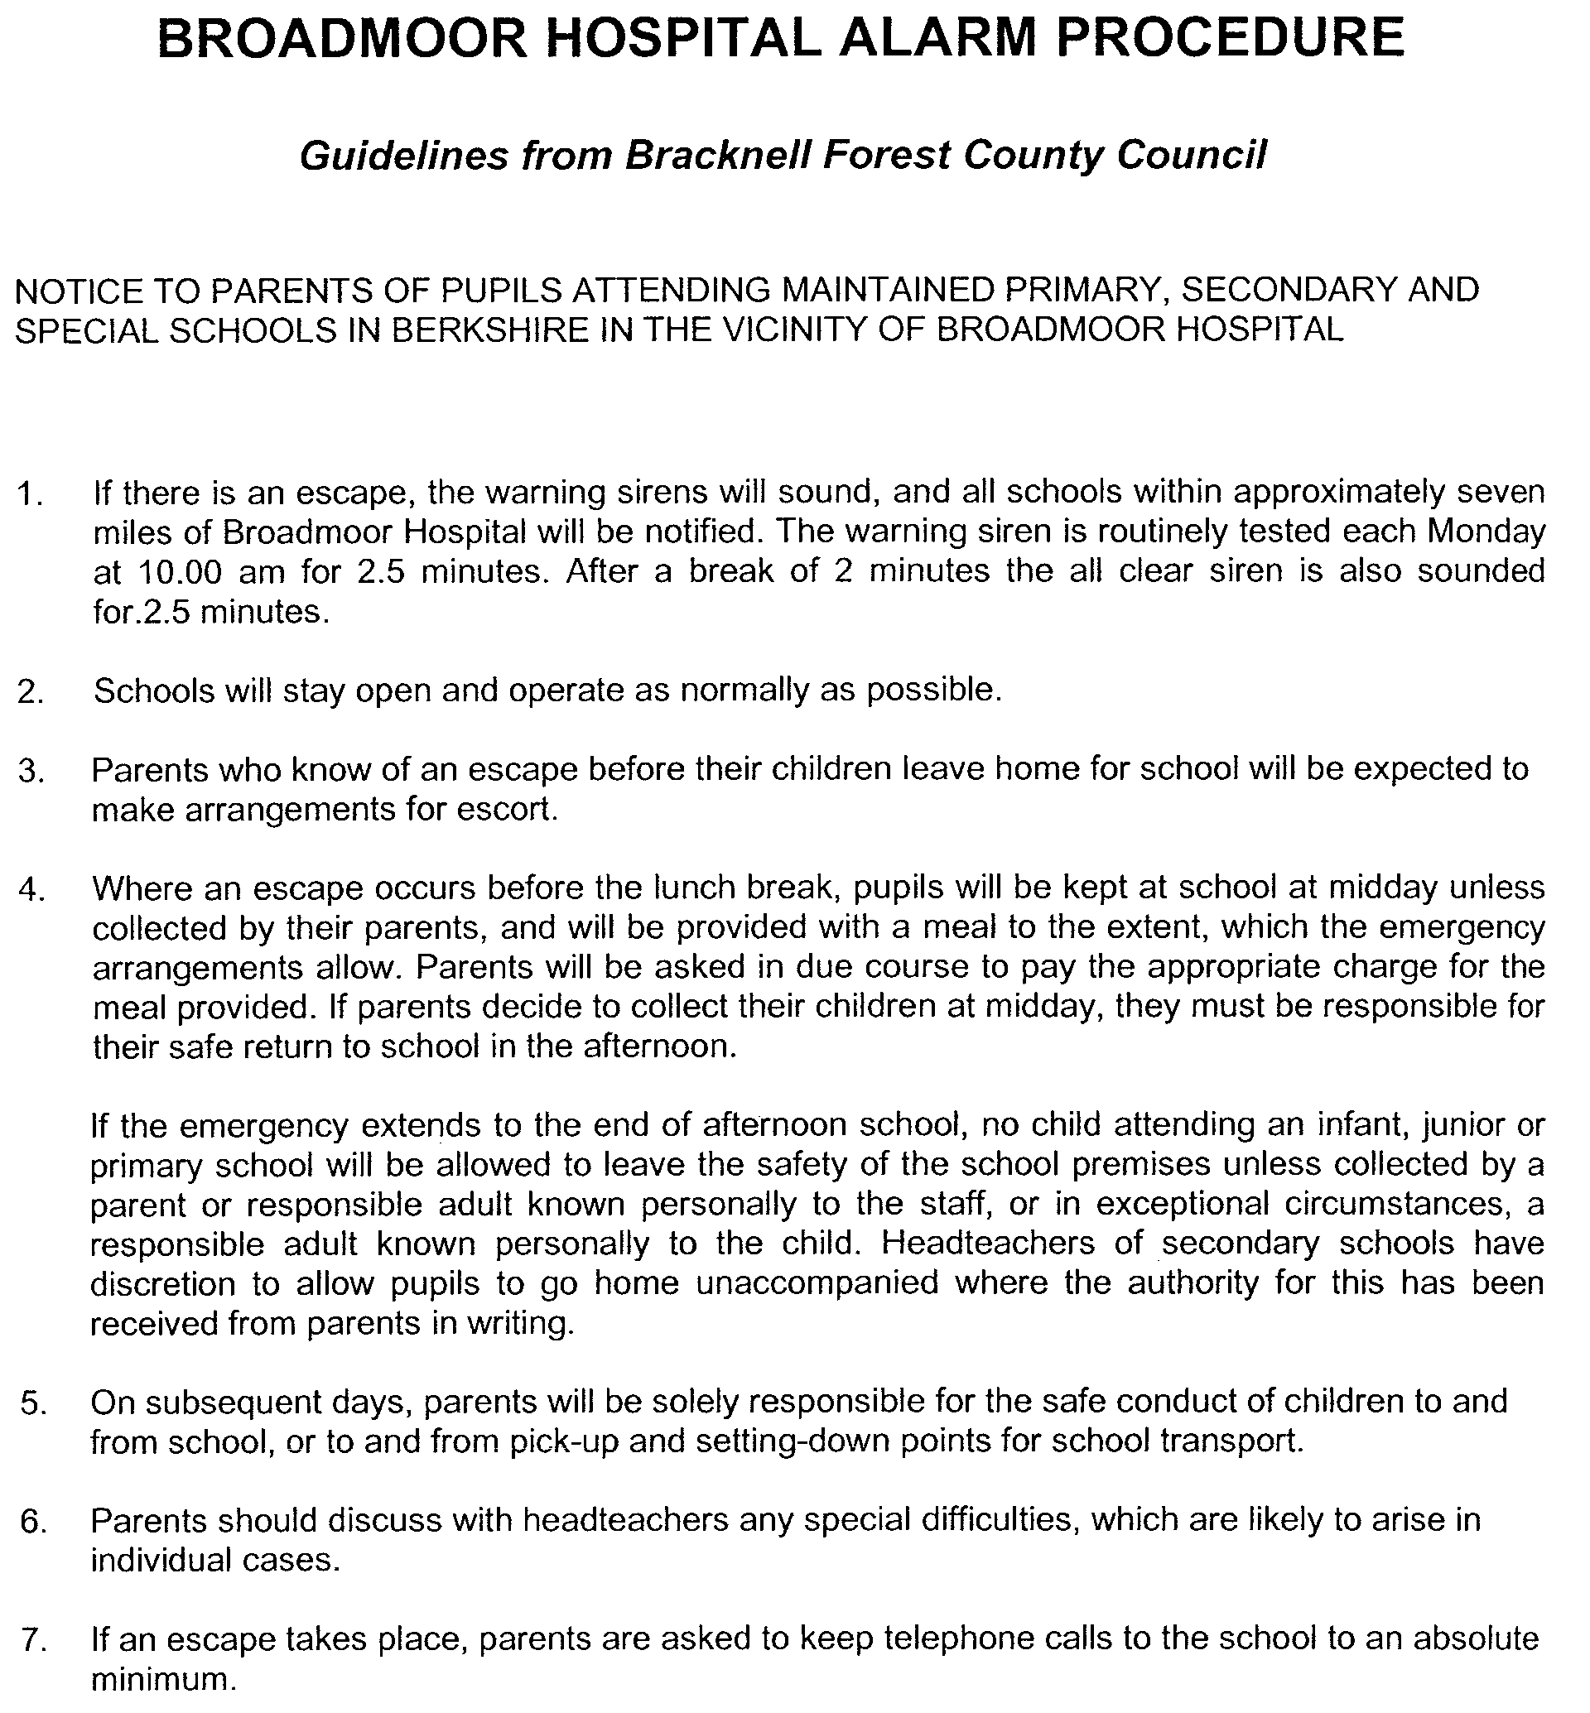
29

