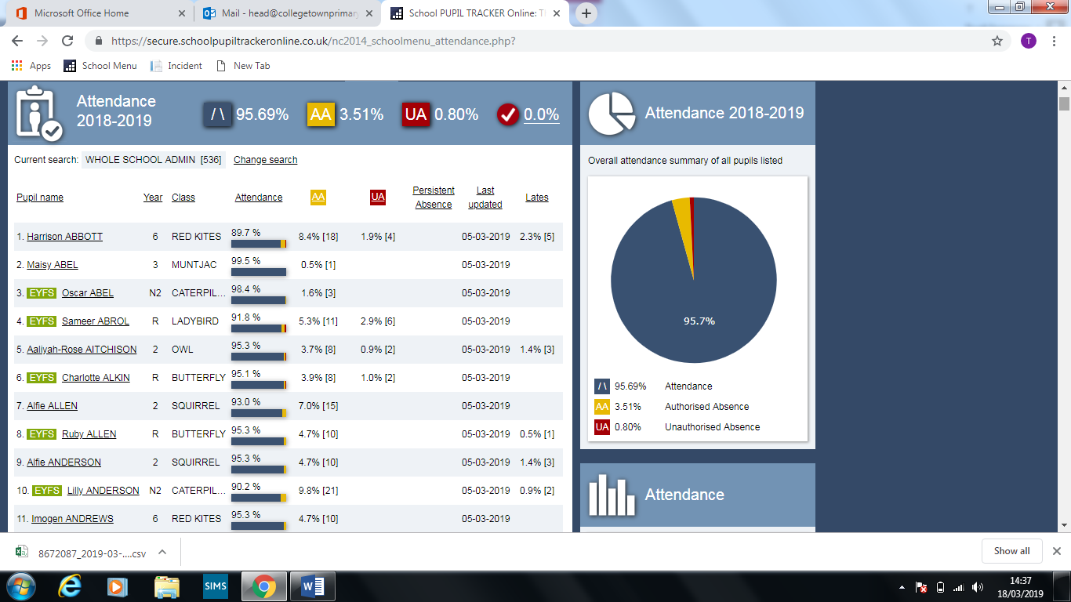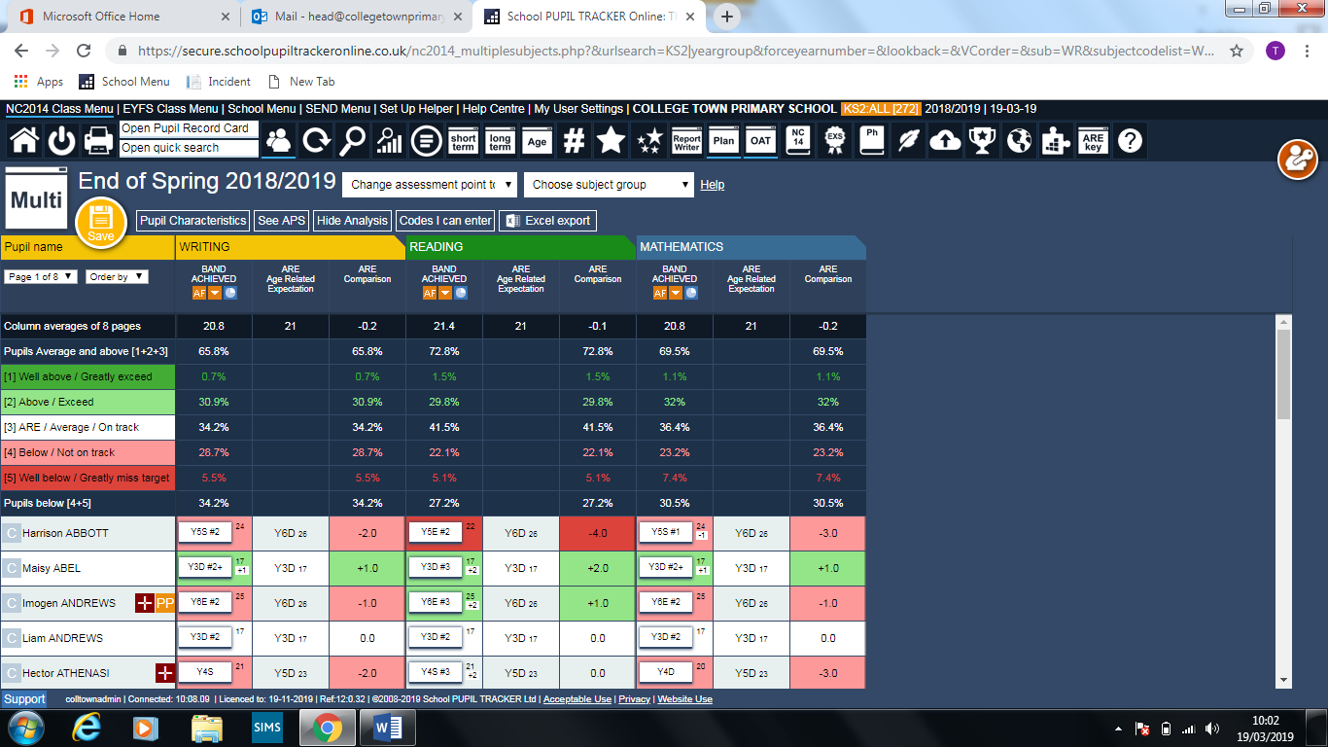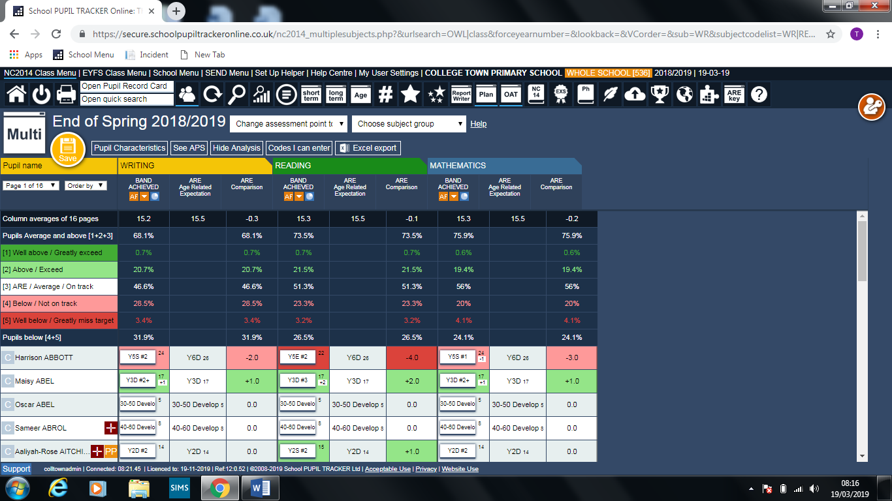

The data box below indicates an entire overview of the school including FS1. Writing is slightly below 70% so this will be an area for further development in the summer term.

The Year 1 assessments in February suggest that our phonic test data should be at 80% which will put us in line nationally and within our own authority.

Year 6 predicted outcomes are looking a great deal better than in the Autumn term and we have raised combined from 8% (wholly inadequate) to now around 55%. The target for combined was 74 % which is unlikely to be achieved with only 10 weeks until final data needs to be submitted. Reading, Maths and SPAG data hall risen substantially and is predicted to be around 73%, maths 62% SPAG 65%. Assessment are currently being held in Year 6 and there may possibly be a verbal update at the meeting if percentages have varied significantly in either direction.

There have been no exclusions this term

Two child remain on alternative provision one is still only up until 1pm

One child will be leaving at Easter to start at their new placement school and the other is undergoing assessment and planning meetings to consider future placement and provision as we are not able to effectively meet his needs.

0 CP Plans

CIN 2 previous now both stepped down to Family Intervention Team

KS2 Core data

