**FGB Follow-up Autumn Report**

**November 19th 2021**

**Contextual data**

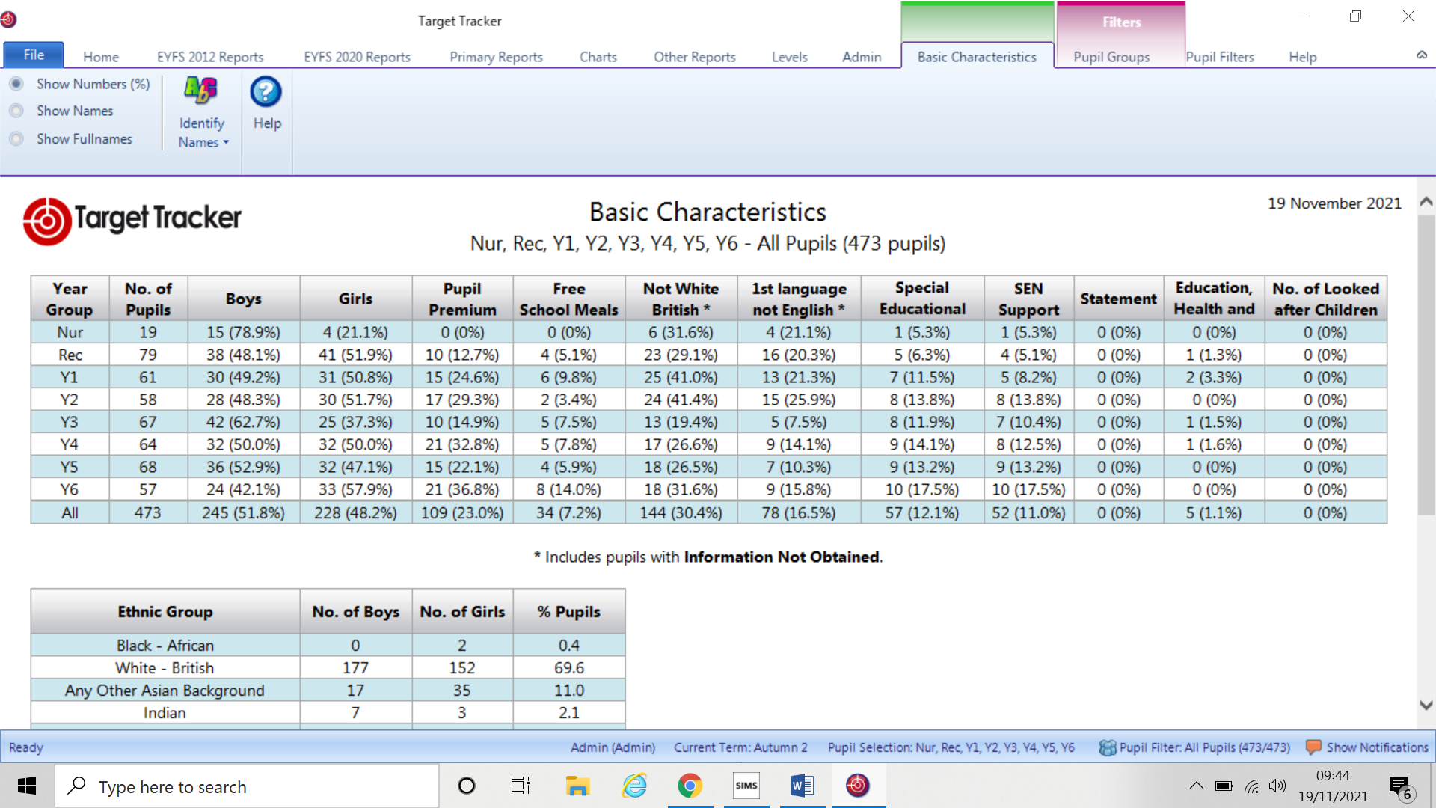

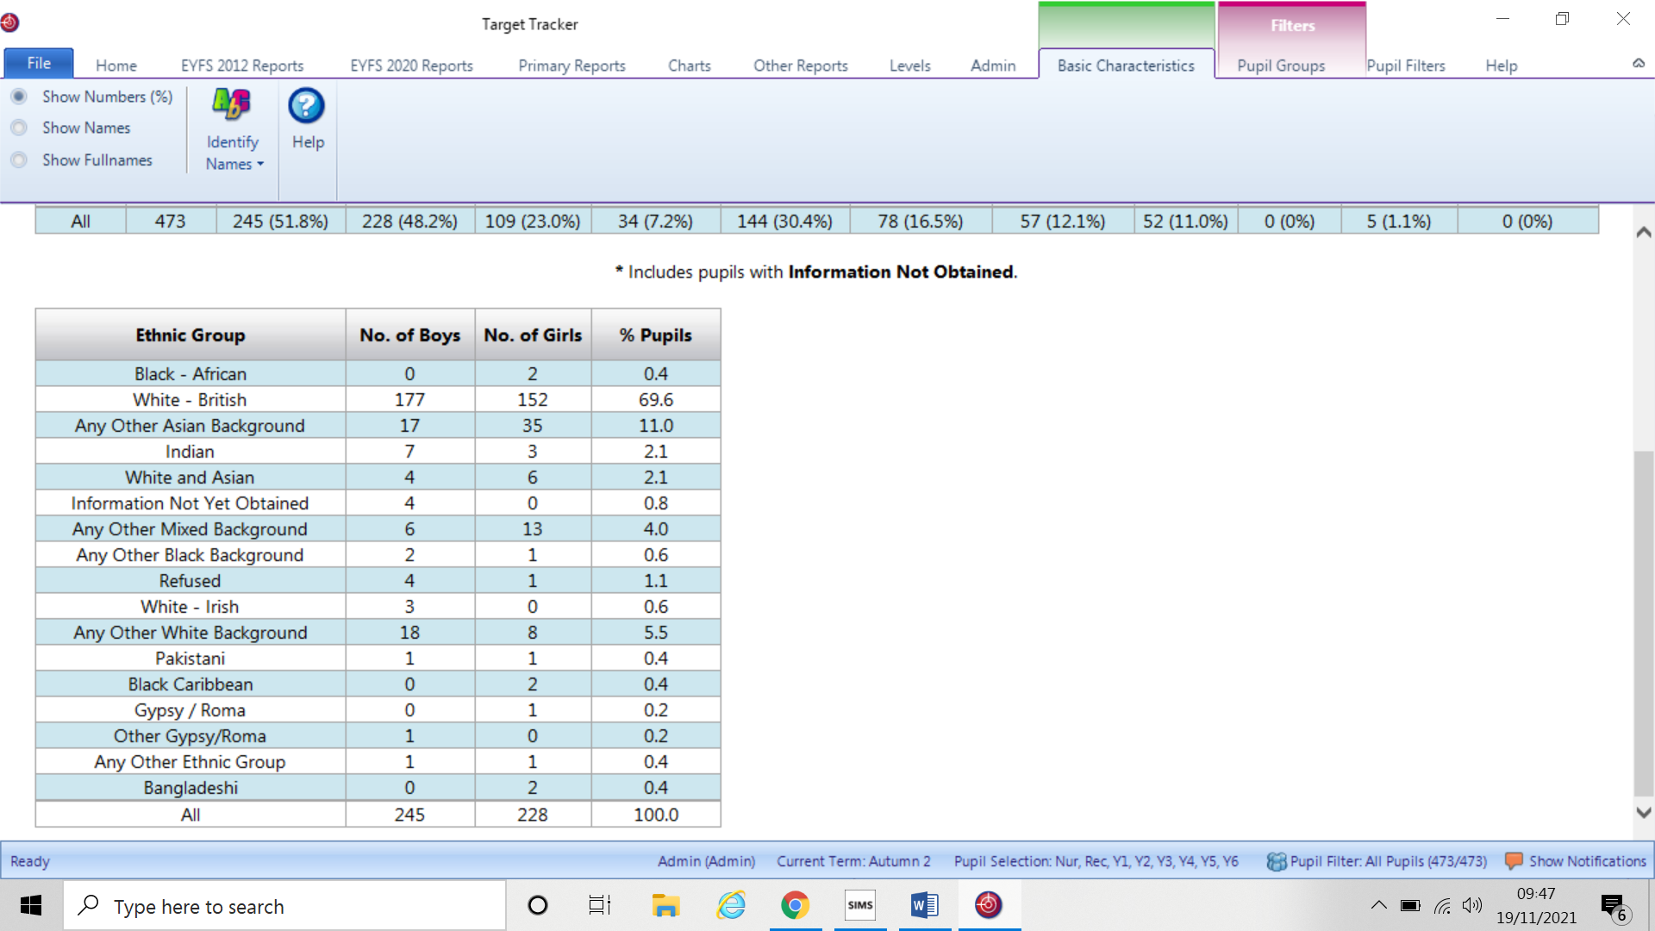

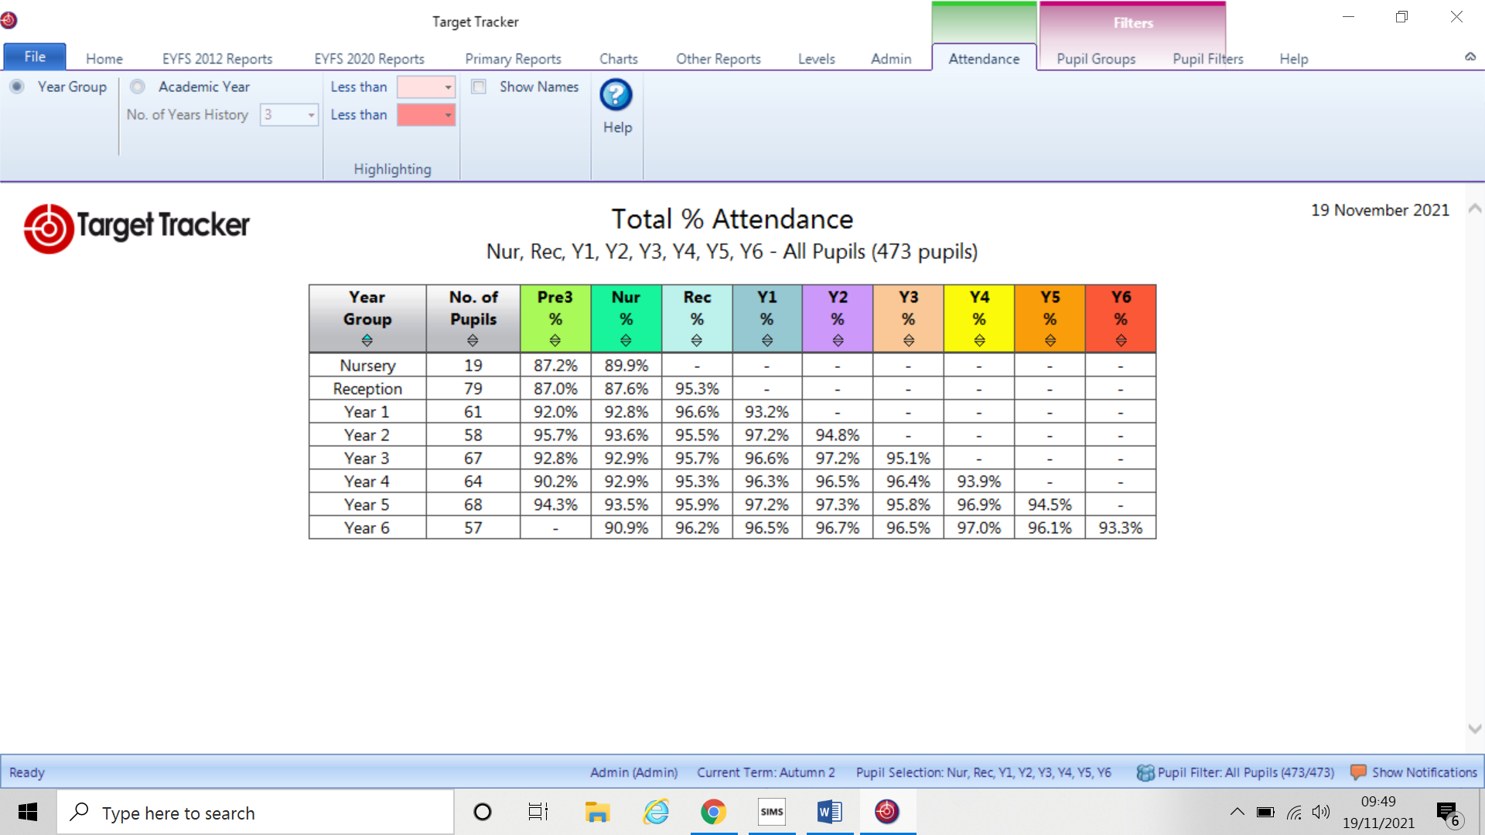

**Training**

There have been several training sessions since we last met, most of these remain virtual, although there have been a couple which have been face-to-face sessions such TEAM TEACH which Mrs Faircloth attended. Twilight sessions from BFC have also been utilised by subject leaders of Maths and English with other foundation areas also being covered such as PE & RE.

Within school we have made use of high quality training from Focus Education with subject leaders, EYFS and Core curriculum areas. These have, and will continue to ensure that we can evaluate and refine our practice using their audits and development suggestions. Indeed a recent writing moderation was delivered using the resources and provided good support and clear exemplifications of writing across the primary school. The school has purchased 4 subject leader sessions and these will be used throughout the year to grow our younger and less experienced staff in fully understanding their role as a subject lead.

General in school training has focussed on differentiation with a particular focus on English as an Additional Language (EAL). There is planned speech & language training for teaching assistants before Christmas for our EYFS staff too.

We have placed an advert for an additional teaching assistant from January to August as we have received a resignation from a staff member who will be leaving in December. The post will be temporary as if pupil numbers do drop in September the post would be financially unsustainable. Currently, as you are aware the school has an over staffed model funded from the catch up funding, although this is a temporary funding mechanism and will mean that such a model will not be achievable for 22-23.

In Year 2 we have been able to place Mrs Tait to cover the maternity post. The advert placed for maternity cover did not attract one application and we are delighted that Mrs Tait has agreed to share class responsibility with Mrs Attrill. I had considered that I might need to combine the three classes into two for the last two terms, but thankfully we have been able to retain very small classes to support good progress for all children. Mrs Tait will receive additional payment for undertaking parent reports, meetings and assessment.

**Designated areas**

Following a meeting with Chris Taylor in mid-November it has become apparent that within BFC there are falling birth rates. I have attached the documentation for you to read and gain a fuller understanding of potential challenges ahead. Potentially there could be redundancies looking ahead should their forecasts become a reality. Headteachers within each area are actively engaged with the LA in how we might overcome and respond to such challenges in the future in order to prepare for a potentially different landscape.

**COVID update**

The school has received new information and letters for two scenarios, an outbreak or a single case. These are taken from the latest version of the UKHSA Education Pack and have been modified to include the latest recommendation of the East Berkshire Health Protection Board.

1. The close and household contact letters should be sent out for individual cases where the outbreak threshold **has not** been met and include a reminder to take daily LFD tests if you fall into this category.
2. The Outbreak letters should be sent when the outbreak threshold has been met and include a recommendation for the whole group/class to take daily LFD tests for 7 days.