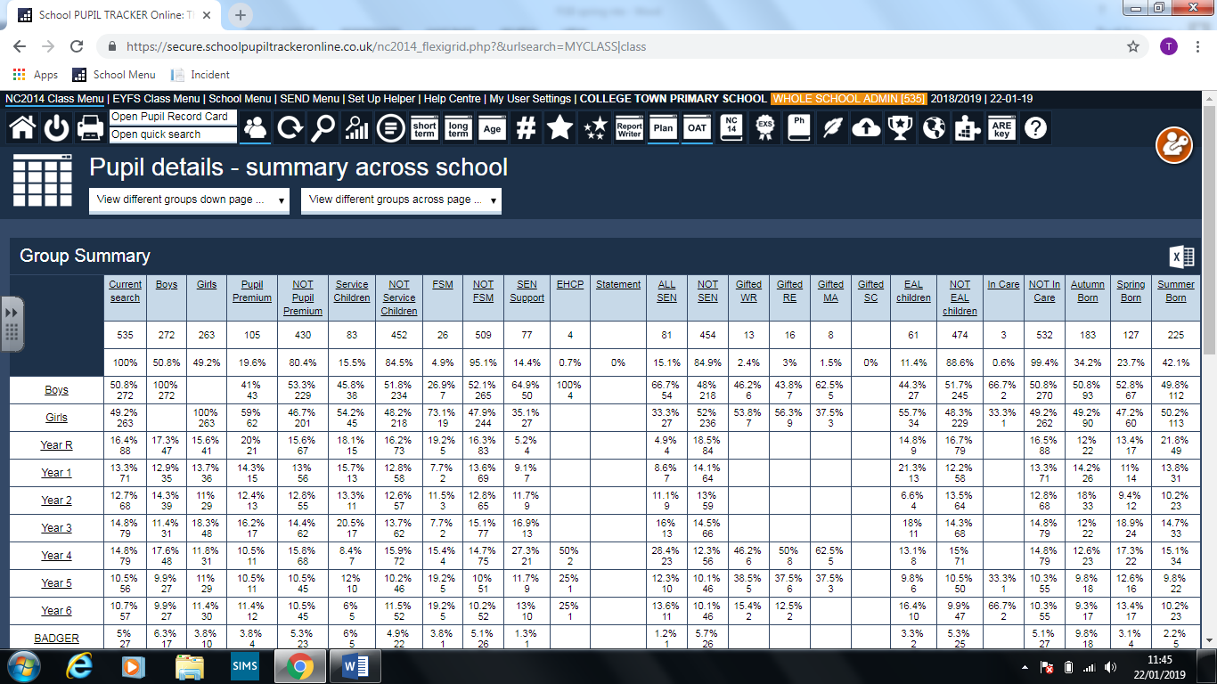  
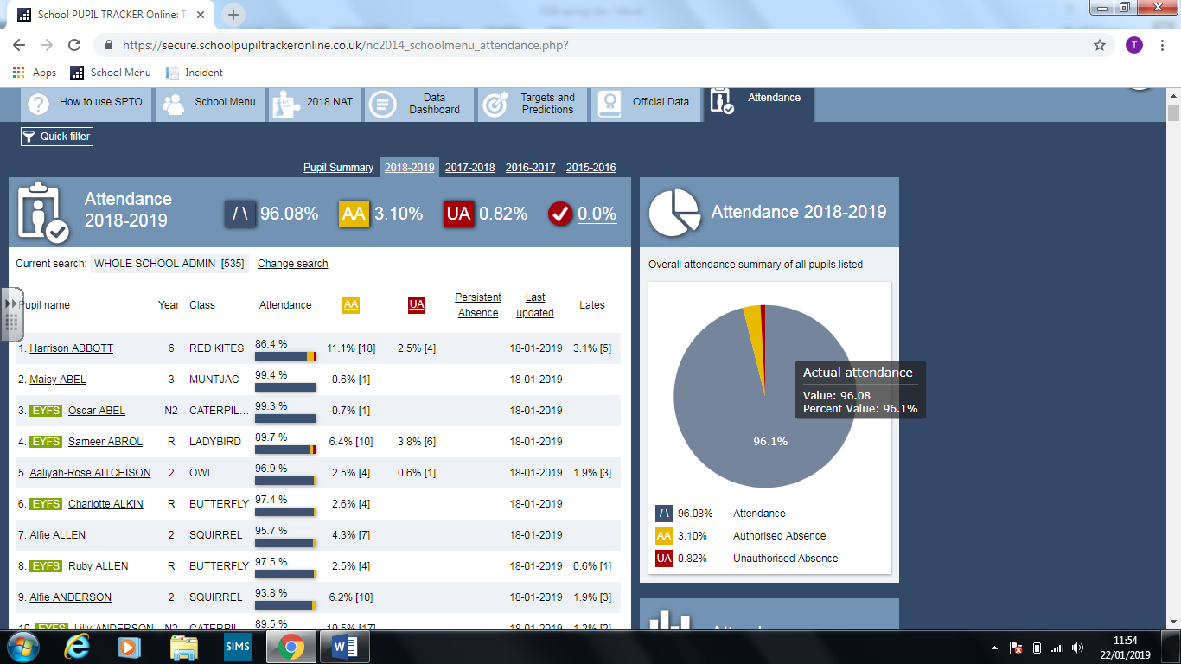**Attendance data correct as of January 23rd 2019**

Attendance the EWO has sent a template for tracking of actions taken for all children with absence below -90%. The purpose of this is to ensure that schools are committed to monitoring and supporting attendance. This document will now form part of our ½ termly tracker.

The school had a new child arrive in October 2018 although the parent did not want to come here and are waiting for a Surry school. This has resulted in the child having poor attendance since they have now applied to a Surrey school. Mrs Collin is sending a letter to explain the legality around attending school.

There have been no fixed term or permanent exclusions this term, although an exclusion of 4 days was given in December and the CofG was duly notified.

One child who had previously received fixed term exclusions and was subject to a part time timetable has now relocated to Newcastle.

Three children on roll are currently not accessing the mainstream classroom, or as in one circumstance the school. The non-attending pupil has been signed unfit to attend school due to severe anxiety and two others are receiving their curriculum via the learning hub. One of these children is on a part time timetable to reduce the risk of exclusion. This will reviewed in February and in consultation with parents and outside supporting agencies. A request for an educational health plan has been submitted to the LA and we are currently waiting to hear the outcome.

**Safeguarding & Child Protection**

The school currently has 1 child on a Child in Need plan (CIN)

The school currently has no children on Child protection plans

The school has received notification from the LA that 3 referrals to their team have now been closed with no further action.

**School Trips**

* Indoor Athletics – The Year 5 & 6 children finished 5th out of the BFC schools
* Butser Farm Y3 and Windsor Y2
* Swimming – This has not been well contributed to by the parents and we are likely to be funding 98% of the Year 5 swimming

All risk assessments have been completed online for all activities

**Vertical classes 2019 – 2020**

There are pressures ahead in terms of financial constraints due to low pupil numbers in some year groups and the new funding measures. Therefore we have been considering options where money can be saved without diminishing the quality of provision. One option which we are proposing is to run with 5 classes from Year 2 – Year 3 instead of 6.

This would mean that the most able Year 2 children would work alongside Year 3 pupils in the morning and then move into Year 2 with their teacher for afternoon sessions. Due to the 30 pupils per class rule for KS1 this would be necessary and the number of Year 3 children in two pm classes would be around 33, which is not above the expected number of pupils in KS2.

We have a teacher in our thoughts who wants to move through to KS2 and this would provide an excellent transition for her. This would assure that finances remained secure allowing the school to continue to be creative and invest in both curriculum and training opportunities for both children and staff.

**NQT Marketing**

Please see the attached NQT marketing flyer which has been sent to both Reading & St Mary’s University. Cath has also placed it on the JobsGoPublic website which will automatically generate nationwide advertisement in Times Ed Supplement. We are hoping to recruit 2/3 NQTs as required to add capacity to the school. Currently we know that there will be vacancies as we are running with agency staff and supply in some classes. Obviously this is likely to change over time, but I would rather over recruit and have capacity than not have adequate staffing in September.

The LA will be letting us have preliminary numbers of children expected for Reception intake Sept 2019 by mi February which will give some indication on 1st preference children. If we are low then vertical or 2 classes may be an option reducing recruitment requirements.

**New Ofsted**

I have responded to the Ofsted consultation regarding the new proposed framework and below are a few slides from their presentation which set out the main changes. Also in the leadership and management judgement there is a term referred to as off-rolling. I was unsure of this terminology and I have since learnt that this is where schools try to either not admit or get rid of pupils who could potentially have a negative impact on their outcomes.

SEND will feature highly within the new framework and we will be well placed to ensure good or better provision following the review from a previous SEND audit coupled with the findings from the Spring term updated review.

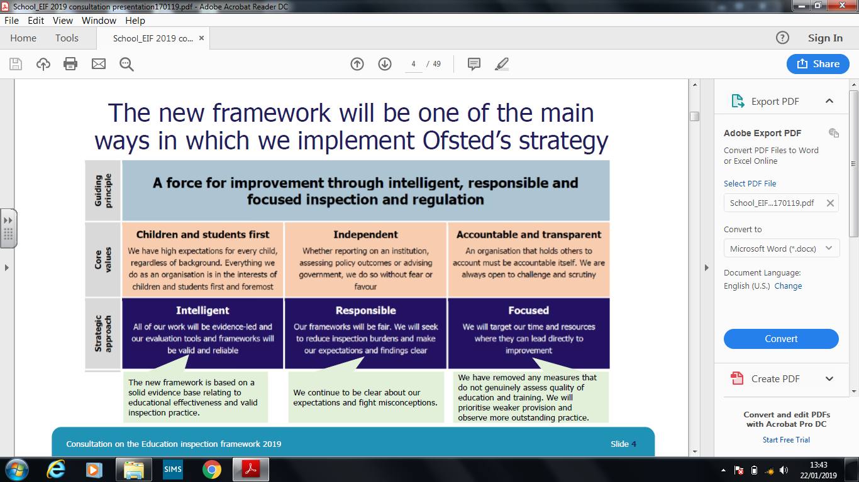

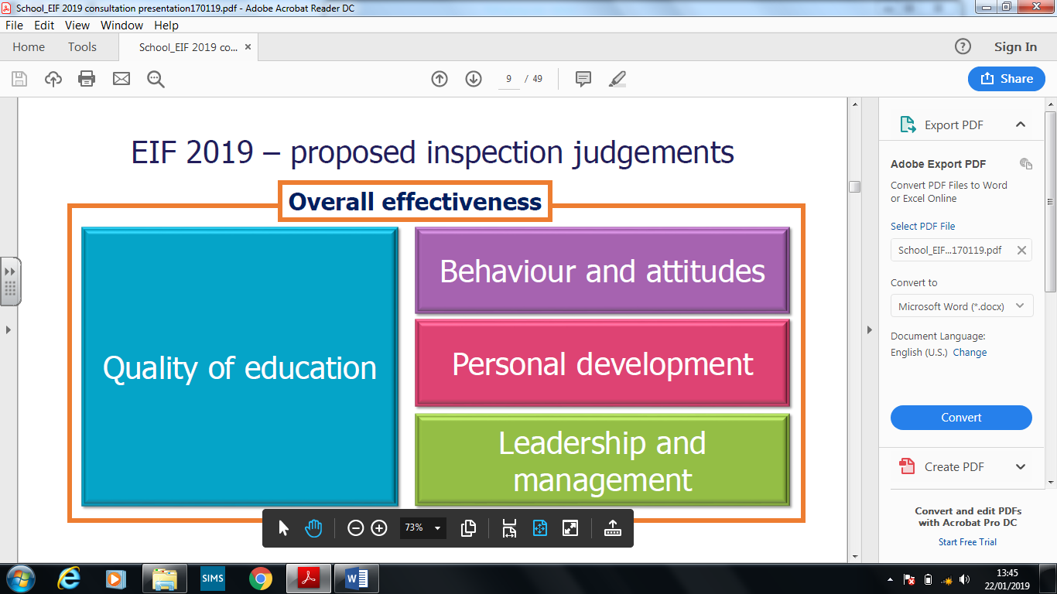

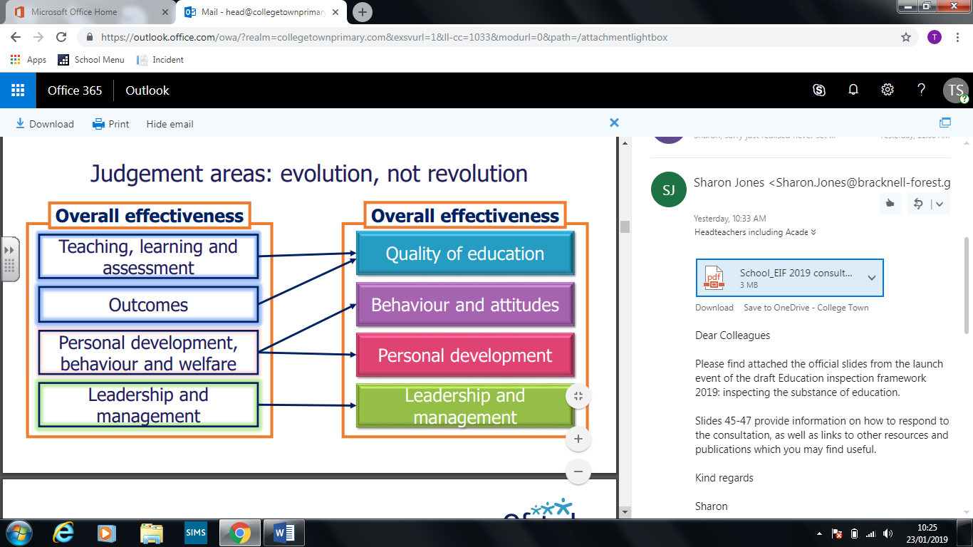

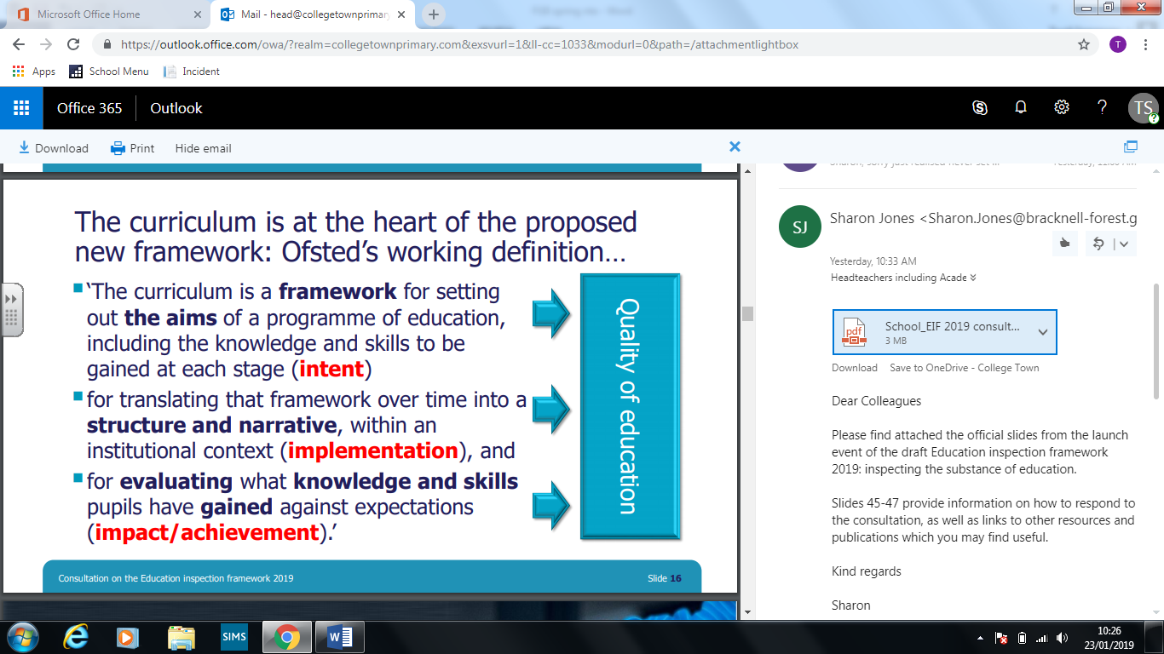

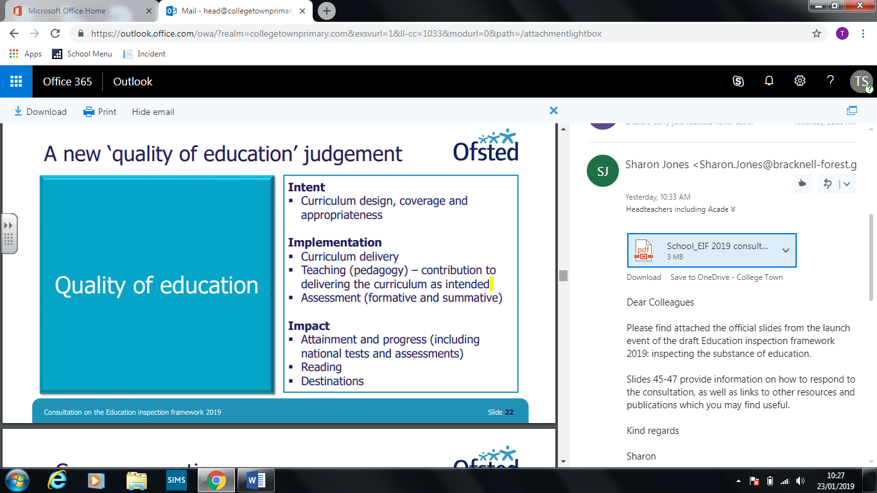

**Computing & future planning**

The current IT room is becoming very out dated and is not required to teach the program of study within the national curriculum. The school, as you are aware, has already invested £10,000 in updating interactive class boards as well as a further £10,000 on ipads with keyboards. Therefore it is our intention to change the use of this room into a KS2 music room. Currently there are musical resources in the empty Year 6 classroom, although in 2020-2021 this will be required for the 3 Year 6 classes. It is therefore planned that we will begin to commence this project from September 2019.

**Additional Support Spaces**

Since January we have been looking at how best to use the two former Assistant Headteacher offices in the KS2 building. These are no longer required as we have the Leadership Suite which allows us all to work together. Indeed, I encourage all SLT to work here as frequently as possible as I believe this is crucial in ensuring that there is good communication, cohesion and collaboration within the leadership team.

So… we have now develop a Therapy Room and next door will be learning Support Room. Currently play therapy is always having to relocate and now they have their own dedicated space dedicated space this will provide stability for her and the children. The learning support team are currently working with 2 children and again they will now have dedicated space. The Learning Support Room will also provide a quiet room for assessment too.

**Target tracker no SPTO**

We found out in September that SPTO was going to close. The reason for this is due to the recent assessment/ curriculum changes and the fact that unless they rewrite the entire program I will not serve schools well. As you can imagine this came as quite a blow as we are rolling this out as part of our development plan. However, we have researched a few options and I have Target Tracker visiting me on Feb 4th to give a demo. I have used this assessment program in Hampshire when it first came out and it was extremely easy, so I am hoping this will provide a solution.

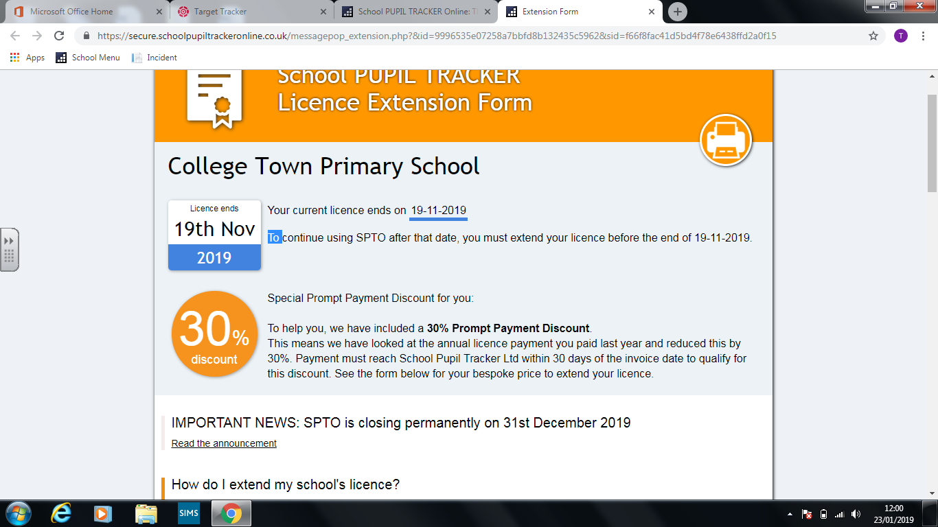

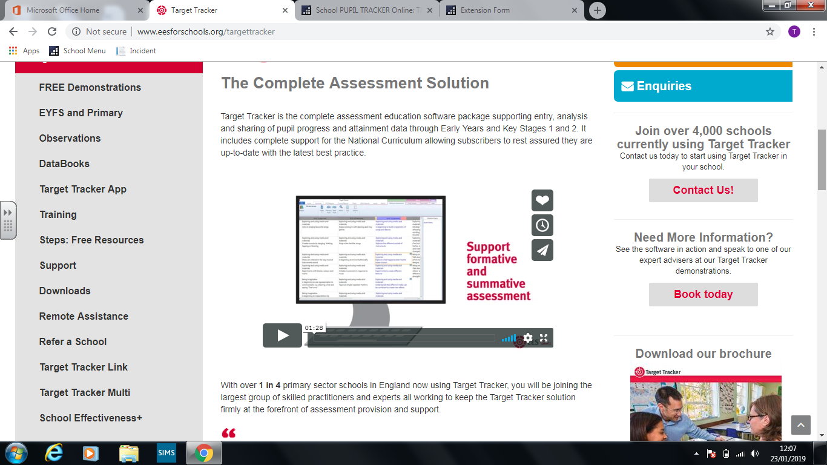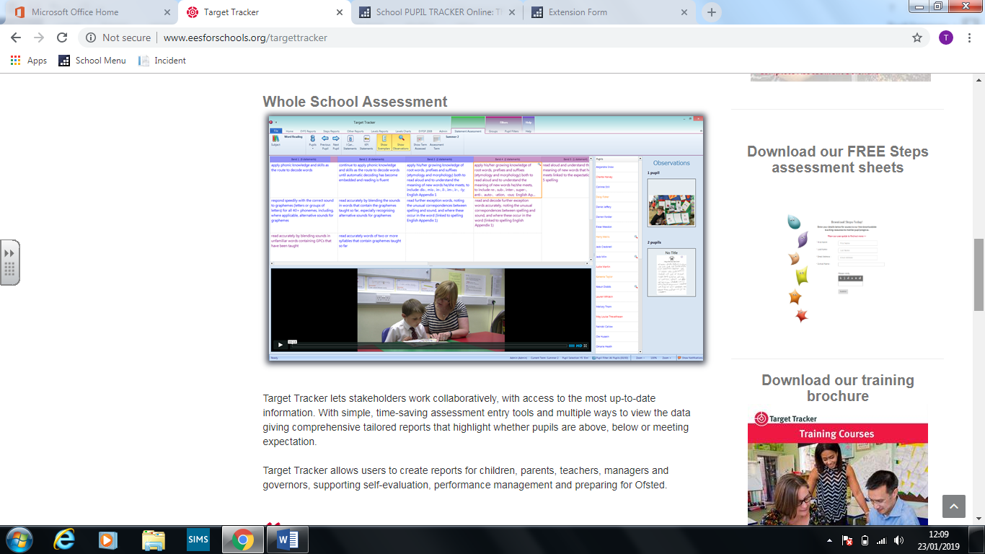

INSET days for 2019 – 2020

* Sept 3rd & 4th
* July 20 21 & 22nd these will be offset throughout the year to help teacher workload and address standards and school improvement tasks.

Please ratify