Maths Planning at College Town
Overview
The purpose of this document is to support all teaching staff in the planning and delivery of the maths curriculum from September 2020 at College Town. This is to ensure continuity and progression across the school, in the light of new teaching materials provided by White Rose Maths. These materials will enable the planning to be briefer and more consistent so that children have equality of teaching both within and across year groups.
Planning and Teaching Process
1 Down load the Primary SOL  from White Rose Maths or Staff Drive  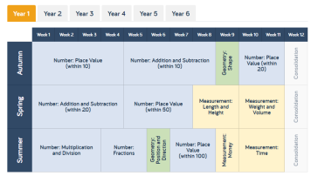 | Example  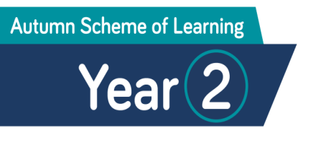
2 Look at the NC Objectives for the  block  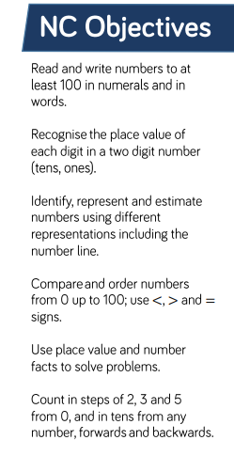 | Then look at the Overview of the Small Steps  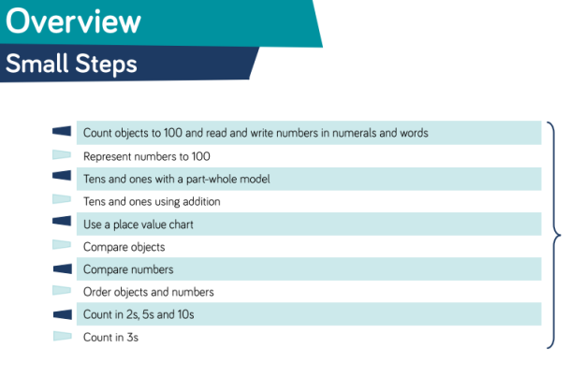
3 Each of the Small Steps is now supported  by a complete teaching sequence that  can be accessed from WRH Premium  Resources     | What do these icons mean?  Flashback 4 – daily lessons begin with a recap of previous learning, 4 questions on a PPT  True Or False – questions to promote mathematical thinking, reinforce language    Teaching PPT – one for every Small Step, it provides the teaching framework to deliver new concepts for each lesson    Worksheet Display- display worksheet to show children the learning they will be involved in  Worksheet Write On- can be displayed and/or printed off for children to complete  Answers- can be discussed and shared

Weekly Plans

1 Front Page of Planning Document  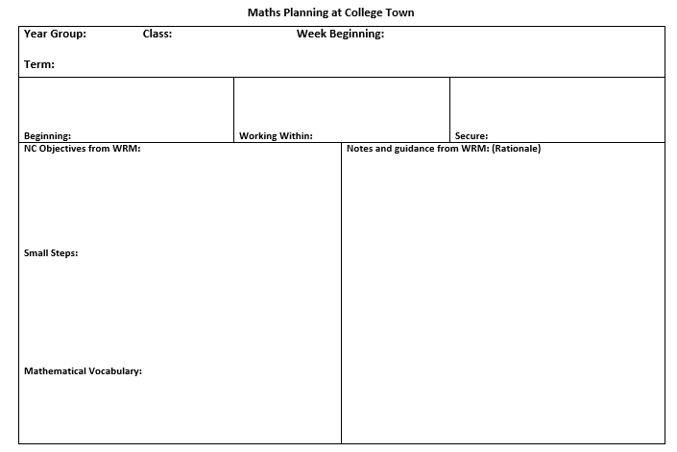 | Add admin details:  Year group & Class  Week Beginning- date  Term  Populate pupil groups- which match Target Tracker language
2 Add curriculum details | Add:  NC Objectives from White Rose Maths - for the block being taught  Small Steps for the week  Mathematical Vocabulary to be taught in the block  Notes and guidance from WRM (teaching)
3 Second page of planning document  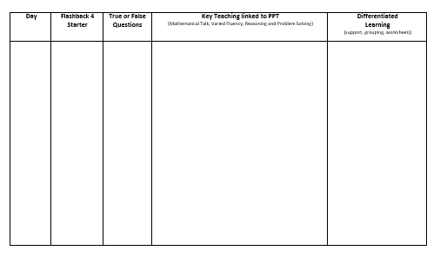 | Flashback 4 – week, day, focus  Key Teaching  - PPT – each slide will be used to teach and model, children to record answers in books  - Plan input for each slide (questions, modelling, notes, target children – this will vary teacher to teacher)  - Think about Mathematical Talk leading into children answering PPT questions in mix-ability pairs. PPT slides may need extension tasks added or snipped in to ensure children are all kept busy (‘Extend your thinking’ questions written by you/WR Scheme of Learning doc questions/I See Reasoning)  - Extend each lesson with Discussion problems from Classroom Secrets (1st) I See Reasoning (2nd)  - True or False – AfL (additional AfL questioning)

