Maths Planning at College Town
Year Group: 6 Class: Red Kites Week Beginning: 15/6/20

Term: Summer 2
Beginning:  MS – PP/SEN  AW | Working Within:  HG, JT – SEN, BN, |  | Secure:  SY, SR,
NC Objectives from WRM:  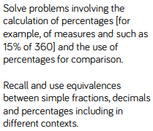  Small Steps:  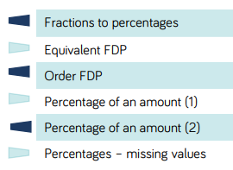 |  | Notes and guidance from WRM: (Rationale)  Children need to know % = out of 100 (Latin: per = by the, cent = 100)  Recall equivs from Y5  Convert between FDP (start simple – equivs to 100th)  Find simple amounts using division (and later div and mult)  Employ use of bar models to demo %s (and sets of)  Employ different strat to solve % problems  Mathematical Vocabulary:  percentage, out of 100, one hundredth, or amount, equivalents, convert, order and compare, ascending and descending, multiples

Day | Flashback 4 Starter | Key Teaching and Differentiated Learning linked to PPT  (Mathematical Talk, Varied Fluency, Reasoning and Problem Solving) | True or False (AfL)
M | Y6-Sp1  Bl 1-  FB4 1 (slide 1)  Model and discuss  Note any misconceptions (and names) on FB sheet | LO – To find equivalent fractions and %s  1 – Array question: how do we know how many are in the array, qs about denominator and numerator. Extend – simplify fractions? Can you find equivs?  2 – Converting fractions into %. Qs about usefulness of den 100. Why does it help? Extend - % match to make 100, why?  3 + 4 – Chn need to draw 10x10 grid (HAVE A FEW PRINTED) Q to MS re why 10x10?  5 – Model 2/5 = ?/100 = %. Extend with WR q from scheme  6 – Remodel above if chn struggled (3/20 = ?/100 = ?%)  7 – Focus on the quality of vocab in answers  8 – Model equiv fractions over 100. Focus on vocab in answers  9 – Model blue portion (4/20). Chn need to draw 5x10 grid (HAVE A FEW PRINTED). EXT = R+PS – discuss answers  10 – Variety of answers, take chance for children to verbalise strategies  11 + 12 – Discussion Problems from CS – whole class ext | 27/50 = 54%  Prove it.  Chn to give example of their own (must be true)  ¼ = ?% (chn to describe their strategy, not answer the question!
Additional Questioning:
BIG question – Why do % and fractions always have equivalents?
Target MS re tt questions
How do we find equiv fractions = ?/100? Why is it useful to find ?/100ths when comparing fractions and %?
Have you answered in a full sentence?
X said blah, has anyone got anything to add to that idea?
If a diagram is 5x10, what would the denominator be when considering it a fraction? How do we find the equiv over/100?

