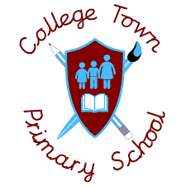
Art
Subject Headlines 2020 -2021
 | Autumn 1 | Autumn 2 | Spring 1 | Spring 2 | Summer 1 | Summer 2
Nursery | Colours and Mark Making | Simple Construction |  | Making and Changing Colours | Drawing/Exploring Different media | Drawing/Using Different Media
Reception | Exploring Colours and Drawing | Mixing Colours, Creating Texture | Exploring Different Media | Choosing and Exploring Colour | Choosing and Exploring Colour
Year 1 | Paint a Postcard  Crayons, chalk, paint, design a postcard |  | Great Fire of London  Paint and collage. Artwork from 1666 |  | Eric Carle Collage  Create collage with different materials | Ten Pieces  Linking music and art, with different media
Year 2 | Vincent Van Gogh  Paint, recreating Starry Night |  | William Morris  Printing and pattern design |  |  | Ten Pieces  Linking music and art, with different media
Year 3 |  | Greek Pottery  Design and create clay pots | Prehistoric Art  Cave painting techniques |  | Ancient Egyptian Art  Portraits, collages
Year 4 |  | Roman Pottery and Mosaics  Mosaic tiles, clay bowls | Anglo Saxon Shields & Helmets  Design and make brooches and shields |  | Tudor Portraits/ Cross Stitch  Cross stitch patterns, portraits
Year 5 | Portraits - Stuarts Era  Exploring different media for creating portraits |  | Street Art  Creating graffiti art and understanding famous street artists. | Local Area Drawings  Create sketches of the local area.
Year 6 | Blitz Pictures, Henry Moore, L.S. Lowry  Line sketches in the style of artists |  | Volcano Painting – Andy Warhol  Pop Art |  | Optical Illusion  Creating patterns, pencil & pen line drawing

