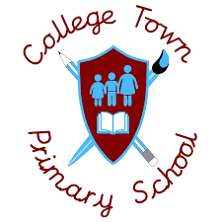
DT
Subject Headlines 2020 -2021
 | Autumn 1 | Autumn 2 | Spring 1 | Spring 2 | Summer 1 | Summer 2
Nursery | Colours and Mark Making | Simple Construction |  | Making and Changing Colours | Drawing/Exploring Different media | Drawing/Using Different Media
Reception | Exploring Colours and Drawing | Mixing Colours, Creating Texture | Exploring Different Media | Choosing and Exploring Colour | Choosing and Exploring Colour
Year 1 |  | Create a moving picture  Make a picture move using a simple structure |  | Design London Bridge  Create a simple design for a purpose | Make a fruit salad  Use simple tools to prepare food safely.
Year 2 | Design a mode of transport  Design a purposeful and functional product |  | Design a Castle  Investigate different materials to ensure your design is sturdy |  | Design a fruit smoothie  Understand the importance of balanced diet
Year 3 | Greek Food  Use a variety of ingredients to prepare Greek food |  |  | British Inventors  Identify and create famous inventions. |  | Building a 3D Landscape  Assemble and create a 3D landscape
Year 4 | Light up Lighthouses  Design and make a light up lighthouse using electrical components |  |  | Create a Bug Hotel  Design and make a sturdy structure for mini beasts to live. |  | Grow own vegetable patch  Understand and grow seasonal vegetables and fruit.
Year 5 |  | North American Food (Burgers)  Design and create own burger from North America. |  |  | Mayan Temples  Design a temple in which Mayans would have been able to live in | Building a bridge  Design a bridge which can be used for a certain purpose
Year 6 |  | Light up boxes  Design a product using electrical components. |  | Great British Dishes  Research, plan and prepare a range of Great British Dishes.

