History
Subject Headlines
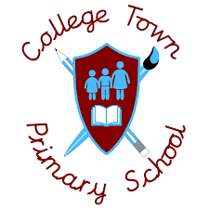
2020 - 2021
 | Autumn 1 | Autumn 2 | Spring 1 | Spring 2 | Summer 1 | Summer 2
Year 1 | Holidays Then and Now  Compare holidays in the past to holidays that we go on now. |  | Great Fire of London  Describe what the Great Fire of London was like and why it occurred. |  | Local History Study (Wellington College and RMA)  Looking at the RMA and Wellington College.
Year 2 | History of Flight  Explain when and why airplanes started flying. |  | Local History Study (Windsor)  Comparing life in the castle then and now. |  | Explorers  Comparison between different explorers.
Year 3 |  | The Ancient Greeks  Explain what life was like during the Ancient Greek times. | The Bronze, Stone and Iron Age  Compare how life was like during the different ages. |  | The Ancient Egyptians  Explain what life was like during the Ancient Egyptian times.
Year 4 |  | The Ancient Romans  Explain what life was like in Ancient Roman times. | The Anglo Saxons  and Scots  The Vikings  Describe life after the Romans and during the Anglo Saxon time. |  | Local History Study (Tudors)  Explain what life was like during the Tudor period - local area study Hampton Court.
Year 5 | The Stuarts  Explain what life was like during the Stuarts. |  | Crime and Punishment  Comparing crime and punishment through different periods of history to now. |  | The Maya  Explain what life was like during the Mayan civilization.
Year 6 | World War Two  Explain what happened during WW2 and analyse the reasons why it started. |  |  | How Britain has changed since 1945  Describe how life has changed during the different decades from 1950 onwards. |  | Overview of ancient civilizations  Sumerian, Indus Valley and Shang Dynasty

