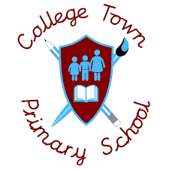
Spanish
Subject Headlines 2020 -2021
 | Autumn 1 | Autumn 2 | Spring 1 | Spring 2 | Summer 1 | Summer 2
Year 3 | Let’s Start Spanish | Countries that speak Spanish  Classroom Instructions  Christmas | Greetings – How are you?  What is your name? | Spanish Alphabet | Plants | Colours
Year 4 | Numbers 0 - 15 | Numbers 16 - 31 | Days of the year  Months of the year | Four Seasons  What is the date? | How old are you? | Happy Birthday
Year 5 | Numbers to 100 | The Solar System | Parts of the head  Parts of the body | Do you have any pets? | Where do you live?  The family | Wild animals  Adjectives for animals
Year 6 | Classroom objects  In the classroom | Fruits and vegetables | Going to the doctor  Jobs | Time  Musical instruments

