# Reading

* Read some common irregular words.
* Use phonic knowledge to decode regular words & read aloud accurately.
* Identify rhymes and alliteration.
* Join in with rhyming patterns.
* Read & understand simple sentences.
* Demonstrate understanding when talking with others about what they have read.
* Make basic predictions.
* Identify start and end of a sentence

# Writing

* Write simple sentences which can be read by themselves & others.
* Use correct pencil grip.
* Write name, labels and captions
* Use correct letter formation
* Begin to demarcate sentences with finger spaces, capital letters and full stops

# Mathematics

Number

* Count reliably to 20
* Order numbers 1–20
* Say 1 more/1 less than numbers to 20
* Add & subtract two single digit numbers
* Count on/back to find the answer
* Solve problems with doubling, halving and sharing

Shape, space and measure

* Use language to describe size, shape, capacity, position, distance and time
* Know the names of common 2D shapes
* Begin to know the names of 3D shapes
* Begin to understand characteristics of everyday objects and shapes

**College Town Primary School**

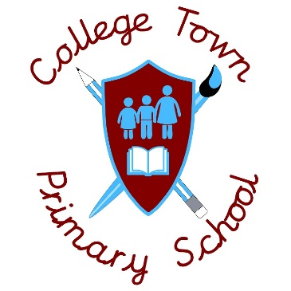

**End of Year Expectations for Reception**

This booklet provides information for parents and carers about the end of year expectations for children in our school.

Meeting these objectives will help your child to make good progress as they move through the school. All the objectives will be worked on throughout the year and will be the focus of direct teaching. Any extra support you can provide in helping your children to achieve these is valued greatly.

If you have any questions about the content of this booklet or want support in knowing how best to help your child, please talk to your child’s teacher.