Year 2 Knowledge Map: Habitats

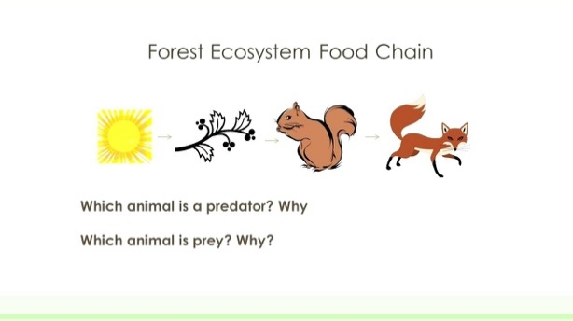

|  |  |
| --- | --- |
| **offspring** | A person’s child or children and an animal’s young. |
| **survival** | Continuing to live or exist in difficult circumstances. |
| **living** | Being alive. Living, breathing and functioning. |
| **dead** | No longer alive. |
| **habitats** | The natural home or environment of an animal, plant or living organism. |
| **micro habitats** | A small home environment for specific creatures and/or insects and plants. |
| **organism** | An individual animal, plant or life form. |
| **prey** | An animal that is hunted or killed by another for food. |
| **predator** | An animal that preys or hunts on others for food. |
| **food chain** | A series of organisms that are dependent on the next as food for survival. |

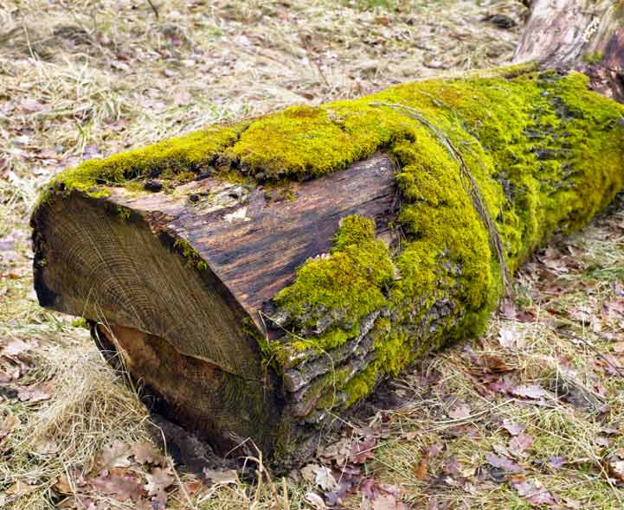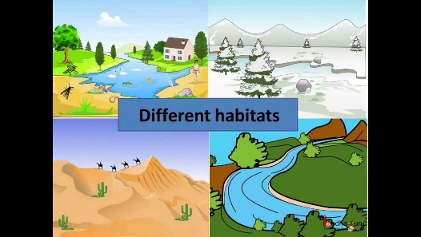

A food chain

**Homework:**

**Due in Friday 15th October.**

Go for a hunt near your house and see what different habitats and micro habitats you can find. Draw and label some of them. Maybe you could include adjectives to describe them. Explain who lives in them.

A micro habitat

Habitats