Staffing & Finance
Headteacher’s Report
The structure below is the model for September 2021 – 2022 due to not replacing the Assistant Head for standards & Outcomes

Class structure for 2021 – 2022
Nursery
Will be staffed with 1 qualified teacher plus 4 teaching assistants
Reception
82 pupils have been placed at CTPS to date and this will see three classes each with a teacher plus three full-time teaching assistants across the base. If it becomes apparent that there are children with additional needs it may be necessary to advertise for additional support.
Year 1
62 children will be split into three classes of between 20- 22. There will be three teachers supported by 2 teaching assistants for general support with one teaching assistant supporting a child with an EHCP.
Year 2
56 Classes will be less than 20 with the existing team of three teachers. Due to the small class size there will only be two teaching assistants supporting across this year group.
Year 3
71 children will be in three classes, although during the morning session when Maths & English is being taught they would be further split into four. The biggest class would be the more able, approximately 24 pupils with two further groups of 18 leaving only 10 – 12 children in a small group where teaching can be highly differentiated to ensure that they are adequately supported.
Year 4
69 children. This will be a straight forward transition with the classes moving through as they currently are. Any moves will be on a highly individualised basis.
Year 5
70 children. This will be a straight forward transition with the classes moving through as they currently are. Any moves will be on a highly individualised basis.
Year 6
61 The children are currently in three small classes across Year 5. However, in Year 6 they will be placed into two form classes. Providing that there is capacity within the teaching staff during the morning the most able children will be taught separately for maths with the two larger classes being split for Maths and writing.

Recruitment
The school has been busy recruiting teachers ready for September. Currently we have successfully recruited teachers with further interviews being held on Monday 10th May. The candidates on Monday are all NQTs as currently we are only expecting to support one NQT. This enables us to consider NQTs as our capacity to deliver the Early Career Framework will be sufficient. This is an important consideration as you appreciate once you have read the information submitted within this report.
We will be reducing teaching assistants in July as two members of the team are heading off to undertake teaching training. In the EYFS and Year 1 there are significant SEND needs and applications for Educational Health Care Assessments have been made for three children, although this is a lengthy process and therefore it could six plus months before any additional funding is received for these children. However, it will be necessary to provide support for these children from September as otherwise they will be unable to manage the school day. Therefore, recruiting teaching assistants will also be necessary towards the end of the summer term, or perhaps even early Autumn.

Training
Training
Jan 21 – May 2021
Course | Date | Attendee
Assessing Writing in Year 2 | 28/01/21 | Callum Dale
Memory Inset Training | 24/02/21 | Jade Faircloth
English Subject Leaders | 24/02/21 | Natasha Startup  Anne Duncan
Maths Subject Leaders | 03/03/21 | Paul Tatum
SEND Forum | 09/03/21 | Jade Faircloth
Reading Inset | 10/03/21 | Jade Faircloth  Natasha Startup
SEND Briefing – Update on Policies | 25/03/21 | Jade Faircloth
First Aider at Work – Red Cross | 16th – 18th April 2021 | Pete Norman
New EHCP form | 04/05/21 | Jade Faircloth
Designated Safeguarding Lead | 19/05/21 | Trudi Sammons
Mermaid UK Awareness – Trans and LGBT awareness training | 14/05/21 | Fiona Mitchell

Safeguarding training has been booked for myself and will be delivered by the LA via Teams. Previously we had used an external provider, but under COVID restrictions it seemed a good opportunity to use the local authority as it is convenient and allows us to compare and evaluate the two training packages.

Early Career Development
You may be aware that from September 2021 the career development programme has been extended from 1 year to 2 years. Below is a brief overview of how as a school we are going to be supporting our new NQTs. Within the report there are various hyperlinks which will take you to further information on this new development. As a school we feel extremely well placed in terms of capacity and expertise to manage this efficiently and effectively for new teachers.
Early Career Professional Development
Overview of the Early Career PDP starting September 2021

What is the Early Career Professional Development Programme?

- The Early Career Framework (ECF) reforms are a significant change in support for early career teachers, providing a funded entitlement to a structured 2-year package of high-quality professional development.

- The reforms are part of the government’s teacher recruitment and retention strategy, which aims to improve the training and development opportunities available to teachers.

- The Early Career Professional Development Programme offers new teachers dedicated time to focus on their development, building on their ITT.

- Schools have been offered three choices in the way they deliver the support programme to early career teachers:

- School Based Programme: Schools can design their own two year programme based on the Early Career Framework
- Core Induction Programme: Schools can deliver their own two year programme using high quality materials and resources, accredited by the DfE
- Full Induction Programme: Schools can opt for accredited training to be delivered by an external provider e.g. Forest Learning Alliance, with direct support for early career teachers and mentors

- College Town Primary School has considered the options for delivering the Early Career Programme in the light of capacity and experience within the school and has decided to select option two i.e. we will be delivering our own two year programme using DfE accredited materials and resources (Core Induction Programme).

- To support this decision College Town Primary School has formally registered
with the DfE to use their service to manage the training programme for early
career teachers. As part of this process we were asked to select from four
providers of accredited materials and have selected the Education Development Trust
materials to use. This is in line with the programme that Bracknell Forest will be using via
the FLA.

- The programme focus is on the early career teacher and mentor relationship that will help turn theory into practice, through a structure and detailed weekly programme of learning.

The Programme that the Early Career Teachers will follow using the Education Development Trust materials:

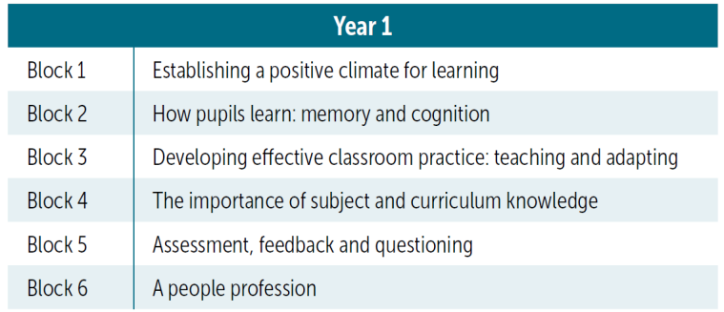

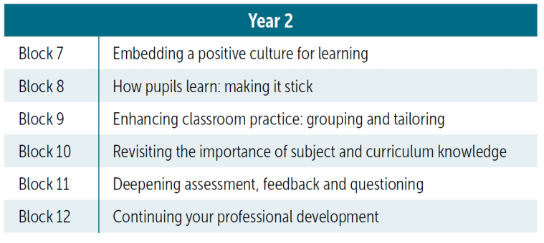
Report compiled by: Anne Duncan – College Town Primary School
Date: 6-05-21
Please follow the link below to see more details of the training programme.

https://www.early-career-framework.education.gov.uk/

