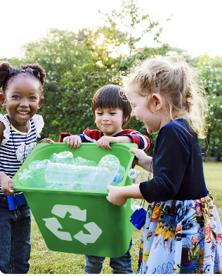
Science - Making connections: Plant-based materials

reduce reuse recycle
material property
flexible strong waterproof

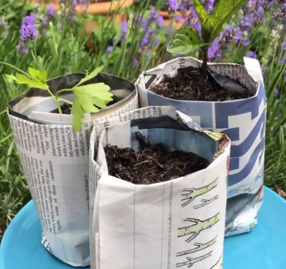

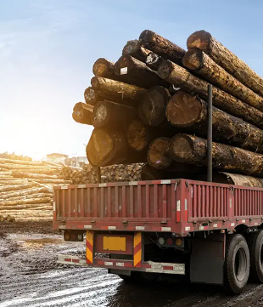

Make a plant pot from something that has been put in the recycling at home. It might be old newspaper, an empty tin can, yoghurt pot or anything else that is there. Think about the material it is made from.
Will it be waterproof? Will it tear? Will it be able to stand up? Will it be strong enough to hold soil?
If you are able to, plant a seed and watch it grow.
Bring in a photograph or drawing of your plant pot, or you could bring in the plant pot itself.
Have fun!
Homework due back on Friday 10th July 2026

