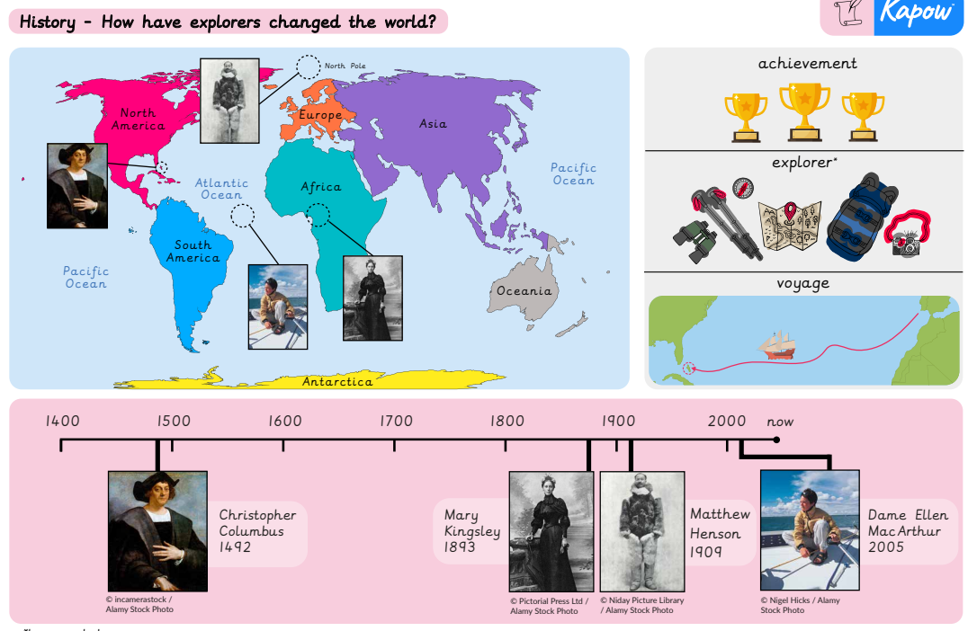
Key vocabulary
Achievement:
something good you finish or succeed at doing, usually after working hard or trying your best.

Explorer:
a person or animal who travels to unknown, new, or distant places to learn about them.

Voyage: a long, exciting journey, usually taken by ship across the ocean or by a spaceship through outer space.
Write about what you use different explorer tools for.
Write a creative story about an adventure.
Optional homework, due in Friday 15th May
Can you make your own timeline which includes different explorers?
Make a poster about an explorer.

