Investigating Science Through Stories

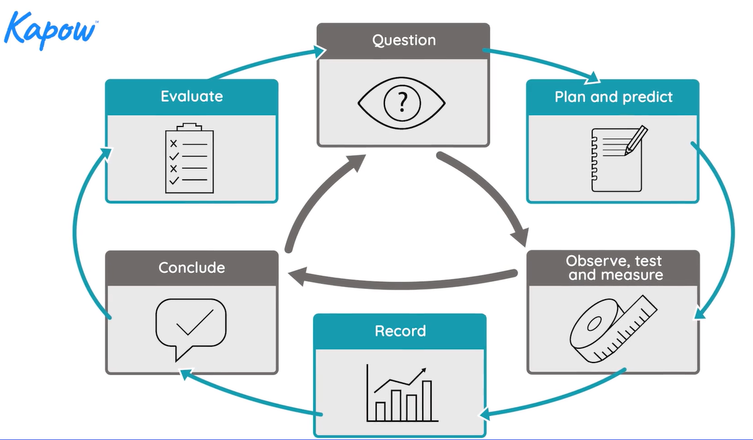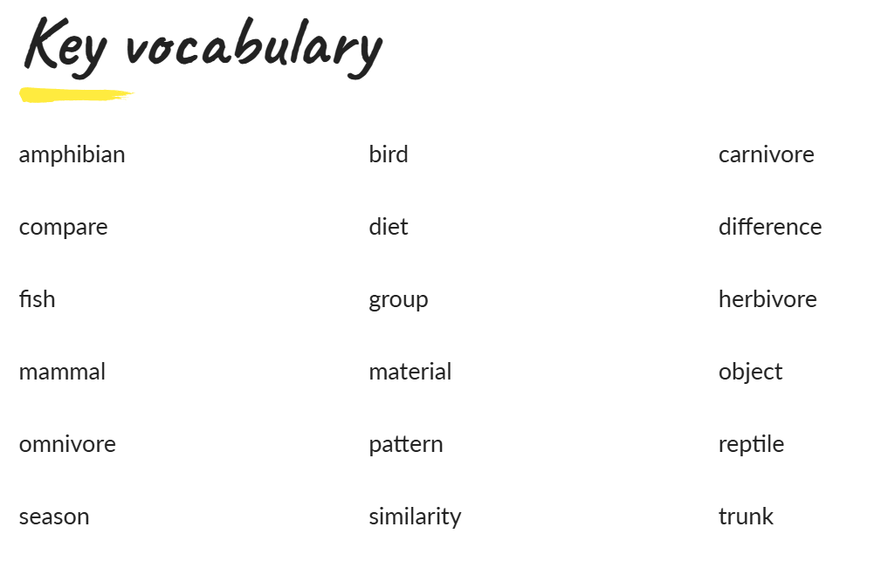

Optional Homework
Due Friday 10th July
- Make a poster about the 4 seasons of the year. Can you draw pictures or collect photos of signs of Summer?
- Create a fact-file about a favourite animal.
- Design or build an animal home. What materials would be most appropriate to suit an animal’s habitat?
- Create a chart about the birds that visit your garden. How many different types of bird are there? Which type of bird comes the most?
This unit revises the following key knowledge from the previous Year 1 units:
- Plants
- Animals, including humans
- Everyday materials
- Seasonal changes

