Theme/Term | Autumn Term (14weeks)
Writing Root/ Spelling Seed Text |   Robot Girl  Malorie Blackman | National Poetry Week  28th September – 2nd October |  |  | 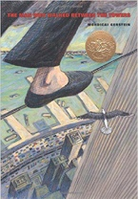  The Man Who Walked Between the Towers  Mordicai Gerstein | Hidden Figures  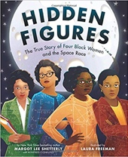  Margot Lee Shetterly |  | The lost thing  Shaun Tan
Length | 15 sessions, 3 weeks | 5 sessions, 1 week |  |  | 15 sessions, 3 weeks | 15+ sessions, 3 + weeks |  | 20 sessions, 4 weeks
Outcomes | Science-fiction narratives  Discussions, debates, dialogue, character comparisons, reviews | Theme: Wonder |  |  | Biographies/autobiographies  Information writing (Wikipedia pages), letters of advice (formal), interviews, news report, persuasive speeches | Non-chronological report  Reports, formal and informal letters, diaries, character descriptions, journalistic writing |  | Own version narratives  Diaries, formal letters, adverts, character and setting descriptions, reports
Theme/Term | Spring Term (11weeks)
Writing Root/  Spelling Seed Text | 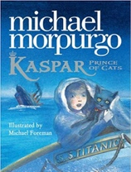  Kaspar, Prince of Cats  Michael Morpurgo |  | 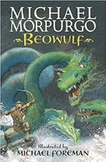  Beowulf  Michael Morpurgo |  |  | The Odyssey  Gillian Cross
Length | 15 sessions, 3 weeks |  | 15 sessions, 3 weeks |  |  | 20 sessions, 4 weeks
Outcomes | Newspaper articles  Character descriptions, reports, letters, advertising leaflets, balanced reports |  | Own version legends/missing chapters Letters of advice, diaries, dialogue, character and setting descriptions, action scenes, obituaries |  |  | Epic stories  Speeches (proclamation, persuasive, soliloquy), dialogue, missing scenes, postcards, adverts
Theme/Term | Summer Term (13 weeks)
Writing Root/  Spelling Seed Text | 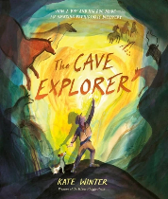  The Cave Explorer  Kate Winter |  |  | 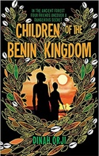  Children of the Benin Kingdom  Dina Orji |  | 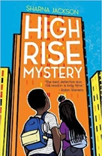  High Rise Mystery  Sharna Jackson | 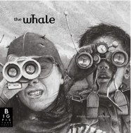  The Whale  Ethan & Vita Murrow
Length | 15 sessions, 3 weeks |  |  | 15 sessions, 3 weeks |  | 15 sessions, 3 weeks | 15 sessions, 3 weeks
Outcomes | Tourist Leaflet for the Lascaux Caves  Debate, opinion piece (blog post), diary entry, newspaper report, non-chronological report, poetry |  |  | Non-chronological reports  Informal letters, diaries, survival guides, eyewitness reports, story summaries |  | Extended stories Character & setting descriptions, police & newspaper report, dialogue, persuasive letters | Film pitches Reported speeches, speech and thought bubbles, descriptions, recounts in role, letters to a newspaper editor

Moderated Writing

